Bathing water profile – Loch Morlich
Bathing water classification

Bathing water description
Loch Morlich is one of only three inland bathing waters in Scotland. It is close to the foot of Cairngorm Mountain. It is approximately 8 km from Aviemore in the Highlands. Loch Morlich is a shallow, freshwater loch surrounded by the Glenmore forest. The designated bathing water is on the eastern side of the loch. It is 500 metres long. Loch Morlich is popular for bathing, water sports, walking and mountain biking.

Site details:
- Local authority: Highland Council
- Year of designation: 2008
- Water sampling location: NH 97160 09750

Risks to water quality
This bathing water is at risk of short term pollution following heavy rainfall. Bathing is not advised during or 1-2 days after heavy rainfall due to the risk to bathers’ health from water pollution.

Catchment description
The Loch Morlich bathing water catchment extends to 300 m2. The catchment is very steep. It ranges from high hills (maximum elevation 600 metres) in the north-east to an average elevation of 320 metres near the loch.
The main river in the catchment is a small unnamed burn which flows directly into the bathing water area. Outside of the catchment, the River Luineag and small burns flow into the loch to the south of the designated area.
The catchment is rural with coniferous forest the major land use (82%). There is no urban development. Next to the catchment is Glenmore Lodge, a caravan park and a reindeer house. Outside the catchment, the upland areas around the River Luineag support forestry and hillside recreational activities.
Loch Morlich is in the Cairngorms National Park and the River Spey Special Area of Conservation. Glenmore Forest, surrounding the loch, is a Site of Special Scientific Interest (SSSI).

Map 1: Loch Morlich bathing water
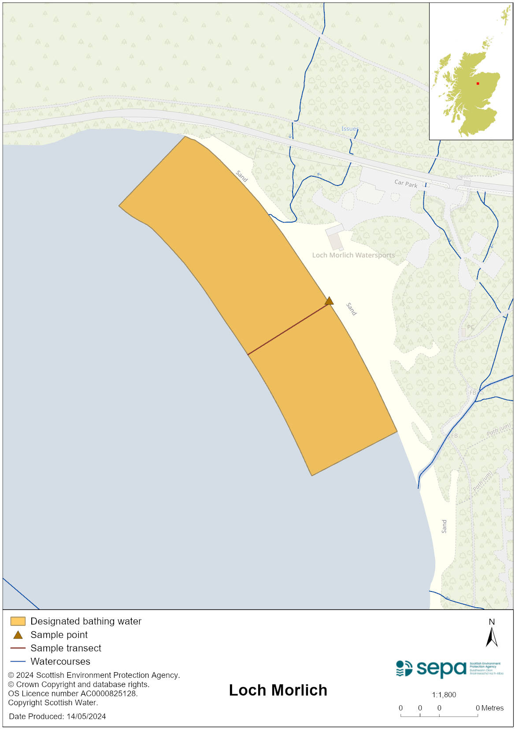

Map 2: Catchment draining into Loch Morlich bathing water
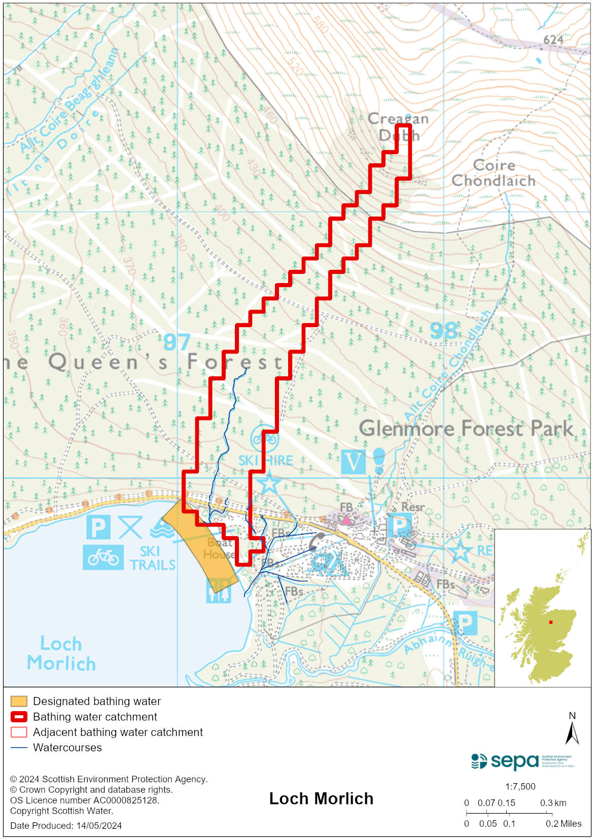

Improving bathing water quality

Sewage
Scottish Water provides most waste water collection and treatment services in Scotland.

Sewage is treated at Glenmore sewage treatment works before being discharged to the Allt Mor watercourse.

Agriculture
Diffuse pollution from agricultural sources is the result of rain driven events causing cumulative inputs of pollutants to rivers and streams.

The bathing water catchment lies within the Spey catchment where work with land managers will take place. Work to address diffuse pollution in the catchment is expected to be completed by 2027.

Cyanobacteria (blue-green algae), algae and jellyfish
Marine waters are not at risk of cyanobacteria overproduction. This bathing water is not at risk of excessive growth of macroalgae (seaweed) or phytoplankton.

The possibility of increased jellyfish numbers in the water during summer months is a naturally occurring phenomenon. Most species common to the UK are harmless; the Marine Conservation Society advises to ‘look but don’t touch’.

Pollution incidents
Pollution can be reported via our website online form or by calling our 24 hours a day Pollution Hotline number 0800 80 70 60

If pollution is reported to us, or identified by our routine water quality monitoring program, we will investigate and where necessary work with others to remediate. We may contact other relevant organisations including the local authority, that local health board, Scottish Water and Scottish Ministers.

If there is a risk to human health the local authority is responsible for placing signs at the bathing water. Information will also be available on our website.

Everyone can help to keep the bathing water clean:
- If you visit the beach with your dog clear up any fouling
- Don’t leave litter or feed birds - this encourages unnatural behaviour, and they can pollute the water
- At home, don’t flush wipes or other inappropriate items as these can block pipes and cause sewage spills

Contact details and information sources

SEPA bathing waters homepage

SEPA rainfall data

Scottish Government protected waters homepage

Highland Council

For information on accessing this document in an alternative format or language, please contact SEPA by emailing equalities@sepa.org.uk
If you are a user of British Sign Language (BSL), the Contact Scotland BSL service gives you access to an online interpreter, enabling you to communicate with us using sign language. contactscotland-bsl.org

