Bathing water profile - Sandyhills
Bathing water classification

Bathing water description
Sandyhills bathing water is a small, shallow bay, about 1 km long. It is found to the south of Dalbeattie.

The sandy beach slopes gently towards the water and depending on the tide, there can be 50-200 metres of beach before the water’s edge. Sandyhills also has an unusual tidal regime which can be dangerous for beach users. Mud flats are exposed at low tide, making the water’s edge difficult to access in certain areas. Low tide also exposes areas of quicksand.

Site details:
- Local authority: Dumfries & Galloway Council
- Year of designation: 1987
- Water sampling location: NX 89200 55100

Risks to water quality
This bathing water is subject to short term pollution following heavy rainfall. Bathing is not advised during or 1-2 days after heavy rainfall due to the risk to bathers’ health from water pollution.

Pollution risks include agricultural run-off and sewerage.

Water quality forecasts
As water quality is likely to be impacted by rainfall we make daily predictions of good or poor bathing water quality. We advise against bathing when poor water quality is predicted as there is an increased risk to bathers’ health from water pollution.

These predictions are displayed on the electronic sign at the beach and online between 15 May and 15 September.

Catchment description
A catchment area of 55 km2 drains into Sandyhills bathing water. Boreland Hill lies to the north east of the catchment. Grassland is the major land use, with the upland areas supporting mixed sheep and beef farming and the lowlands intensive dairy farming. Approximately 1% of the bathing water catchment is urban. The main population centre is Sandyhills village.
The main rivers within the catchment are the Barnhourie Burn (Fairgirth Lane) and Southwick Burn. The smaller Cairngill Burn also flows directly onto the beach.

Map 1: Sandyhills bathing water
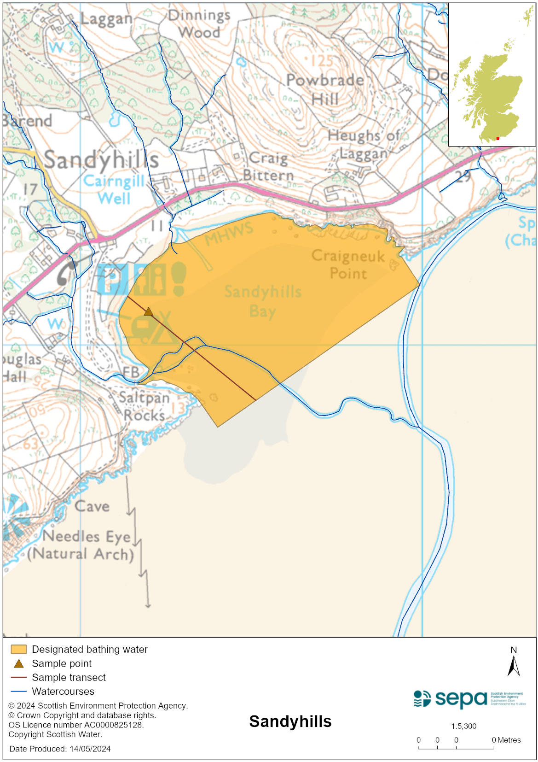

Map 2: Catchment draining into Sandyhills bathing water
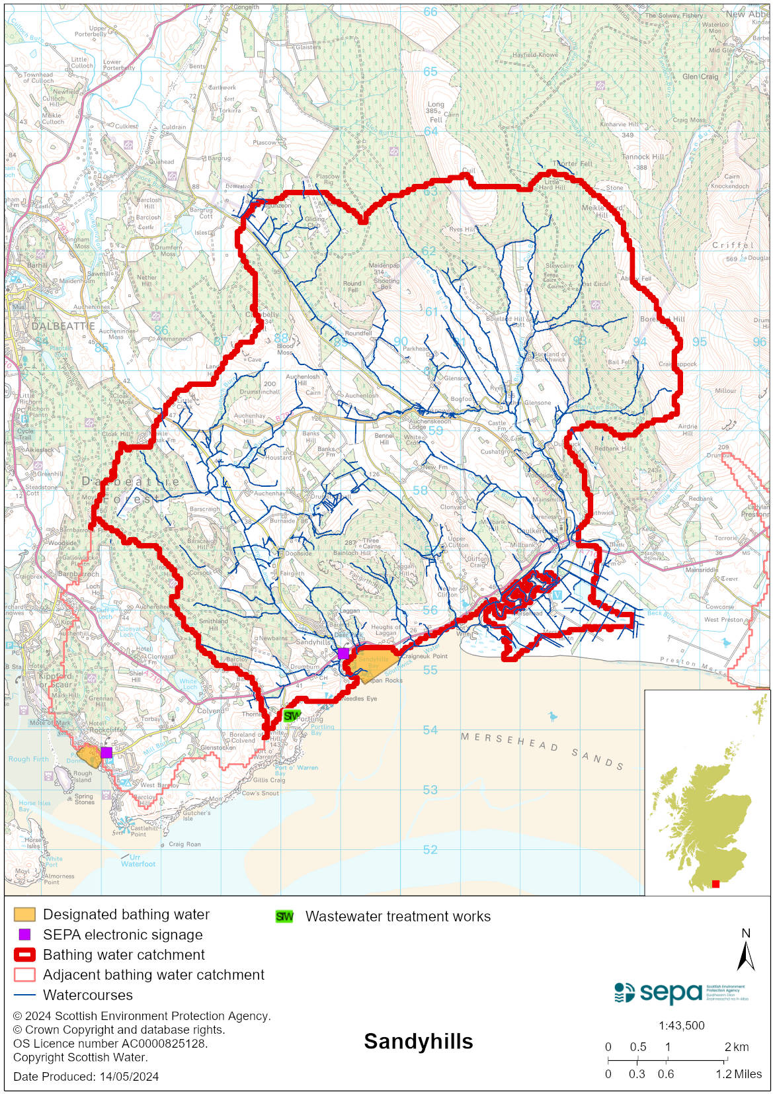

Improving bathing water quality

Sewage
Whilst Scottish Water provides most waste water collection and treatment services in Scotland, there are no Scottish Water assets in the vicinity of this bathing water.

Private sewage treatment systems from a caravan park and a chalet park are located within the bathing water catchment area. Both sites are on SEPA’s monitoring programme to ensure compliance with licence conditions. Effluent from the caravan park is treated before being discharged into a soakaway system adjacent to the Barnhourie Burn. The chalet park effluent is treated before being discharged to the Barnhourie Burn.

Agriculture
Diffuse pollution from agricultural sources is the result of rain driven events causing cumulative inputs of pollutants to rivers and streams.
There is potential for agricultural diffuse pollution to occur in the Fairgirth Lane and Southwick Burn which could impact on the bathing beach during and following heavy rain.
Sandyhills is part of the Stewartry Coastal catchment. All agricultural compliance work has been completed in this bathing water catchment.
SEPA is content all farms are in a compliant state and will continue to engage with farmers and the NFUS to remind them of good practice when applying slurries and manures and grazing livestock.
A study of Sandyhills Bay was carried out by the Centre for Research into Environment and Health (CREH) in 2014. It concluded that there is a connectivity of microbial pollutants between nearby rivers and the bathing water. In addition, it determined that sediments in Sandyhills Bay act as a microbial pollutant store. Remobilisation of sediments along with microbial pollutants is thought to affect water quality. CREH also concluded that tidal movements affected concentrations of microbial pollutants in the bay.

Cyanobacteria (blue-green algae), algae and jellyfish
Marine waters are not at risk of cyanobacteria overproduction. This bathing water is not at risk of excessive growth of macroalgae (seaweed) or phytoplankton.

The possibility of increased jellyfish numbers in the water during summer months is a naturally occurring phenomenon. Most species common to the UK are harmless; the Marine Conservation Society advises to ‘look but don’t touch’.

Pollution incidents
Pollution can be reported via our website online form or by calling our 24 hours a day Pollution Hotline number 0800 80 70 60

If pollution is reported to us, or identified by our routine water quality monitoring program, we will investigate and where necessary work with others to remediate. We may contact other relevant organisations including the local authority, that local health board, Scottish Water and Scottish Ministers.

If there is a risk to human health the local authority is responsible for placing signs at the bathing water. Information will also be available on our website.

Everyone can help to keep the bathing water clean:
- If you visit the beach with your dog clear up any fouling
- Don’t leave litter or feed birds - this encourages unnatural behaviour, and they can pollute the water
- At home, don’t flush wipes or other inappropriate items as these can block pipes and cause sewage spills

Contact details and information sources

SEPA bathing waters homepage

SEPA rainfall data

Scottish Government protected waters homepage

Dumfries & Galloway Council

For information on accessing this document in an alternative format or language, please contact SEPA by emailing equalities@sepa.org.uk
If you are a user of British Sign Language (BSL), the Contact Scotland BSL service gives you access to an online interpreter, enabling you to communicate with us using sign language. contactscotland-bsl.org

