Bathing water profile - Whitesands
Bathing water classification

Bathing water description
Whitesands bathing water is located approximately 3 km south east of Dunbar in East Lothian. It is a small, shallow, enclosed sandy bay which is popular with walkers and picnickers. The beach slopes gently towards the water and depending on the tide, there can be 0-400 metres of beach before the water’s edge.

Site details:
- Local authority: East Lothian Council
- Year of designation: 1999
- Water sampling location: NT 71186 77436

Risks to water quality
This bathing water is at risk of short term pollution following heavy rainfall. Bathing is not advised during or 1-2 days after heavy rainfall due to the risk to bathers’ health from water pollution.

Catchment description
A catchment of 2.5 km2 drains into the Whitesands bathing water. The area is mostly rural (72%), with agriculture the major land use. Although 4% of the bathing water catchment is classed as urban, there are no main population centres within it. A portion of the catchment is occupied by a quarry and associated cement works.

There are no major rivers within the bathing water catchment.

The bathing water lies within the Barns Ness Coastal Site of Special Scientific Interest (SSSI). The SSSI was designated due to the presence of salt marshes, shingle and sand dunes. It is not considered to be an influence on bathing water quality. The Lothian and Borders area was designated as a surface water Nitrate Vulnerable Zone in 2002.

Map 1: Whitesands bathing water
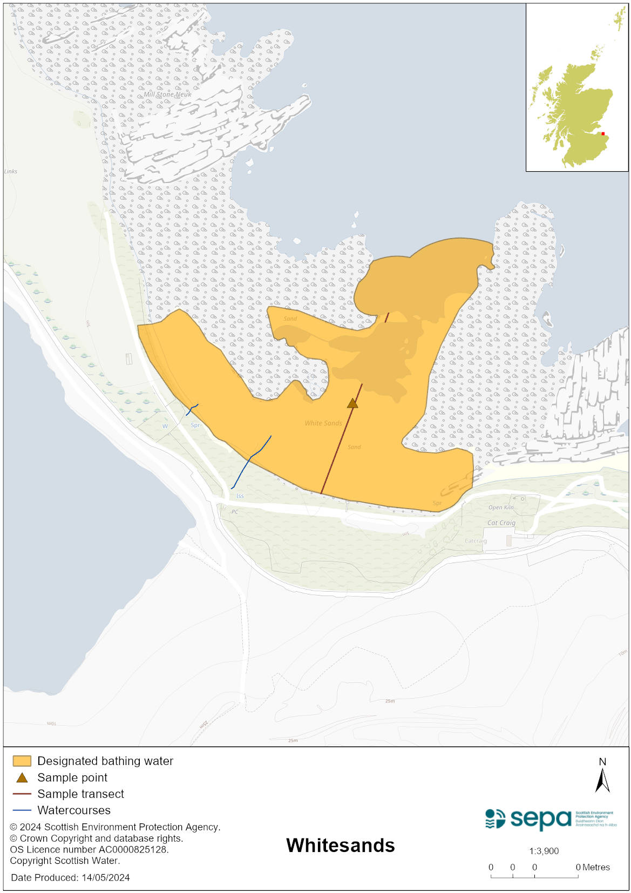

Map 2: Catchment draining into Whitesands bathing water
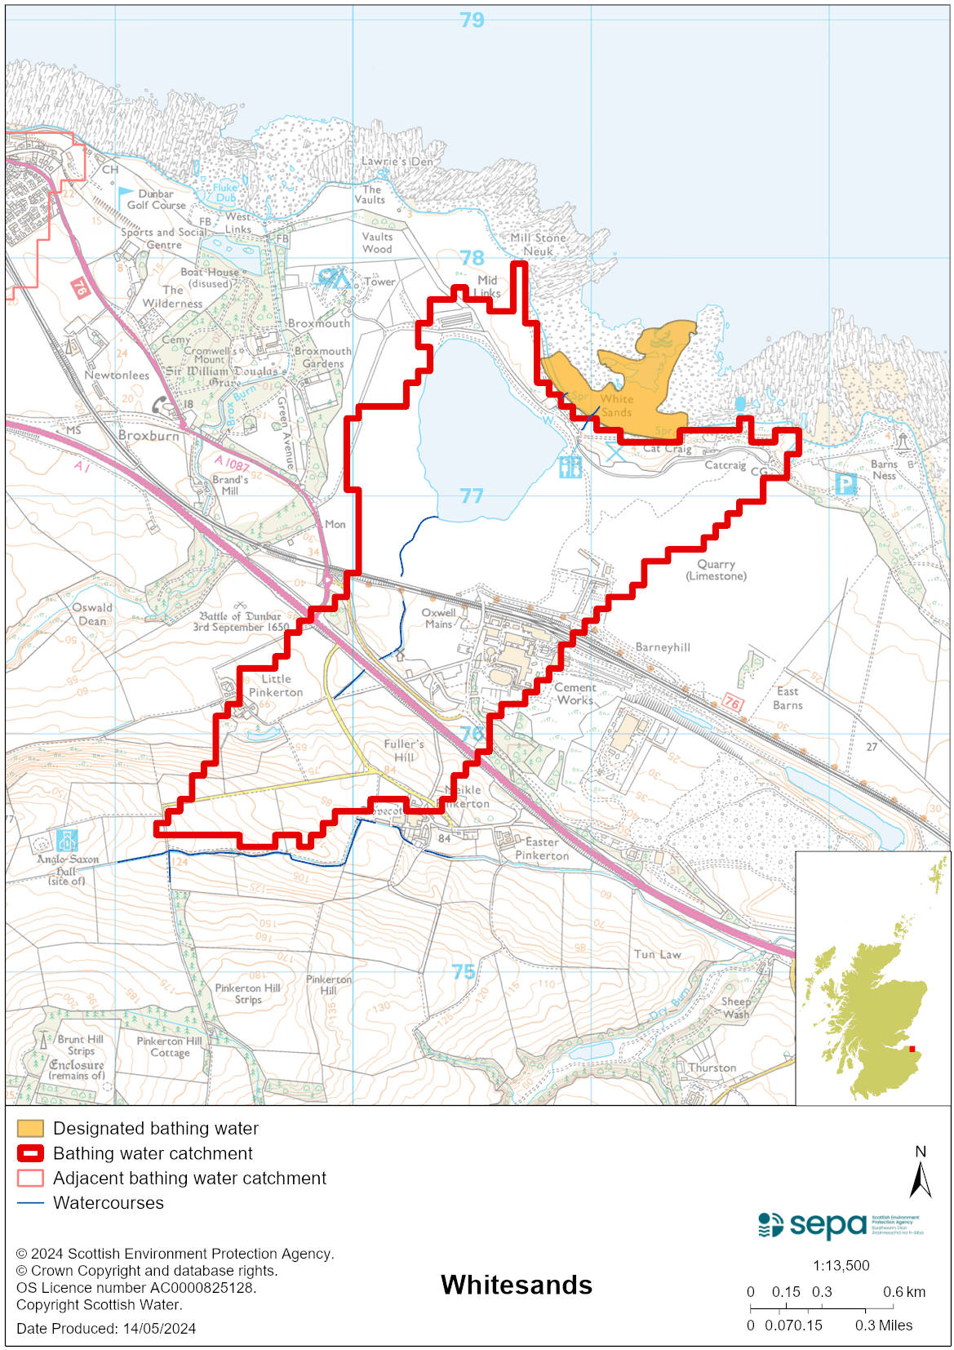

Improving bathing water quality

Sewage
Whilst Scottish Water provides most water water collection and treatment services in Scotland, there are no Scottish Water assets in the vicinity of this bathing water.

There are no other significant sewage discharges likely to threaten the water quality at this bathing water.

Sewage from Tarmac Cement Plant in Dunbar goes to a private sewage treatment plant and is discharged to the North Sea.

Agriculture
There are no impacts from agriculture affecting this bathing water.

Cyanobacteria (blue-green algae), algae and jellyfish
Marine waters are not at risk of cyanobacteria overproduction. This bathing water is not at risk of excessive growth of macroalgae (seaweed) or phytoplankton.

The possibility of increased jellyfish numbers in the water during summer months is a naturally occurring phenomenon. Most species common to the UK are harmless; the Marine Conservation Society advises to ‘look but don’t touch’.

Pollution incidents
Pollution can be reported via our website online form or by calling our 24 hours a day Pollution Hotline number 0800 80 70 60

If pollution is reported to us, or identified by our routine water quality monitoring program, we will investigate and where necessary work with others to remediate. We may contact other relevant organisations including the local authority, that local health board, Scottish Water and Scottish Ministers.

If there is a risk to human health the local authority is responsible for placing signs at the bathing water. Information will also be available on our website.

Everyone can help to keep the bathing water clean:
- If you visit the beach with your dog clear up any fouling
- Don’t leave litter or feed birds - this encourages unnatural behaviour, and they can pollute the water
- At home, don’t flush wipes or other inappropriate items as these can block pipes and cause sewage spills

Contact details and information sources

SEPA bathing waters homepage

SEPA rainfall data

Scottish Government protected waters homepage

East Lothian Council

For information on accessing this document in an alternative format or language, please contact SEPA by emailing equalities@sepa.org.uk
If you are a user of British Sign Language (BSL), the Contact Scotland BSL service gives you access to an online interpreter, enabling you to communicate with us using sign language. contactscotland-bsl.org

