Bathing water profile - Irvine
Bathing water classification

Bathing water description
Irvine bathing water extends 2.5 km along the front of the town of Irvine. The beach is very popular with locals and summer visitors. The southern end of the beach is next to Glasgow Gailes Golf Club. Depending on the tide, the approximate distance to the water’s edge can vary from 30–240 metres.

Site details:
- Local authority: North Ayrshire Council
- Year of designation: 1987
- Water sampling location: NS 30700 37499

Risks to water quality
This bathing water is subject to short term pollution following heavy rainfall. Bathing is not advised during or 1-2 days after heavy rainfall due to the risk to bathers’ health from water pollution.

Pollution risks include agricultural run-off, sewer overflows and surface water discharges.

Water quality forecasts
As water quality is likely to be impacted by rainfall we make daily predictions of good or poor bathing water quality. We advise against bathing when poor water quality is predicted as there is an increased risk to bathers’ health from water pollution.

These predictions are displayed on the electronic sign at the beach and online between 15 May and 15 September.

Catchment description
The Irvine bathing water catchment extends to about 732 km2. It comprises of rolling countryside with a low-lying coastal plain to the west. There are hills of 200–500 metres to the north and east. The main urban area is of much lower elevation (average of 10–20 metres).
The catchment is mainly rural with agriculture the major land use. The upland areas support beef and sheep farming. The middle and lower catchment supports intensive dairy farming. A small portion of the catchment is urban. The main towns are Kilwinning, Irvine and Kilmarnock. There is some largescale and smaller scale industrial activity within the lower reaches of the River Irvine.
There are several protected areas within the catchment. This includes Special Areas of Conservation, Special Protection Areas and Sites of Special Scientific Interest (SSSI).

Map 1: Irvine bathing water
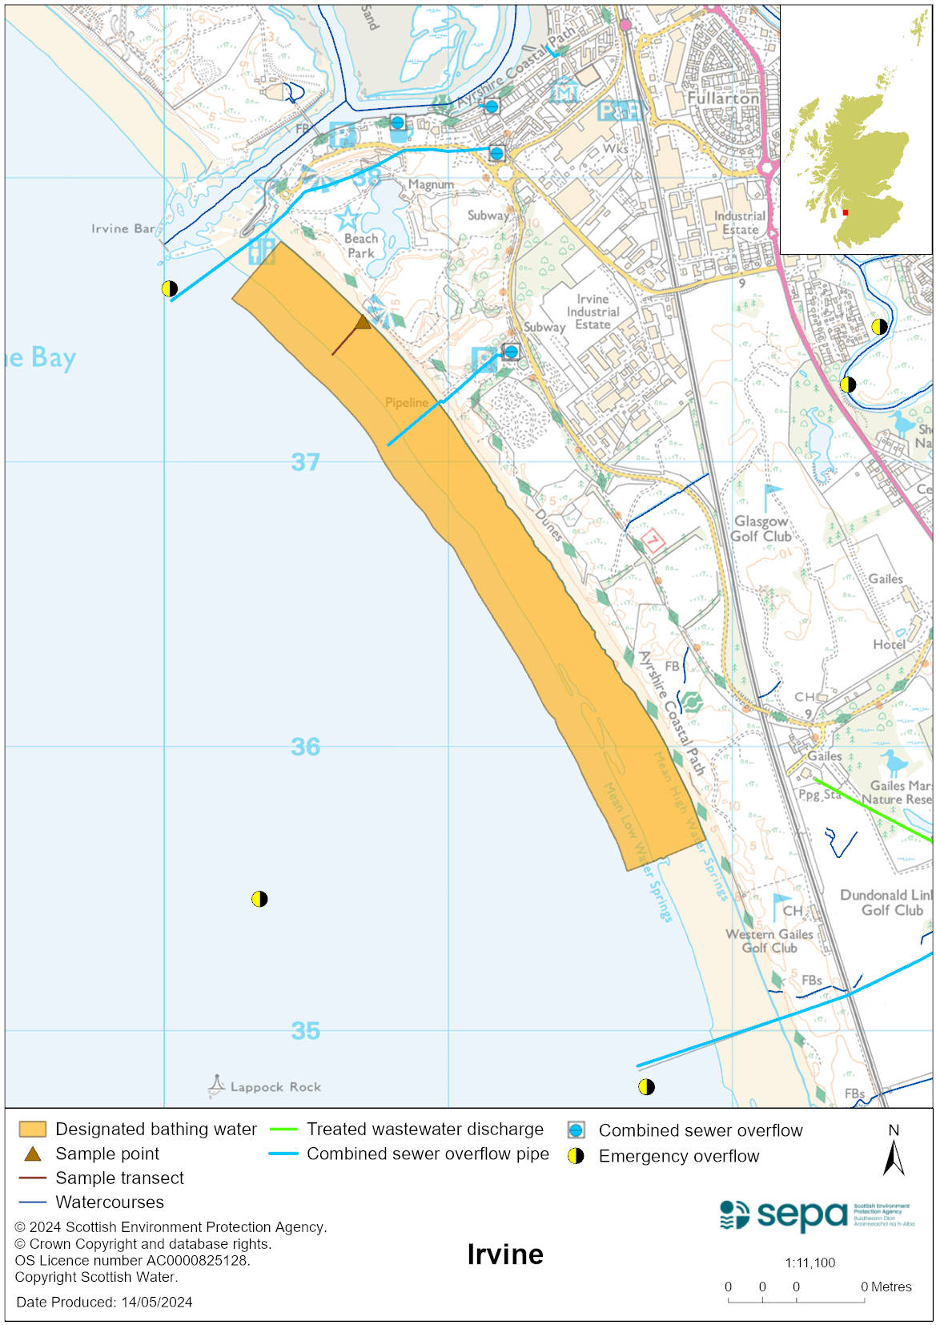

Map 2: Catchment draining into Irvine bathing water
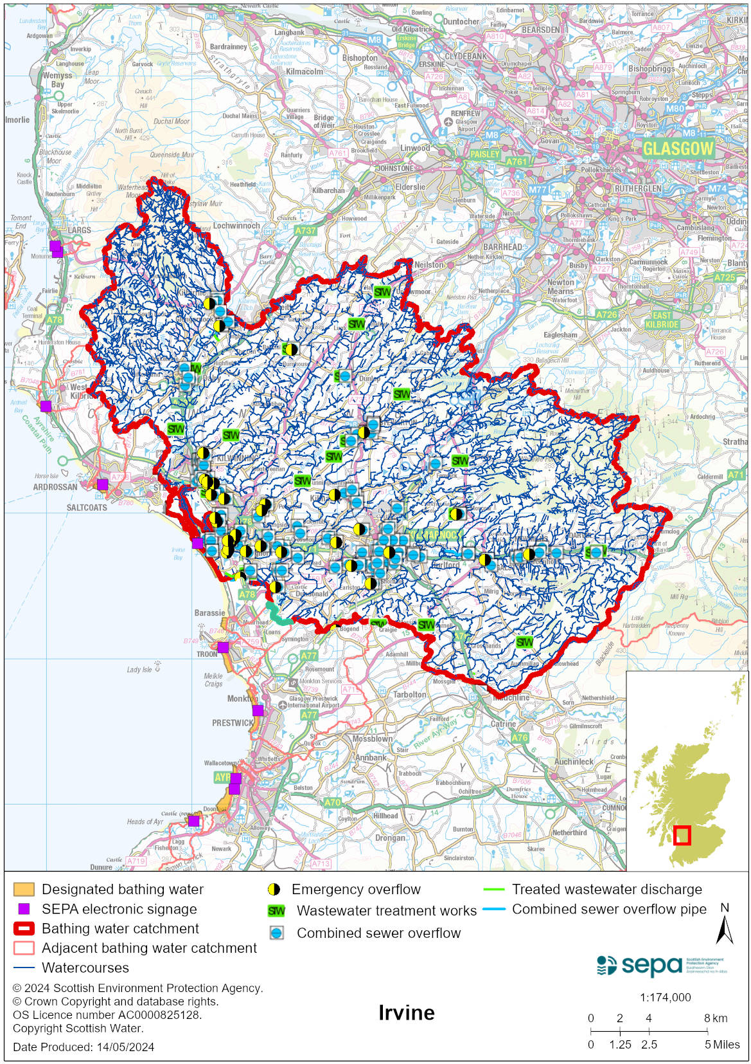

Improving bathing water quality

Sewage
Scottish Water provides most waste water collection and treatment services in Scotland.

Combined sewer overflows can have a significant impact on the water quality at Irvine beach. These discharges only normally occur as a result of rainfall. Most of the overflows are situated beside rivers in the towns of Irvine and Kilmarnock.

Scottish Water completed the construction of a £50million storm sewage overflow improvement scheme to significantly reduce storm sewage quantities discharged to the River Irvine. The storm sewage interceptor system in Irvine was brought on line in December 2012. The equivalent system serving Kilmarnock was completed in late 2013. Minor improvements were made to the new storm sewage interceptor system in Irvine and Kilmarnock during 2014. Scottish Water undertook a study of Irvine bathing water which indicated that Gailes Pumping Station required investment. In June 2018 the operating regime at Gailes pumping station was changed to allow the continuous discharge to the long sea outfall with the intermittent discharge to the short sea outfall as models indicated this would be beneficial to the bathing water.

Agriculture
Diffuse pollution from agricultural sources is the cumulative effect of pollutants from several different sources.

There is potential for agricultural diffuse pollution to occur in the Rivers Irvine and Garnock. They are a risk to Irvine’s bathing water quality, particularly during and after periods of wet weather.

Farm visits have been ongoing in this catchment since 2013 and SEPA will continue to work with rural land managers to reduce the risk of pollution to the bathing water. SEPA has observed significant changes in land manager practice resulting in improvements which are known to reduce pollution risk. There has been significant capital expenditure resulting in many rural land managers going beyond regulatory compliance to address issues arising from their farming activities.

Urban
Urban diffuse source pollution comes from contaminated rainwater discharging to rivers and streams. The River Irvine and River Garnock are both affected by urban runoff.

Cyanobacteria (blue-green algae), algae and jellyfish
Marine waters are not at risk of cyanobacteria overproduction. This bathing water is not at risk of excessive growth of macroalgae (seaweed) or phytoplankton.

The possibility of increased jellyfish numbers in the water during summer months is a naturally occurring phenomenon. Most species common to the UK are harmless; the Marine Conservation Society advises to ‘look but don’t touch’.

Pollution incidents
Pollution can be reported via our website online form or by calling our 24 hours a day Pollution Hotline number 0800 80 70 60

If pollution is reported to us, or identified by our routine water quality monitoring program, we will investigate and where necessary work with others to remediate. We may contact other relevant organisations including the local authority, that local health board, Scottish Water and Scottish Ministers.

If there is a risk to human health the local authority is responsible for placing signs at the bathing water. Information will also be available on our website.

Everyone can help to keep the bathing water clean:
- If you visit the beach with your dog clear up any fouling
- Don’t leave litter or feed birds - this encourages unnatural behaviour, and they can pollute the water
- At home, don’t flush wipes or other inappropriate items as these can block pipes and cause sewage spills

Contact details and information sources

SEPA bathing waters homepage

SEPA rainfall data

Scottish Government protected waters homepage

North Ayrshire Council

For information on accessing this document in an alternative format or language, please contact SEPA by emailing equalities@sepa.org.uk
If you are a user of British Sign Language (BSL), the Contact Scotland BSL service gives you access to an online interpreter, enabling you to communicate with us using sign language. contactscotland-bsl.org

