Bathing water profile – Broad Sands
Bathing water classification

Bathing water description
The Broad Sands bathing water is close to North Berwick in East Lothian. The sandy bay, around 1.6 km long, is adjacent to Yellow Craig bathing water. Depending on the tide, the approximate distance to the water’s edge can vary from 70–300 metres. The sandy beach slopes gently towards the water.

Site details:
- Local authority: East Lothian Council
- Year of designation: 2008
- Water sampling location: NT 52440 85870

Risks to water quality
This bathing water is at risk of short term pollution following heavy rainfall. Bathing is not advised during or 1-2 days after heavy rainfall due to the risk to bathers’ health from water pollution.

Pollution risks are from sewer overflows.

Catchment description
The catchment draining into the Broad Sands bathing water extends to 7 km2. The area is mainly rural (96%) with agriculture the major land use. Approximately 2.5% of the bathing water catchment is urban. The main urban areas are the western outskirts of North Berwick. In addition, there are several small villages and farms. There are no major watercourses within the bathing water catchment.

The bathing water is located within the Firth of Forth Site of Special Scientific Interest designated for over-wintering birds. The large number of birds in the area may have an influence on water quality at the bathing water.

Map 1: Broad Sands bathing water
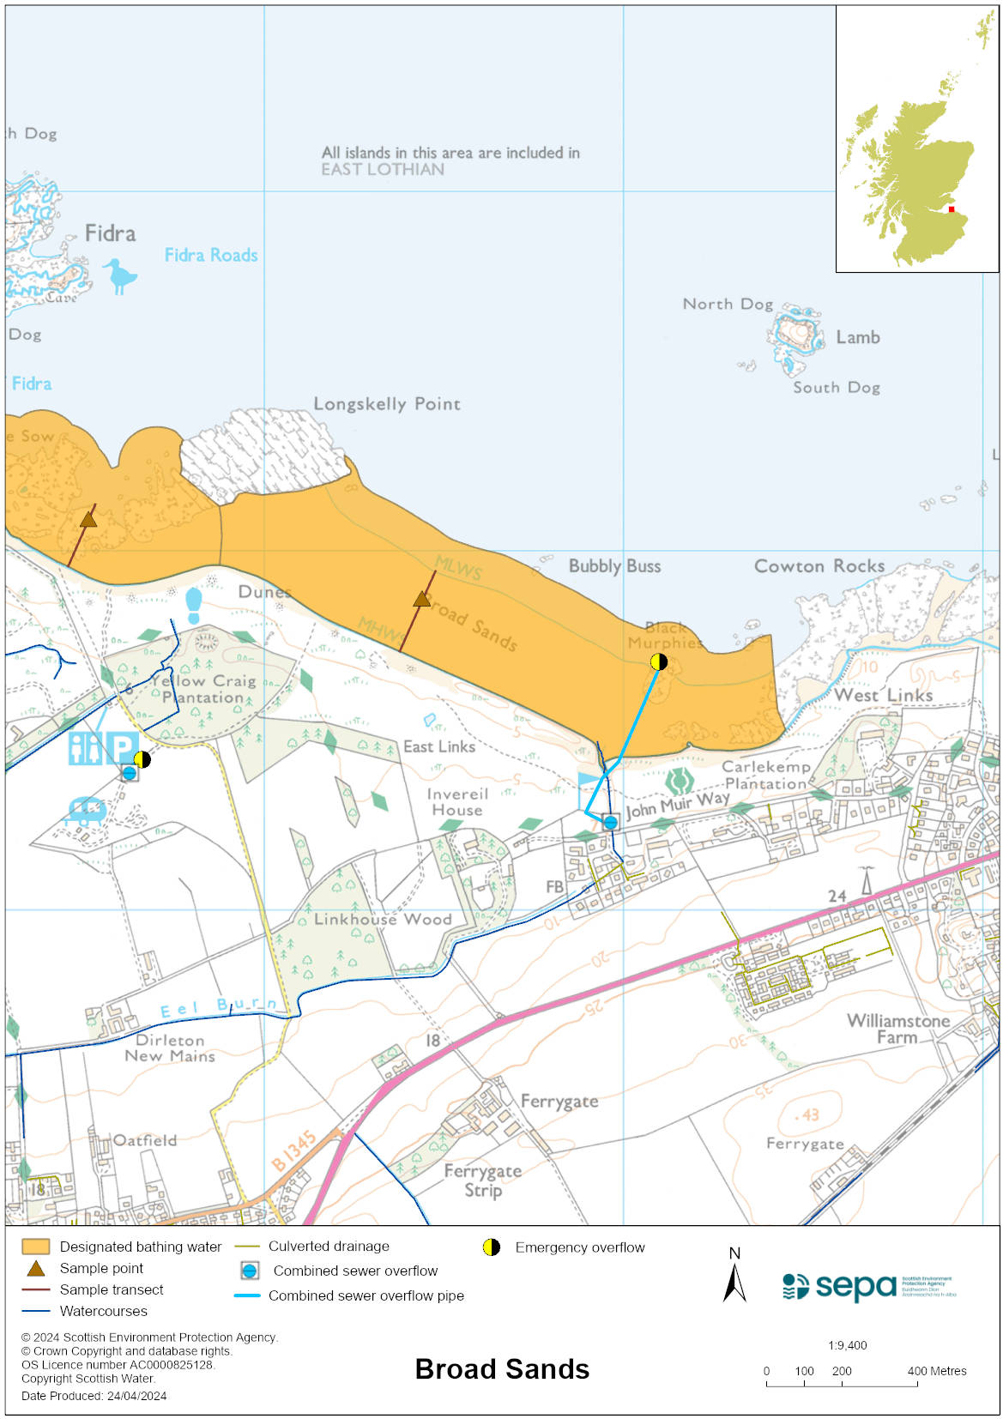

Map 2: Catchment draining into Broad Sands bathing water
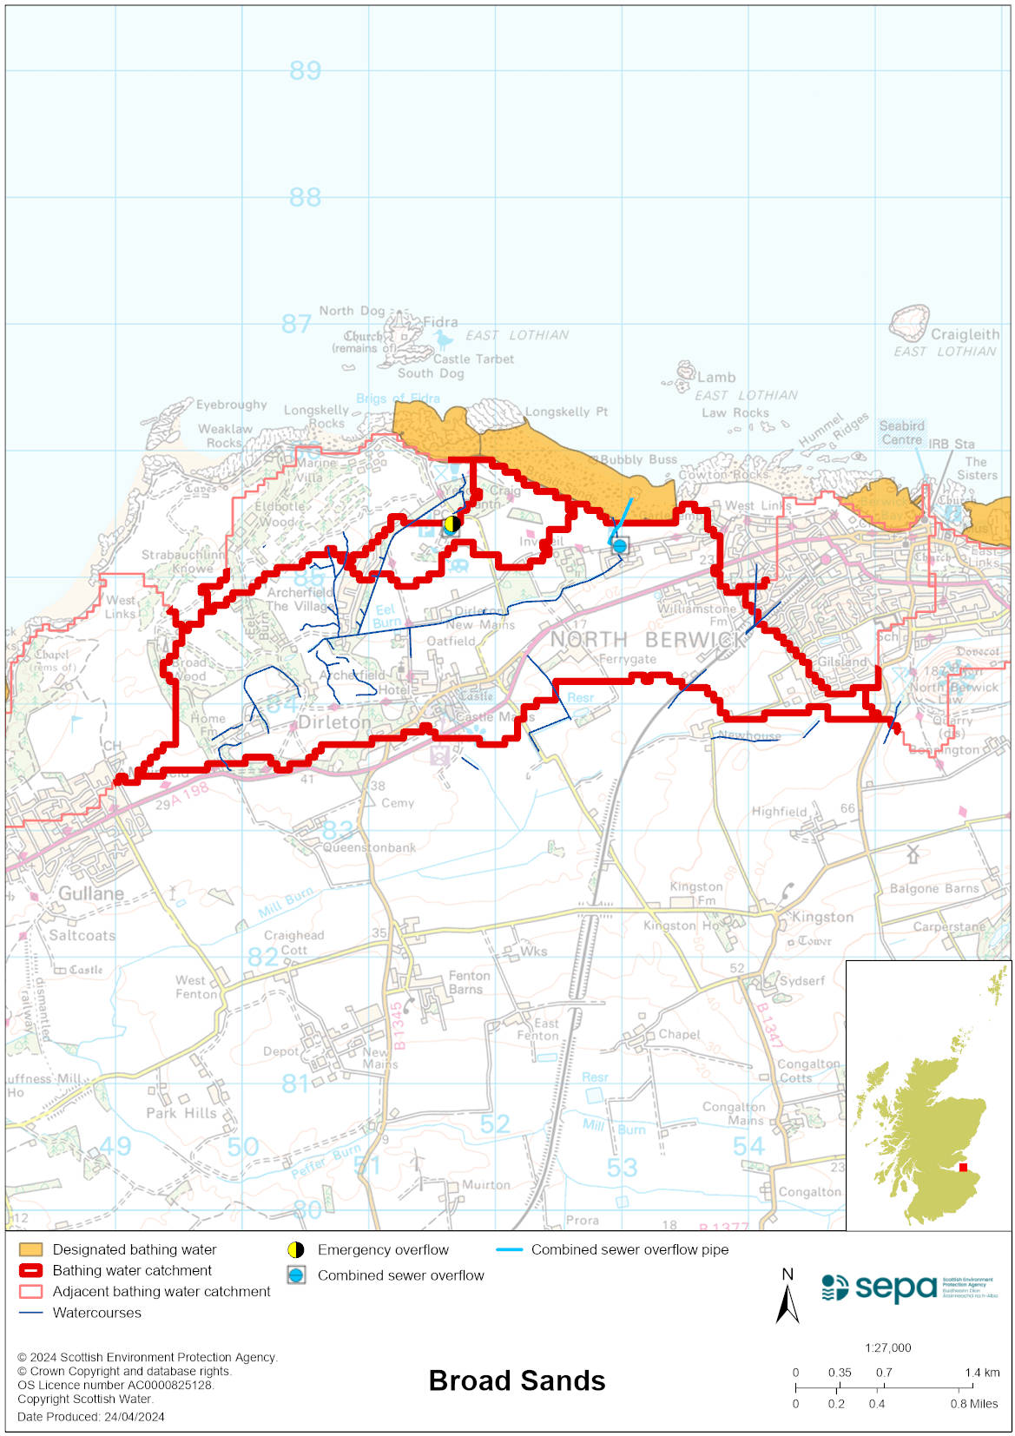

Improving bathing water quality

Sewage
Scottish Water provides most waste water collection and treatment services in Scotland.

Sewage from Dirleton village is treated at North Berwick sewage treatment works and then discharged to the Firth of Forth via a long sea outfall to the east of North Berwick.
Two combined sewer overflows (CSO) have discharge locations nearby, one to the eastern end of the bathing water area and one out with to the east. These may discharge and impact the bathing water during heavy rainfall.

Agriculture
There are no impacts from agriculture affecting this bathing water.

Cyanobacteria (blue-green algae), algae and jellyfish
Marine waters are not at risk of cyanobacteria overproduction. This bathing water is not at risk of excessive growth of macroalgae (seaweed) or phytoplankton.

The possibility of increased jellyfish numbers in the water during summer months is a naturally occurring phenomenon. Most species common to the UK are harmless; the Marine Conservation Society advises to ‘look but don’t touch’.

Pollution incidents
Pollution can be reported via our website online form or by calling our 24 hours a day Pollution Hotline number 0800 80 70 60

If pollution is reported to us, or identified by our routine water quality monitoring program, we will investigate and where necessary work with others to remediate. We may contact other relevant organisations including the local authority, that local health board, Scottish Water and Scottish Ministers.

If there is a risk to human health the local authority is responsible for placing signs at the bathing water. Information will also be available on our website.

Everyone can help to keep the bathing water clean:
- If you visit the beach with your dog clear up any fouling
- Don’t leave litter or feed birds - this encourages unnatural behaviour, and they can pollute the water
- At home, don’t flush wipes or other inappropriate items as these can block pipes and cause sewage spills

Contact details and information sources

SEPA bathing waters homepage

SEPA rainfall data

Scottish Government protected waters homepage

East Lothian Council

For information on accessing this document in an alternative format or language, please contact SEPA by emailing equalities@sepa.org.uk
If you are a user of British Sign Language (BSL), the Contact Scotland BSL service gives you access to an online interpreter, enabling you to communicate with us using sign language. contactscotland-bsl.org

