Bathing water profile - Achmelvich
Bathing water classification

Bathing water description
The Achmelvich bathing water is in a small, shallow bay, about 200 metres long. It is three miles northwest of Lochinver, on the west coast of the Highlands. The white sandy beach and clean water quality attracts visitors and tourists interested water sports, especially in the summer. Depending on the tide, the distance to the water’s edge can vary from 200–250 metres. The sandy beach slopes gently towards the water.

Site details:
- Local authority: Highland Council
- Year of designation: 2008
- Water sampling location: NC 05560 24940

Risks to water quality
Our water quality monitoring indicates that there are no significant pollution inputs to this bathing water under normal situations, including after rainfall.

There remains a risk that water pollution may occur after extreme rainfall.

Catchment description
The catchment draining into the Achmelvich bathing water is low-lying and extends to about 500 m2. It ranges from plains along the coast to low hills in the south-east. The area is mainly rural (96%) with agriculture the major land use. The area is a mixture of grassland and heath. There are numerous crofts which support sheep farming. There is no urban development within the catchment and the population density is very low. In the summer, there can be a high influx of tourists to the area.
There are no rivers or small burns within the bathing water catchment. There are a few drainage ditches draining directly into the bathing water.

Map 1: Achmelvich bathing water
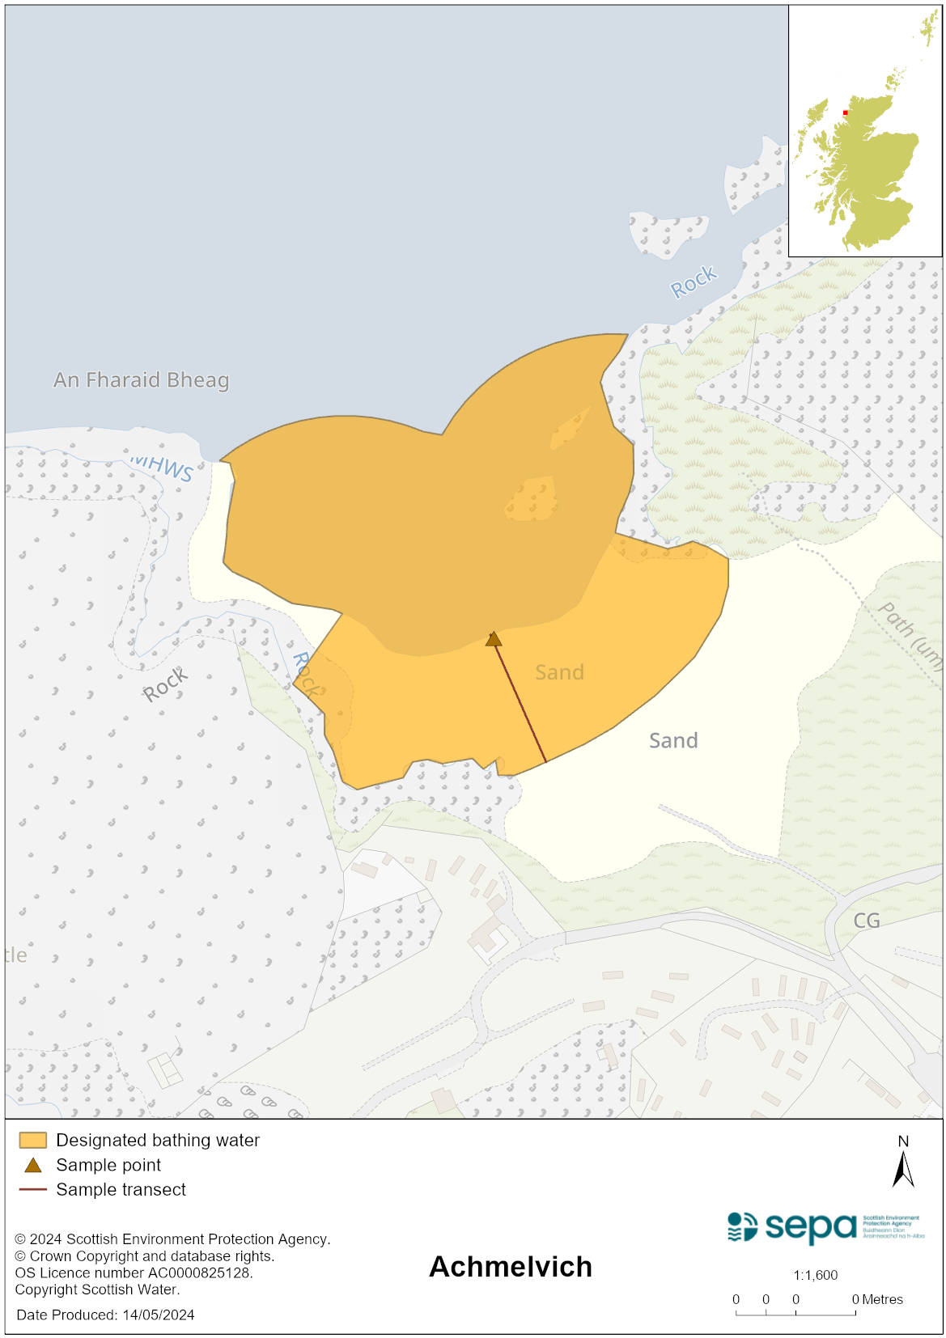

Map 2: Catchment draining into Achmelvich bathing water
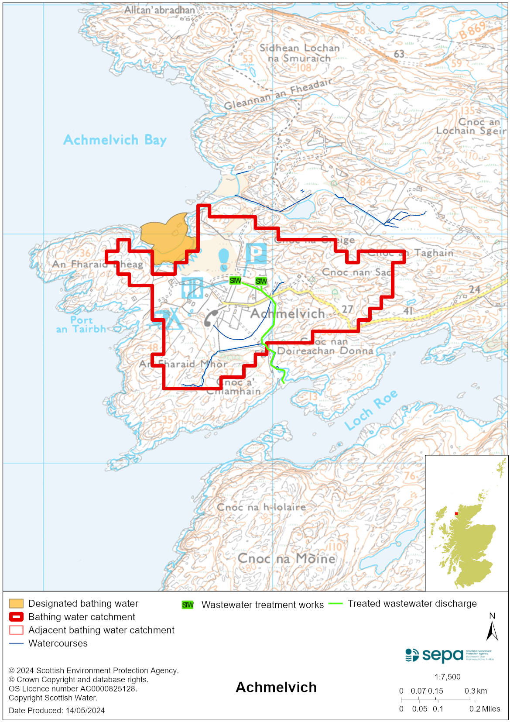

Improving bathing water quality

Sewage
Whilst Scottish Water provides most water water collection and treatment services in Scotland, there are no Scottish Water assets in the vicinity of this bathing water.
A caravan park discharges effluent to a soakaway via a septic tank and there are several other septic tanks within the catchment. These are thought to pose a minimal risk to bathing water quality under normal operating conditions.

Agriculture
Diffuse pollution from agricultural sources is the result of rain driven events causing cumulative inputs of pollutants to rivers and streams.

There are many crofts supporting sheep farming in this area. There is potential for agricultural diffuse pollution to occur in small unnamed ditches to the north of the bathing water.

Cyanobacteria (blue-green algae), algae and jellyfish
Marine waters are not at risk of cyanobacteria overproduction. This bathing water is not at risk of excessive growth of macroalgae (seaweed) or phytoplankton.

The possibility of increased jellyfish numbers in the water during summer months is a naturally occurring phenomenon. Most species common to the UK are harmless; the Marine Conservation Society advises to ‘look but don’t touch’.

Pollution incidents
Pollution can be reported via our website online form or by calling our 24 hours a day Pollution Hotline number 0800 80 70 60

If pollution is reported to us, or identified by our routine water quality monitoring program, we will investigate and where necessary work with others to remediate. We may contact other relevant organisations including the local authority, that local health board, Scottish Water and Scottish Ministers.

If there is a risk to human health the local authority is responsible for placing signs at the bathing water. Information will also be available on our website.

Everyone can help to keep the bathing water clean:
- If you visit the beach with your dog clear up any fouling
- Don’t leave litter or feed birds - this encourages unnatural behaviour, and they can pollute the water
- At home, don’t flush wipes or other inappropriate items as these can block pipes and cause sewage spills

Contact details and information sources

SEPA bathing waters homepage

SEPA rainfall data

Scottish Government protected waters homepage

Highland Council

For information on accessing this document in an alternative format or language, please contact SEPA by emailing equalities@sepa.org.uk
If you are a user of British Sign Language (BSL), the Contact Scotland BSL service gives you access to an online interpreter, enabling you to communicate with us using sign language. contactscotland-bsl.org

