Bathing water profile - Coldingham
Bathing water classification

Bathing water description
Coldingham bathing water is approximately 1km northeast of the town of Coldingham. The beach is a sandy bay about 200 metres long, sheltered by rocky outcrops at either end. It is popular with swimmers, surfers and wildlife enthusiasts. Depending on the tide, the distance to the water’s edge can vary from 30–160 metres. The sandy beach slopes gently towards the water.

Site details:
- Local authority: Scottish Borders Council
- Year of designation: 1999
- Water sampling location: NT 91769 66557

Risks to water quality
This bathing water is at risk of short term pollution following heavy rainfall. Bathing is not advised during or 1-2 days after heavy rainfall due to the risk to bathers’ health from water pollution.

Pollution risks include sewer overflows.

Catchment description
The Coldingham bathing water catchment extends to 9 km2. The area is mainly rural (98%) with arable agriculture and grassland the major land use. Approximately 2% of the catchment is urban. The main population centre is the town of Coldingham, with population density outside of the towns generally low.
The Milldown Burn flows into the sea approximately 100 metres south of the bathing water.
There are several protected areas in or overlapping with the catchment, including a Special Area of Conservation, a Special Protection Area (SPA) and a Site of Special Scientific Interest. The breeding bird population at St Abbs Head to Fast Castle SPA may potentially influence bathing water quality.

Map 1: Coldingham bathing water
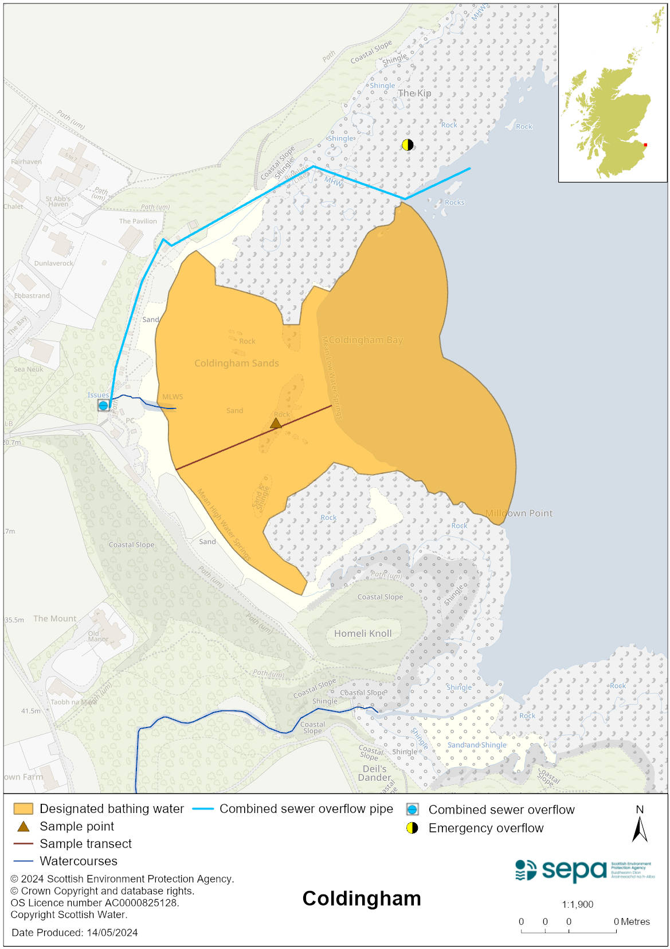

Map 2: Catchment draining into Coldingham bathing water
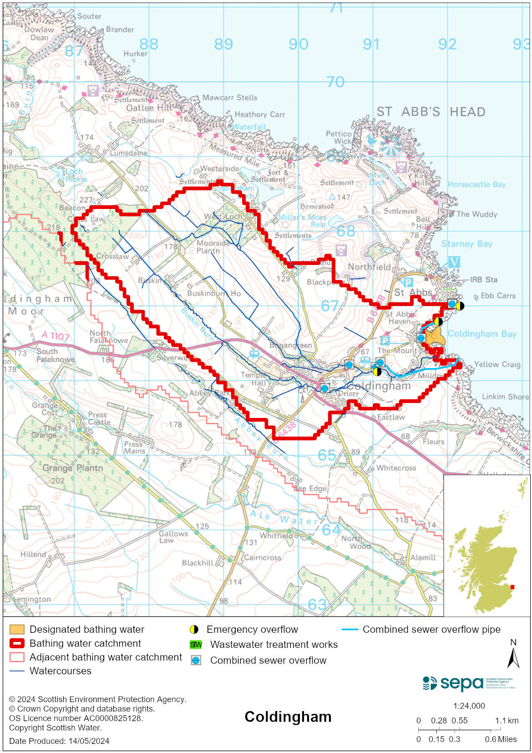

Improving bathing water quality

Sewage
Scottish Water provides most waste water collection and treatment services in Scotland.
Sewage from Coldingham is collected and pumped to Eyemouth sewage treatment works for treatment before being discharged to the North Sea via a long sea outfall.
Three combined sewer overflows (CSO) have discharge locations near the bathing water. These may discharge and impact the bathing water during heavy rainfall.

Agriculture
There are no impacts from agriculture affecting this bathing water.

Cyanobacteria (blue-green algae), algae and jellyfish
Marine waters are not at risk of cyanobacteria overproduction. This bathing water is not at risk of excessive growth of macroalgae (seaweed) or phytoplankton.

The possibility of increased jellyfish numbers in the water during summer months is a naturally occurring phenomenon. Most species common to the UK are harmless; the Marine Conservation Society advises to ‘look but don’t touch’.

Pollution incidents
Pollution can be reported via our website online form or by calling our 24 hours a day Pollution Hotline number 0800 80 70 60

If pollution is reported to us, or identified by our routine water quality monitoring program, we will investigate and where necessary work with others to remediate. We may contact other relevant organisations including the local authority, that local health board, Scottish Water and Scottish Ministers.

If there is a risk to human health the local authority is responsible for placing signs at the bathing water. Information will also be available on our website.

Everyone can help to keep the bathing water clean:
- If you visit the beach with your dog clear up any fouling
- Don’t leave litter or feed birds - this encourages unnatural behaviour, and they can pollute the water
- At home, don’t flush wipes or other inappropriate items as these can block pipes and cause sewage spills

Contact details and information sources

SEPA bathing waters homepage

SEPA rainfall data

Scottish Government protected waters homepage

Scottish Borders Council

For information on accessing this document in an alternative format or language, please contact SEPA by emailing equalities@sepa.org.uk
If you are a user of British Sign Language (BSL), the Contact Scotland BSL service gives you access to an online interpreter, enabling you to communicate with us using sign language. contactscotland-bsl.org

