Bathing water profile – Thurso Bay
Bathing water classification

Bathing water description
Thurso Bay (Central) bathing water is located on the north coast of Scotland, beside the town of Thurso. It extends from Rockwell Point in the west, to Little Ebb in the east and is popular with bathers and water sport enthusiasts. The sandy beach slopes gently towards the water and depending on the tide, there can be 0-160 metres of beach before the water’s edge.

Site details:
- Local authority: Highland Council
- Year of designation: 2008
- Water sampling location: ND 11697 68860

Risks to water quality
This bathing water is at risk of short term pollution following heavy rainfall. Bathing is not advised during or 1-2 days after heavy rainfall due to the risk to bathers’ health from water pollution.

Pollution risks include agricultural run-off, sewer overflows and surface water discharges.

Catchment description
A catchment area of 487 km2 drains into the Thurso bathing water. Its topography varies from hills in the south to the low-lying land along the coast. Land use in the catchment is mainly split between rural land and bog. The principal rural land uses are improved grassland (14%), shrub (12%) and coniferous woodland (10%). The upper catchment around Halkirk is mainly sheep farming with beef farming around Thurso. Less than one percent of the bathing water catchment is classed as urban, with the main population centre the town of Thurso. The population density outside of Thurso is generally low.

The main river within the bathing water catchment is the River Thurso which discharges to the east of the designated bathing water.

There are several protected areas either fully or partially within the bathing water catchment. These include two Special Areas of Conservation, two Special Protection Areas, 17 Sites of Special Scientific Interest, two Ramsar sites and two bird reserves.

Map 1: Thurso Bay bathing water
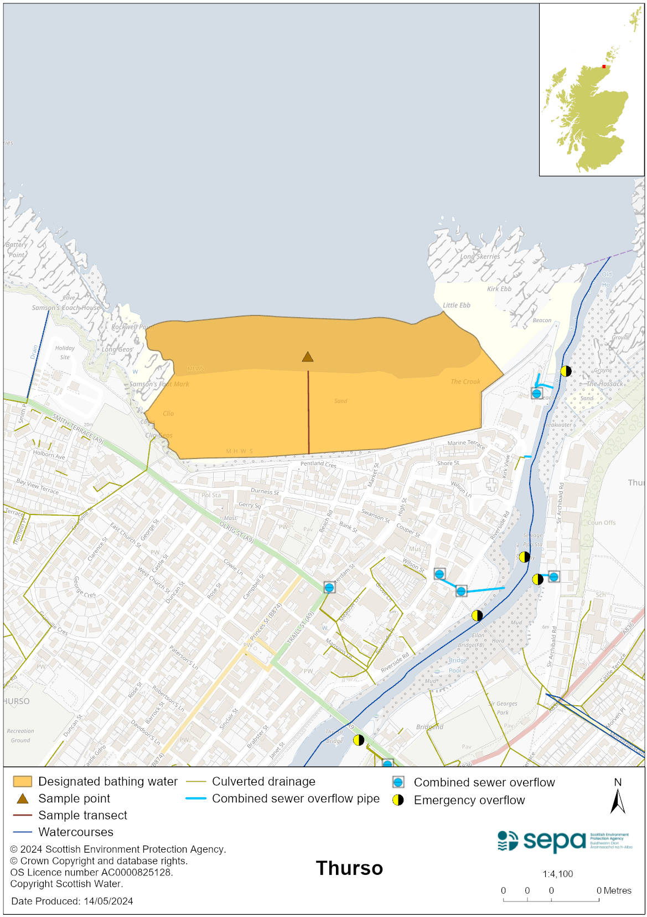

Map 2: Catchment draining into Thurso Bay bathing water
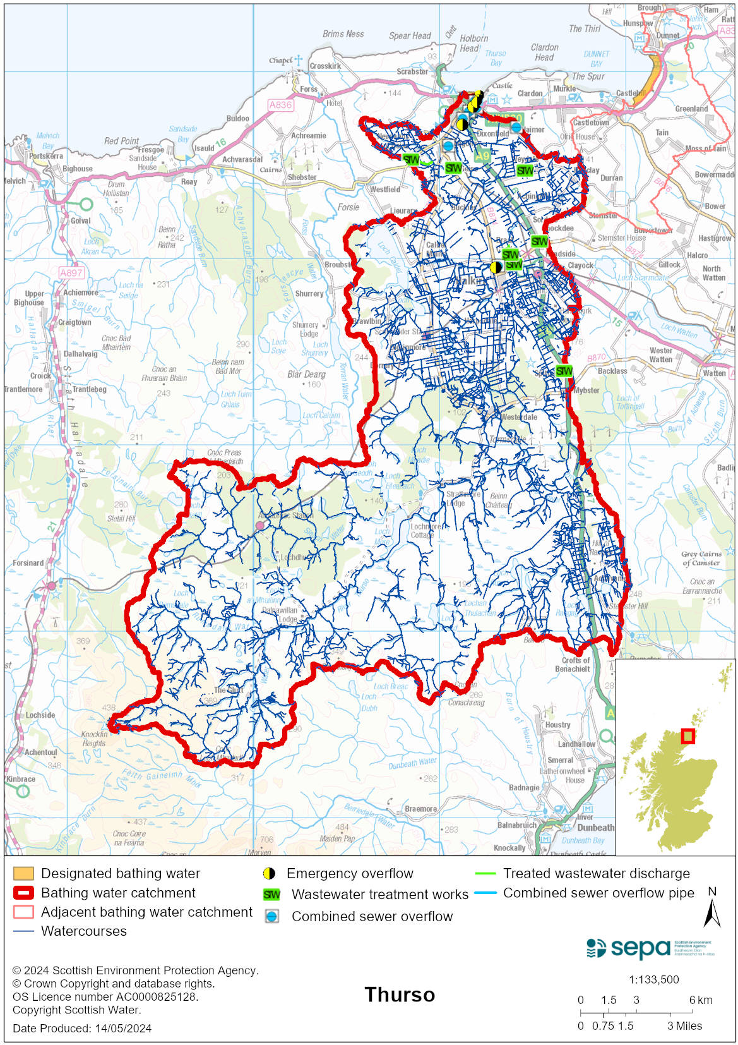

Improving bathing water quality

Sewage
Scottish Water provides most waste water collection and treatment services in Scotland.

Since 2006, sewage from the town of Thurso has been treated at and discharged from Thurso sewage treatment works. Prior to this, sewage effluent was discharged to the sea via a long sea outfall in Thurso Bay. The long sea outfall is now used as a combined sewer overflow and spills intermittently during wet weather. During or after extremely high rainfall, diluted effluent can be discharged to the River Thurso at Thurso Headworks. Both of these overflows, together with other intermittent discharges in the area, have the potential to affect the bathing water quality during wet weather.

Private septic tanks in the Thurso area have the potential to impact on bathing water quality.

Agriculture
Diffuse pollution from agricultural sources is the result of rain driven events causing cumulative inputs of pollutants to rivers and streams.

There is potential for agricultural diffuse pollution to occur in the Thurso River which could impact on the bathing beach during and following heavy rain.

Farm visits started in the Thurso & Wick priority catchment in 2022 and are ongoing. These visits look to identify diffuse pollution sources and pathways. Mitigation measures have been agreed with land managers to reduce the risk of bacterial pollution on water quality.

SEPA will continue to work with farmers to reduce the risk of pollution to the bathing water.

Urban
Urban diffuse source pollution comes from contaminated rainwater discharging to rivers and streams. The River Thurso is known to be affected by surface water run-off from the urban area through which it runs and therefore could potentially affect bathing water quality.

Cyanobacteria (blue-green algae), algae and jellyfish
Marine waters are not at risk of cyanobacteria overproduction. This bathing water is not at risk of excessive growth of macroalgae (seaweed) or phytoplankton.

The possibility of increased jellyfish numbers in the water during summer months is a naturally occurring phenomenon. Most species common to the UK are harmless; the Marine Conservation Society advises to ‘look but don’t touch’.

Pollution incidents
Pollution can be reported via our website online form or by calling our 24 hours a day Pollution Hotline number 0800 80 70 60

If pollution is reported to us, or identified by our routine water quality monitoring program, we will investigate and where necessary work with others to remediate. We may contact other relevant organisations including the local authority, that local health board, Scottish Water and Scottish Ministers.

If there is a risk to human health the local authority is responsible for placing signs at the bathing water. Information will also be available on our website.

Everyone can help to keep the bathing water clean:
- If you visit the beach with your dog clear up any fouling
- Don’t leave litter or feed birds - this encourages unnatural behaviour, and they can pollute the water
- At home, don’t flush wipes or other inappropriate items as these can block pipes and cause sewage spills

Contact details and information sources

SEPA bathing waters homepage

SEPA rainfall data

Scottish Government protected waters homepage

Highland Council

For information on accessing this document in an alternative format or language, please contact SEPA by emailing equalities@sepa.org.uk
If you are a user of British Sign Language (BSL), the Contact Scotland BSL service gives you access to an online interpreter, enabling you to communicate with us using sign language. contactscotland-bsl.org

