Bathing water profile – Aberdour Harbour (Black Sands)
Bathing water classification

Bathing water description
Aberdour Harbour (Black Sands) bathing water is adjacent to the town of Aberdour in Fife. The beach is a mixture of sand and rocks, approximately 0.7 kilometres long and is popular with walkers. Seals can often be seen on shore to the west. There can be 0-200 metres of beach before the water’s edge, depending on tides.

Site details:
- Local authority: Fife Council
- Year of designation: 2010
- Water sampling location: NT 19400 85000

Risks to water quality
This bathing water is at risk of short term pollution following heavy rainfall. Bathing is not advised during or 1-2 days after heavy rainfall due to the risk to bathers’ health from water pollution.

Pollution risks include sewer overflows and agricultural run-off.

Catchment description
The catchment area draining into the Aberdour Harbour (Black Sands) bathing water is approximately 13 km2. The area is predominantly rural (94%). Arable horticulture and grassland are the major land uses. Just over 4% of the bathing water catchment is urban. The main population centre is Aberdour town. There are several small, scattered settlements within the catchment with lower population densities. The main river within the bathing water catchment is the Dour Burn which flows into the sea on the northeastern boundary of the designated area.

Map 1: Aberdour Harbour (Black Sands) bathing water
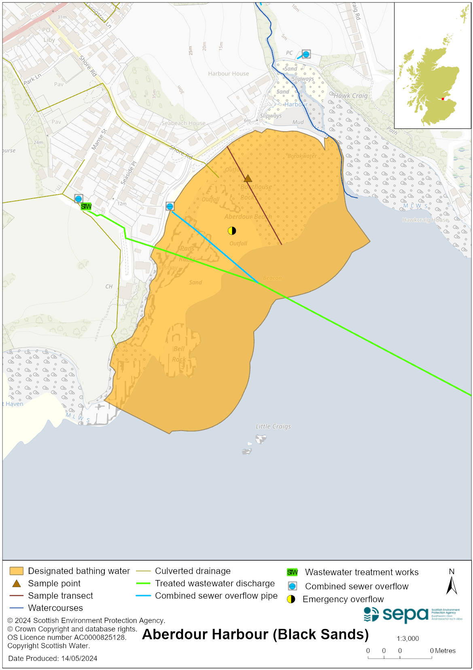

Map 2: Catchment draining into Aberdour Harbour (Black Sands) bathing water
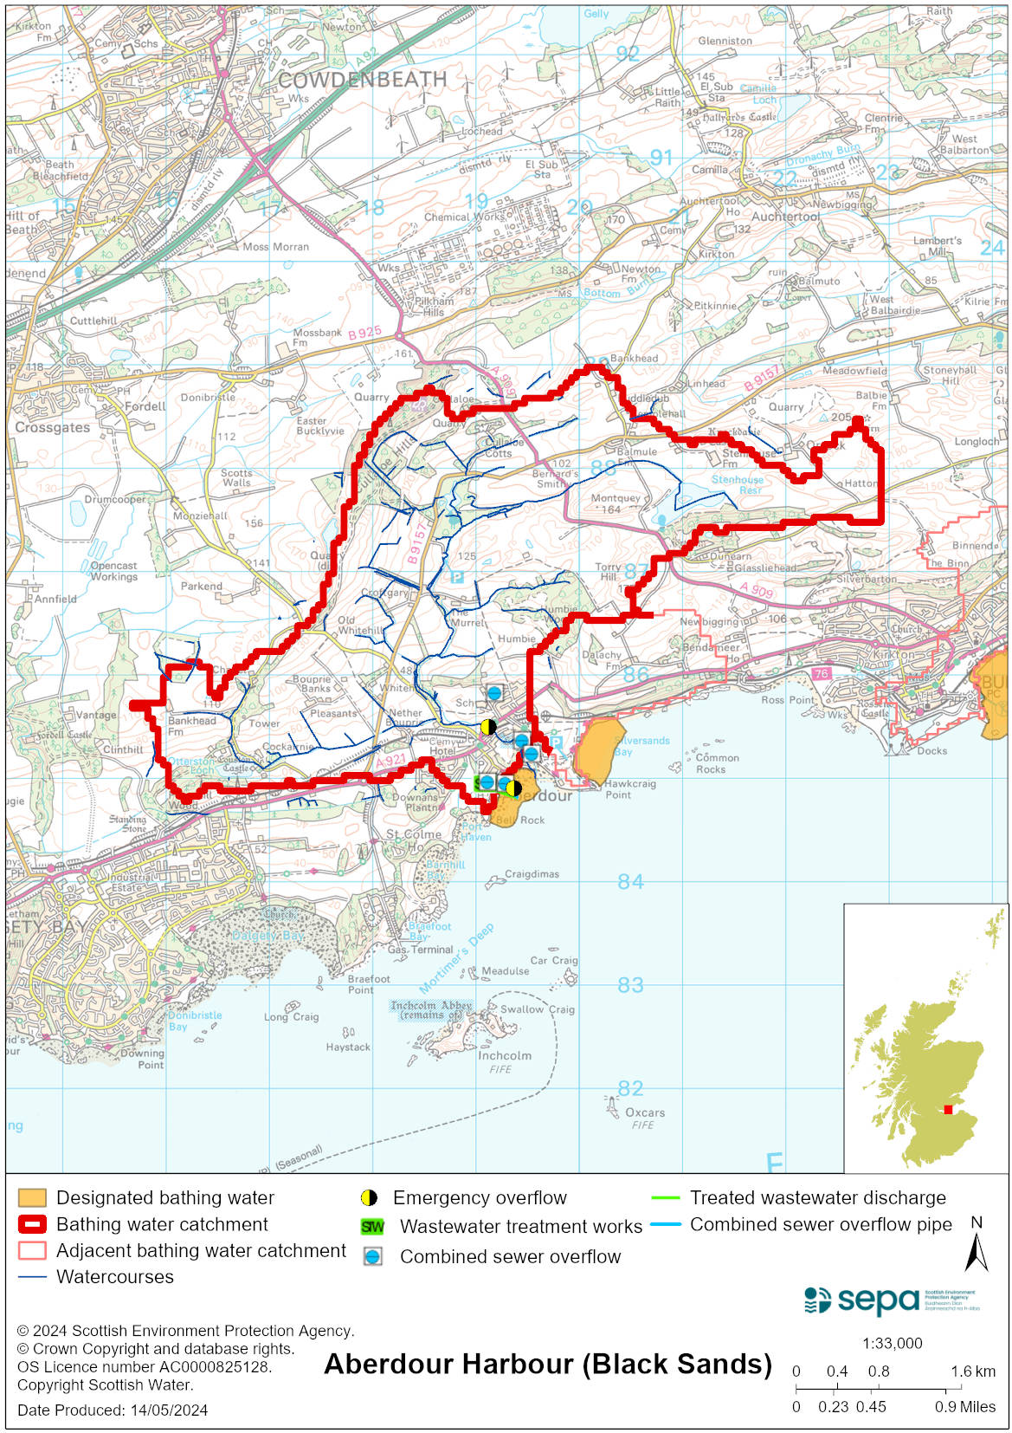

Improving bathing water quality

Sewage
Scottish Water provides most waste water collection and treatment services in Scotland.
Scottish Water has a sewage treatment plant at Aberdour, which discharges to the Firth of Forth via a long sea outfall.

Sewage from Dalgety Bay town is treated outside of the catchment at Dunfermline sewage treatment works, removing a potential risk to bathing water quality.

Two combined sewer overflows (CSO) have outfalls to the bathing water area. These may discharge and impact the bathing water during heavy rainfall.

Agriculture
Diffuse pollution from agricultural sources is the result of rain driven events causing cumulative inputs of pollutants to rivers and streams.

There is potential for agricultural diffuse pollution to occur in the Dour Burn. Cattle are known to frequent the harbour area, which may give rise to bovine faecal pollution.

Tackling diffuse agricultural pollution requires concerted action across catchments. We will work with land managers to help them identify actions to prevent and reduce pollution.

Cyanobacteria (blue-green algae), algae and jellyfish
Marine waters are not at risk of cyanobacteria overproduction. This bathing water is not at risk of excessive growth of macroalgae (seaweed) or phytoplankton.

The possibility of increased jellyfish numbers in the water during summer months is a naturally occurring phenomenon. Most species common to the UK are harmless; the Marine Conservation Society advises to ‘look but don’t touch’.

Pollution incidents
Pollution can be reported via our website online form or by calling our 24 hours a day Pollution Hotline number 0800 80 70 60

If pollution is reported to us, or identified by our routine water quality monitoring program, we will investigate and where necessary work with others to remediate. We may contact other relevant organisations including the local authority, that local health board, Scottish Water and Scottish Ministers.

If there is a risk to human health the local authority is responsible for placing signs at the bathing water. Information will also be available on our website.

Everyone can help to keep the bathing water clean:
- If you visit the beach with your dog clear up any fouling
- Don’t leave litter or feed birds - this encourages unnatural behaviour, and they can pollute the water
- At home, don’t flush wipes or other inappropriate items as these can block pipes and cause sewage spills

Contact details and information sources

SEPA bathing waters homepage

SEPA rainfall data

Scottish Government protected waters homepage

Fife Council

For information on accessing this document in an alternative format or language, please contact SEPA by emailing equalities@sepa.org.uk
If you are a user of British Sign Language (BSL), the Contact Scotland BSL service gives you access to an online interpreter, enabling you to communicate with us using sign language. contactscotland-bsl.org

