Bathing water profile – Peterhead (Lido)
Bathing water classification

Bathing water description
Peterhead (Lido) bathing water is in the Peterhead harbour on the east coast of Aberdeenshire. Its location is unusual as it forms the shoreline of a boating marina within the outer harbour. The sandy beach is about 300 metres long. It slopes gently towards the water. Depending on the tide, the distance to the water’s edge can vary from 80–150 metres.

Site details:
- Local authority: Aberdeenshire Council
- Year of designation: 1999
- Water sampling location: NK 12489 45175

Risks to water quality
This bathing water is at risk of short term pollution following heavy rainfall. Bathing is not advised during or 1-2 days after heavy rainfall due to the risk to bathers’ health from water pollution.

Pollution risks include sewer overflows.

Catchment description
The Peterhead (Lido) bathing water catchment extends to 1 km2. The elevation ranges from 45 metres in the west to an average of 5 metres along the coast.
The catchment is largely urban (65%) with some rural areas (30%), mainly in the south and west. The main population centre is the town of Peterhead, within 500 metres of the bathing water. The area outside of the catchment comprises some intensive and large-scale commercial activity in Peterhead Bay. This includes industrial activity within 500 metres of the bathing water. The harbour is used by fishing vessels, many of which discharge hold water to the harbour area.
The Peterhead (Lido) bathing water is in a Nitrate Vulnerable Zone

Map 1: Peterhead (Lido) bathing water
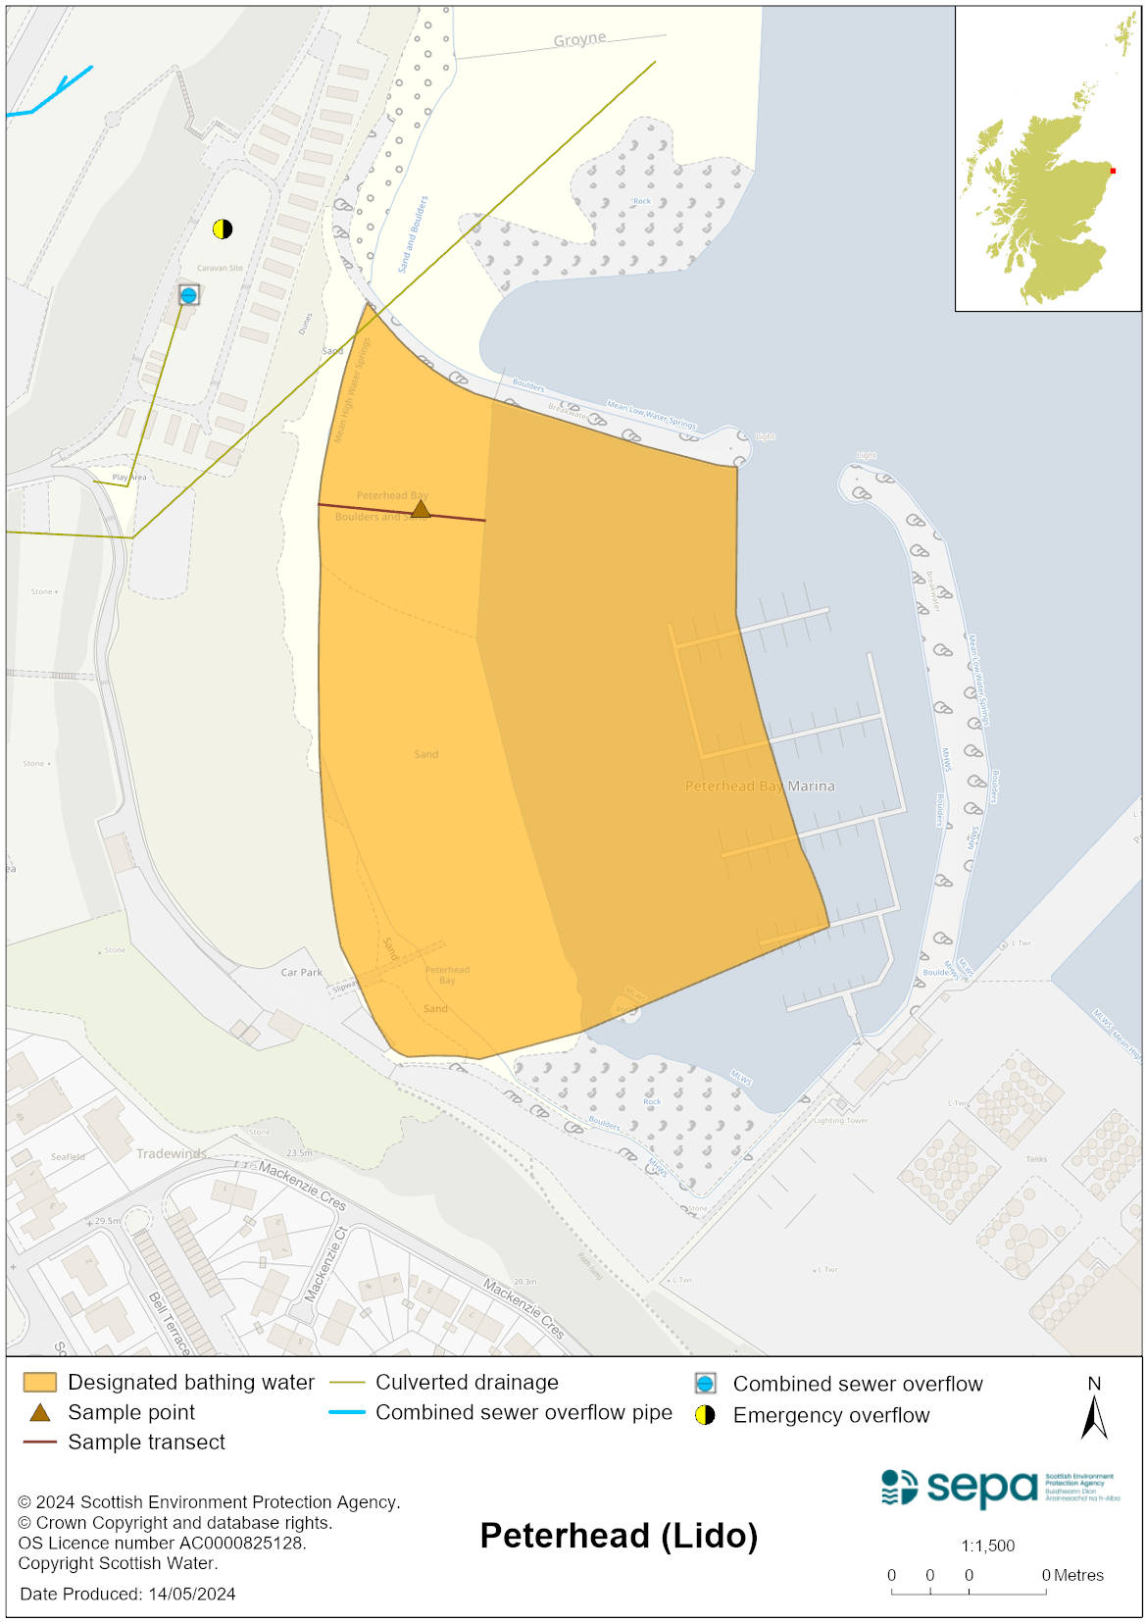

Map 2: Catchment draining into Peterhead (Lido) bathing water
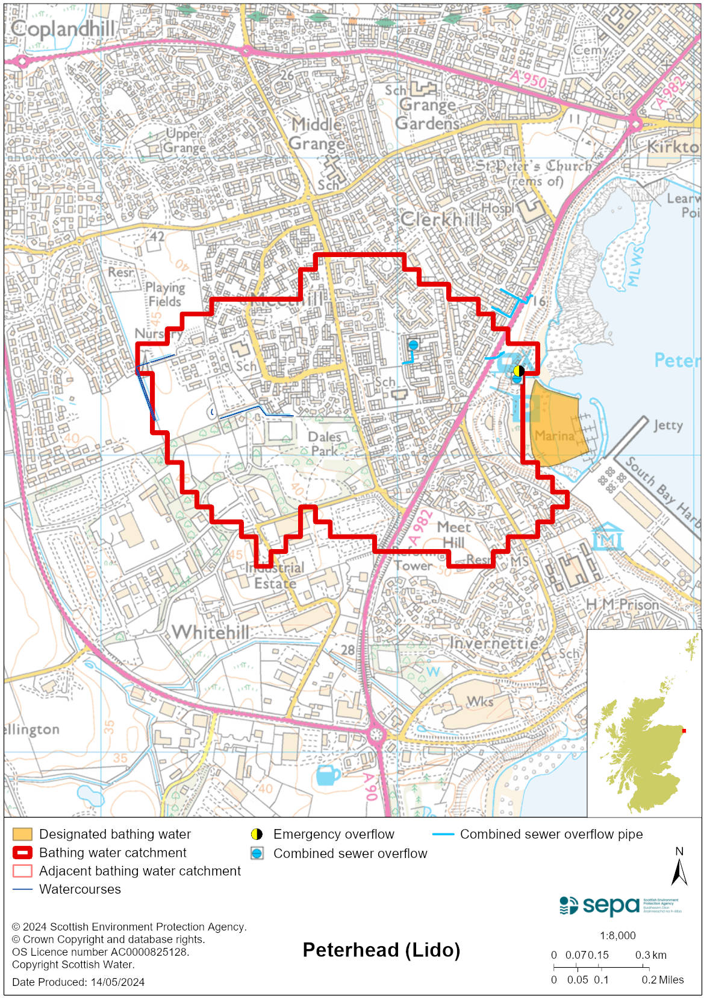

Improving bathing water quality

Sewage
Scottish Water provides most waste water collection and treatment services in Scotland.

Discharges from the main pumping station to Peterhead bay are only permitted under wet weather or emergency conditions. There are two other combined sewer/emergency overflows near the bathing water, one just beyond the marina and the second at the northern edge of Peterhead Bay. These overflows can potentially affect the bathing water quality.

Agriculture
There are no impacts from agriculture affecting this bathing water.

Cyanobacteria (blue-green algae), algae and jellyfish
Marine waters are not at risk of cyanobacteria overproduction. This bathing water is not at risk of excessive growth of macroalgae (seaweed) or phytoplankton.

The possibility of increased jellyfish numbers in the water during summer months is a naturally occurring phenomenon. Most species common to the UK are harmless; the Marine Conservation Society advises to ‘look but don’t touch’.

Pollution incidents
Pollution can be reported via our website online form or by calling our 24 hours a day Pollution Hotline number 0800 80 70 60

If pollution is reported to us, or identified by our routine water quality monitoring program, we will investigate and where necessary work with others to remediate. We may contact other relevant organisations including the local authority, that local health board, Scottish Water and Scottish Ministers.

If there is a risk to human health the local authority is responsible for placing signs at the bathing water. Information will also be available on our website.

Everyone can help to keep the bathing water clean:
- If you visit the beach with your dog clear up any fouling
- Don’t leave litter or feed birds - this encourages unnatural behaviour, and they can pollute the water
- At home, don’t flush wipes or other inappropriate items as these can block pipes and cause sewage spills

Contact details and information sources

SEPA bathing waters homepage

SEPA rainfall data

Scottish Government protected waters homepage

Aberdeenshire Council

For information on accessing this document in an alternative format or language, please contact SEPA by emailing equalities@sepa.org.uk
If you are a user of British Sign Language (BSL), the Contact Scotland BSL service gives you access to an online interpreter, enabling you to communicate with us using sign language. contactscotland-bsl.org

