Bathing water profile – Dunbar (Belhaven)
Bathing water classification

Bathing water description
Dunbar (Belhaven) bathing water is to the west of the town of Dunbar. The designated area is around 1.3 km long. It extends northwest from Belhaven Bay to about halfway down the beach. The beach is bordered by sand dunes and slopes gently towards the water. It is popular with windsurfers, walkers, and picnickers. Depending on the tide, the distance to the water’s edge can vary from 0–630 metres.

Site details:
- Local authority: East Lothian Council
- Year of designation: 1987
- Water sampling location: NT 65491 79125

Risks to water quality
This bathing water is at risk of short term pollution following heavy rainfall. Bathing is not advised during or 1-2 days after heavy rainfall due to the risk to bathers’ health from water pollution.

Pollution risks include sewer overflows.

Catchment description
The Dunbar (Belhaven) bathing water catchment extends to 396 km2. The area is mainly rural (98%) with arable agriculture the major land use. Around 1.5% of the bathing water catchment is urban. The main population centres are Haddington, Gifford, Pencaitland and Ormiston, with many smaller villages in the catchment. The main rivers in the bathing water catchment are the River Tyne, Biel Water and Whittingehame Water.
There are several protected areas either fully or partly within the catchment. This includes 12 Sites of Special Scientific Interest (SSSI), two Special Protection Areas (SPA) and two Ramsar sites. Bird populations in Firth of Forth and the Fala Flow protected areas have the potential to impact bathing water quality.

Map 1: Dunbar (Belhaven) bathing water
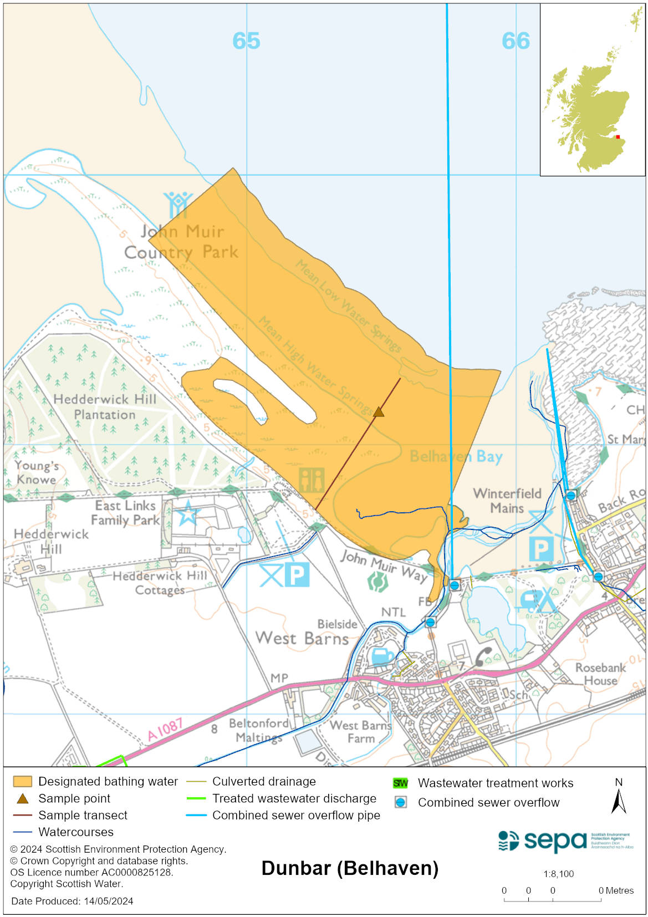

Map 2: Catchment draining into Dunbar (Belhaven) bathing water
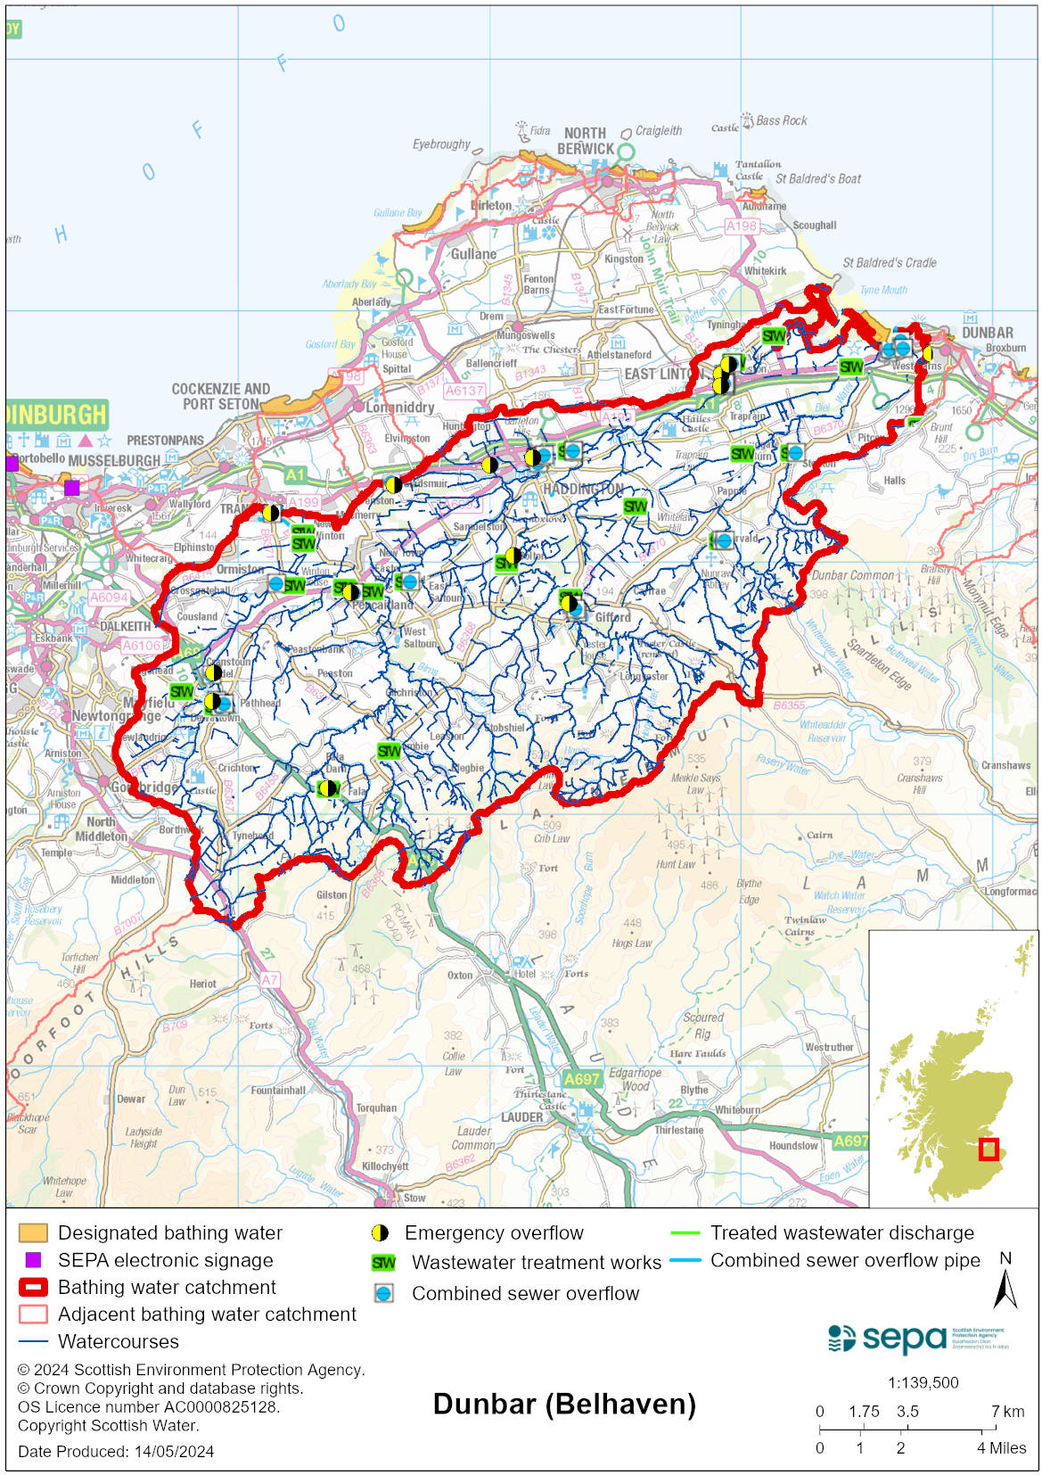

Improving bathing water quality

Sewage
Scottish Water provides most waste water collection and treatment services in Scotland.
Sewage from Belhaven is treated at Beltonford sewage treatment works, using membrane technology to ensure a high quality effluent, before being discharged to the Biel Water.
There are combined sewer overflow (CSO) discharge locations to the east of the bathing water. These may discharge and impact the bathing water during heavy rainfall.

Agriculture
There are no impacts from agriculture affecting this bathing water.

Cyanobacteria (blue-green algae), algae and jellyfish
Marine waters are not at risk of cyanobacteria overproduction. This bathing water is not at risk of excessive growth of macroalgae (seaweed) or phytoplankton.

The possibility of increased jellyfish numbers in the water during summer months is a naturally occurring phenomenon. Most species common to the UK are harmless; the Marine Conservation Society advises to ‘look but don’t touch’.

Pollution incidents
Pollution can be reported via our website online form or by calling our 24 hours a day Pollution Hotline number 0800 80 70 60

If pollution is reported to us, or identified by our routine water quality monitoring program, we will investigate and where necessary work with others to remediate. We may contact other relevant organisations including the local authority, that local health board, Scottish Water and Scottish Ministers.

If there is a risk to human health the local authority is responsible for placing signs at the bathing water. Information will also be available on our website.

Everyone can help to keep the bathing water clean:
- If you visit the beach with your dog clear up any fouling
- Don’t leave litter or feed birds - this encourages unnatural behaviour, and they can pollute the water
- At home, don’t flush wipes or other inappropriate items as these can block pipes and cause sewage spills

Contact details and information sources

SEPA bathing waters homepage

SEPA rainfall data

Scottish Government protected waters homepage

East Lothian Council

For information on accessing this document in an alternative format or language, please contact SEPA by emailing equalities@sepa.org.uk
If you are a user of British Sign Language (BSL), the Contact Scotland BSL service gives you access to an online interpreter, enabling you to communicate with us using sign language. contactscotland-bsl.org

