Bathing water profile – Lower Largo
Bathing water classification

Bathing water description
Lower Largo Beach is in the pretty village of Lower Largo on the coast of Fife. The village and beach are north of the Firth of Forth. It is an attractive spot with a long and interesting maritime history. The beach is made up of a good-sized stretch of soft sand. There are rocks and pools further down the shoreline. There are also splendid views from the beach over the Firth of Forth.

Site details:
- Local authority: Fife Council
- Year of designation: 2022
- Water sampling location: NO 42154 02536

Risks to water quality
Pollution risks are from sewerage sources. Water quality monitoring has shown that pollution levels from sewerage sources are particularly poor at low tide and on incoming tides.

This bathing water is at risk of short term pollution following heavy rainfall. Bathing is not advised during or 1-2 days after heavy rainfall due to the risk to bathers’ health from water pollution.

Catchment description
The Lower Largo bathing water catchment covers approx. 2.6 km2. It comprises of countryside descending southwards from the steep hill of Largo Law to the coast. Largo Law is a local landmark with an elevation of 290 metres. The only suburban area lies in the flatter southern portion (average of 0–50 metres).
The catchment is mainly rural with agriculture a significant land use. A small proportion of the catchment is residential, comprising the villages of Lower Largo and Upper Largo.

Map 1: Lower Largo bathing water
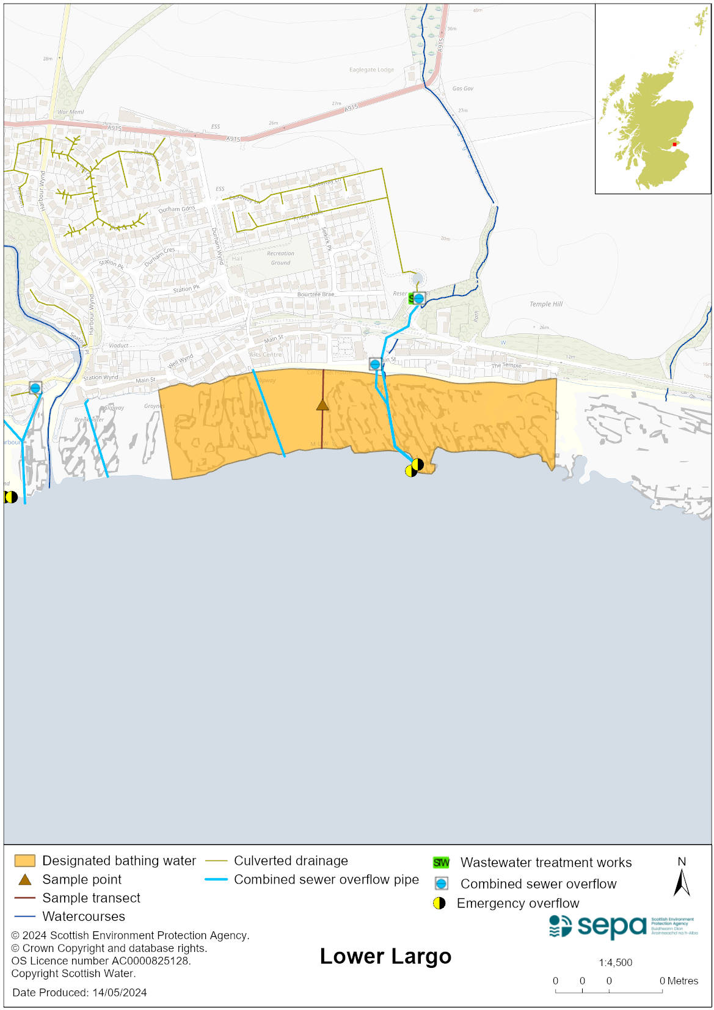

Map 2: Catchment draining into Lower Largo bathing water
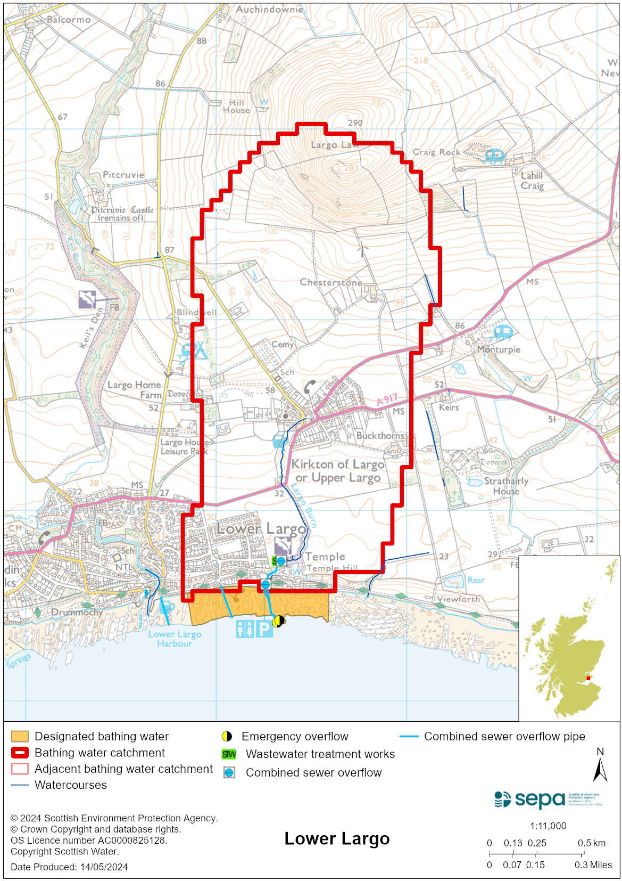

Improving bathing water quality

Sewage
Scottish Water provides most waste water collection and treatment services in Scotland.

The Lower Largo network is almost entirely a combined sewerage system and as such, there are a number of Scottish Water assets within the catchment which have the potential to impact on bathing water quality. Lower Largo WwTW is a primary treatment works, which discharges via an outfall to Largo Bay. Scottish Water have an on-going programme of work in Lower Largo, to understand the impacts of the waste water system on water quality. We will work with Scottish Water to ensure delivery of any improvements identified as needed.

Agriculture
Diffuse pollution from agricultural sources is the result of rain driven events causing cumulative inputs of pollutants to rivers and streams.

Our current evidence does not indicate that either the Keil or Largo Burns are a significant source of rural diffuse pollution. Most of the farms within the Lower Largo bathing water catchment support mixed livestock and a little arable farming. Following rural inspections SEPA does not believe the agricultural sector is a major source of diffuse pollution which would impact on the bathing beach.

SEPA will continue to engage the farmers in this catchment to reduce the risk of agricultural source of pollution affecting the bathing water.

Cyanobacteria (blue-green algae), algae and jellyfish
Marine waters are not at risk of cyanobacteria overproduction. This bathing water is not at risk of excessive growth of macroalgae (seaweed) or phytoplankton.

The possibility of increased jellyfish numbers in the water during summer months is a naturally occurring phenomenon. Most species common to the UK are harmless; the Marine Conservation Society advises to ‘look but don’t touch’.

Pollution incidents
Pollution can be reported via our website online form or by calling our 24 hours a day Pollution Hotline number 0800 80 70 60

If pollution is reported to us, or identified by our routine water quality monitoring program, we will investigate and where necessary work with others to remediate. We may contact other relevant organisations including the local authority, that local health board, Scottish Water and Scottish Ministers.

If there is a risk to human health the local authority is responsible for placing signs at the bathing water. Information will also be available on our website.

Everyone can help to keep the bathing water clean:
- If you visit the beach with your dog clear up any fouling
- Don’t leave litter or feed birds - this encourages unnatural behaviour, and they can pollute the water
- At home, don’t flush wipes or other inappropriate items as these can block pipes and cause sewage spills

Contact details and information sources

SEPA bathing waters homepage

SEPA rainfall data

Scottish Government protected waters homepage

Fife Council

For information on accessing this document in an alternative format or language, please contact SEPA by emailing equalities@sepa.org.uk
If you are a user of British Sign Language (BSL), the Contact Scotland BSL service gives you access to an online interpreter, enabling you to communicate with us using sign language. contactscotland-bsl.org

