Bathing water profile – Lunderston Bay
Bathing water classification

Bathing water description
Lunderston Bay bathing water is a small shallow bay on the Firth of Clyde, looking towards Dunoon. It is close to the town of Gourock and sits within Clyde Muirshiel Regional Park. The small sandy beach is a popular recreation and picnic area. It benefits from free parking, a ranger service, environmental education events and various seaside activities. National Cycle Route 75 extends from Lunderston Bay along the coast to Gourock and beyond. A coastal walk goes south to Inverkip (2km). Depending on the tide, the distance to the water’s edge can vary from 20–140 metres.

Site details:
- Local authority: Inverclyde Council
- Year of designation: 2008
- Water sampling location: NS 20400 74514

Risks to water quality
This bathing water is at risk of short term pollution following heavy rainfall. Bathing is not advised during or 1-2 days after heavy rainfall due to the risk to bathers’ health from water pollution.

Pollution risks include sewer overflows.

Catchment description
The Lunderston Bay bathing water catchment extends to 1.3 km2. The area is hilly and gently slopes towards the bathing water. Elevation ranges from 150 metres in the east to 5 metres along the coast.
The area is 98% rural with grassland (38%), woodland (32%) and shrub heath (27%). The upland areas support mixed sheep and beef farming. The lowlands are mainly used for recreation. Approximately 2% of the catchment is urban. Population density within the catchment is low.
There are no significant rivers in this catchment. However, there are a few small burns flowing through the catchment.
The nearby Clyde Muirshiel Regional Park is within a greenbelt area. It covers 108 square miles of countryside in the west of Scotland.

Map 1: Lunderston Bay bathing water
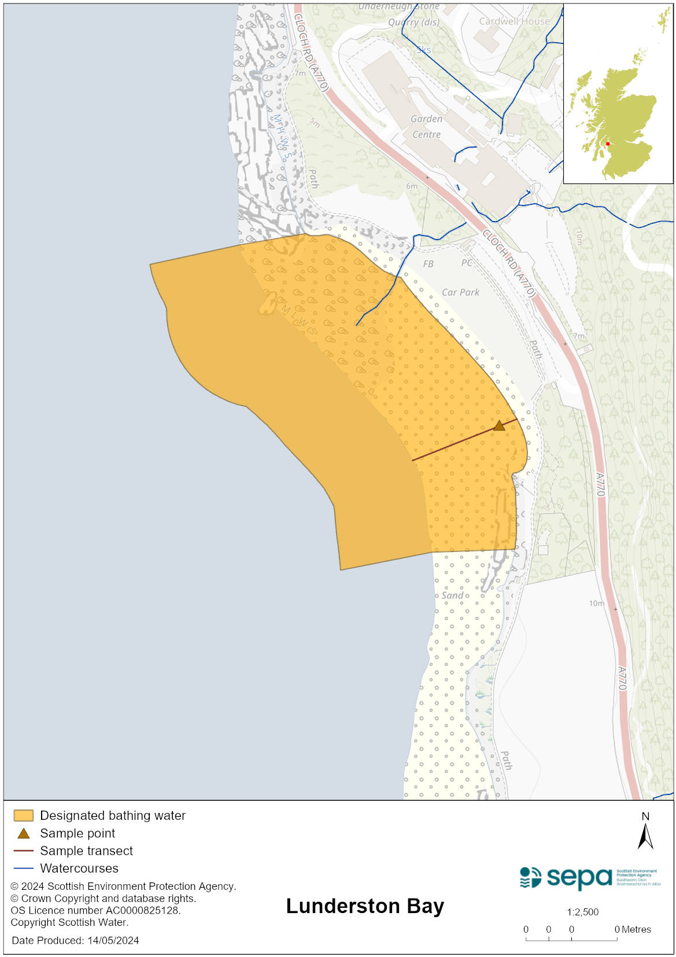

Map 2: Catchment draining into Lunderston Bay bathing water
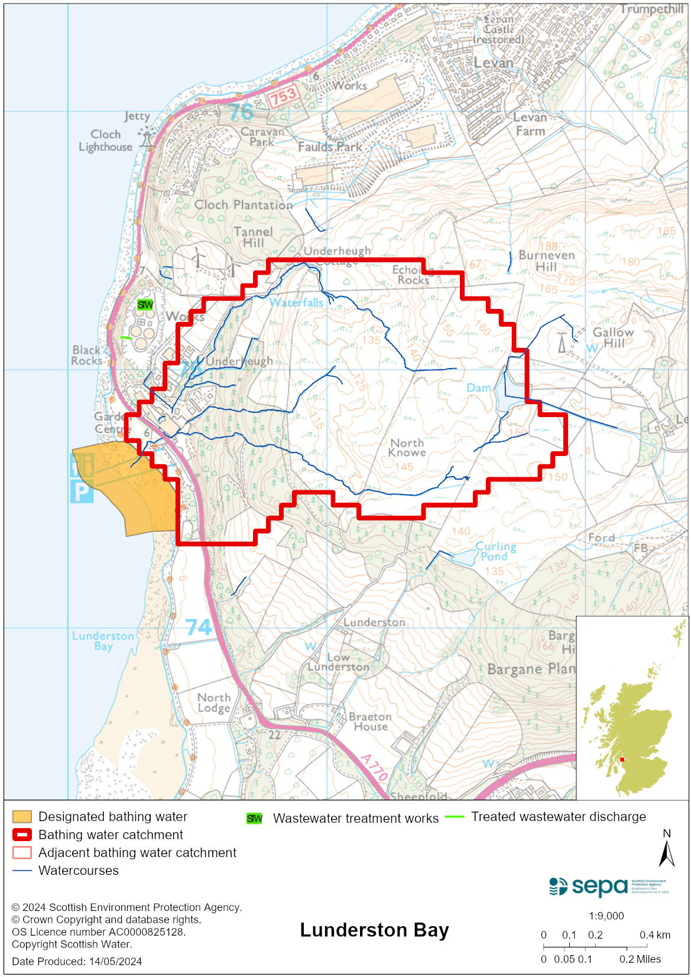

Improving bathing water quality

Sewage
Scottish Water provides most waste water collection and treatment services in Scotland.

Lunderston bathing water catchment contains a waste water treatment works operated by a PFI. There are several pumping stations and combined and emergency sewer overflows which discharge at locations along the Firth of Clyde. SEPA monitor the works and the sewerage network throughout the year to ensure compliance with licence conditions which are in place to ensure protection of the water environment.

A garden centre and some small properties within the catchment have their own private discharges to rivers and soakaways.

Agriculture
There are no impacts from agriculture affecting this bathing water.

Cyanobacteria (blue-green algae), algae and jellyfish
Marine waters are not at risk of cyanobacteria overproduction. This bathing water is not at risk of excessive growth of macroalgae (seaweed) or phytoplankton.

The possibility of increased jellyfish numbers in the water during summer months is a naturally occurring phenomenon. Most species common to the UK are harmless; the Marine Conservation Society advises to ‘look but don’t touch’.

Pollution incidents
Pollution can be reported via our website online form or by calling our 24 hours a day Pollution Hotline number 0800 80 70 60

If pollution is reported to us, or identified by our routine water quality monitoring program, we will investigate and where necessary work with others to remediate. We may contact other relevant organisations including the local authority, that local health board, Scottish Water and Scottish Ministers.

If there is a risk to human health the local authority is responsible for placing signs at the bathing water. Information will also be available on our website.

Everyone can help to keep the bathing water clean:
- If you visit the beach with your dog clear up any fouling
- Don’t leave litter or feed birds - this encourages unnatural behaviour, and they can pollute the water
- At home, don’t flush wipes or other inappropriate items as these can block pipes and cause sewage spills

Contact details and information sources

SEPA bathing waters homepage

SEPA rainfall data

Scottish Government protected waters homepage

Inverclyde Council

For information on accessing this document in an alternative format or language, please contact SEPA by emailing equalities@sepa.org.uk
If you are a user of British Sign Language (BSL), the Contact Scotland BSL service gives you access to an online interpreter, enabling you to communicate with us using sign language. contactscotland-bsl.org

