Bathing water profile – St Andrews (West Sands)
Bathing water classification

Bathing water description
The St Andrews (West Sands) bathing water is situated to the north of the town of St. Andrews. The 1.8 km long beach is backed by sand dunes which form the boundary with the St Andrews Links Jubilee golf course. The area is popular for walking, running and swimming.

The sandy beach slopes gently towards the water and depending on the tide, there can be 20-400 metres before the water’s edge.

Site details:
- Local authority: Fife Council
- Year of designation: 1987
- Water sampling location: NO 50474 17681

Risks to water quality
This bathing water is subject to short term pollution following heavy rainfall. Bathing is not advised during or 1-2 days after heavy rainfall due to the risk to bathers’ health from water pollution.

Pollution risks include sewer overflows.

Water quality forecasts
As water quality is likely to be impacted by rainfall we make daily predictions of good or poor bathing water quality. We advise against bathing when poor water quality is predicted as there is an increased risk to bathers’ health from water pollution.

These predictions are displayed on the electronic sign at the beach and online between 15 May and 15 September.

Catchment description
A catchment area of 6 km2 drains into the St Andrews (West Sands) bathing water. The area is predominantly rural (69%) with arable agriculture the major land use. Approximately 7% of the bathing water catchment is urban with the main population area being the northern outskirts of the town of St Andrews.

The small Swilken Burn drains to the sea immediately to the south of the bathing water.

There are several protected areas either within or nearby the bathing water and its catchment, including a Special Area of Conservation (SAC), a Special Protection Area (SPA), a Site of Special Scientific Interest (SSSI) and a Ramsar site. The Strathmore and Fife area was designated as a surface water Nitrate Vulnerable Zone in 2002.

Map 1: St Andrews (West Sands) bathing water
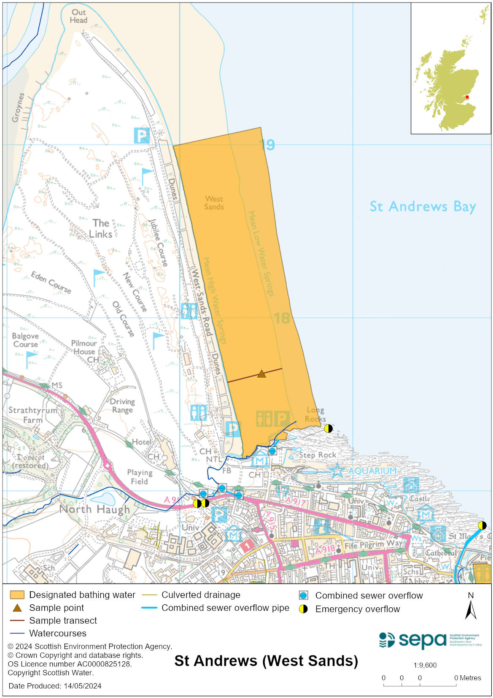

Map 2: Catchment draining into St Andrews (West Sands) bathing water
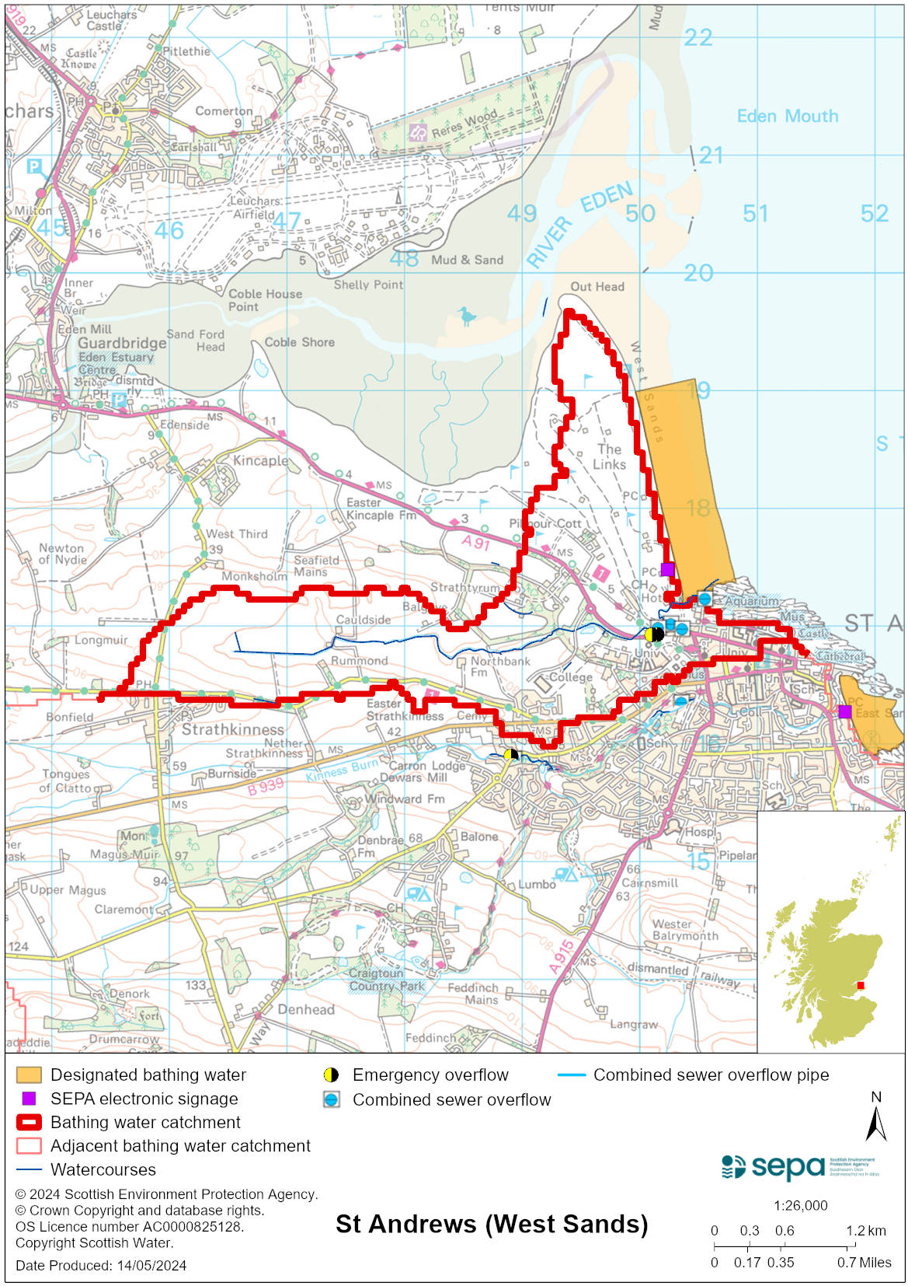

Improving bathing water quality

Sewage
Scottish Water provides most waste water collection and treatment services in Scotland.

Sewage from St Andrews is treated at Kinkell Ness treatment works before being discharged via long sea outfall. The works has tertiary treatment including disinfection. Storm tanks have also been constructed in the Kinness Burn sewer catchment to minimise discharges from the combined sewer overflows.

There is a combined sewer overflow (CSO) outfall to the south of the bathing water. This may discharge and impact the bathing water during heavy rainfall.

Agriculture
There are no impacts from agriculture affecting this bathing water.

Cyanobacteria (blue-green algae), algae and jellyfish
Marine waters are not at risk of cyanobacteria overproduction. This bathing water is not at risk of excessive growth of macroalgae (seaweed) or phytoplankton.

The possibility of increased jellyfish numbers in the water during summer months is a naturally occurring phenomenon. Most species common to the UK are harmless; the Marine Conservation Society advises to ‘look but don’t touch’.

Pollution incidents
Pollution can be reported via our website online form or by calling our 24 hours a day Pollution Hotline number 0800 80 70 60

If pollution is reported to us, or identified by our routine water quality monitoring program, we will investigate and where necessary work with others to remediate. We may contact other relevant organisations including the local authority, that local health board, Scottish Water and Scottish Ministers.

If there is a risk to human health the local authority is responsible for placing signs at the bathing water. Information will also be available on our website.

Everyone can help to keep the bathing water clean:
- If you visit the beach with your dog clear up any fouling
- Don’t leave litter or feed birds - this encourages unnatural behaviour, and they can pollute the water
- At home, don’t flush wipes or other inappropriate items as these can block pipes and cause sewage spills

Contact details and information sources

SEPA bathing waters homepage

SEPA rainfall data

Scottish Government protected waters homepage

Fife Council

For information on accessing this document in an alternative format or language, please contact SEPA by emailing equalities@sepa.org.uk
If you are a user of British Sign Language (BSL), the Contact Scotland BSL service gives you access to an online interpreter, enabling you to communicate with us using sign language. contactscotland-bsl.org

