Bathing water profile – Anstruther (Billow Ness)
Bathing water classification

Bathing water description
Anstruther (Billow Ness) bathing water is a quiet, sandy cove with rock pools. It is situated to the west of Anstruther harbour. The designated area lies between two rocky outcrops and is approximately 300 metres wide. Depending on the tide, the approximate distance to the water’s edge can vary from 10–250 metres.

Site details:
- Local authority: Fife Council
- Year of designation: 2010
- Water sampling location: NO 56277 03028

Risks to water quality
This bathing water is at risk of short term pollution following heavy rainfall. Bathing is not advised during or 1-2 days after heavy rainfall due to the risk to bathers’ health from water pollution.

Pollution risks include sewer overflows.

Catchment description
The catchment area draining into the Anstruther (Billow Ness) bathing water is less than 1 km2. Land use is a mixture of rural (59%) and urban (39%). The rural area is a mix of horticulture and grassland. The catchment includes part of the town of Anstruther Wester. Anstruther golf course is adjacent to the bathing water.
There are no watercourses within the catchment, although the Dreel Burn flows into the sea near the harbour.

Map 1: Anstruther (Billow Ness) bathing water
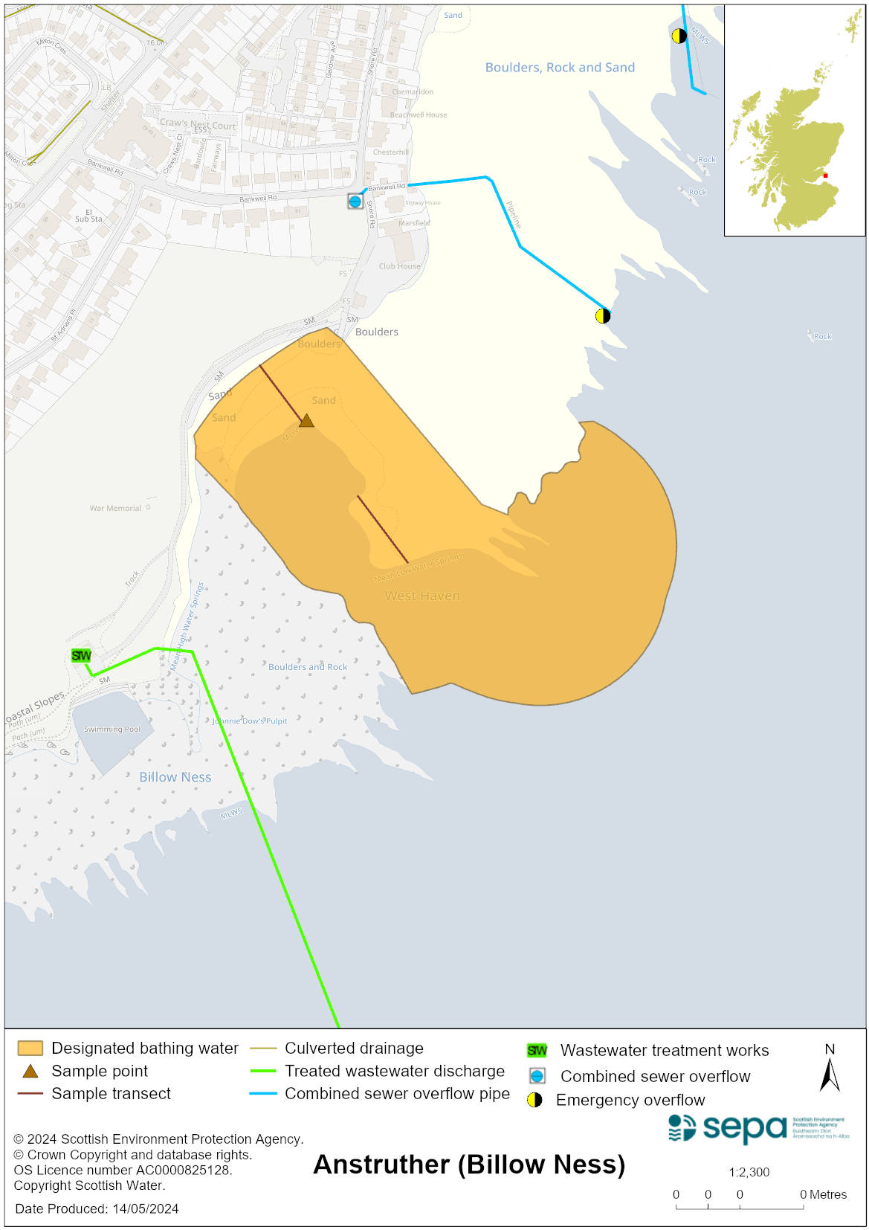

Map 2: Catchment draining into Anstruther (Billow Ness) bathing water
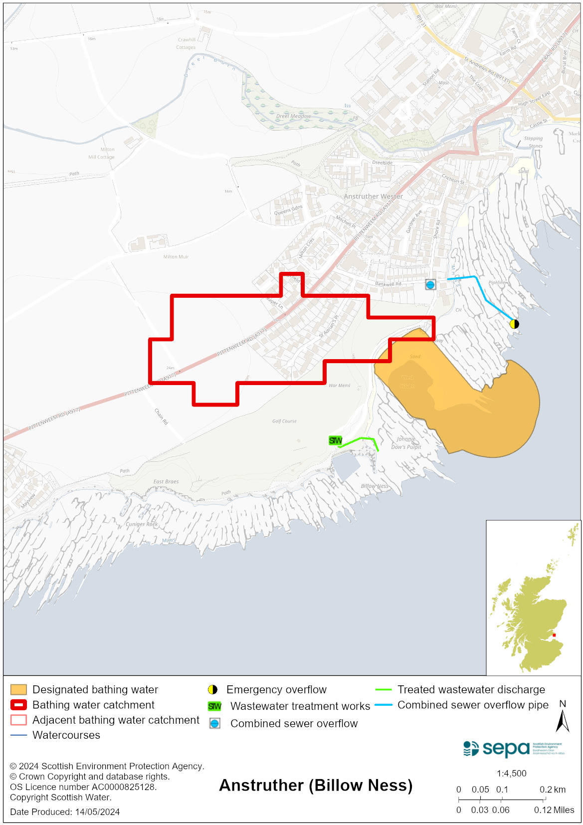

Improving bathing water quality

Sewage
Scottish Water provides most waste water collection and treatment services in Scotland.

The Scottish Water sewage treatment system for Anstruther discharges to the Firth of Forth via a long sea outfall.

There is a combined sewer overflows (CSO) outfall to the north east of the bathing water area. This may discharge and impact the bathing water during heavy rainfall.

Agriculture
There are no impacts from agriculture affecting this bathing water.

Cyanobacteria (blue-green algae), algae and jellyfish
Marine waters are not at risk of cyanobacteria overproduction. This bathing water is not at risk of excessive growth of macroalgae (seaweed) or phytoplankton.

The possibility of increased jellyfish numbers in the water during summer months is a naturally occurring phenomenon. Most species common to the UK are harmless; the Marine Conservation Society advises to ‘look but don’t touch’.

Pollution incidents
Pollution can be reported via our website online form or by calling our 24 hours a day Pollution Hotline number 0800 80 70 60

If pollution is reported to us, or identified by our routine water quality monitoring program, we will investigate and where necessary work with others to remediate. We may contact other relevant organisations including the local authority, that local health board, Scottish Water and Scottish Ministers.

If there is a risk to human health the local authority is responsible for placing signs at the bathing water. Information will also be available on our website.

Everyone can help to keep the bathing water clean:
- If you visit the beach with your dog clear up any fouling
- Don’t leave litter or feed birds - this encourages unnatural behaviour, and they can pollute the water
- At home, don’t flush wipes or other inappropriate items as these can block pipes and cause sewage spills

Contact details and information sources

SEPA bathing waters homepage

SEPA rainfall data

Scottish Government protected waters homepage

Fife Council

For information on accessing this document in an alternative format or language, please contact SEPA by emailing equalities@sepa.org.uk
If you are a user of British Sign Language (BSL), the Contact Scotland BSL service gives you access to an online interpreter, enabling you to communicate with us using sign language. contactscotland-bsl.org

