Bathing water profile – Yellow Craig
Bathing water classification

Bathing water description
Yellow Craig bathing water is located close to the town of North Berwick. The beach slopes gently towards the water. It is a small sandy bay, about 700 metres long and is situated beside Broad Sands bathing water. Depending on the tide, there can be 10–150 metres of beach before the waters edge.

The area is popular with families and walkers due to a nearby footpath network.

Site details:
- Local authority: East Lothian Council
- Year of designation: 1987
- Water sampling location: NT 51512 86019

Risks to water quality
This bathing water is at risk of short term pollution following heavy rainfall. Bathing is not advised during or 1-2 days after heavy rainfall due to the risk to bathers’ health from water pollution.

Pollution risks include sewerage.

Catchment description
The Yellow Craig bathing water catchment extends to 2.1 km2. The catchment is predominantly rural (92%) with land use split between woodland (38%), grassland (32%) and agriculture (22%). Approximately 1% of the bathing water catchment is urban. There are no towns or villages in the catchment, although a few houses are located in the centre of the catchment.

The bathing water sits within the Firth of Forth which is designated as a Special Protection Area (SPA), Site of Special Scientific Interest (SSSI) and a Ramsar site. These protected areas are home to several internationally important bird populations, and as such, may have the potential to influence water quality at the bathing water. The nearby Forth Islands are also designated as an SPA due to their aggregation of breeding birds.

Map 1: Yellow Craig bathing water
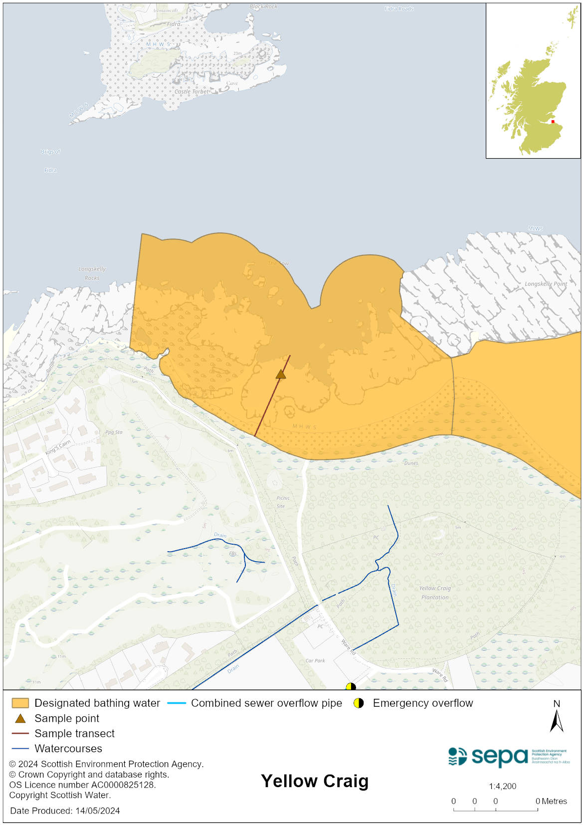

Map 2: Catchment draining into Yellow Craig bathing water
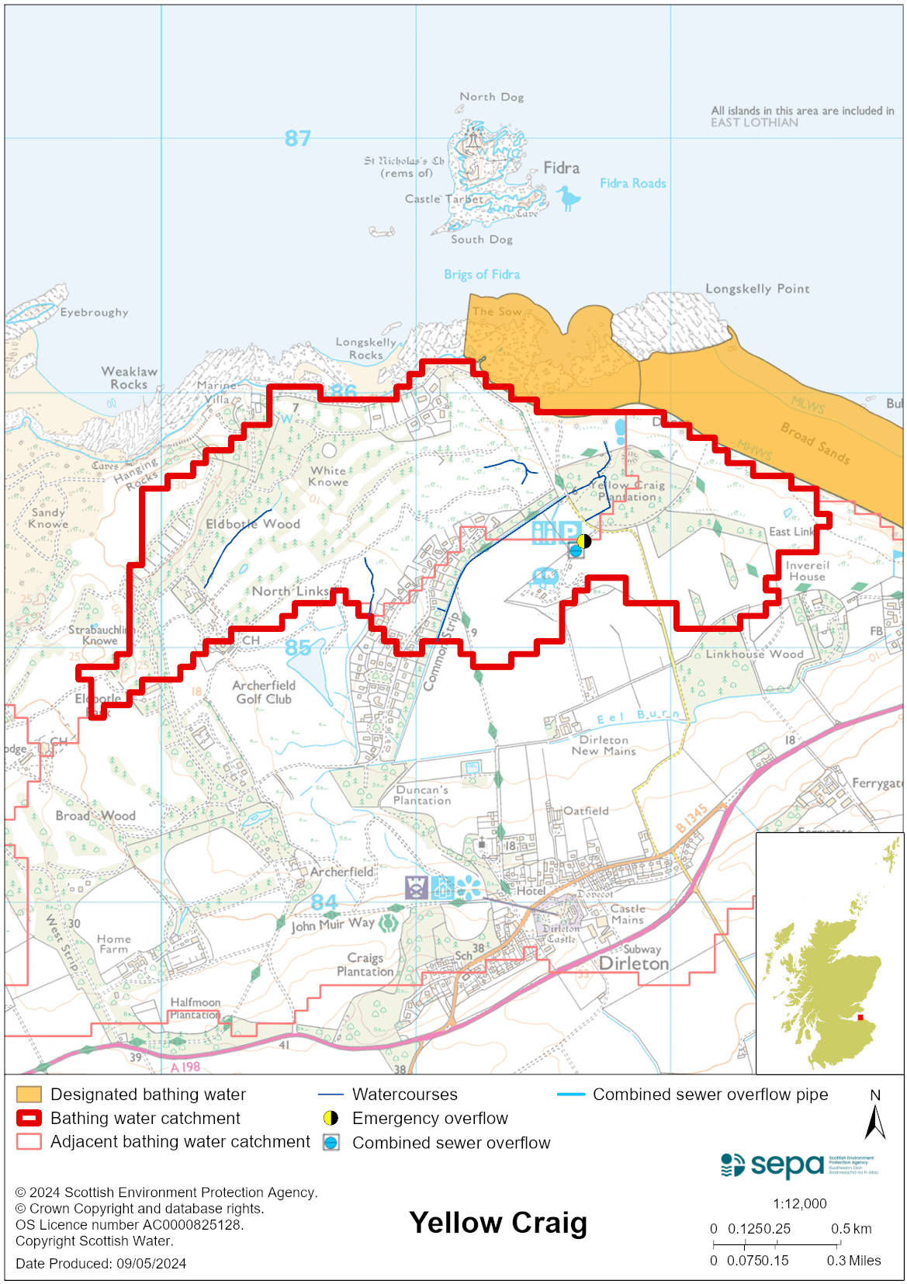

Improving bathing water quality

Sewage
Scottish Water provides most waste water collection and treatment services in Scotland.

Sewage from Dirleton village is treated at North Berwick sewage treatment works and is then discharged to the Firth of Forth via a long sea outfall to the east of North Berwick.

Agriculture
There are no impacts from agriculture affecting this bathing water.

Cyanobacteria (blue-green algae), algae and jellyfish
Marine waters are not at risk of cyanobacteria overproduction. This bathing water is not at risk of excessive growth of macroalgae (seaweed) or phytoplankton.

The possibility of increased jellyfish numbers in the water during summer months is a naturally occurring phenomenon. Most species common to the UK are harmless; the Marine Conservation Society advises to ‘look but don’t touch’.

Pollution incidents
Pollution can be reported via our website online form or by calling our 24 hours a day Pollution Hotline number 0800 80 70 60

If pollution is reported to us, or identified by our routine water quality monitoring program, we will investigate and where necessary work with others to remediate. We may contact other relevant organisations including the local authority, that local health board, Scottish Water and Scottish Ministers.

If there is a risk to human health the local authority is responsible for placing signs at the bathing water. Information will also be available on our website.

Everyone can help to keep the bathing water clean:
- If you visit the beach with your dog clear up any fouling
- Don’t leave litter or feed birds - this encourages unnatural behaviour, and they can pollute the water
- At home, don’t flush wipes or other inappropriate items as these can block pipes and cause sewage spills

Contact details and information sources

SEPA bathing waters homepage

SEPA rainfall data

Scottish Government protected waters homepage

East Lothian Council

For information on accessing this document in an alternative format or language, please contact SEPA by emailing equalities@sepa.org.uk
If you are a user of British Sign Language (BSL), the Contact Scotland BSL service gives you access to an online interpreter, enabling you to communicate with us using sign language. contactscotland-bsl.org

