Bathing water profile – Cullen Bay
Bathing water classification

Bathing water description
Cullen Bay bathing water is an attractive sandy beach about 1km in length, on the north coast of Moray. It lies between the villages of Cullen and Portknockie. It is backed by Cullen Links golf course. Depending on the tide, the distance to the water’s edge can vary from 20–110 metres.

Site details:
- Local authority: Moray Council
- Year of designation: 1987
- Water sampling location: NJ 50320 67499

Risks to water quality
This bathing water is at risk of short term pollution following heavy rainfall. Bathing is not advised during or 1-2 days after heavy rainfall due to the risk to bathers’ health from water pollution.

Pollution risks are from agricultural run-off and sewer overflows.

Catchment description
The Cullen Bay bathing water catchment extends to 54 km2. The area varies in topography from gentle hills to low-lying plains along the coast.
The main river within the catchment is Deskford Burn which flows into the sea at the eastern end of the bay.
The area is mainly rural (99%) with agriculture the major land use (35% arable farming and 23% grassland). Some of the area is woodland (38%). The arable areas are mostly in the lower catchment with livestock farming further inland. About 1% of the catchment is urban. The main population centres are the coastal villages of Cullen and Portnockie. They are 1 km east and west from the bathing water respectively. Population density outside of the villages is generally low.

Map 1: Cullen Bay bathing water
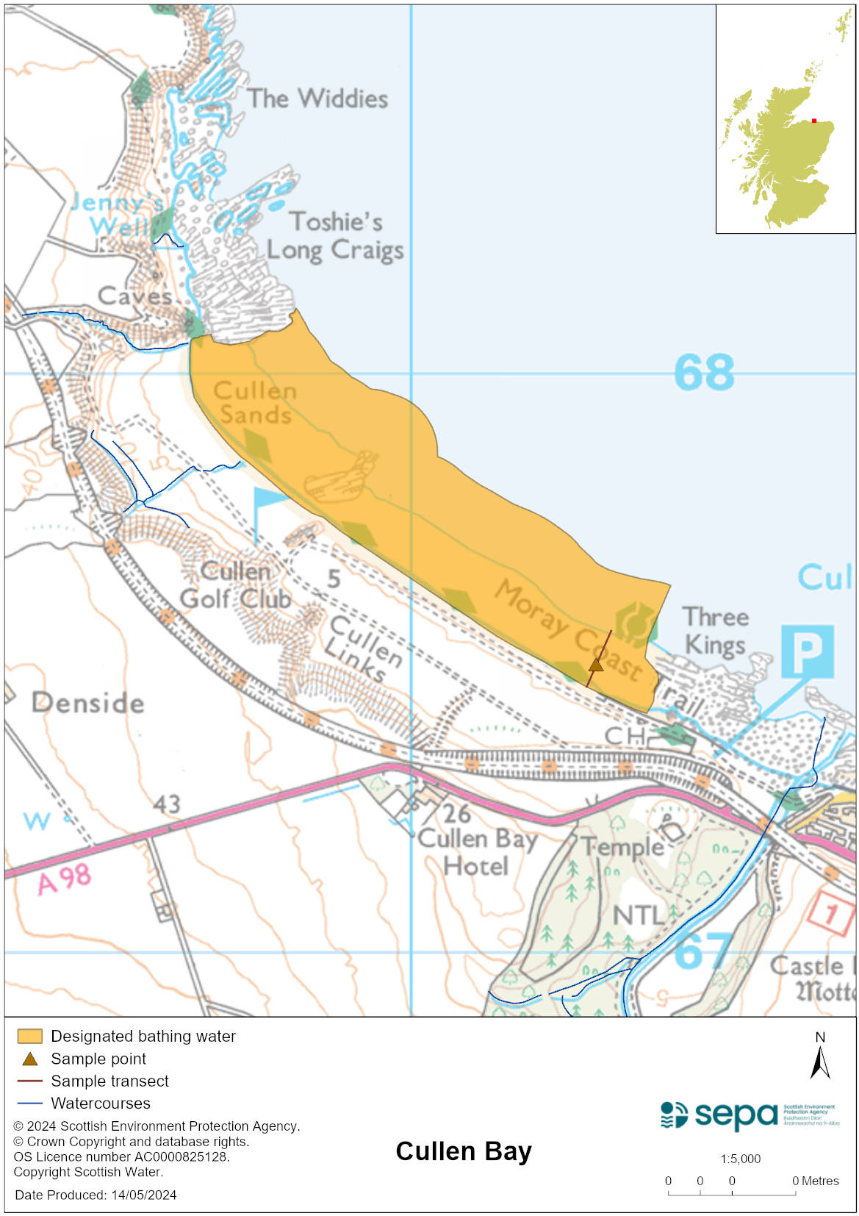

Map 2: Catchment draining into Cullen Bay bathing water
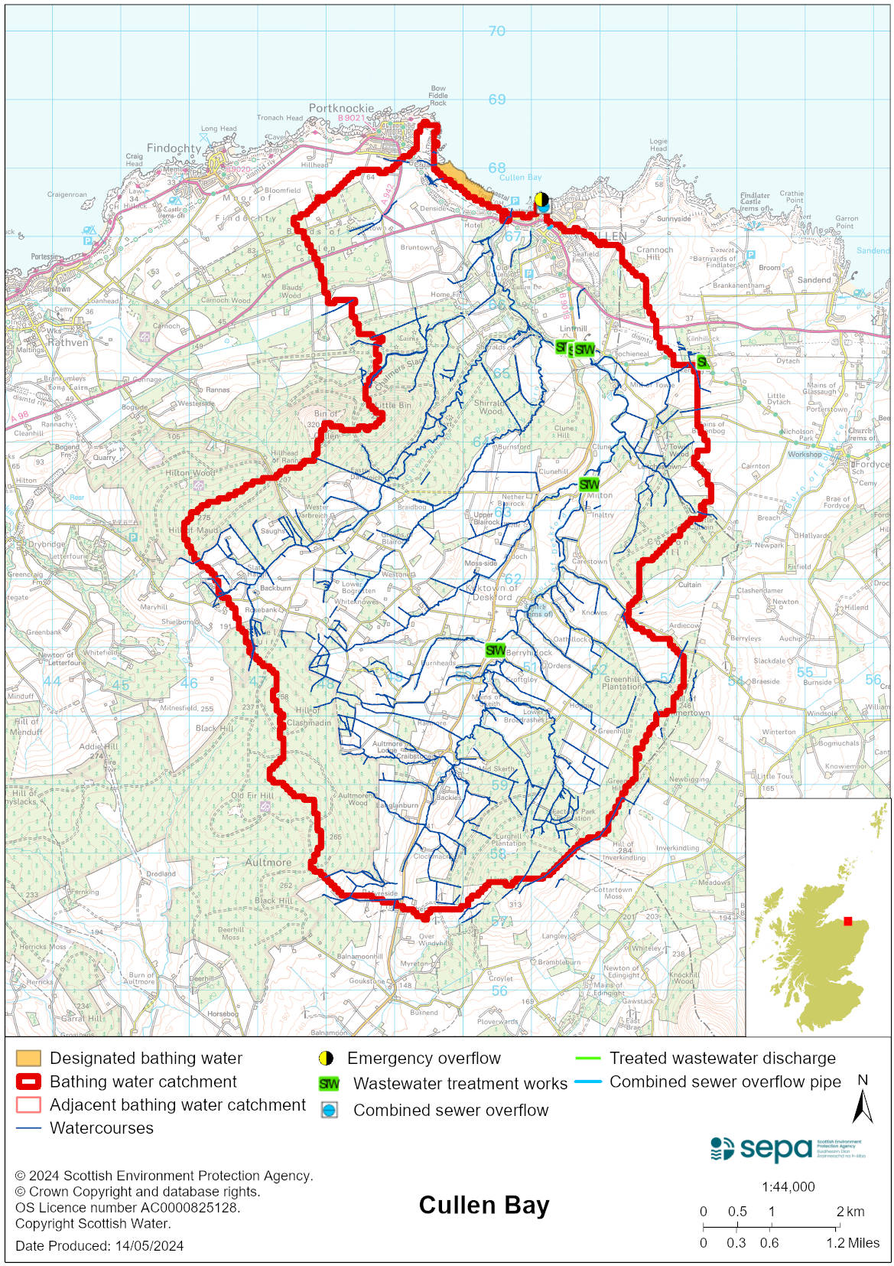

Improving bathing water quality

Sewage
Scottish Water provides most waste water collection and treatment services in Scotland.

Sewage from Cullen is treated at Buckie sewage treatment works. Cullen pumping station has a combined sewage overflow which discharges 700m to the west of the bathing water.

Septic tanks serving the communities of Lintmill and Deskford discharge to the Deskford Burn inland from the bathing water. These discharges pose a minimal risk to bathing water quality at Cullen Bay.

Agriculture
Diffuse pollution from agricultural sources is the result of rain driven events causing cumulative inputs of pollutants to rivers and streams.

The bathing water catchment lies within the Banff Coastal catchment where work with land managers will take place. Work to address diffuse pollution in the catchment is expected to be completed by 2027.

Cyanobacteria (blue-green algae), algae and jellyfish
Marine waters are not at risk of cyanobacteria overproduction. This bathing water is not at risk of excessive growth of macroalgae (seaweed) or phytoplankton.

The possibility of increased jellyfish numbers in the water during summer months is a naturally occurring phenomenon. Most species common to the UK are harmless; the Marine Conservation Society advises to ‘look but don’t touch’.

Pollution incidents
Pollution can be reported via our website online form or by calling our 24 hours a day Pollution Hotline number 0800 80 70 60

If pollution is reported to us, or identified by our routine water quality monitoring program, we will investigate and where necessary work with others to remediate. We may contact other relevant organisations including the local authority, that local health board, Scottish Water and Scottish Ministers.

If there is a risk to human health the local authority is responsible for placing signs at the bathing water. Information will also be available on our website.

Everyone can help to keep the bathing water clean:
- If you visit the beach with your dog clear up any fouling
- Don’t leave litter or feed birds - this encourages unnatural behaviour, and they can pollute the water
- At home, don’t flush wipes or other inappropriate items as these can block pipes and cause sewage spills

Contact details and information sources

SEPA bathing waters homepage

SEPA rainfall data

Scottish Government protected waters homepage

Moray Council

For information on accessing this document in an alternative format or language, please contact SEPA by emailing equalities@sepa.org.uk
If you are a user of British Sign Language (BSL), the Contact Scotland BSL service gives you access to an online interpreter, enabling you to communicate with us using sign language. contactscotland-bsl.org

