Bathing water profile - Aberdeen

Bathing water classification

Bathing water description
Aberdeen bathing water is adjacent to the city of Aberdeen with amusements and a golf course nearby. It is a sandy beach approximately four kilometres long and is popular with walkers, swimmers, surfers and kite surfers.

Depending on the tide, there can be 0-120 metres of beach before the water’s edge.

Site details:
- Local authority: Aberdeen City Council
- Year of designation: 1987
- Water sampling location: NJ 95401 07812

Risks to water quality
This bathing water is subject to short term pollution following heavy rainfall. Bathing is not advised during or 1-2 days after heavy rainfall due to the risk to bathers’ health from water pollution.

Pollution risks include agricultural run-off, sewer overflows and surface water discharges.

Water quality forecasts
As water quality is likely to be impacted by rainfall we make daily predictions of good or poor bathing water quality. We advise against bathing when poor water quality is predicted as there is an increased risk to bathers’ health from water pollution.

These predictions are displayed on the electronic sign at the beach and online between 15 May and 15 September.

Catchment description
A catchment area of 3440 km2 drains into the Aberdeen bathing water. Its topography varies from high mountains to low-lying plains. It is predominantly rural with agriculture being the major land use, especially in the mid-catchment.

The Rivers Don and Dee are the main rivers in the bathing water catchment. The upper reaches of both are predominantly estate land. The River Don catchment is the more intensively farmed of the two. The agricultural areas in the River Dee catchment are mainly given over to livestock farming with forestry and moorland also present.

The lower part of the bathing water catchment is within the Aberdeen city urban area. There is a harbour area to the south side of the beach which contains intensive, large-scale commercial and industrial activity.

Map 1: Aberdeen bathing water
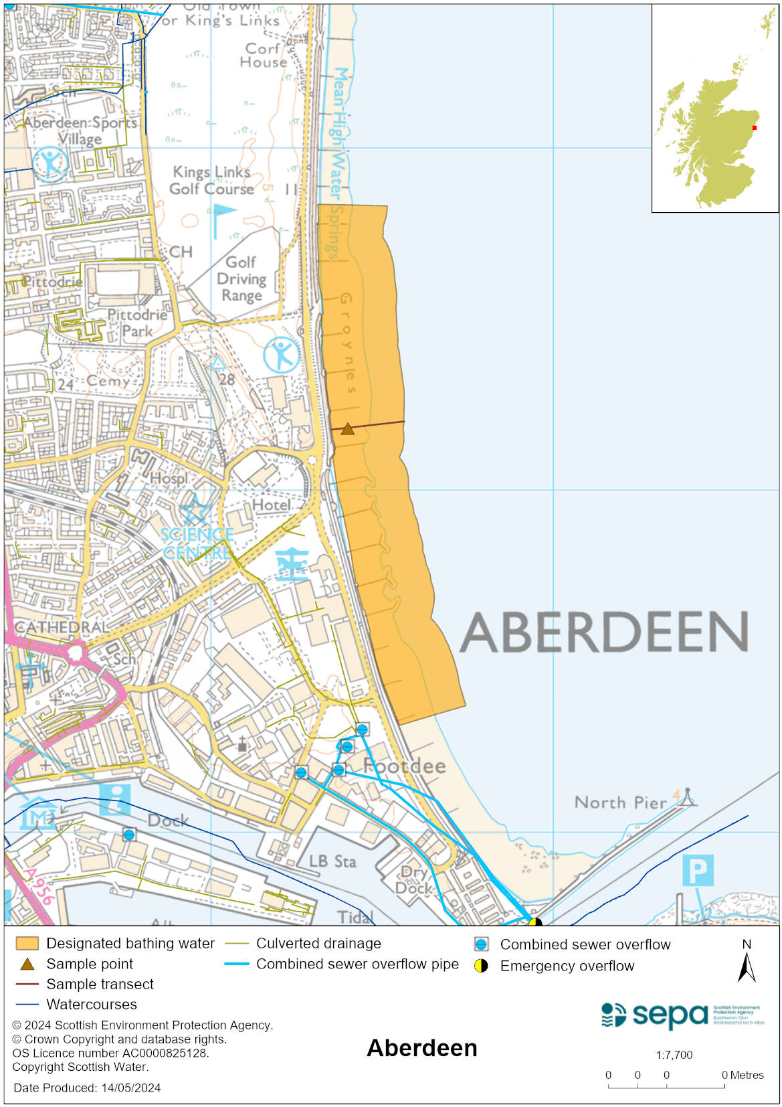

Map 2: Catchment draining into Aberdeen bathing water
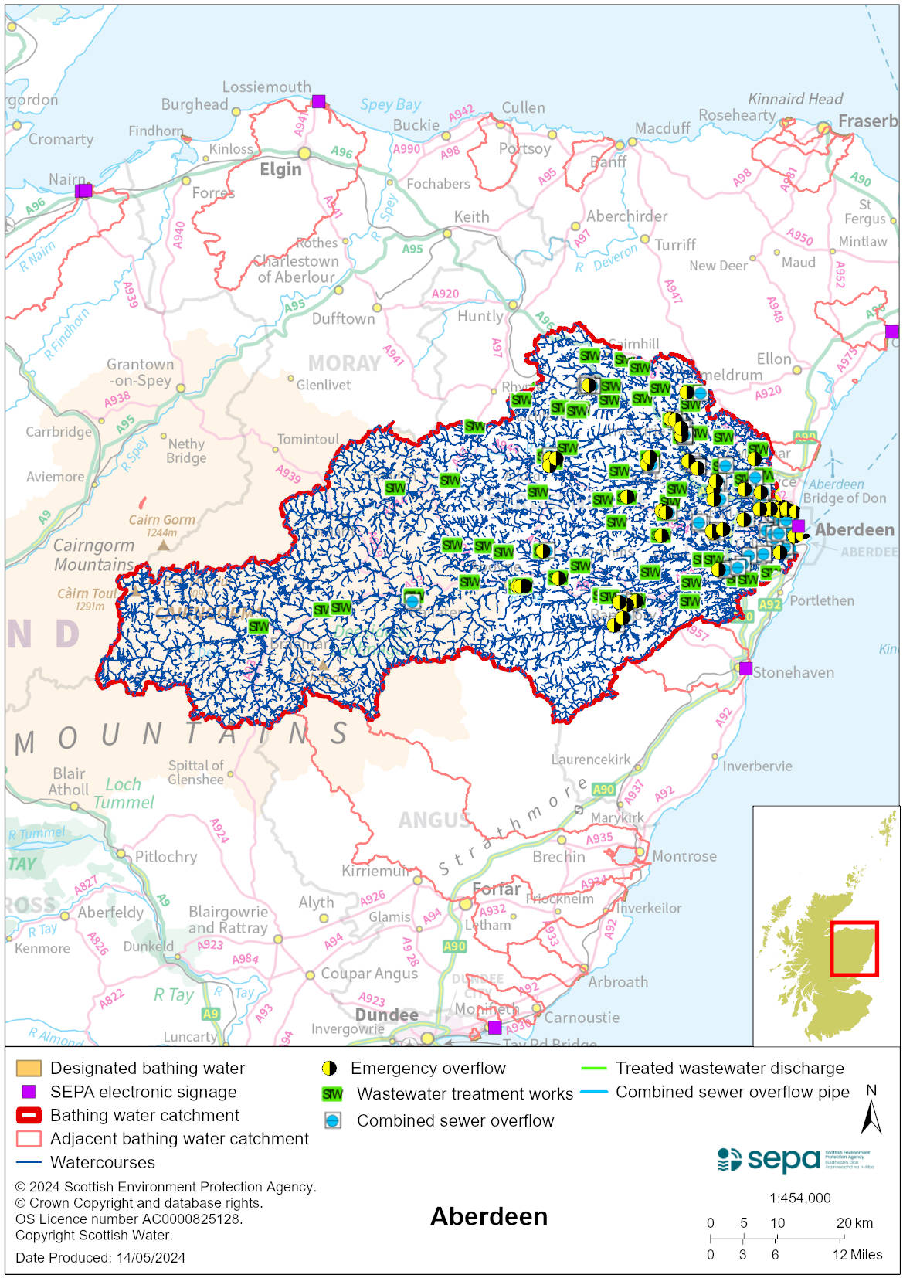

Improving bathing water quality

Sewage
Scottish Water provides most waste water collection and treatment services in Scotland.

Nigg and Persley sewage treatment works are the main works for Aberdeen city and surrounding areas. Full biological treatment is applied to the effluent from Nigg which discharges out to sea, several kilometres south of the beach area and approximately 2km offshore.
Persley sewage treatment works discharges effluent treated with ultraviolet disinfection to the River Don.

A Scottish Water study into improving Aberdeen’s bathing water quality concluded that investment in their assets is not required. Trade effluent, surface water and septic tank discharges do not add a significant bacterial input to the bathing water.

Agriculture
Diffuse pollution from agricultural sources is the result of rain driven events causing cumulative inputs of pollutants to rivers and streams.

There is the potential for agricultural diffuse pollution to occur in both the Rivers Dee and Don. This is a risk to Aberdeen’s bathing water quality, particularly during periods of wet weather.

Farm visits have been ongoing in the Rivers Dee and Don since 2014. These visits looked to identify diffuse pollution sources and provide advice on possible mitigation measures the farmer could employ to reduce the pollution risk.

SEPA has observed significant changes in land management practice within the catchments and will continue to work with farmers to reduce the risk of pollution to the bathing water.

Urban
Urban diffuse source pollution comes from contaminated rainwater discharging to rivers and streams. The River Dee and the River Don are known to be impacted by surface water run-off. This potentially impacts on bathing water quality at Aberdeen.

Cyanobacteria (blue-green algae), algae and jellyfish
Marine waters are not at risk of cyanobacteria overproduction. This bathing water is not at risk of excessive growth of macroalgae (seaweed) or phytoplankton.

The possibility of increased jellyfish numbers in the water during summer months is a naturally occurring phenomenon. Most species common to the UK are harmless; the Marine Conservation Society advises to ‘look but don’t touch’.

Pollution incidents
Pollution can be reported via our website online form or by calling our 24 hours a day Pollution Hotline number 0800 80 70 60

If pollution is reported to us, or identified by our routine water quality monitoring program, we will investigate and where necessary work with others to remediate. We may contact other relevant organisations including the local authority, that local health board, Scottish Water and Scottish Ministers.

If there is a risk to human health the local authority is responsible for placing signs at the bathing water. Information will also be available on our website.

Everyone can help to keep the bathing water clean:
- If you visit the beach with your dog clear up any fouling
- Don’t leave litter or feed birds - this encourages unnatural behaviour, and they can pollute the water
- At home, don’t flush wipes or other inappropriate items as these can block pipes and cause sewage spills

Contact details and information sources

SEPA bathing waters homepage

SEPA rainfall data

Scottish Government protected waters homepage

Aberdeen City Council

For information on accessing this document in an alternative format or language, please contact SEPA by emailing equalities@sepa.org.uk
If you are a user of British Sign Language (BSL), the Contact Scotland BSL service gives you access to an online interpreter, enabling you to communicate with us using sign language. contactscotland-bsl.org

