Bathing water profile - Southerness
Bathing water classification

Bathing water description
Southerness bathing water is a relatively small, horse shoe shaped area of beach. It sits on the north coast of the Solway Firth close to the village of Southerness. The beach is fairly rocky, leaving an array of rock pools exposed at low tide. As this beach sits on a transitional water, mud flats are exposed at low tide making the water’s edge difficult to access in certain areas.

Depending on the tide, there can be 50 metres to just over 1 km of beach before the water’s edge.

Site details:
- Local authority: Dumfries & Galloway Council
- Year of designation: 1999
- Water sampling location: NX 97686 54006

Risks to water quality
This bathing water is at risk of short term pollution following heavy rainfall. Bathing is not advised during or 1-2 days after heavy rainfall due to the risk to bathers’ health from water pollution.

Pollution risks include agricultural run-off and sewerage.

Catchment description
A catchment of just under 7 km2 drains to the Southerness bathing water. The area varies in elevation from around 200 metres in the north to around 10 metres along the coast.
The bathing water catchment is predominantly rural (97%) with grassland being the major land use. The area supports some, but not many, dairy and beef cattle as well as arable production. Approximately 1% of the catchment is urban, with the main population centre being Southerness village. Population density out with the village is low comprises of a few scattered farms and houses.

There are two coastal burns within this catchment, one of which drains directly into the designated area.

The bathing water sits within the Upper Solway flats and marshes which is a Ramsar site, a Special Area of Conservation (SAC), a Site of Special Scientific Interest (SSSI) and a Special Protected Area (SPA).

Map 1: Southerness bathing water
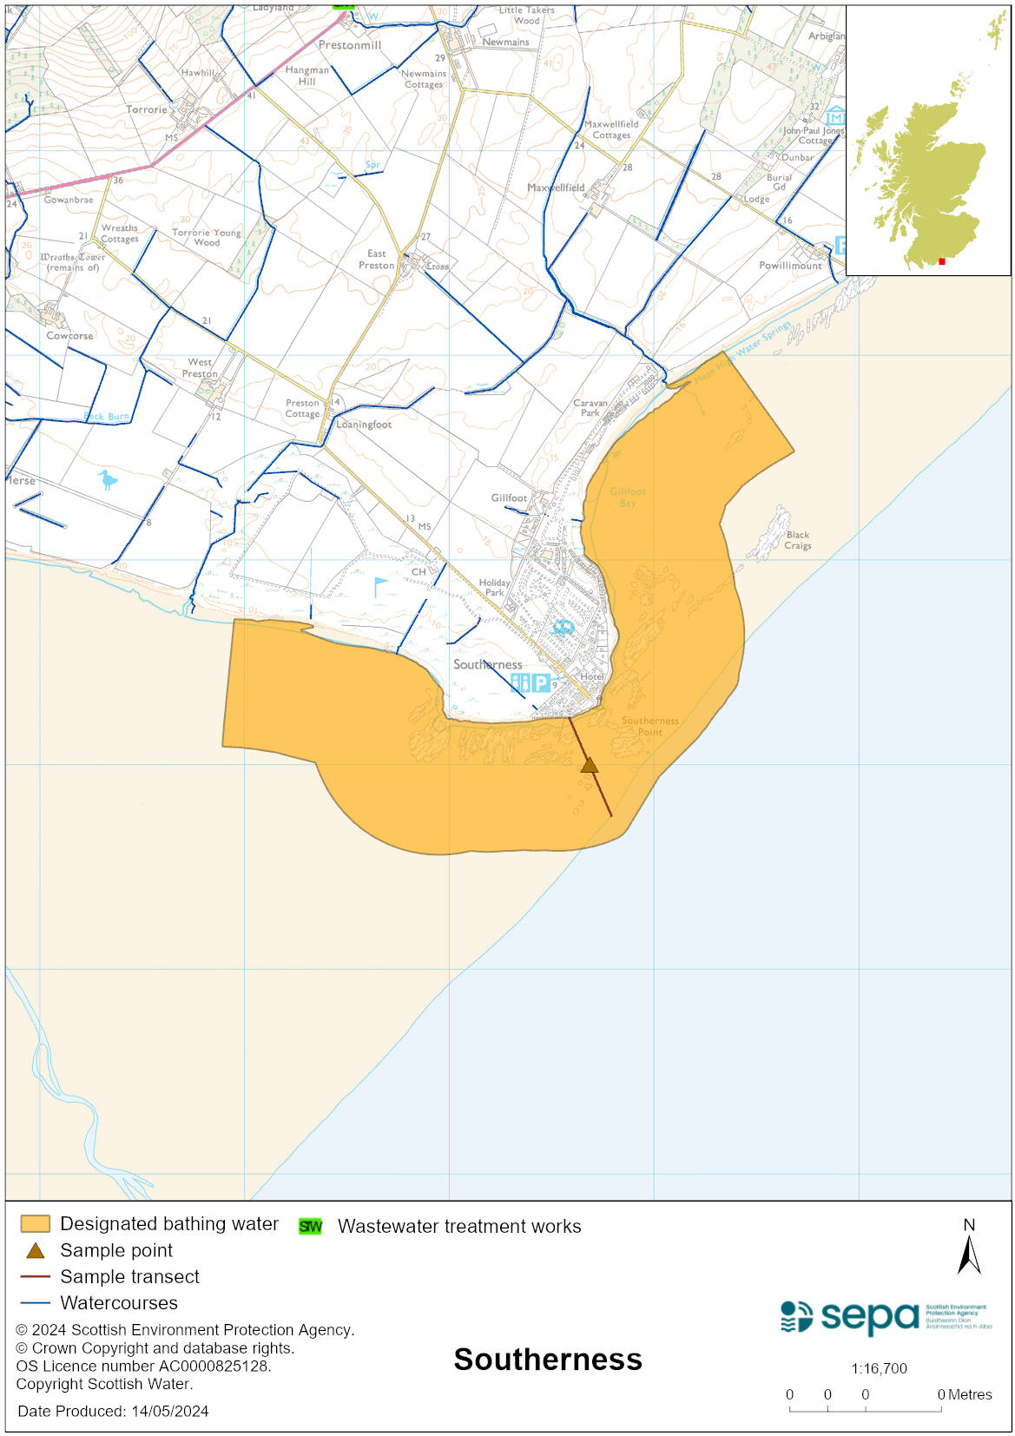

Map 2: Catchment draining into Southerness bathing water
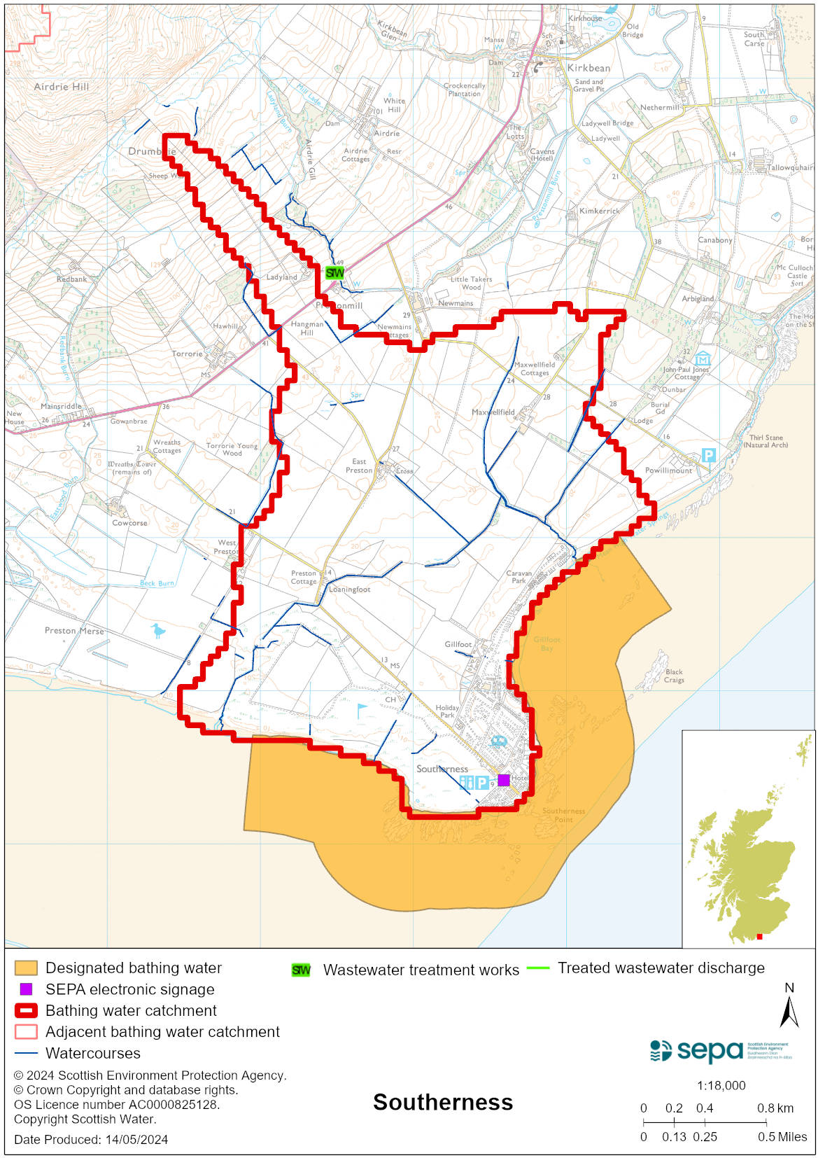

Improving bathing water quality

Sewage
Scottish Water provides most waste water collection and treatment services in Scotland.

Combined sewer outfalls in the Troqueer catchment of Dumfries were upgraded in 2005 to provide better screening and reduce the frequency of spills. Residual issues at two outfalls and settled sewage at Troqueer sewage treatment works were addressed in 2010.

There is a private wastewater treatment plant at Southerness, which serves both the caravan park and the village. This treatment works has been upgraded to secondary treatment and includes ultraviolet disinfection during the bathing season.

SEPA is investigating a cross connection into the Gillfoot burn.

Agriculture
Diffuse pollution from agricultural sources is the result of rain driven events causing cumulative inputs of pollutants to rivers and streams.
There is potential for agricultural diffuse pollution to occur in the River Nith which could impact on the bathing beach during and following heavy rain. Also cattle are known to have direct access to the River Nith at the Merse, downstream of Dumfries.
Farm visits started in the Nith priority catchment in 2014 and are ongoing. These visits look to identify diffuse pollution sources and pathways. Mitigation measures have been agreed with land managers to reduce the risk of bacterial pollution on water quality.
SEPA has observed significant changes in land management practice within the catchment and will continue to work with farmers to reduce the risk of pollution to the bathing water.

Cyanobacteria (blue-green algae), algae and jellyfish
Marine waters are not at risk of cyanobacteria overproduction. This bathing water is not at risk of excessive growth of macroalgae (seaweed) or phytoplankton.

The possibility of increased jellyfish numbers in the water during summer months is a naturally occurring phenomenon. Most species common to the UK are harmless; the Marine Conservation Society advises to ‘look but don’t touch’.

Pollution incidents
Pollution can be reported via our website online form or by calling our 24 hours a day Pollution Hotline number 0800 80 70 60

If pollution is reported to us, or identified by our routine water quality monitoring program, we will investigate and where necessary work with others to remediate. We may contact other relevant organisations including the local authority, that local health board, Scottish Water and Scottish Ministers.

If there is a risk to human health the local authority is responsible for placing signs at the bathing water. Information will also be available on our website.

Everyone can help to keep the bathing water clean:
- If you visit the beach with your dog clear up any fouling
- Don’t leave litter or feed birds - this encourages unnatural behaviour, and they can pollute the water
- At home, don’t flush wipes or other inappropriate items as these can block pipes and cause sewage spills

Contact details and information sources

SEPA bathing waters homepage

SEPA rainfall data

Scottish Government protected waters homepage

Dumfries & Galloway Council

For information on accessing this document in an alternative format or language, please contact SEPA by emailing equalities@sepa.org.uk
If you are a user of British Sign Language (BSL), the Contact Scotland BSL service gives you access to an online interpreter, enabling you to communicate with us using sign language. contactscotland-bsl.org

