Bathing water profile - Mossyard
Bathing water classification

Bathing water description
The Mossyard bathing water is a small sandy beach (about 1 km long). It is located at the south-west corner of Fleet Bay on the south coast of Dumfries and Galloway. It is close to the small
town of Gatehouse of Fleet. Mossyard is a privately owned beach within the boundary of Mossyard farm. It is popular with visitors to the nearby caravan and camping park. Mossyard has a tombolo (sand bar) which links Garvellan Rocks to the mainland. The tombolo is usually exposed, even at high tide. At low tide, there is a sandy area between the shore and Garvellan Rocks. This beach sits on transitional water. Mud flats are exposed at low tide making the
water’s edge difficult to access in certain areas.

Site details:
- Local authority: Dumfries and Galloway Council
- Year of designation: 2008
- Water sampling location: NX 55250 51870

Risks to water quality
This bathing water is at risk of short term pollution following heavy rainfall. Bathing is not advised during or 1-2 days after heavy rainfall due to the risk to bathers’ health from water pollution.

Pollution risks include agricultural run-off and from sewerage.

Catchment description
The Mossyard bathing water catchment is less than 1 km2. The area is flat with a maximum elevation of about 50 metres, falling to around 15 metres along the coast.
The area is mainly rural (97%) with grassland the major land use. The upland areas support mixed sheep and beef farming. Approximately 1% of the catchment is urban. At peak times, the holiday park in the catchment accommodates around 1000 people. Outside the catchment, the small town of Gatehouse of Fleet is approximately 8 km from the bathing water.

Map 1: Mossyard bathing water
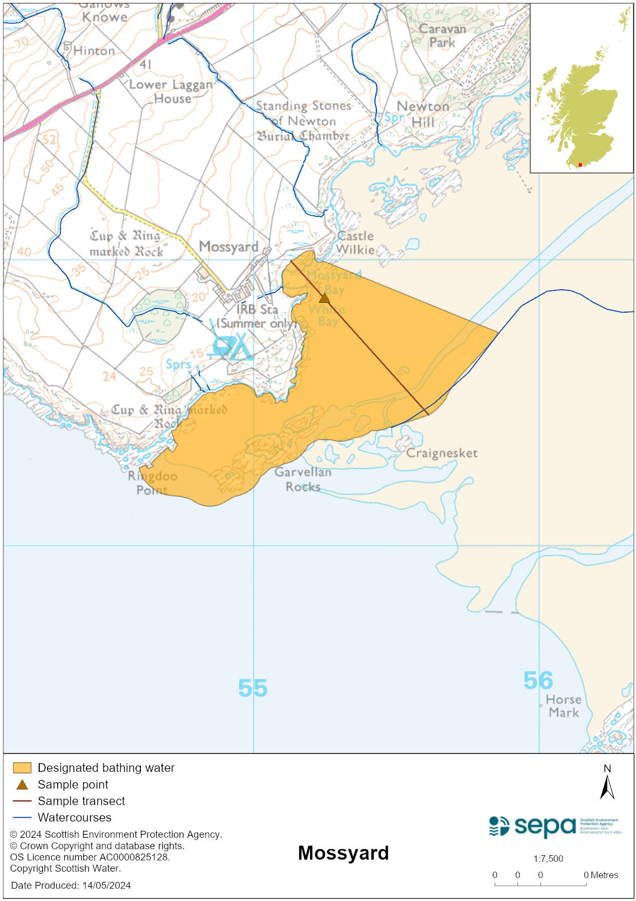

Map 2: Catchment draining into Mossyard bathing water
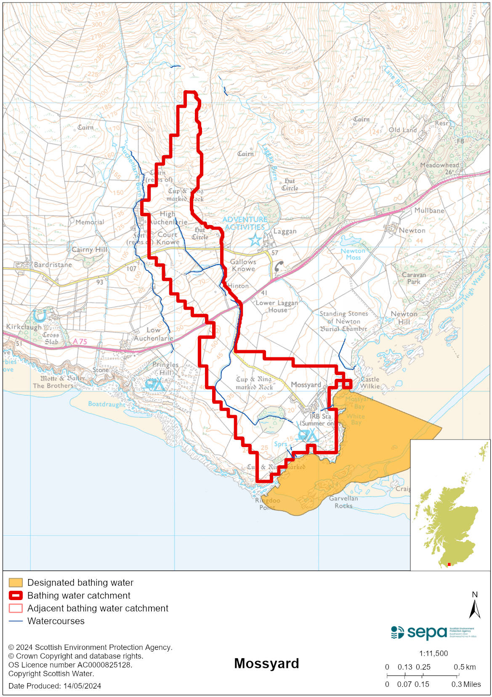

Improving bathing water quality

Sewage
Whilst Scottish Water provides most waste water collection and treatment services in Scotland, there are no Scottish Water assets in the vicinity of this bathing water.

The nearby Auchenlairie holiday park implemented a private sewage treatment facility to improve discharges into Wigtown Bay. The new system includes a fine screening unit, septic tanks and reed bed.

Agriculture
Diffuse pollution from agricultural sources is the result of rain driven events causing cumulative inputs of pollutants to rivers and streams.

There is potential for agricultural diffuse pollution to occur in small tributaries discharging onto the bathing beach. These are a risk to Mossyard bathing water quality, particularly during and after periods of wet weather.

Farm visits started in this catchment in 2014 and were completed in 2019. SEPA has observed significant changes in land management practice and improvements which are known to reduce pollution risk. There has been significant capital expenditure resulting in many rural land managers going beyond regulatory compliance to address issues arising from their farming activities.

SEPA will continue to work with rural land managers in this catchment to reduce the risk of pollution to the bathing water.

Cyanobacteria (blue-green algae), algae and jellyfish
Marine waters are not at risk of cyanobacteria overproduction. This bathing water is not at risk of excessive growth of macroalgae (seaweed) or phytoplankton.

The possibility of increased jellyfish numbers in the water during summer months is a naturally occurring phenomenon. Most species common to the UK are harmless; the Marine Conservation Society advises to ‘look but don’t touch’.

Pollution incidents
Pollution can be reported via our website online form or by calling our 24 hours a day Pollution Hotline number 0800 80 70 60

If pollution is reported to us, or identified by our routine water quality monitoring program, we will investigate and where necessary work with others to remediate. We may contact other relevant organisations including the local authority, that local health board, Scottish Water and Scottish Ministers.

If there is a risk to human health the local authority is responsible for placing signs at the bathing water. Information will also be available on our website.

Everyone can help to keep the bathing water clean:
- If you visit the beach with your dog clear up any fouling
- Don’t leave litter or feed birds - this encourages unnatural behaviour, and they can pollute the water
- At home, don’t flush wipes or other inappropriate items as these can block pipes and cause sewage spills

Contact details and information sources

SEPA bathing waters homepage

SEPA rainfall data

Scottish Government protected waters homepage

Dumfries and Galloway Council

For information on accessing this document in an alternative format or language, please contact SEPA by emailing equalities@sepa.org.uk
If you are a user of British Sign Language (BSL), the Contact Scotland BSL service gives you access to an online interpreter, enabling you to communicate with us using sign language. contactscotland-bsl.org

