Bathing water profile - Rosemarkie
Bathing water classification

Bathing water description
Rosemarkie bathing water is on the Black Isle, north of the Chanonry Ness peninsula. It is near the small town of Rosemarkie. It is a relatively small, shallow bay, about 500 metres in length. The bathing water looks across the Moray Firth to the Moray coastline and Fort George. Depending on the tide, the distance to the water’s edge can vary from 0–100 metres. The beach slopes gently towards the water.

Site details:
- Local authority: Highland Council
- Year of designation: 2008
- Water sampling location: NH 73900 57900

Risks to water quality
This bathing water is at risk of short term pollution following heavy rainfall. Bathing is not advised during or 1-2 days after heavy rainfall due to the risk to bathers’ health from water pollution.

Pollution risks include sewer overflows, agricultural run-off and surface water discharges.

Catchment description
The Rosemarkie bathing water catchment extends to 15 km2. The steep catchment from high hills (maximum elevation 220 metres at Callachy Hill) in the north west to the low-lying areas (average elevation 5 metres) along the coast.
The main rivers within the catchment are the Rosemarkie Burn and the Whitebog Spring, which flows into the Rosemarkie Burn.
The catchment is mainly rural (98%) with agriculture the major land use. The rural land comprises grassland (46%), arable agricultural (18%) and woodland (29%). The area supports mixed farming. About 1% of the catchment is urban. The main population centre is the small town of Rosemarkie, within 500 metres of the bathing water. Population density outside of the town is low.
There are two protected areas which lie partially within the catchment. One is the Moray Firth, a Special Area of Conservation, and the other is a Site of Special Scientific Interest.

Map 1: Rosemarkie bathing water
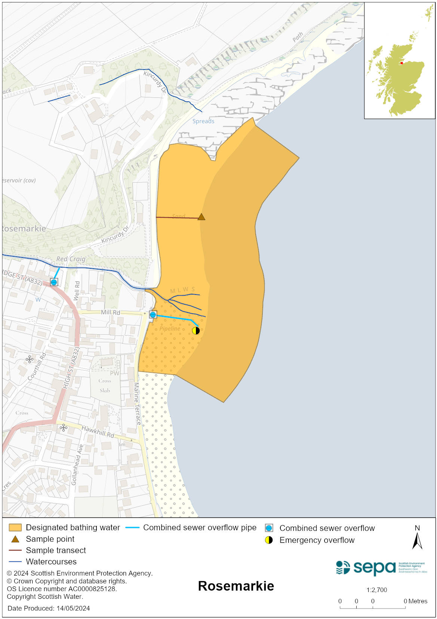

Map 2: Catchment draining into Rosemarkie bathing water
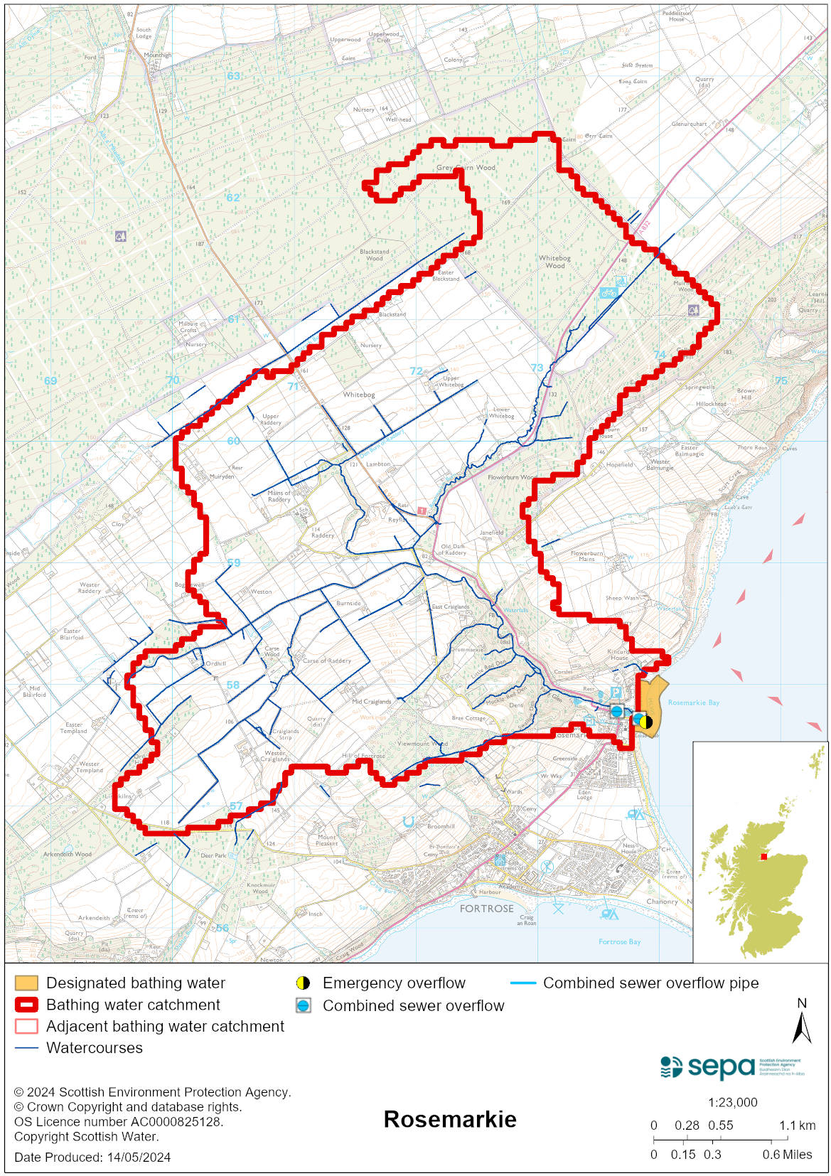

Improving bathing water quality

Sewage
Scottish Water provides most waste water collection and treatment services in Scotland.

Two combined sewer overflows (CSO) have discharge locations in the area, one to the Rosemarkie Burn and one to the bathing water. These may discharge and impact the bathing water during heavy rainfall. There is also an emergency overflow (EO) which should only discharge under rare, abnormal circumstances.

Septic tanks discharge to the Rosemarkie Burn.

Agriculture
Diffuse pollution from agricultural sources is the result of rain driven events causing cumulative inputs of pollutants to rivers and streams.

There is potential for agricultural diffuse pollution to occur in the Rosemarkie Burn which could impact on the bathing beach during and following heavy rain.

Farm visits started in the Cromarty coastal priority catchment in 2014 and are ongoing. These visits look to identify diffuse pollution sources and pathways. Mitigation measures have been agreed with land managers to reduce the risk of bacterial pollution on water quality.

SEPA has observed significant changes in land management practice within the catchment and will continue to work with farmers to reduce the risk of pollution to the bathing water.

Urban
Urban diffuse source pollution comes from contaminated rainwater discharging to rivers and streams. Rosemarkie Burn is known to be affected by surface water run-off from the urban area through which it runs.

Cyanobacteria (blue-green algae), algae and jellyfish
Marine waters are not at risk of cyanobacteria overproduction. This bathing water is not at risk of excessive growth of macroalgae (seaweed) or phytoplankton.

The possibility of increased jellyfish numbers in the water during summer months is a naturally occurring phenomenon. Most species common to the UK are harmless; the Marine Conservation Society advises to ‘look but don’t touch’.

Pollution incidents
Pollution can be reported via our website online form or by calling our 24 hours a day Pollution Hotline number 0800 80 70 60

If pollution is reported to us, or identified by our routine water quality monitoring program, we will investigate and where necessary work with others to remediate. We may contact other relevant organisations including the local authority, that local health board, Scottish Water and Scottish Ministers.

If there is a risk to human health the local authority is responsible for placing signs at the bathing water. Information will also be available on our website.

Everyone can help to keep the bathing water clean:
- If you visit the beach with your dog clear up any fouling
- Don’t leave litter or feed birds - this encourages unnatural behaviour, and they can pollute the water
- At home, don’t flush wipes or other inappropriate items as these can block pipes and cause sewage spills

Contact details and information sources

SEPA bathing waters homepage

SEPA rainfall data

Scottish Government protected waters homepage

Highland Council

For information on accessing this document in an alternative format or language, please contact SEPA by emailing equalities@sepa.org.uk
If you are a user of British Sign Language (BSL), the Contact Scotland BSL service gives you access to an online interpreter, enabling you to communicate with us using sign language. contactscotland-bsl.org

