Bathing water profile – Fisherrow Sands
Bathing water classification

Bathing water description
Fisherrow Sands bathing water is a relatively small area of sandy beach. It is situated in between the town of Musselburgh and the Joppa area of Edinburgh. The bathing water is beside Fisherrow Harbour and is southwest of the River Esk. The sandy beach slopes gently towards the water and depending on the tide, the distance to the water’s edge can vary from 0–500 metres.

Site details
- Local authority: East Lothian Council
- Year of designation: 2013
- Water sampling location: NT 3320 7310

Risks to water quality
This bathing water is subject to short term pollution following heavy rainfall. Bathing is not advised during or 1-2 days after heavy rainfall due to the risk to bathers’ health from water pollution.

Pollution risks include sewer overflows and surface water discharges.

Catchment description
A catchment area of 26.7 km² drains into Fisherrow Sands bathing water. The catchment has a mix of rural and urban land and varies in topography from hills in the southwest to low-lying land along the coast. The main population centres within the catchment are Musselburgh and Portobello.

The main river within the bathing water catchment is the Brunstane/Niddrie Burn. The River Esk enters the Firth of Forth east of the bathing water.

Map 1: Fisherrow Sands bathing water
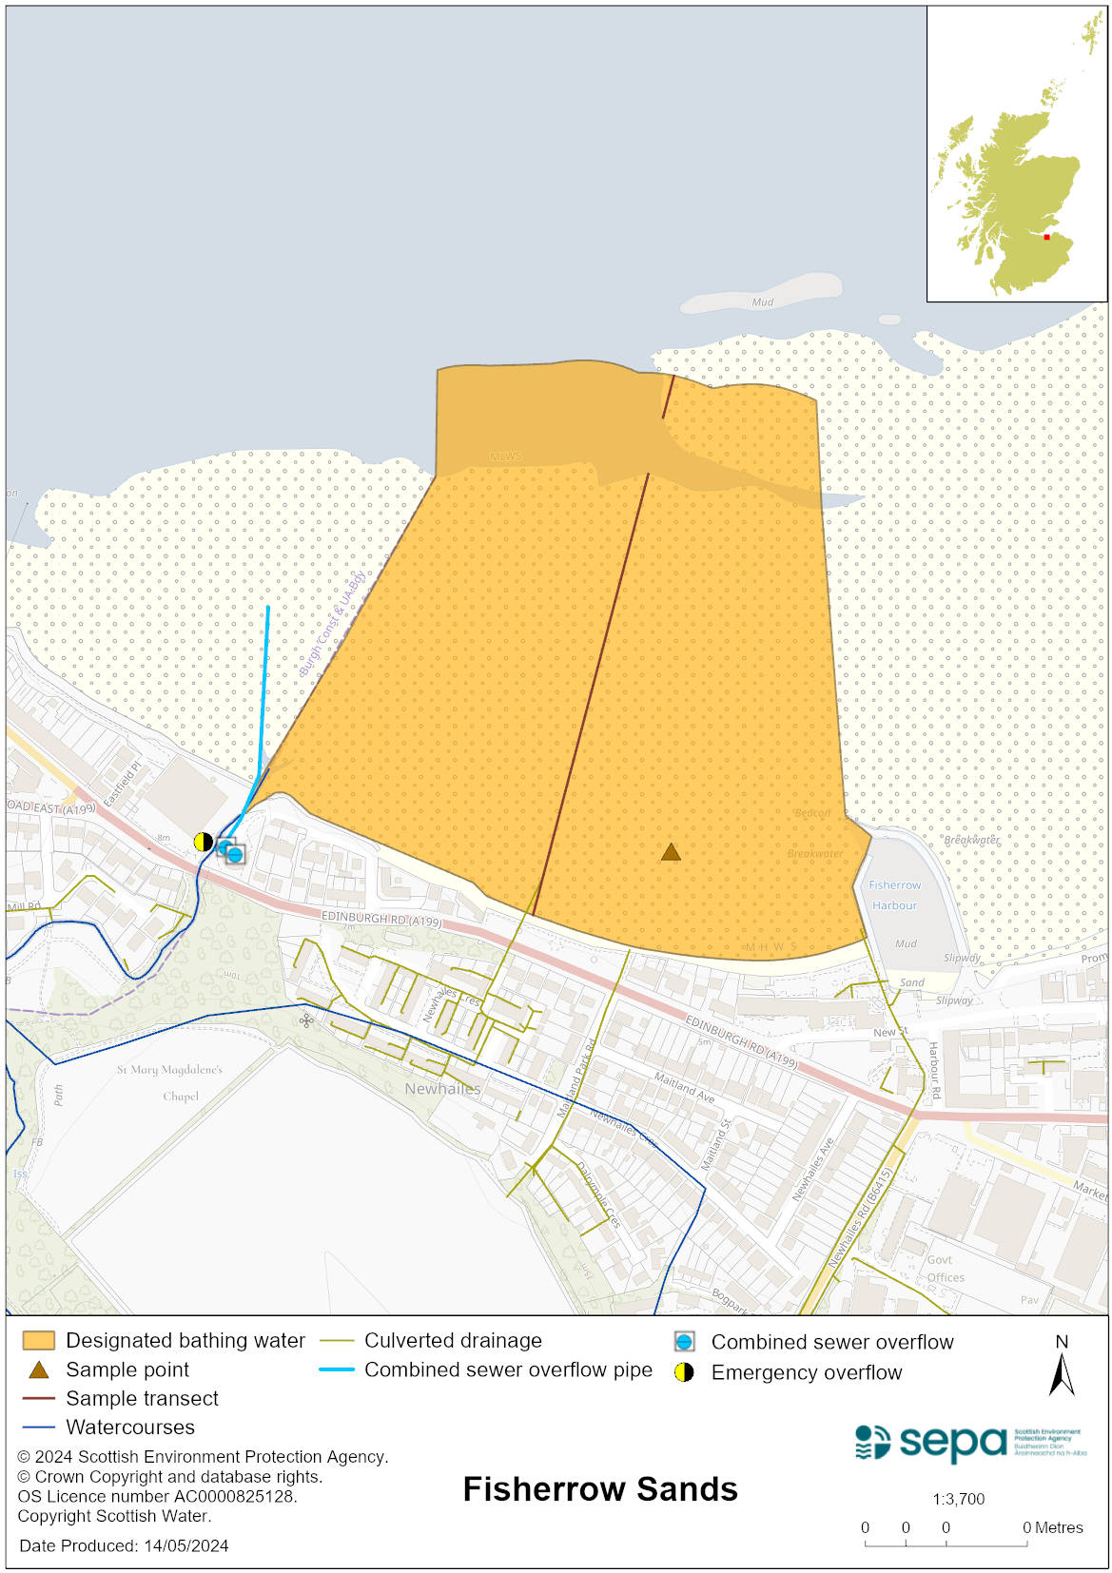

Map 2: Catchment draining into Fisherrow Sands bathing water
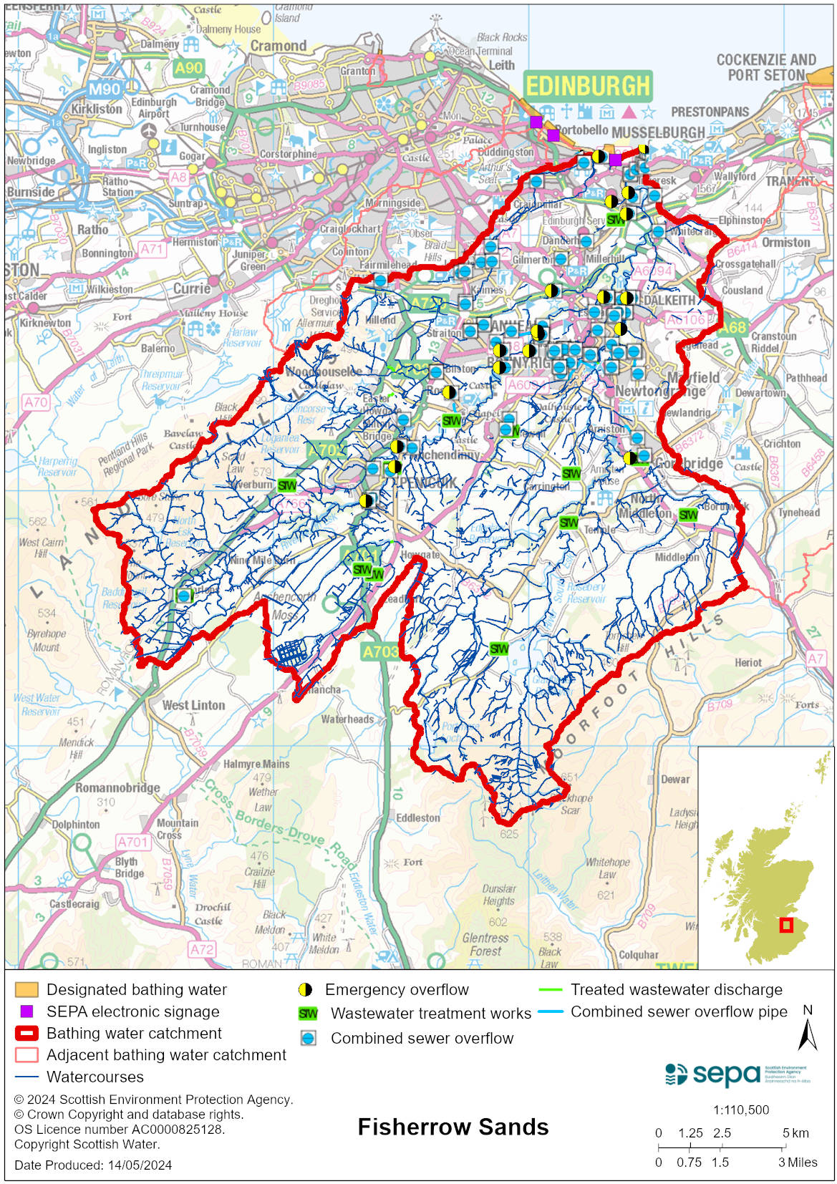

Improving bathing water quality

Sewage
Scottish Water provides most waste water collection and treatment services in Scotland.

Sewage from the Fisherrow area is treated at Edinburgh sewage treatment works and is then discharged to the Firth of Forth via a long sea outfall.
There is a combined sewer overflow (CSO) with a discharge location to the west of the bathing water which may discharge and impact the bathing water during heavy rainfall. There is an emergency overflow (EO) with a discharge location to the Brunstane Burn. This EOs should only discharge under rare, abnormal circumstances.

Significant work has been undertaken by Scottish Water, Scottish Government, SEPA and wider stakeholders to improve the bathing water quality at Fisherrow Sands. The work identified and addressed, where possible, misconnections, blockages to the sewerage network and structural defects.

Agriculture
There are no impacts from agriculture affecting this bathing water.

Urban
The Brunstane Burn is impacted by urban pollution. This can be from surface water run-off from the urban area through which it runs and mis connections to the surface water network.

Cyanobacteria (blue-green algae), algae and jellyfish
Marine waters are not at risk of cyanobacteria overproduction. This bathing water is not at risk of excessive growth of macroalgae (seaweed) or phytoplankton.

The possibility of increased jellyfish numbers in the water during summer months is a naturally occurring phenomenon. Most species common to the UK are harmless; the Marine Conservation Society advises to ‘look but don’t touch’.

Pollution incidents
Pollution can be reported via our website online form or by calling our 24 hours a day Pollution Hotline number 0800 80 70 60

If pollution is reported to us, or identified by our routine water quality monitoring program, we will investigate and where necessary work with others to remediate. We may contact other relevant organisations including the local authority, that local health board, Scottish Water and Scottish Ministers.

If there is a risk to human health the local authority is responsible for placing signs at the bathing water. Information will also be available on our website.

Everyone can help to keep the bathing water clean:
- If you visit the beach with your dog clear up any fouling
- Don’t leave litter or feed birds - this encourages unnatural behaviour, and they can pollute the water
- At home, don’t flush wipes or other inappropriate items as these can block pipes and cause sewage spills

Contact details and information sources

SEPA bathing waters homepage

SEPA rainfall data

Scottish Government protected waters homepage

East Lothian Council

For information on accessing this document in an alternative format or language, please contact SEPA by emailing equalities@sepa.org.uk
If you are a user of British Sign Language (BSL), the Contact Scotland BSL service gives you access to an online interpreter, enabling you to communicate with us using sign language. contactscotland-bsl.org

