Bathing water profile – Dhoon Bay
Bathing water classification

Bathing water description
Dhoon Bay bathing water is in a relatively small bay, about 350 metres long. It is on the west shore of the Dee Estuary opposite St Mary’s Isle. It is close to a caravan park and is popular with holidaymakers. The sandy beach slopes gently towards the water. The whole of the beach can be under water at high tide. At low tide, there is a sandy area for approximately 180m. Mud flats are exposed at low tide making the water’s edge difficult to access in certain areas.

Site details:
- Local authority: Dumfries and Galloway Council
- Year of designation: 2008
- Water sampling location: NX 65748 48600

Risks to water quality
This bathing water is subject to short term pollution following heavy rainfall. Bathing is not advised during or 1-2 days after heavy rainfall due to the risk to bathers’ health from water pollution.

Pollution risks include agricultural run-off and sewer overflows.

Water quality forecasts
As water quality is likely to be impacted by rainfall we make daily predictions of good or poor bathing water quality. We advise against bathing when poor water quality is predicted as there is an increased risk to bathers’ health from water pollution.

These predictions are displayed on the electronic sign at the beach and online between 15 May and 15 September.

Catchment description
A catchment area of 11.5 km2 drains into Dhoon Bay bathing water. It is a hilly catchment with elevations of 20–50 metres along the coast, extending to 130 metres in northerly parts. Mill Hall Burn and Corraford Burn drain into Dhoon Bay.
The land supports mixed grazing and intensive dairy farming. Population density within the catchment is low with a few scattered farms and houses. Kirkcudbright town is approximately 5 km to the north-east of the bathing water. A caravan park and campsite is close to the bathing water.
Average summer rainfall for the region is 356 mm compared to 331 mm across Scotland as a whole.

Map 1: Dhoon Bay bathing water
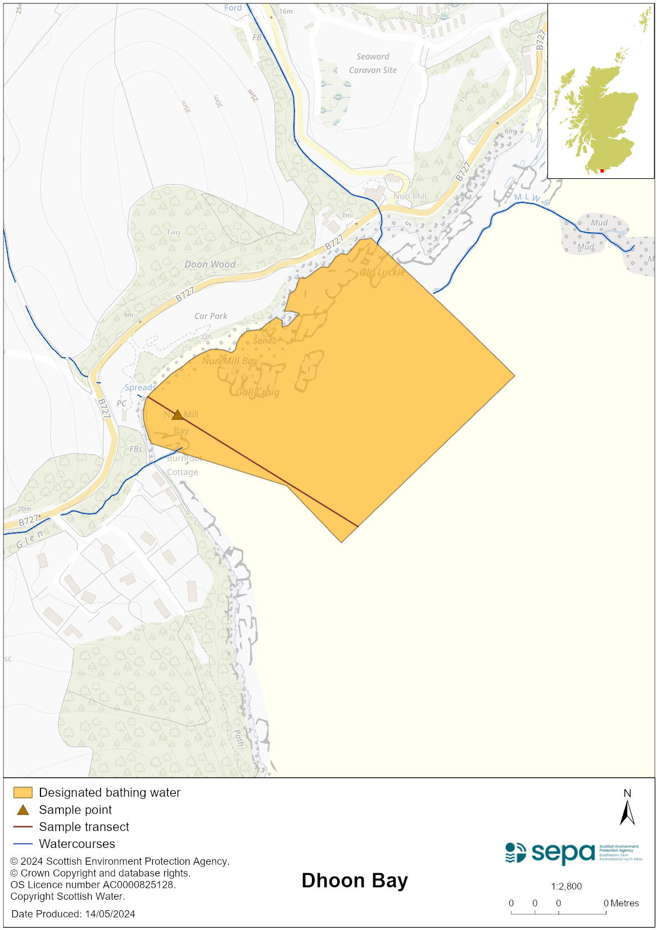

Map 2: Catchment draining into Dhoon Bay bathing water
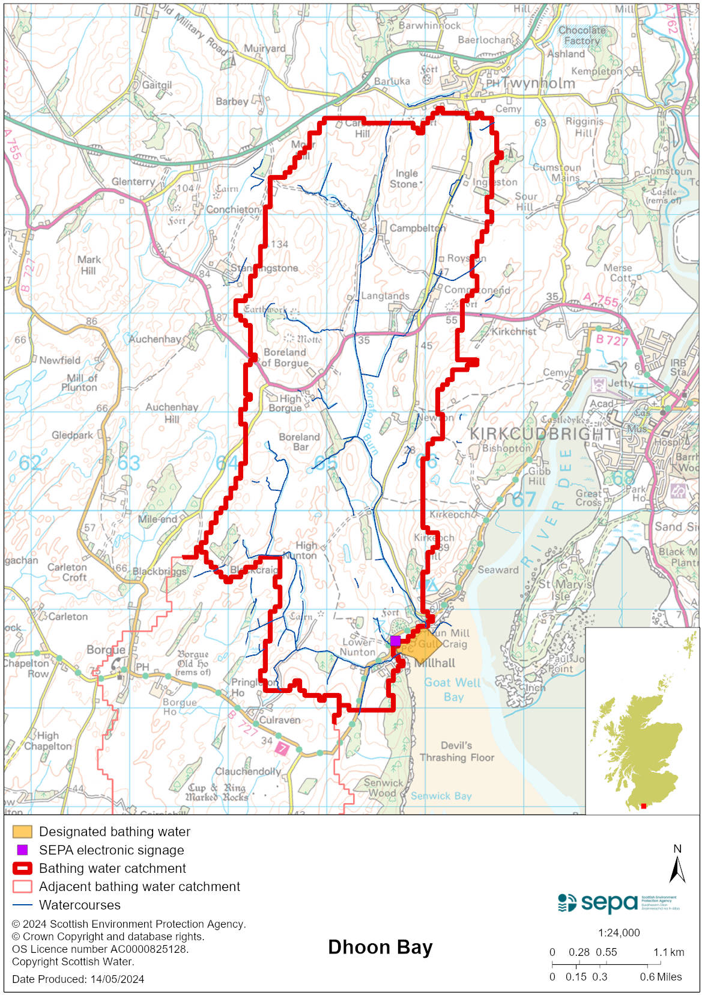

Improving bathing water quality

Sewage
Whilst Scottish Water provides most waste water collection and treatment services in Scotland, there are no Scottish Water assets in the vicinity of this bathing water.

SEPA is investigating the impact of septic tanks on water quality and are working with local residents to try and improve the discharges from the private domestic systems. SEPA is also working with the owner of the local caravan park to upgrade the current treatment systems to improve the effluent quality.

Agriculture
Diffuse pollution from agricultural sources is the result of cumulative inputs of pollutants to rivers and streams.

There is potential for agricultural diffuse pollution to occur in the Mill Hall Burn and Corraford Burn. Our current evidence suggests that the River Dee and its extensive catchment are not a significant source of diffuse pollution.

The majority of the farms within the Dhoon Bay area support dairy cows, although there are some sheep and beef farms in upland areas. Farm visits were undertaken in the Stewartry coastal catchment in 2014. These visits looked to identify diffuse pollution sources and pathways. Mitigation measures were agreed with land managers to reduce the risk of bacterial pollution on water quality. All agricultural compliance work has been completed in this bathing water catchment and all farms are in a compliant state.

SEPA will continue to engage with farmers and the NFUS to remind them of good practice when applying slurries and manures and grazing livestock.

Cyanobacteria (blue-green algae), algae and jellyfish
Marine waters are not at risk of cyanobacteria overproduction. This bathing water is not at risk of excessive growth of macroalgae (seaweed) or phytoplankton.

The possibility of increased jellyfish numbers in the water during summer months is a naturally occurring phenomenon. Most species common to the UK are harmless; the Marine Conservation Society advises to ‘look but don’t touch’.

Pollution incidents
Pollution can be reported via our website online form or by calling our 24 hours a day Pollution Hotline number 0800 80 70 60

If pollution is reported to us, or identified by our routine water quality monitoring program, we will investigate and where necessary work with others to remediate. We may contact other relevant organisations including the local authority, that local health board, Scottish Water and Scottish Ministers.

If there is a risk to human health the local authority is responsible for placing signs at the bathing water. Information will also be available on our website.

Everyone can help to keep the bathing water clean:
- If you visit the beach with your dog clear up any fouling
- Don’t leave litter or feed birds - this encourages unnatural behaviour, and they can pollute the water
- At home, don’t flush wipes or other inappropriate items as these can block pipes and cause sewage spills

Contact details and information sources

SEPA bathing waters homepage

SEPA rainfall data

Scottish Government protected waters homepage

Dumfries and Galloway Council

For information on accessing this document in an alternative format or language, please contact SEPA by emailing equalities@sepa.org.uk
If you are a user of British Sign Language (BSL), the Contact Scotland BSL service gives you access to an online interpreter, enabling you to communicate with us using sign language. contactscotland-bsl.org

