Bathing water profile – Kirkcaldy (Seafield)
Bathing water classification

Bathing water description
Kirkcaldy (Seafield) bathing water is south of the town of Kirkcaldy in Fife. The sandy beach is about 600 metres long and slopes gently towards the water. The area is popular with walkers due to the proximity of the Fife Coastal Path. Depending on the tide, the approximate distance to the water’s edge can vary from 10–210 metres.

Site details:
- Local authority: Fife Council
- Year of designation: 2008
- Water sampling location: NT 28105 89694

Risks to water quality
This bathing water is subject to short term pollution following heavy rainfall. Bathing is not advised during or 1-2 days after heavy rainfall due to the risk to bathers’ health from water pollution.

Pollution risks include sewer overflows and surface water discharges.

Water quality forecasts
As water quality is likely to be impacted by rainfall we make daily predictions of good or poor bathing water quality. We advise against bathing when poor water quality is predicted as there is an increased risk to bathers’ health from water pollution.

These predictions are displayed on the electronic sign at the beach and online between 15 May and 15 September.

Catchment description
The Kirkcaldy (Seafield) bathing water catchment extends to 0.5 km2. Land use in the area is divided between urban (50%) and rural (50%). Arable agriculture is the major rural land use. Kirkcaldy is the main population centre in the catchment. The area also includes the disused Invertiel Quarry.
The main rivers within the catchment are the Tiel, Dronachy and Tyrie burns. The Tiel Burn discharges into the sea 100 metres north of the bathing water. The Tyrie Burn discharges to the sea 270 metres south of the bathing water.
The Firth of Forth is a Site of Special Scientific Interest, a Ramsar site and contains Special Protection Areas for internationally important bird populations.

Map 1: Kirkcaldy (Seafield) bathing water
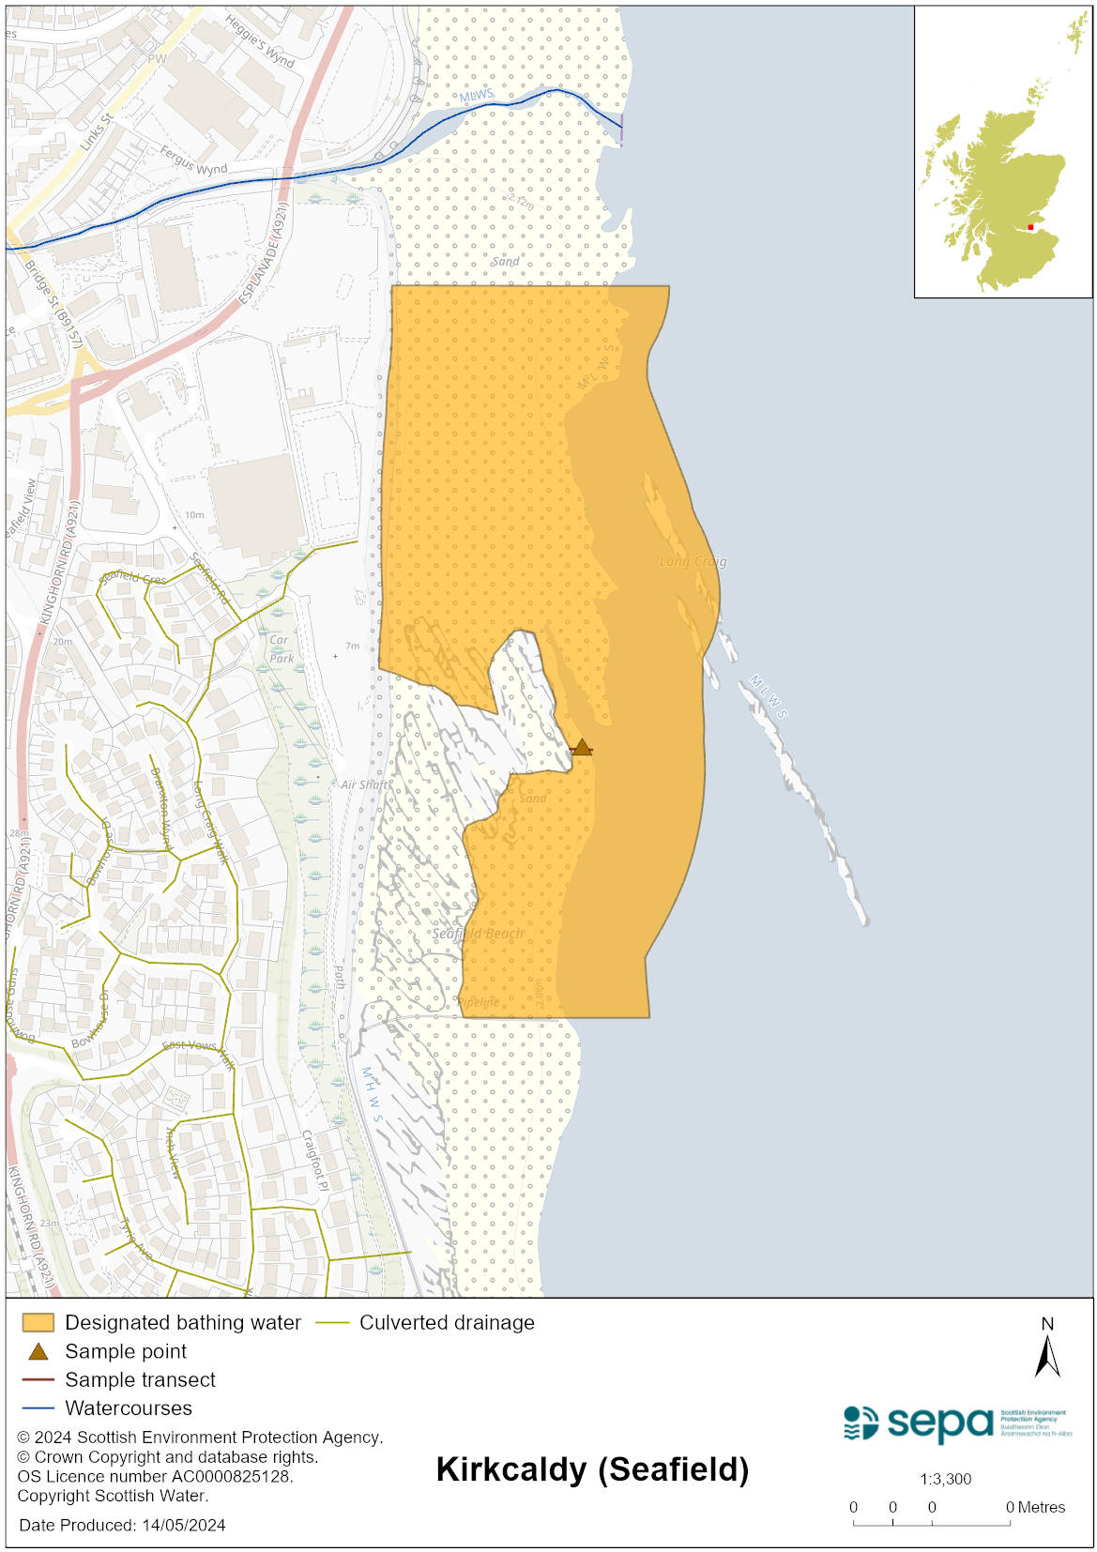

Map 2: Catchment draining into Kirkcaldy (Seafield) bathing water
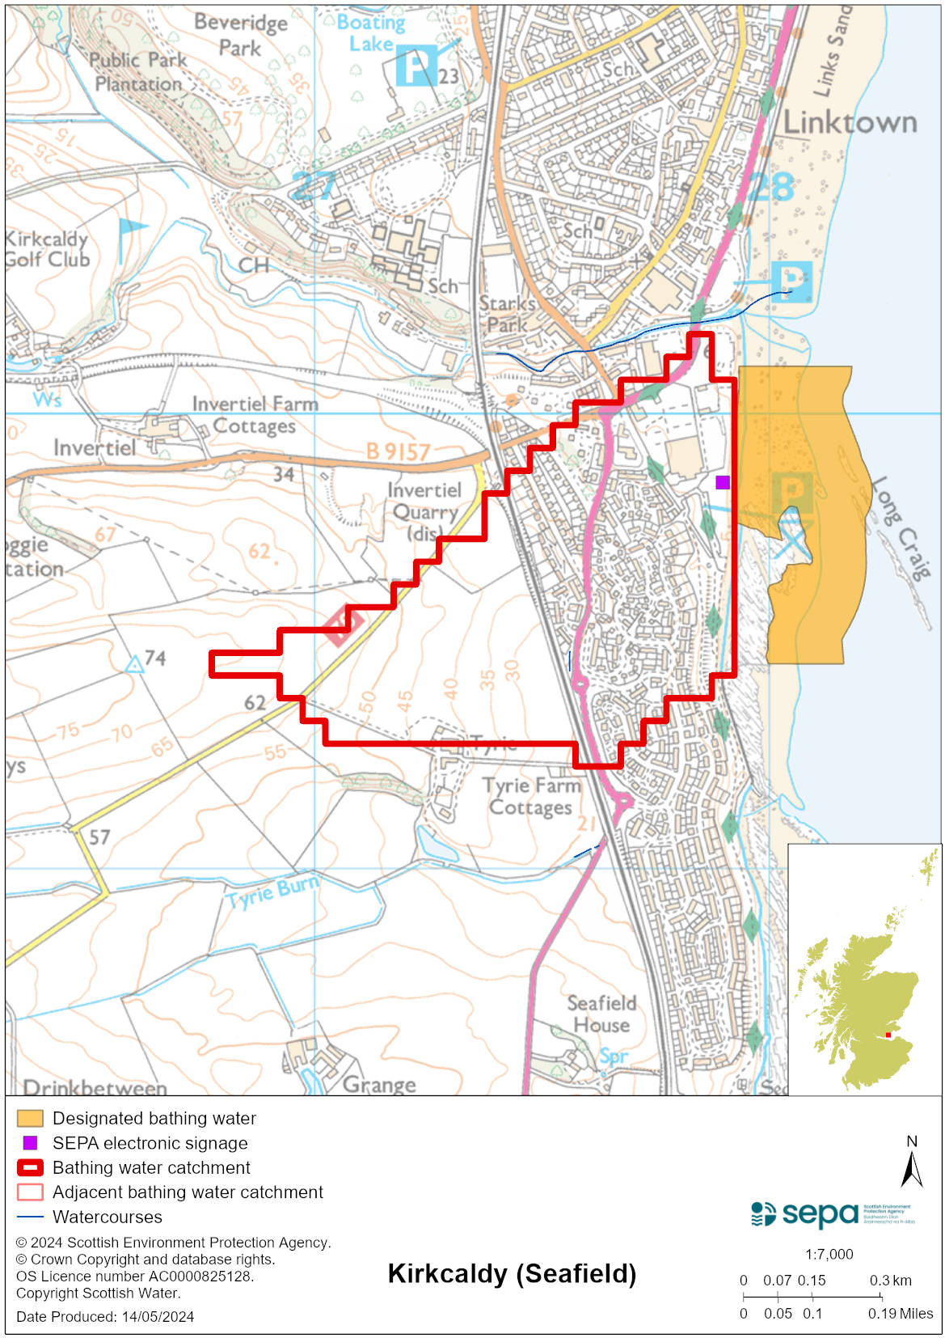

Improving bathing water quality

Sewage
Scottish Water provides most waste water collection and treatment services in Scotland.

Sewage from the catchment is treated at Kirkcaldy sewage treatment works before being discharged to the Firth of Forth via a long sea outfall.

Scottish Water has carried out upgrade work on sewerage assets to help improve bathing water quality.

Agriculture
There are no impacts from agriculture affecting this bathing water.

Cyanobacteria (blue-green algae), algae and jellyfish
Marine waters are not at risk of cyanobacteria overproduction. This bathing water is not at risk of excessive growth of macroalgae (seaweed) or phytoplankton.

The possibility of increased jellyfish numbers in the water during summer months is a naturally occurring phenomenon. Most species common to the UK are harmless; the Marine Conservation Society advises to ‘look but don’t touch’.

Pollution incidents
Pollution can be reported via our website online form or by calling our 24 hours a day Pollution Hotline number 0800 80 70 60

If pollution is reported to us, or identified by our routine water quality monitoring program, we will investigate and where necessary work with others to remediate. We may contact other relevant organisations including the local authority, that local health board, Scottish Water and Scottish Ministers.

If there is a risk to human health the local authority is responsible for placing signs at the bathing water. Information will also be available on our website.

Everyone can help to keep the bathing water clean:
- If you visit the beach with your dog clear up any fouling
- Don’t leave litter or feed birds - this encourages unnatural behaviour, and they can pollute the water
- At home, don’t flush wipes or other inappropriate items as these can block pipes and cause sewage spills

Contact details and information sources

SEPA bathing waters homepage

SEPA rainfall data

Scottish Government protected waters homepage

Fife Council

For information on accessing this document in an alternative format or language, please contact SEPA by emailing equalities@sepa.org.uk
If you are a user of British Sign Language (BSL), the Contact Scotland BSL service gives you access to an online interpreter, enabling you to communicate with us using sign language. contactscotland-bsl.org

