Bathing water profile - Barassie
Bathing water classification

Bathing water description
Barassie is a long, wide and mostly flat, sandy beach with views of the Isle of Arran and the Firth of Clyde. It lies to the north of Troon Harbour and is popular for family picnics and a range of water sports including kite surfing, windsurfing and sailing. At low tide, there is a vast area for visitors to explore. At high tide, most of the beach is covered. The beach is separated from the main road and the town of Barassie by a wide grassy area.

Site details:
- Local authority: South Ayrshire Council
- Year of designation: 2022
- Water sampling location: NS 32398 32414

Risks to water quality
This bathing water is at risk of short term pollution following heavy rainfall. Bathing is not advised during or 1-2 days after heavy rainfall due to the risk to bathers’ health from water pollution.

Pollution risks include sewer overflows and agricultural run-off.

Catchment description
The catchment area draining into Barassie bathing water covers around 7km2. It comprises of rolling countryside with a low-lying sandy strip to the west and hills with elevations of up to 145 metres to the east. A predominantly suburban area of lower elevations (average of 0–30 metres) lies in the western half.

The catchment is mainly rural, with agriculture the major land use. A small but significant portion of the catchment is suburban (residential) including the villages of Barassie, Muirhead and Loans.

Map 1: Barassie bathing water
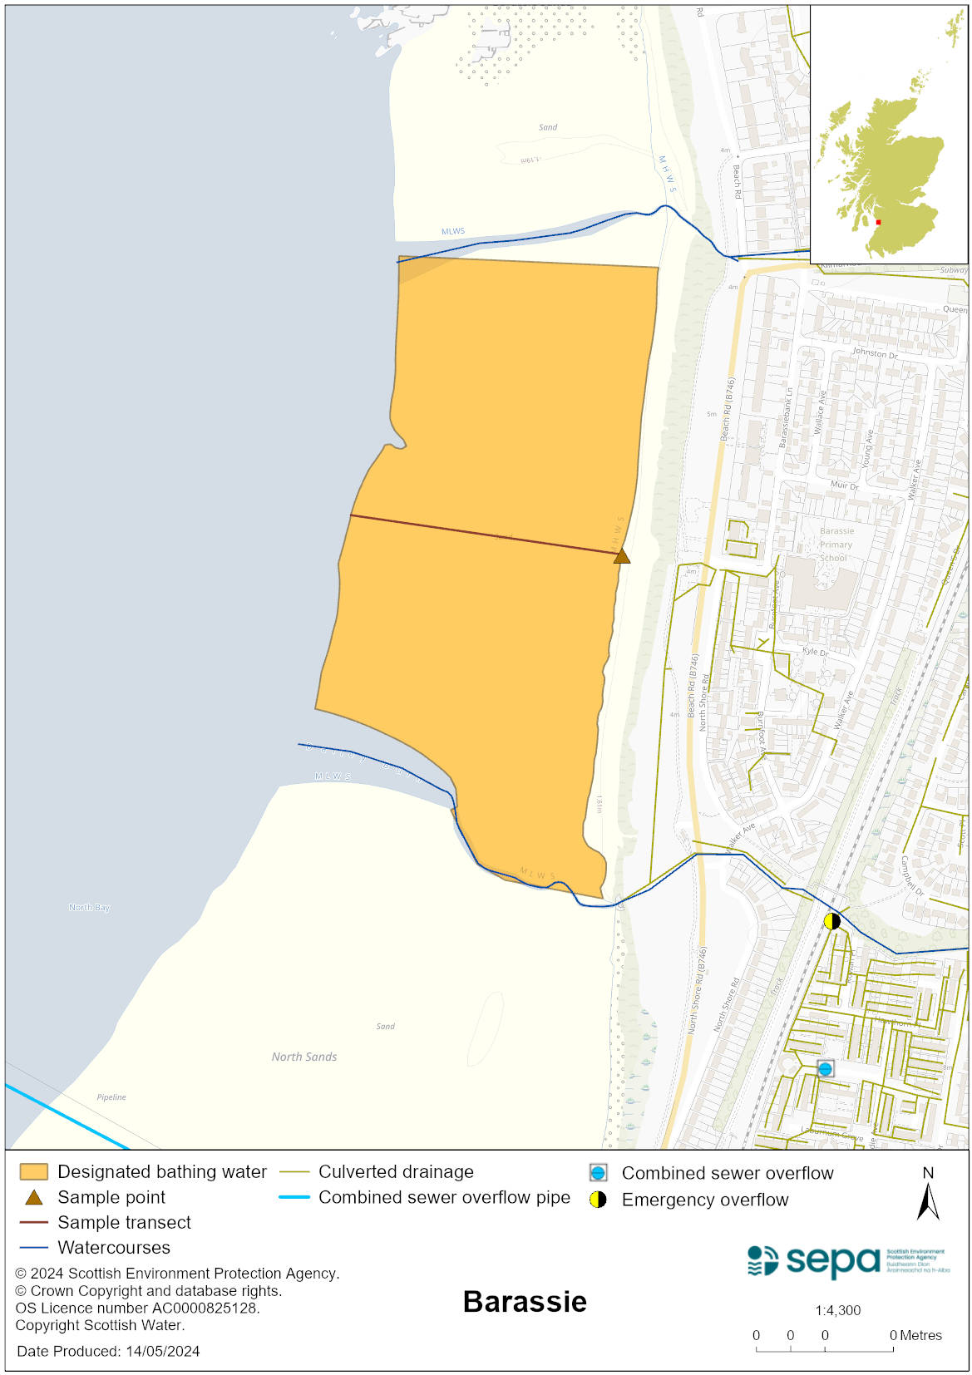

Map 2: Catchment draining into Barassie bathing water
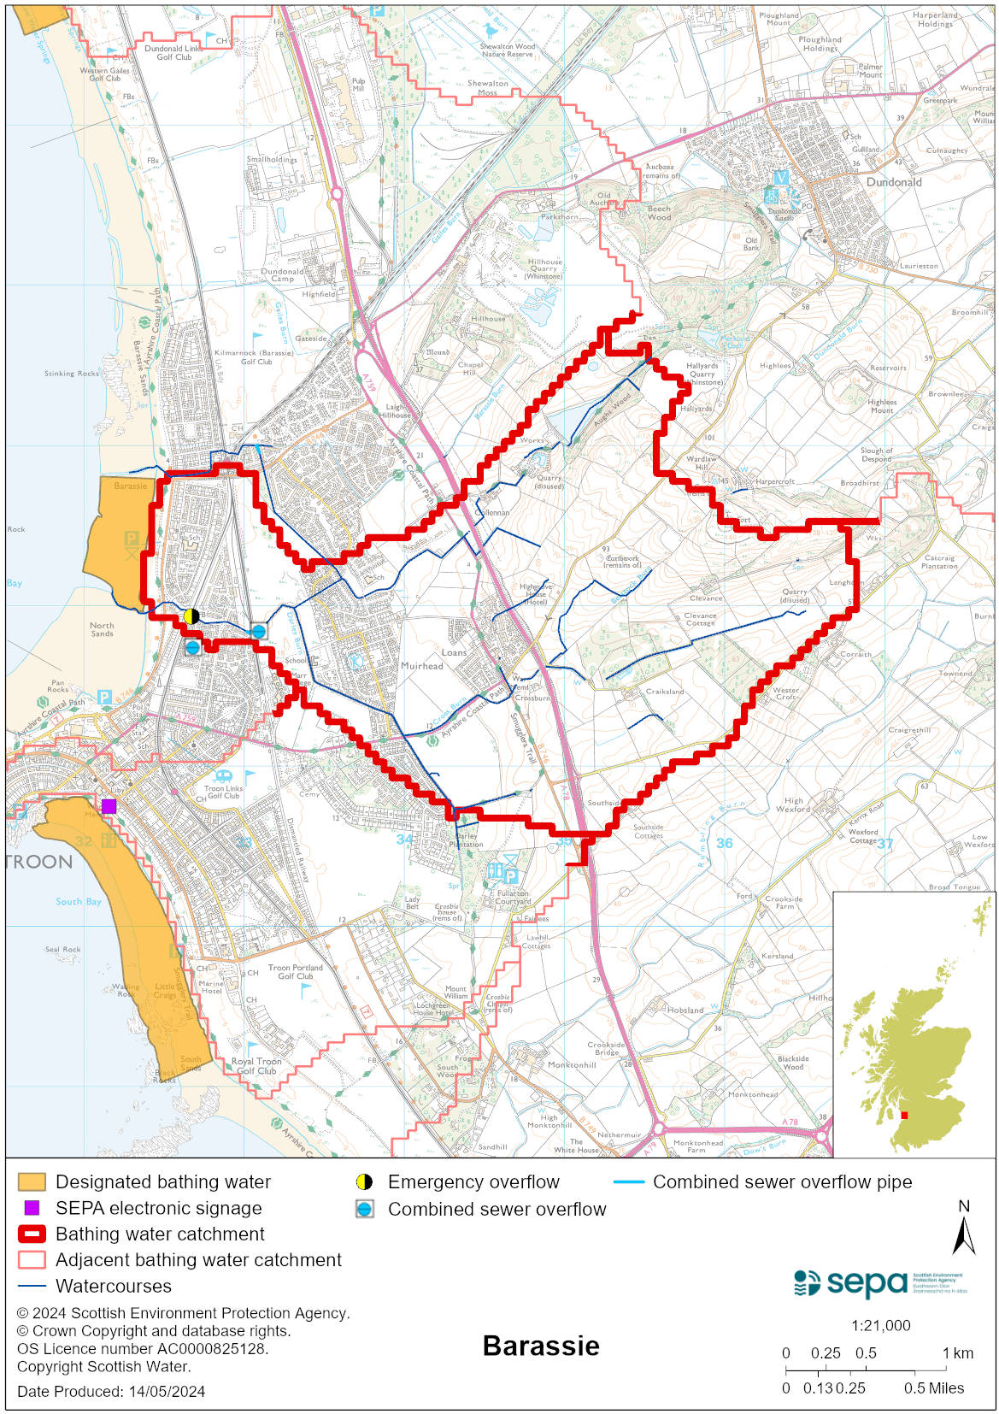

Improving bathing water quality

Sewage
There are no continuous discharges of sewage to Barassie bathing water under normal circumstances. Sewage from the area is treated at Meadowhead Waste Water Treatment Works (WWTW) and is then discharged to Irvine Bay via long sea outfall.

Under wet weather conditions, there is a risk to bathing water quality from combined sewer overflows (CSOs). Under rare, abnormal circumstances there is a risk from emergency discharges of sewage from the sewerage system.

Agriculture
Diffuse pollution from agricultural sources is the result of rain driven events causing cumulative inputs of pollutants to rivers and streams.

Our current evidence does not indicate that the small rural burns in the catchment are a significant source of rural diffuse pollution. Most of the farms within the Barassie bathing water catchment are livestock units. SEPA intends to engage with farmers in the catchment to identify possible diffuse pollution sources and if necessary, agree mitigation measures to reduce the impact of diffuse pollution on the bathing water with land managers.

Urban
Urban run-off and surface waters discharge into the Darley and Barassie Burns. These have the potential to impact on the bathing water due to sewage contamination from cross-connections.

Cyanobacteria (blue-green algae), algae and jellyfish
Marine waters are not at risk of cyanobacteria overproduction. This bathing water is not at risk of excessive growth of macroalgae (seaweed) or phytoplankton.

The possibility of increased jellyfish numbers in the water during summer months is a naturally occurring phenomenon. Most species common to the UK are harmless; the Marine Conservation Society advises to ‘look but don’t touch’.

Pollution incidents
Pollution can be reported via our website online form or by calling our 24 hours a day Pollution Hotline number 0800 80 70 60

If pollution is reported to us, or identified by our routine water quality monitoring program, we will investigate and where necessary work with others to remediate. We may contact other relevant organisations including the local authority, that local health board, Scottish Water and Scottish Ministers.

If there is a risk to human health the local authority is responsible for placing signs at the bathing water. Information will also be available on our website.

Everyone can help to keep the bathing water clean:
- If you visit the beach with your dog clear up any fouling
- Don’t leave litter or feed birds - this encourages unnatural behaviour, and they can pollute the water
- At home, don’t flush wipes or other inappropriate items as these can block pipes and cause sewage spills

Contact details and information sources

SEPA bathing waters homepage

SEPA rainfall data

Scottish Government protected waters homepage

South Ayrshire Council

For information on accessing this document in an alternative format or language, please contact SEPA by emailing equalities@sepa.org.uk
If you are a user of British Sign Language (BSL), the Contact Scotland BSL service gives you access to an online interpreter, enabling you to communicate with us using sign language. contactscotland-bsl.org

