Bathing water profile - Ganavan
Bathing water classification

Bathing water description
Ganavan Bay bathing water is located to the north of Oban. It is approximately 300 metres in length. The designated area consists of two sandy beaches, separated by a jetty. The beaches provide excellent views of the Isle of Mull, Isle of Lismore and the surrounding area. Depending on the tide, the distance to the water’s edge can vary from 20–150 metres.

Site details:
- Local authority: Argyll and Bute Council
- Year of designation: 1999
- Water sampling location: NM 86200 32813

Risks to water quality
This bathing water is at risk of short term pollution following heavy rainfall. Bathing is not advised during or 1-2 days after heavy rainfall due to the risk to bathers’ health from water pollution.

Pollution risks include agricultural run-off and sewer overflows.

Catchment description
The Ganavan Bay bathing water catchment extends to just over 1 km2. It is a low-lying catchment comprising of small hills. Cnoc Carnach, in the south, is the highest point at approximately 130 metres. There are no major rivers within the catchment. However, there are small streams discharging to the sea at the northern end and midpoint of the bathing water.
The area is mainly rural (97%) with grassland the major land use. The upland areas support some sheep farming. The remaining 3% of the area is made up of rock and sediment. Population density within the catchment is generally low. South of the bathing water is an area of private housing. Oban town lies to the south of Ganavan Bay.

Map 1: Ganavan bathing water
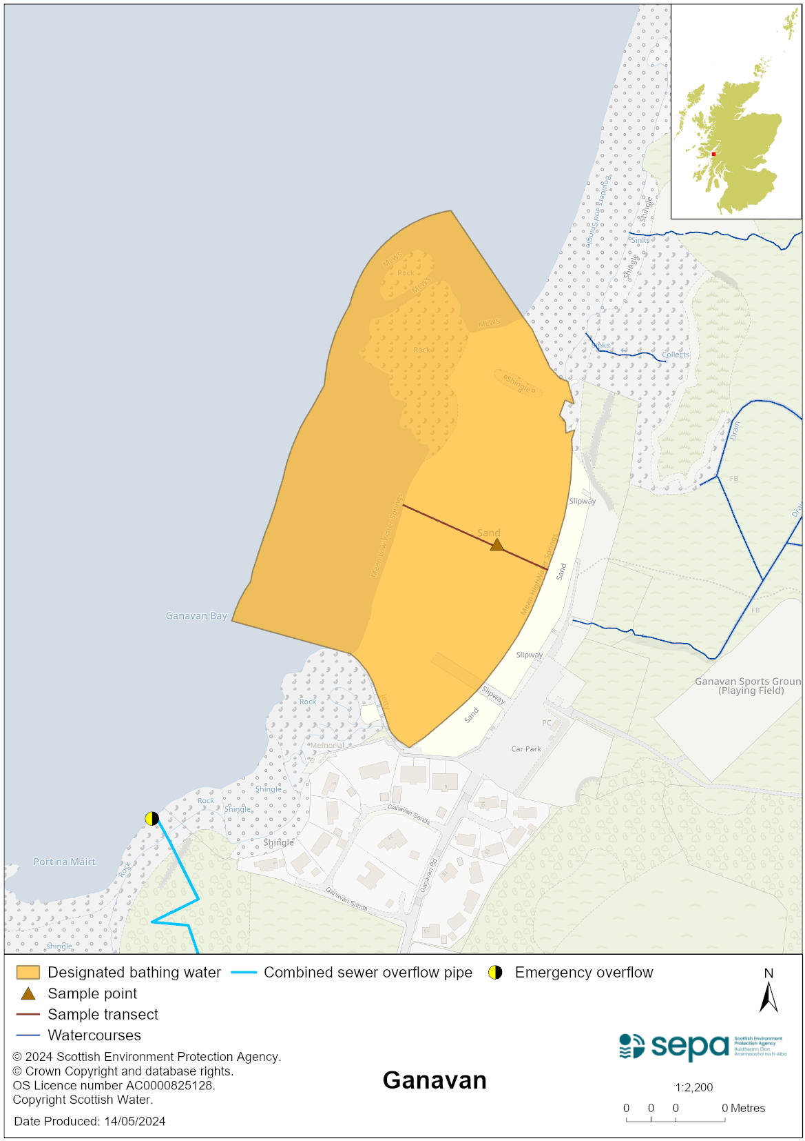

Map 2: Catchment draining into Ganavan bathing water
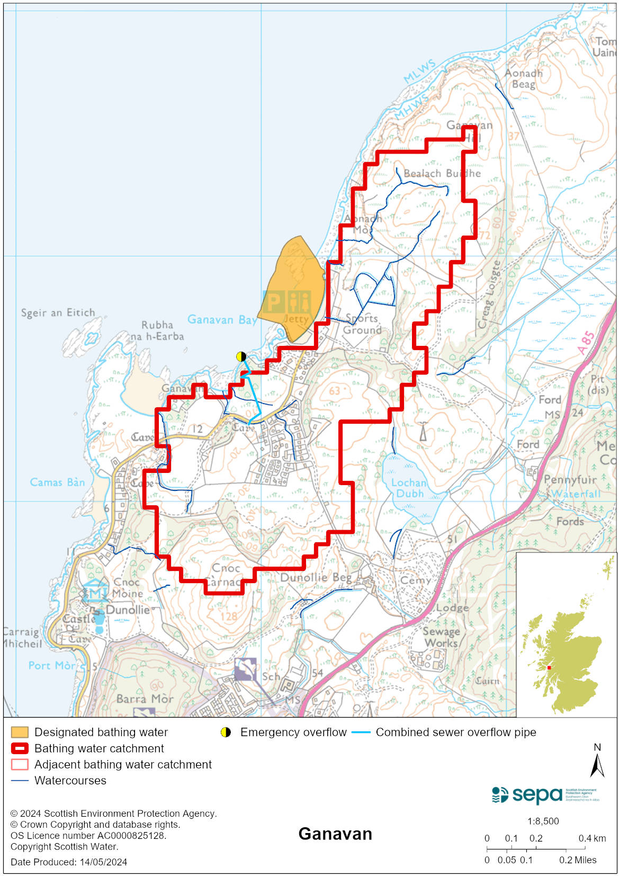

Improving bathing water quality

Sewage
Scottish Water provides most waste water collection and treatment services in Scotland.

Sewage from Ganavan village is treated at Oban sewage treatment works.

Agriculture
Diffuse pollution from agricultural sources is the result of cumulative inputs of pollutants to rivers and streams.

The Ganavan catchment is part of the Firth of Lorn Coastal catchment. Work in this catchment was completed in 2022. SEPA will continue to work with the farmers in these catchments to reduce the risk of pollution to the bathing water.

Cyanobacteria (blue-green algae), algae and jellyfish
Marine waters are not at risk of cyanobacteria overproduction. This bathing water is not at risk of excessive growth of macroalgae (seaweed) or phytoplankton.

The possibility of increased jellyfish numbers in the water during summer months is a naturally occurring phenomenon. Most species common to the UK are harmless; the Marine Conservation Society advises to ‘look but don’t touch’.

Pollution incidents
Pollution can be reported via our website online form or by calling our 24 hours a day Pollution Hotline number 0800 80 70 60

If pollution is reported to us, or identified by our routine water quality monitoring program, we will investigate and where necessary work with others to remediate. We may contact other relevant organisations including the local authority, that local health board, Scottish Water and Scottish Ministers.

If there is a risk to human health the local authority is responsible for placing signs at the bathing water. Information will also be available on our website.

Everyone can help to keep the bathing water clean:
- If you visit the beach with your dog clear up any fouling
- Don’t leave litter or feed birds - this encourages unnatural behaviour, and they can pollute the water
- At home, don’t flush wipes or other inappropriate items as these can block pipes and cause sewage spills

Contact details and information sources

SEPA bathing waters homepage

SEPA rainfall data

Scottish Government protected waters homepage

Argyll and Bute Council

For information on accessing this document in an alternative format or language, please contact SEPA by emailing equalities@sepa.org.uk
If you are a user of British Sign Language (BSL), the Contact Scotland BSL service gives you access to an online interpreter, enabling you to communicate with us using sign language. contactscotland-bsl.org

