Bathing water profile - Prestwick
Bathing water classification

Bathing water description
Prestwick bathing water is between Ayr and Troon on the Ayrshire coast. The beach runs parallel to the town of Prestwick and is near the Troon Golf Links. The 3 km long beach is sandy with rocky outcrops and shingle at the southern end. It is popular with windsurfers and the adjacent sailing club. Depending on the tide, the distance to the water’s edge can vary from 25–300 metres. The beach is relatively flat but slopes gently towards the water.

Site details:
- Local authority: South Ayrshire Council
- Year of designation: 1987
- Water sampling location: NS 34466 26192

Risks to water quality
This bathing water is subject to short term pollution following heavy rainfall. Bathing is not advised during or 1-2 days after heavy rainfall due to the risk to bathers’ health from water pollution.

Pollution risks include agricultural run-off and sewer overflows.

Water quality forecasts
As water quality is likely to be impacted by rainfall we make daily predictions of good or poor bathing water quality. We advise against bathing when poor water quality is predicted as there is an increased risk to bathers’ health from water pollution.

These predictions are displayed on the electronic sign at the beach and online between 15 May and 15 September.

Catchment description
The Prestwick bathing water catchment extends to 55 km2. The land around the bathing water and the urban areas is low (average elevation 10–20 metres). It rises to low hills (max elevation 150 metres) to the east.
The area is mainly rural (84%) with agriculture the major land use. The more upland areas support mixed sheep and beef cattle farming. The lowland areas are used for intensive dairy farming. About 15% of the catchment is urban. The town of Prestwick is near the bathing water. The area also includes some small-scale commercial activity and Glasgow Prestwick International Airport.
Troon golf links and foreshore to the north of the bathing water is a Site of Special Scientific Interest. It supports a significant sand dune and dune grassland ecosystem.

Map 1: Prestwick bathing water
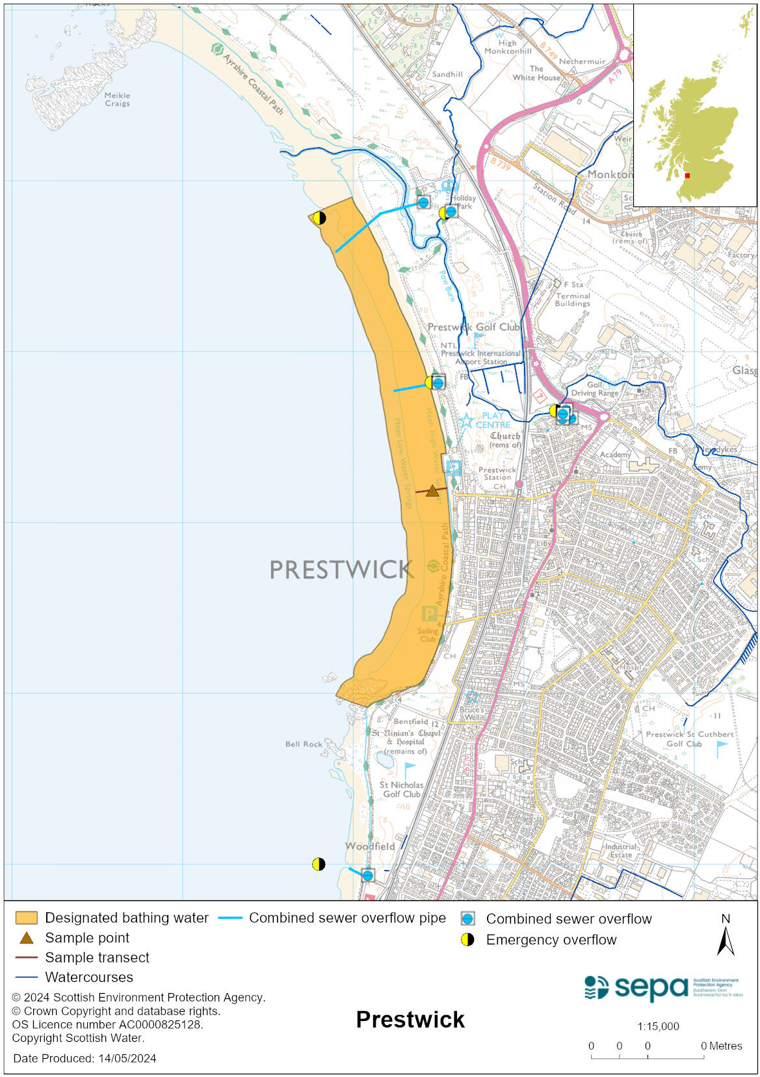

Map 2: Catchment draining into Prestwick bathing water
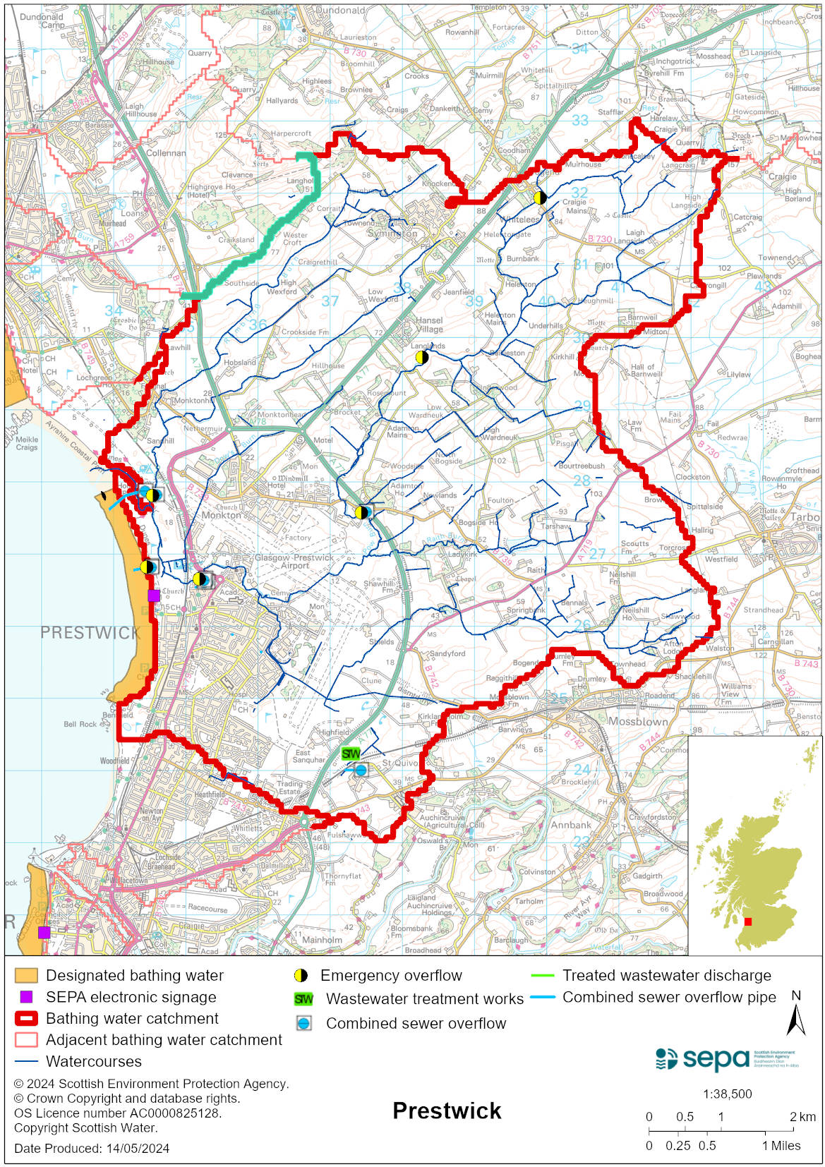

Improving bathing water quality

Sewage
Scottish Water provides most waste water collection and treatment services in Scotland.

There are several surface water outfalls, combined sewer overflows and emergency sewage overflows which discharge to the Pow Burn. There are also combined and emergency sewage overflows at St Andrews Caravan Park and the Esplanade pumping stations that discharge to the Firth of Clyde. Under dry weather conditions and when the pumping stations are operating normally, there are no continuous discharges from the public sewerage system.

SEPA is monitoring the impact of septic tanks and private sewage treatment works on water quality.

Agriculture
Diffuse pollution from agricultural sources is the result of rain driven events causing cumulative inputs of pollutants to rivers and streams.

There is potential for agricultural diffuse pollution to occur in the Pow and Rumbling Burns which could impact on the bathing beach during and following heavy rain.

Farm visits in this area were undertaken as part of the South Ayrshire priority catchment campaign in 2015. These visits looked to identify diffuse pollution sources and pathways. Mitigation measures were agreed with land managers to reduce the risk of bacterial pollution on water quality.

SEPA has observed significant changes in land management practice within the catchments and will continue to work with farmers to reduce the risk of pollution to the bathing water.

Urban
Urban diffuse source pollution comes from contaminated rainwater discharging to rivers and streams. Ladykirk Burn and Pow Burn are likely to be affected by surface water run-off from urban area. This is not thought to have a significant effect on bathing water quality.

Cyanobacteria (blue-green algae), algae and jellyfish
Marine waters are not at risk of cyanobacteria overproduction. This bathing water is not at risk of excessive growth of macroalgae (seaweed) or phytoplankton.

The possibility of increased jellyfish numbers in the water during summer months is a naturally occurring phenomenon. Most species common to the UK are harmless; the Marine Conservation Society advises to ‘look but don’t touch’.

Pollution incidents
Pollution can be reported via our website online form or by calling our 24 hours a day Pollution Hotline number 0800 80 70 60

If pollution is reported to us, or identified by our routine water quality monitoring program, we will investigate and where necessary work with others to remediate. We may contact other relevant organisations including the local authority, that local health board, Scottish Water and Scottish Ministers.

If there is a risk to human health the local authority is responsible for placing signs at the bathing water. Information will also be available on our website.

Everyone can help to keep the bathing water clean:
- If you visit the beach with your dog clear up any fouling
- Don’t leave litter or feed birds - this encourages unnatural behaviour, and they can pollute the water
- At home, don’t flush wipes or other inappropriate items as these can block pipes and cause sewage spills

Contact details and information sources

SEPA bathing waters homepage

SEPA rainfall data

Scottish Government protected waters homepage

South Ayrshire Council

For information on accessing this document in an alternative format or language, please contact SEPA by emailing equalities@sepa.org.uk
If you are a user of British Sign Language (BSL), the Contact Scotland BSL service gives you access to an online interpreter, enabling you to communicate with us using sign language. contactscotland-bsl.org

