Bathing water profile – Lunan Bay
Bathing water classification

Bathing water description
The Lunan Bay bathing water is next to the small hamlet of Lunan, about 4.5 km south of Montrose. The sandy beach is 1.6 km long and slopes gently towards the water. The beach is backed by sand dunes. It is popular for surfing, horse riding and fishing. Depending on the tide, the distance to the water’s edge can vary from 10–250 metres.

Site details
- Local authority: Angus Council
- Year of designation: 2008
- Water sampling location: NO 69300 51600

Risks to water quality
Our water quality monitoring indicates that there are no significant pollution inputs to this bathing water under normal situations, including after rainfall.

There remains a risk that water pollution may occur after extreme rainfall.

Catchment description
The Lunan Bay bathing water catchment extends to 400km2. The catchment ranges from low hills (maximum elevation 250m) in the west to low-lying areas (average elevation 5m) along the coast.
The catchment is mainly rural (96%) with arable agriculture the major land use. There is also some soft fruit farming and livestock present. The Lunan Water and the Vinny Water are the two main rivers in the catchment. They drain into the bathing water.
The Strathmore and Fife area was a surface water Nitrate Vulnerable Zone in 2002.

Map 1: Lunan Bay bathing water
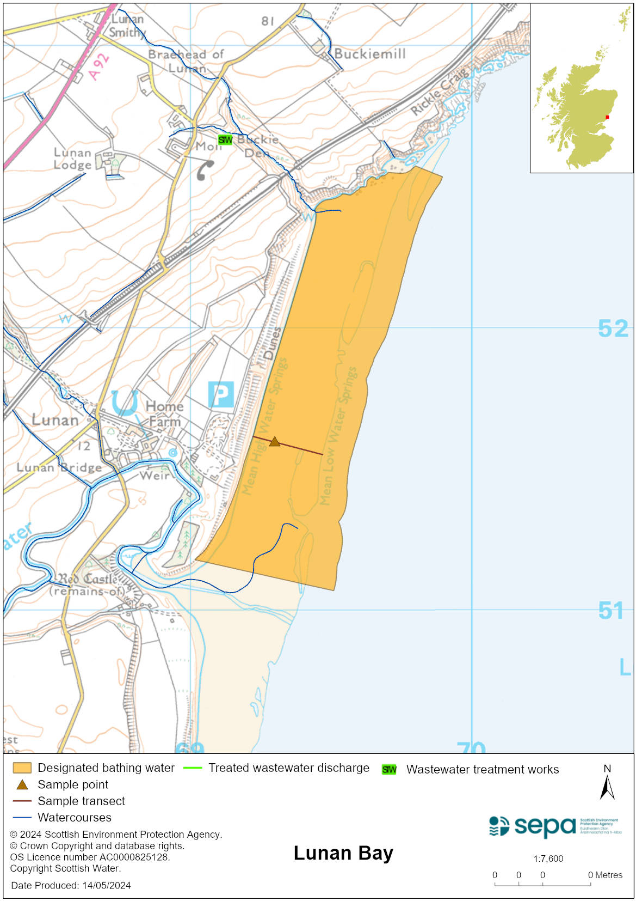

Map 2: Catchment draining into Lunan Bay bathing water
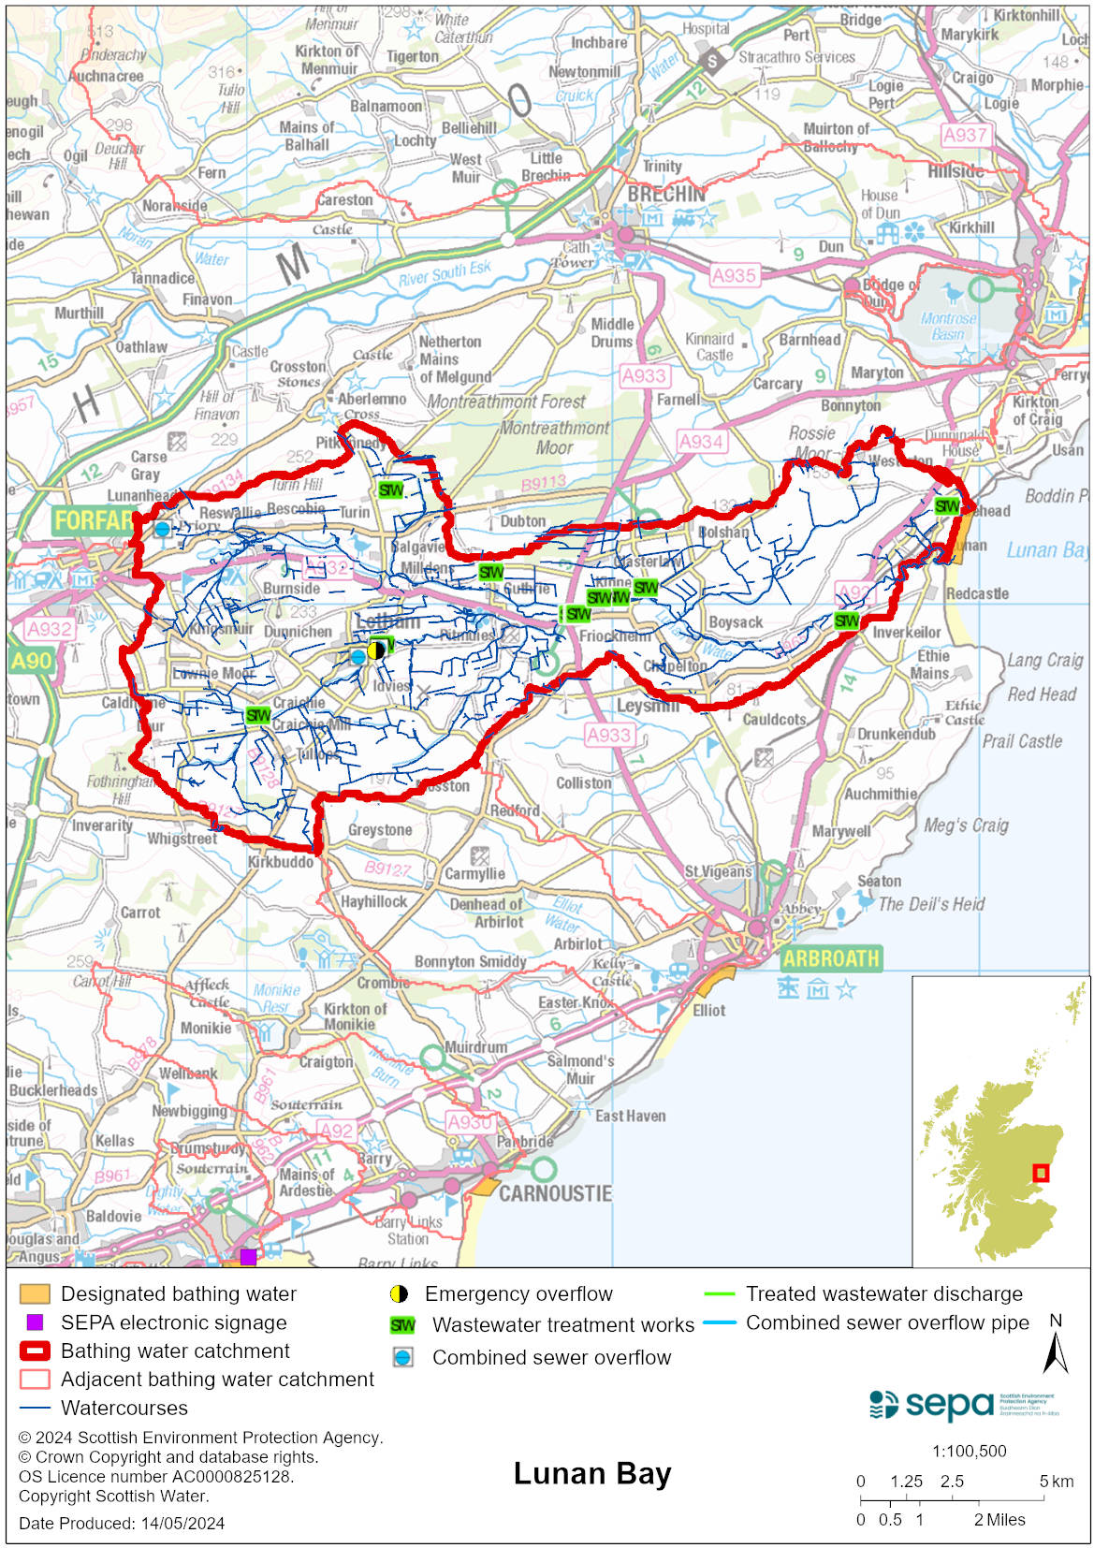

Improving bathing water quality

Sewage
Scottish Water provides most waste water collection and treatment services in Scotland.

There are sewage treatment works in the local area inland from Lunan Bay. These works are not thought likely to threaten water quality at this bathing water.

Agriculture
There are no impacts from agriculture affecting this bathing water.

Cyanobacteria (blue-green algae), algae and jellyfish
Marine waters are not at risk of cyanobacteria overproduction. This bathing water is not at risk of excessive growth of macroalgae (seaweed) or phytoplankton.

The possibility of increased jellyfish numbers in the water during summer months is a naturally occurring phenomenon. Most species common to the UK are harmless; the Marine Conservation Society advises to ‘look but don’t touch’.

Pollution incidents
Pollution can be reported via our website online form or by calling our 24 hours a day Pollution Hotline number 0800 80 70 60

If pollution is reported to us, or identified by our routine water quality monitoring program, we will investigate and where necessary work with others to remediate. We may contact other relevant organisations including the local authority, that local health board, Scottish Water and Scottish Ministers.

If there is a risk to human health the local authority is responsible for placing signs at the bathing water. Information will also be available on our website.

Everyone can help to keep the bathing water clean:
- If you visit the beach with your dog clear up any fouling
- Don’t leave litter or feed birds - this encourages unnatural behaviour, and they can pollute the water
- At home, don’t flush wipes or other inappropriate items as these can block pipes and cause sewage spills

Contact details and information sources

SEPA bathing waters homepage

SEPA rainfall data

Scottish Government protected waters homepage

Angus Council

For information on accessing this document in an alternative format or language, please contact SEPA by emailing equalities@sepa.org.uk
If you are a user of British Sign Language (BSL), the Contact Scotland BSL service gives you access to an online interpreter, enabling you to communicate with us using sign language. contactscotland-bsl.org

