Bathing water profile – Nairn (Central)
Bathing water classification

Bathing water description
Nairn (Central) bathing water is on the Moray Firth, next to the town of Nairn. It is a shallow bay, about 1 km long. Nairn is a popular seaside town. The beach is popular with families and water sports enthusiasts, including sailors, windsurfers and kite surfers. Depending on the tide, the distance to the water’s edge can vary from 0–160 metres. The beach slopes gently towards the water.

Site details:
- Local authority: Highland Council
- Year of designation: 1999
- Water sampling location: NH 88227 57117

Risks to water quality
This bathing water is subject to short term pollution following heavy rainfall. Bathing is not advised during or 1-2 days after heavy rainfall due to the risk to bathers’ health from water pollution.

Pollution risks include agricultural run-off, sewer overflows and surface water discharges.

Water quality forecasts
As water quality is likely to be impacted by rainfall we make daily predictions of good or poor bathing water quality. We advise against bathing when poor water quality is predicted as there is an increased risk to bathers’ health from water pollution.

These predictions are displayed on the electronic sign at the beach and online between 15 May and 15 September.

Catchment description
The Nairn (Central) bathing water catchment extends to 338 km2. The area varies from high mountains in the south-west to low-lying coastal areas.
River Nairn is the main river in the catchment. It bisects the Nairn (Central) and Nairn (East) bathing waters. Prevailing currents tend to carry fresh water from River Nairn eastwards towards Nairn (East) bathing water. However, the river can still influence the Nairn (Central) bathing water.
Land use in River Nairn catchment is largely agricultural. There is intensively farmed arable land in the lower catchment. Rough pasture and livestock farming more common further inland. Approximately 1% of the catchment is urban. The main population centre is the town of Nairn. Population outside of Nairn is mainly concentrated in small nearby villages.

Map 1: Nairn (Central) bathing water
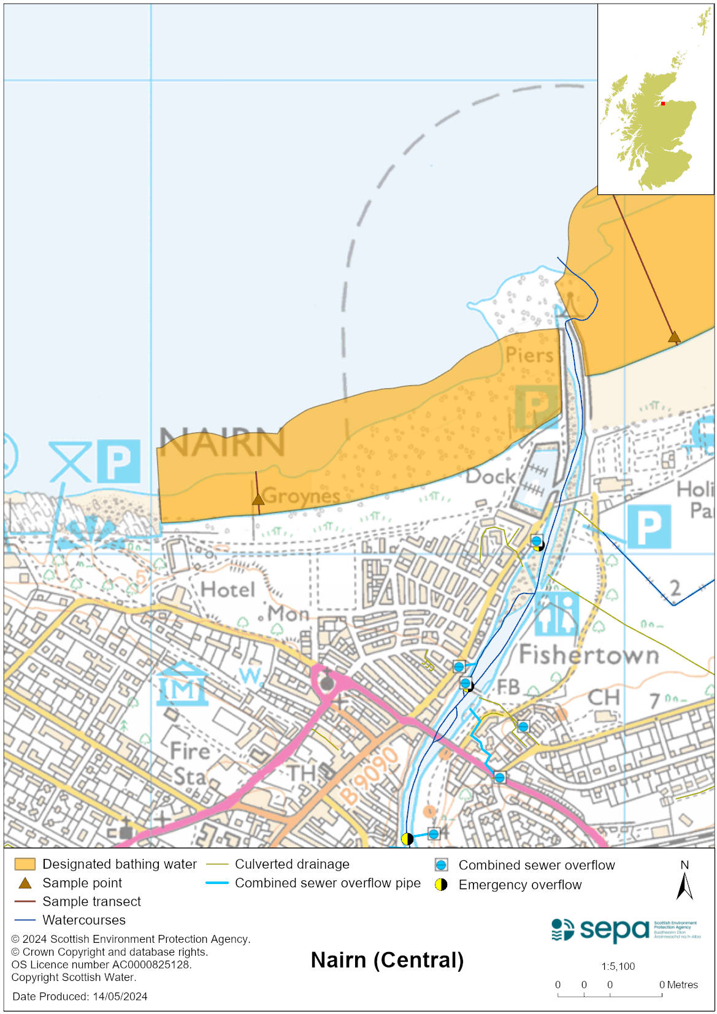

Map 2: Catchment draining into Nairn (Central) bathing water
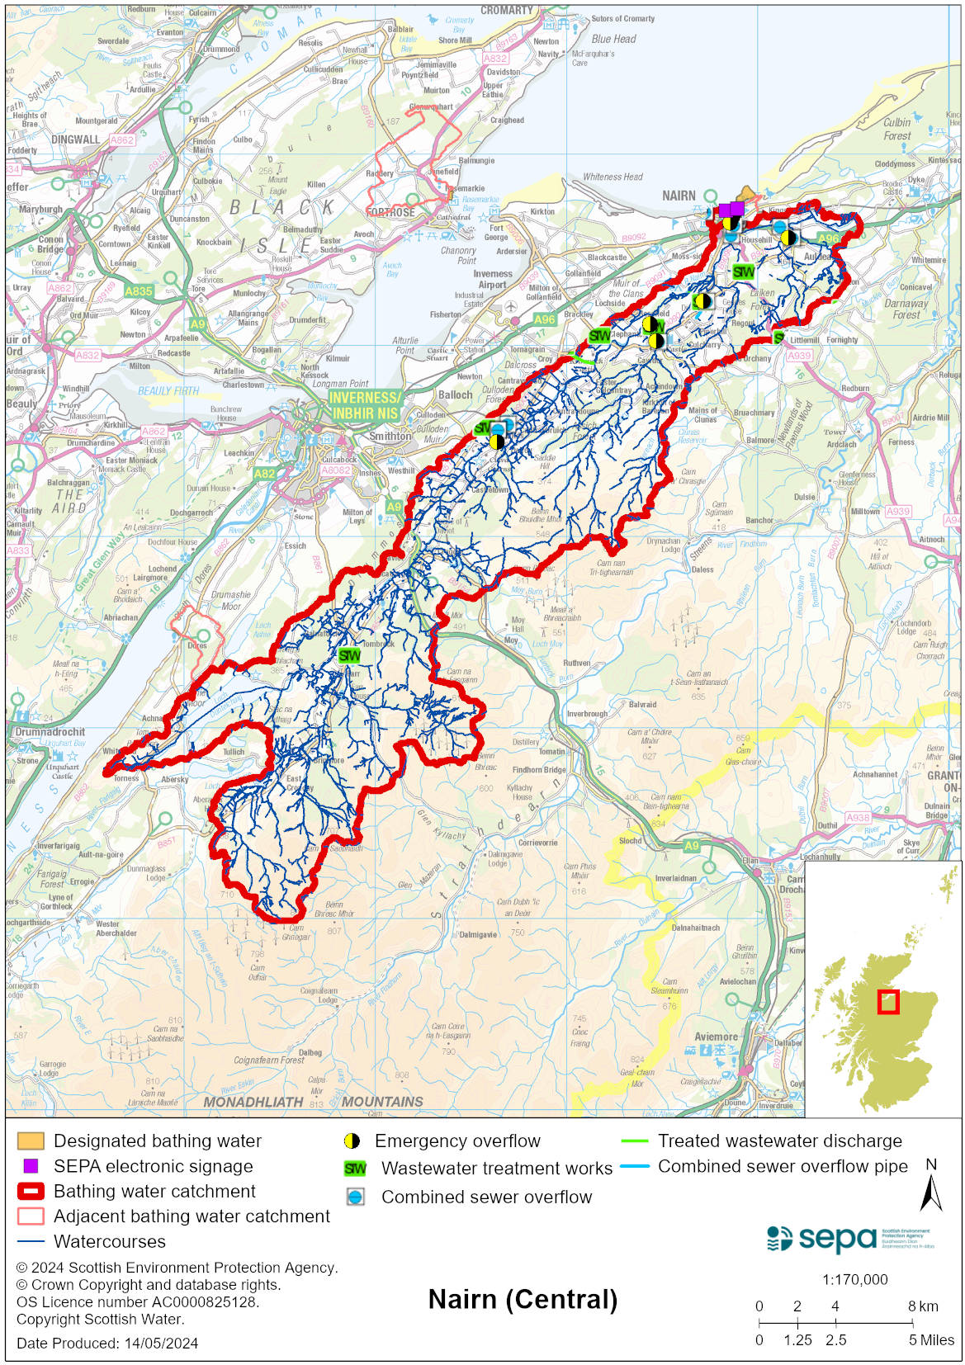

Improving bathing water quality

Sewage
Scottish Water provides most waste water collection and treatment services in Scotland.

Nairn sewage treatment works discharges final effluent to sea below the low water mark, directly out from the Nairn (East) bathing water. There are several combined sewer overflow outfalls to the River Nairn in its tidal reaches. These may discharge and impact the bathing water during heavy rainfall. There are many private septic tank discharges to the River Nairn which cumulatively could influence the bathing water quality during periods of wet weather.

In order to protect the bathing water, SEPA is unlikely to grant licenses for any further septic tank discharges to the lower reaches of the River Nairn, where connection to the public sewer is an option.

Agriculture
Diffuse pollution from agricultural sources is the result of rain driven events causing cumulative inputs of pollutants to rivers and streams.

There is potential for agricultural diffuse pollution to occur in the River Nairn Burn. This could impact on the bathing beach following heavy rain.

Farm visits in this area were undertaken as part of the River Nairn priority catchment campaign in 2016. These visits looked to identify diffuse pollution sources and pathways. Mitigation measures were agreed with land managers to reduce the risk of bacterial pollution on water quality.

SEPA has observed significant changes in land management practice within the catchments and will continue to work with farmers to reduce the risk of pollution to the bathing water.

Urban
The River Nairn is known to be affected by surface water run-off from Nairn town. SEPA is monitoring the potential impact from surface water run-off on bathing water quality.

Cyanobacteria (blue-green algae), algae and jellyfish
Marine waters are not at risk of cyanobacteria overproduction. This bathing water is not at risk of excessive growth of macroalgae (seaweed) or phytoplankton.

The possibility of increased jellyfish numbers in the water during summer months is a naturally occurring phenomenon. Most species common to the UK are harmless; the Marine Conservation Society advises to ‘look but don’t touch’.

Pollution incidents
Pollution can be reported via our website online form or by calling our 24 hours a day Pollution Hotline number 0800 80 70 60

If pollution is reported to us, or identified by our routine water quality monitoring program, we will investigate and where necessary work with others to remediate. We may contact other relevant organisations including the local authority, that local health board, Scottish Water and Scottish Ministers.

If there is a risk to human health the local authority is responsible for placing signs at the bathing water. Information will also be available on our website.

Everyone can help to keep the bathing water clean:
- If you visit the beach with your dog clear up any fouling
- Don’t leave litter or feed birds - this encourages unnatural behaviour, and they can pollute the water
- At home, don’t flush wipes or other inappropriate items as these can block pipes and cause sewage spills

Contact details and information sources

SEPA bathing waters homepage

SEPA rainfall data

Scottish Government protected waters homepage

Highland Council

For information on accessing this document in an alternative format or language, please contact SEPA by emailing equalities@sepa.org.uk
If you are a user of British Sign Language (BSL), the Contact Scotland BSL service gives you access to an online interpreter, enabling you to communicate with us using sign language. contactscotland-bsl.org

