Bathing water profile – Lossiemouth (East)
Bathing water classification

Bathing water description
Lossiemouth (East) bathing water is on the north coast of Moray to the east of Lossiemouth. The beach is approximately 2 km long and is prized for its unspoilt golden sands. It is popular with surfers and walkers. It is close to a caravan park. Depending on the tide, the distance to the water’s edge can vary from 0–140m.

Site details:
- Local authority: Moray Council
- Year of designation: 2008
- Water sampling location: NJ 24050 70500

Risks to water quality
This bathing water is subject to short term pollution following heavy rainfall. Bathing is not advised during or 1-2 days after heavy rainfall due to the risk to bathers’ health from water pollution.

Pollution risks include sewer overflows, agricultural run-off and surface water discharges.

Water quality forecasts
As water quality is likely to be impacted by rainfall we make daily predictions of good or poor bathing water quality. We advise against bathing when poor water quality is predicted as there is an increased risk to bathers’ health from water pollution.

These predictions are displayed on the electronic sign at the beach and online between 15 May and 15 September.

Catchment description
The Lossiemouth (East) bathing water catchment extends to 380 km2. The catchment ranges from high hills (520 metres tall) in the south to low-lying plains (average of 5 metres) along the coast.
The area is 96% rural (33% is woodland, 21% arable agricultural, 28% grassland). There is mixed farming in the catchment. Approximately 2% of the catchment is urban. The main population centre is the city of Elgin, 9 km inland and south of the bathing water. The town of Lossiemouth is 500 metres west of the bathing water. Population density outside of the towns is low. RAF Lossiemouth is in the area.
There are several protected areas either fully or partly within the catchment. This includes one Special Protection Area, 12 Sites of Special Scientific Interest and one Ramsar site. The catchment also partly lies in a Nitrate Vulnerable Zone.

Map 1: Lossiemouth (East) bathing water
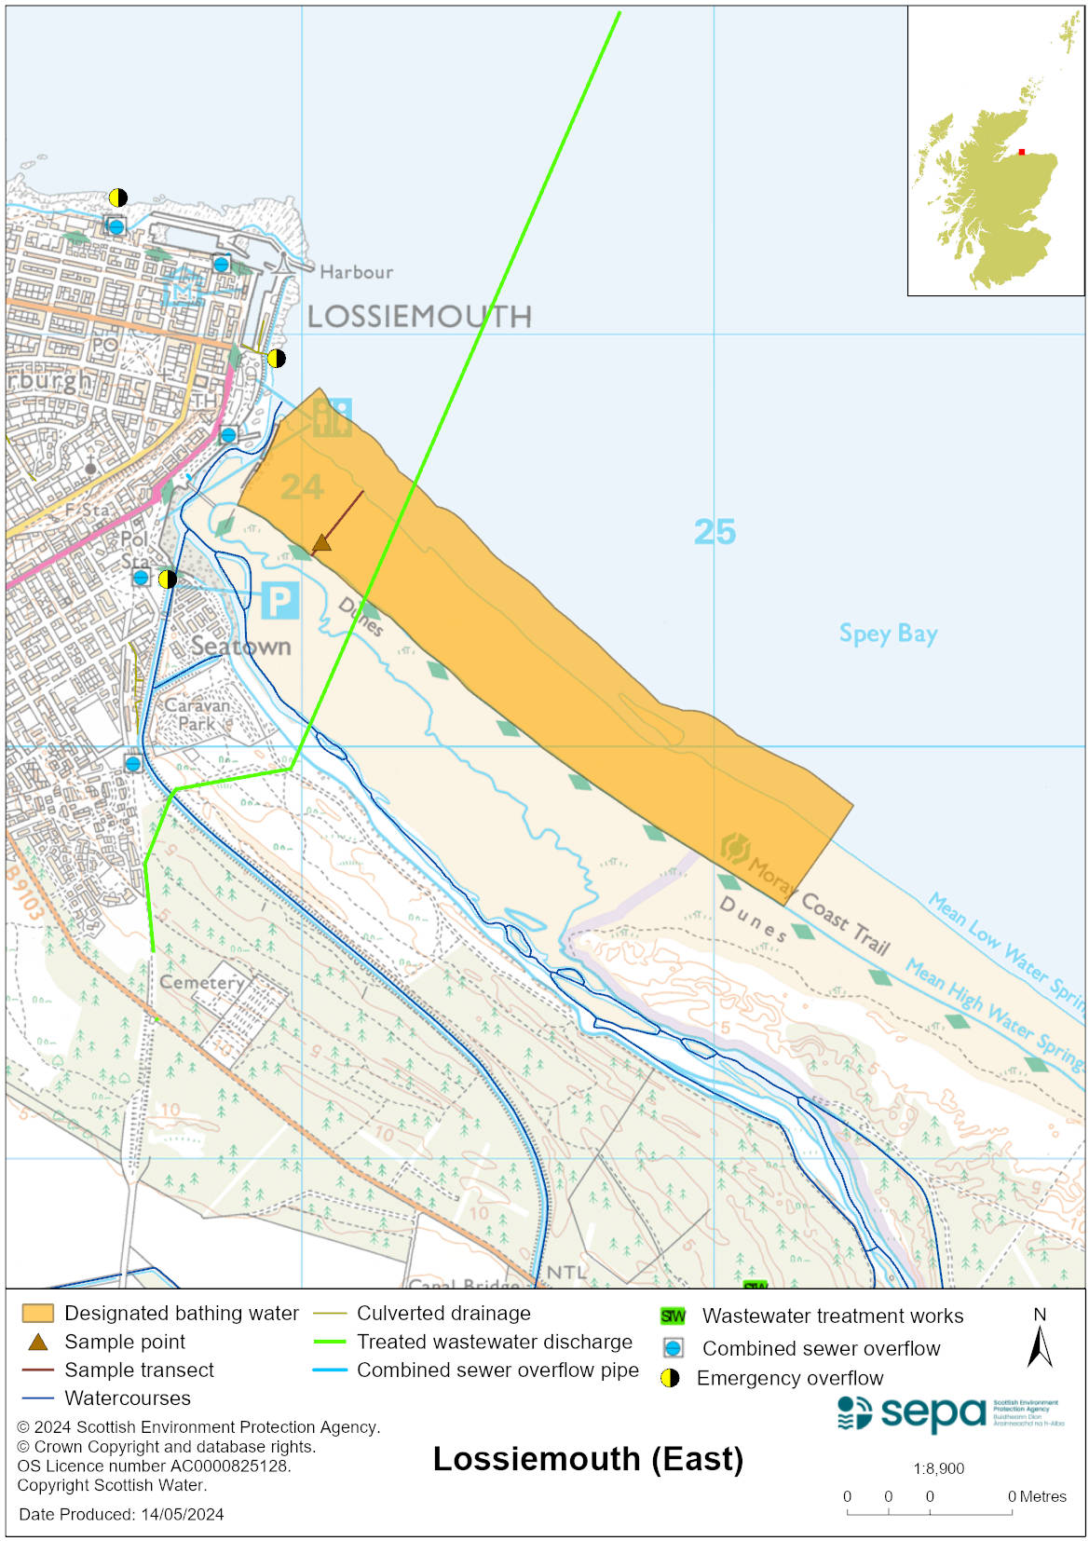

Map 2: Catchment draining into Lossiemouth (East) bathing water
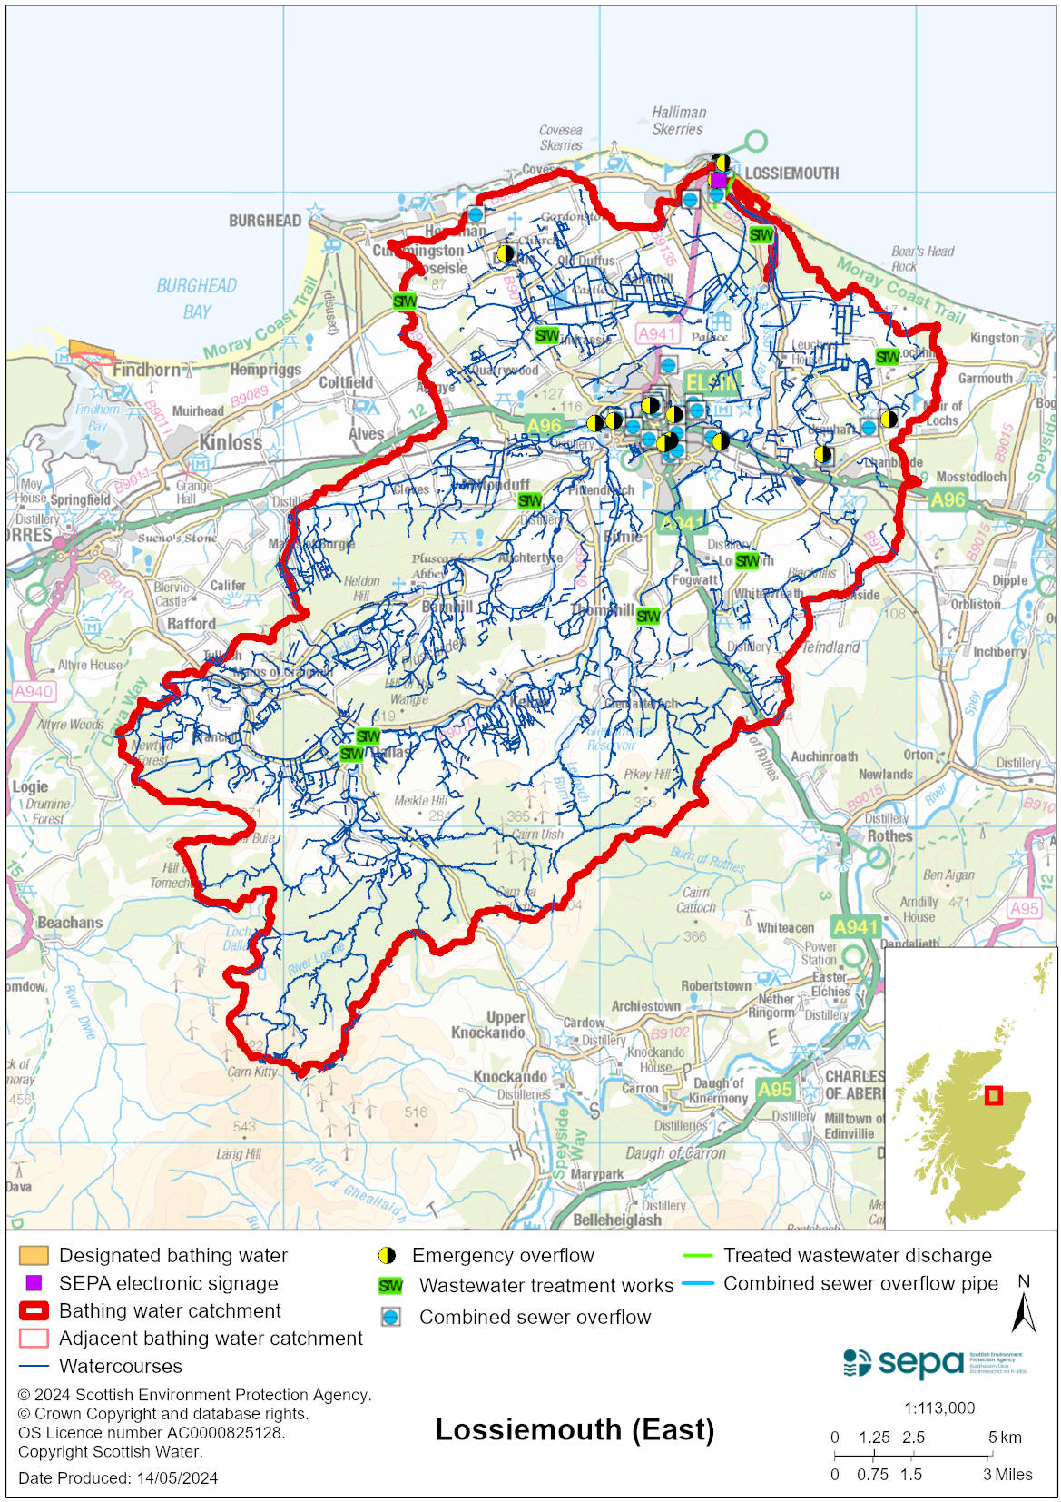

Improving bathing water quality

Sewage
Scottish Water provides most waste water collection and treatment services in Scotland.

Oakenhead Wood sewage treatment works is situated to the east of Lossiemouth. It provides full biological treatment for sewage from Lossiemouth and Elgin, with the final effluent being discharged via a long sea outfall 1.4 km from the beach.

There are several combined sewer overflows (CSOs) and emergency overflows (EOs) that discharge in the vicinity of the bathing water. The CSOs may discharge and impact the bathing water during heavy rainfall. The EOs should only discharge under rare, abnormal circumstances.

Many private septic tanks discharge to the River Lossie and to the Spynie Canal.

Agriculture
Diffuse pollution from agricultural sources is the result of rain driven events causing cumulative inputs of pollutants to rivers and streams.

There are many farms in the catchment draining to the Lossiemouth (East) bathing water. Pollution from agricultural run-off is thought to occur mostly in the River Lossie and this is believed to be a primary source of pollution at the bathing water. The catchment draining to Lossiemouth (East) bathing water is within the Moray Coastal catchment.

Work to address diffuse pollution issues in this catchment is expected to be completed by 2027.

Urban
Urban diffuse source pollution comes from contaminated rainwater discharging to rivers and streams. The River Lossie is likely to be affected by surface water run-off as it flows through Elgin town.

Cyanobacteria (blue-green algae), algae and jellyfish
Marine waters are not at risk of cyanobacteria overproduction. This bathing water is not at risk of excessive growth of macroalgae (seaweed) or phytoplankton.

The possibility of increased jellyfish numbers in the water during summer months is a naturally occurring phenomenon. Most species common to the UK are harmless; the Marine Conservation Society advises to ‘look but don’t touch’.

Pollution incidents
Pollution can be reported via our website online form or by calling our 24 hours a day Pollution Hotline number 0800 80 70 60

If pollution is reported to us, or identified by our routine water quality monitoring program, we will investigate and where necessary work with others to remediate. We may contact other relevant organisations including the local authority, that local health board, Scottish Water and Scottish Ministers.

If there is a risk to human health the local authority is responsible for placing signs at the bathing water. Information will also be available on our website.

Everyone can help to keep the bathing water clean:
- If you visit the beach with your dog clear up any fouling
- Don’t leave litter or feed birds - this encourages unnatural behaviour, and they can pollute the water
- At home, don’t flush wipes or other inappropriate items as these can block pipes and cause sewage spills

Contact details and information sources

SEPA bathing waters homepage

SEPA rainfall data

Scottish Government protected waters homepage

Moray Council

For information on accessing this document in an alternative format or language, please contact SEPA by emailing equalities@sepa.org.uk
If you are a user of British Sign Language (BSL), the Contact Scotland BSL service gives you access to an online interpreter, enabling you to communicate with us using sign language. contactscotland-bsl.org

