Bathing water profile - Gairloch
Bathing water classification

Bathing water description
Gairloch Beach is a sandy beach with large dunes. It is located south of Gairloch village in the North-West Highlands. Gairloch is popular for several recreational uses including swimming, rowing, kayaking and snorkelling. The An Dun headland is a North West Highland Snorkel Trail site. Depending on the tides, the distance to the water’s edge can vary from 0 to 170m.

Site details:
- Local authority: Highland Council
- Year of designation: 2017
- Water sampling location: NG 80405 75701

Risks to water quality
This bathing water is at risk of short term pollution following heavy rainfall. Bathing is not advised during or 1-2 days after heavy rainfall due to the risk to bathers’ health from water pollution.

Pollution risks include sewer overflows.

Catchment description
A catchment area of 0.7 km2 drains into Gairloch Beach bathing water. Meall Achadh Deisteil hill is in the eastern area of the catchment. The small burn Allt a’ Ghamhna flows from the hilly area into the bathing water.
Land use in the catchment includes improved grassland and heather grassland as well as broadleaved and coniferous woodland. The main village of Gairloch is north of the catchment area.

Map 1: Gairloch bathing water
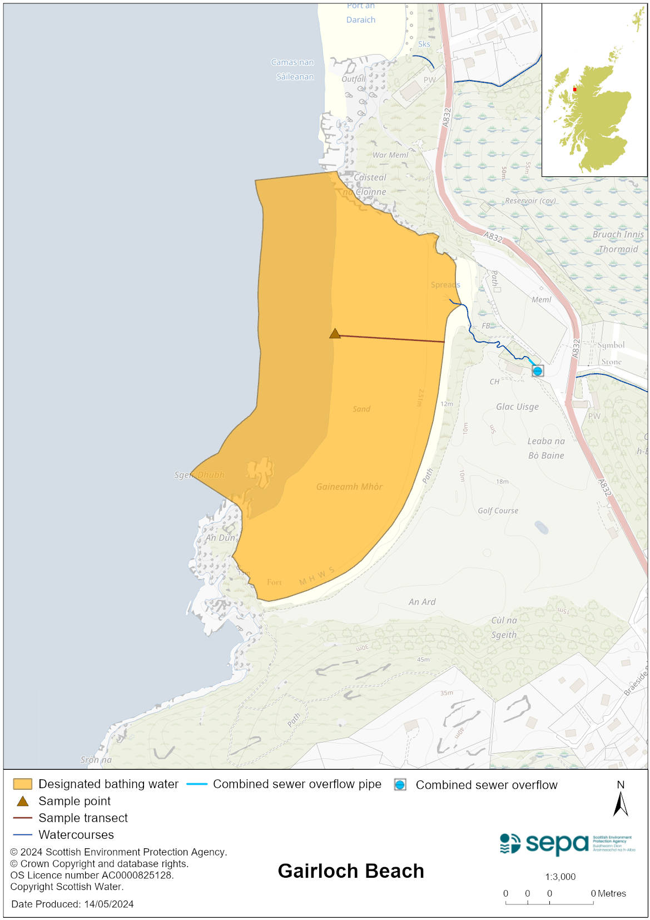

Map 2: Catchment draining into Gairloch bathing water
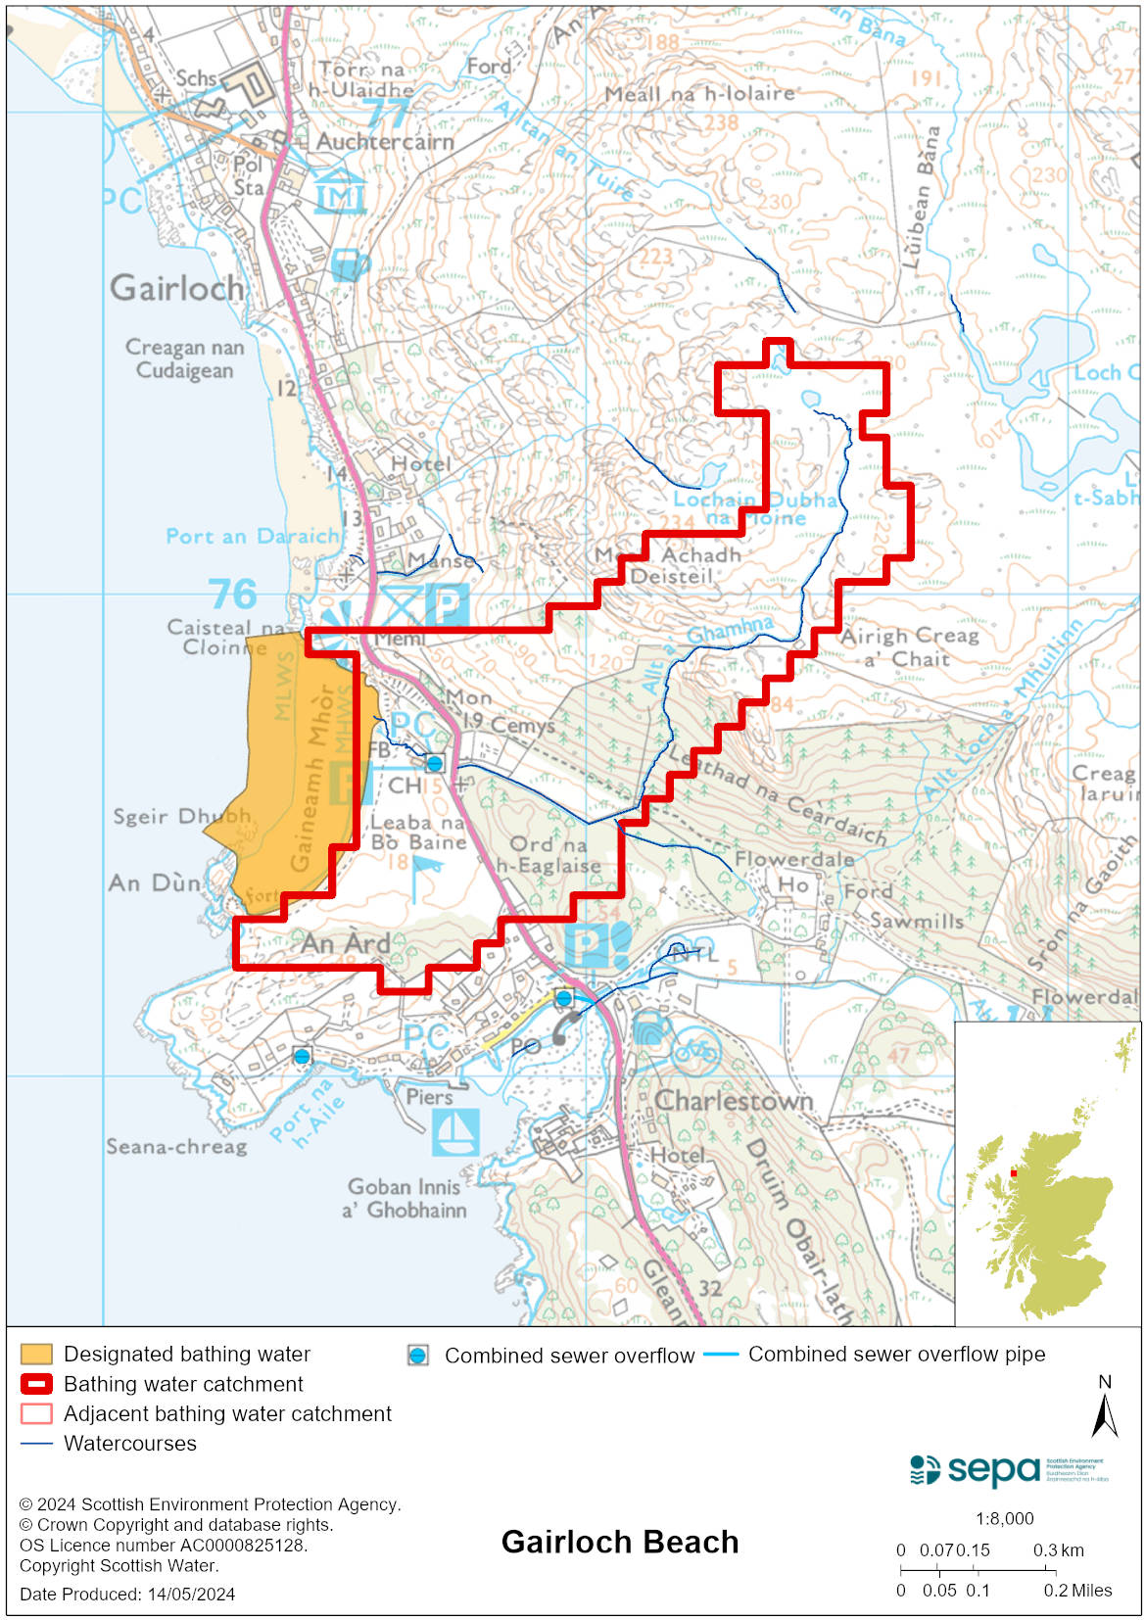

Improving bathing water quality

Sewage
Scottish Water provides most waste water collection and treatment services in Scotland.

There is a combined sewer overflow (CSO) with a discharge location to the small burn Allt a’ Ghamhna which discharges to the bathing water. This may discharge and impact the bathing water during heavy rainfall.

Agriculture
Agriculture does not have a significant impact on this bathing water.

Cyanobacteria (blue-green algae), algae and jellyfish
Marine waters are not at risk of cyanobacteria overproduction. This bathing water is not at risk of excessive growth of macroalgae (seaweed) or phytoplankton.

The possibility of increased jellyfish numbers in the water during summer months is a naturally occurring phenomenon. Most species common to the UK are harmless; the Marine Conservation Society advises to ‘look but don’t touch’.

Pollution incidents
Pollution can be reported via our website online form or by calling our 24 hours a day Pollution Hotline number 0800 80 70 60

If pollution is reported to us, or identified by our routine water quality monitoring program, we will investigate and where necessary work with others to remediate. We may contact other relevant organisations including the local authority, that local health board, Scottish Water and Scottish Ministers.

If there is a risk to human health the local authority is responsible for placing signs at the bathing water. Information will also be available on our website.

Everyone can help to keep the bathing water clean:
- If you visit the beach with your dog clear up any fouling
- Don’t leave litter or feed birds - this encourages unnatural behaviour, and they can pollute the water
- At home, don’t flush wipes or other inappropriate items as these can block pipes and cause sewage spills

Contact details and information sources

SEPA bathing waters homepage

SEPA rainfall data

Scottish Government protected waters homepage

Highland Council

For information on accessing this document in an alternative format or language, please contact SEPA by emailing equalities@sepa.org.uk
If you are a user of British Sign Language (BSL), the Contact Scotland BSL service gives you access to an online interpreter, enabling you to communicate with us using sign language. contactscotland-bsl.org

