Bathing water profile - Culzean
Bathing water classification

Bathing water description
Culzean is a very small, attractive beach at the south-west edge of Culzean Country Park. The village of Maidens is to the south. To the north-east are the dramatic cliffs and rocky shore of the country park, which are noted for their wildlife. Depending on the tide, the distance to the water’s edge can vary from 20–100 metres.

Site details:
- Local authority: South Ayrshire Council
- Year of designation: 2008
- Water sampling location: NS 22041 09681

Risks to water quality
This bathing water is at risk of short term pollution following heavy rainfall. Bathing is not advised during or 1-2 days after heavy rainfall due to the risk to bathers’ health from water pollution.

Catchment description
The Culzean bathing water catchment is very small, extending to just over 1 km2. The area is largely parkland. The catchment is 88% rural and 9% urban. Population density is low as there are no towns or villages within the catchment. The nearest village is Maidens, about 1 km south of the bathing water. The remaining 3% of the catchment is made up of standing water and rocks.
There are no major rivers within catchment. There is a small unnamed burn which flows on to the beach via the swan pond.
Part of the catchment is within the Maidens to Doonfoot Site of Special Scientific Interest (SSSI). It is designated on both biological and geological grounds. From the Heads of Ayr to Culzean, there are several rich intertidal areas and cliffs. They are home to breeding ravens and one of the few colonies of fulmars in Ayrshire.

Map 1: Culzean bathing water
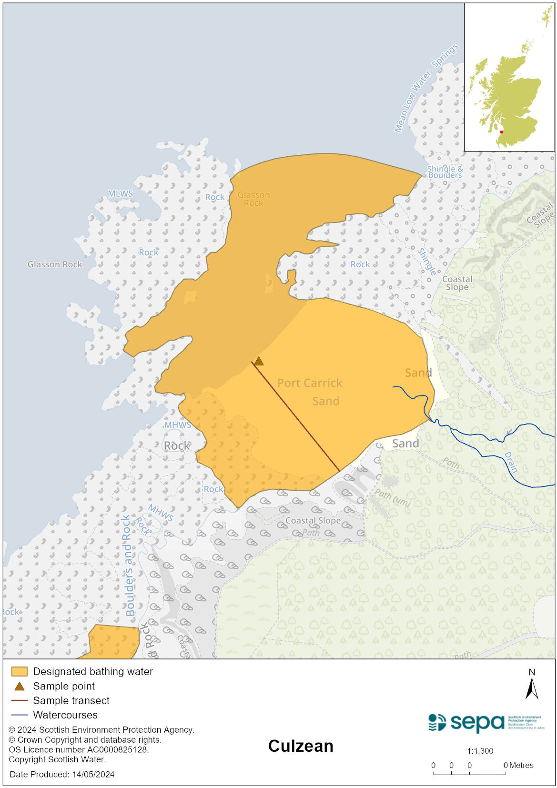

Map 2: Catchment draining into Culzean bathing water
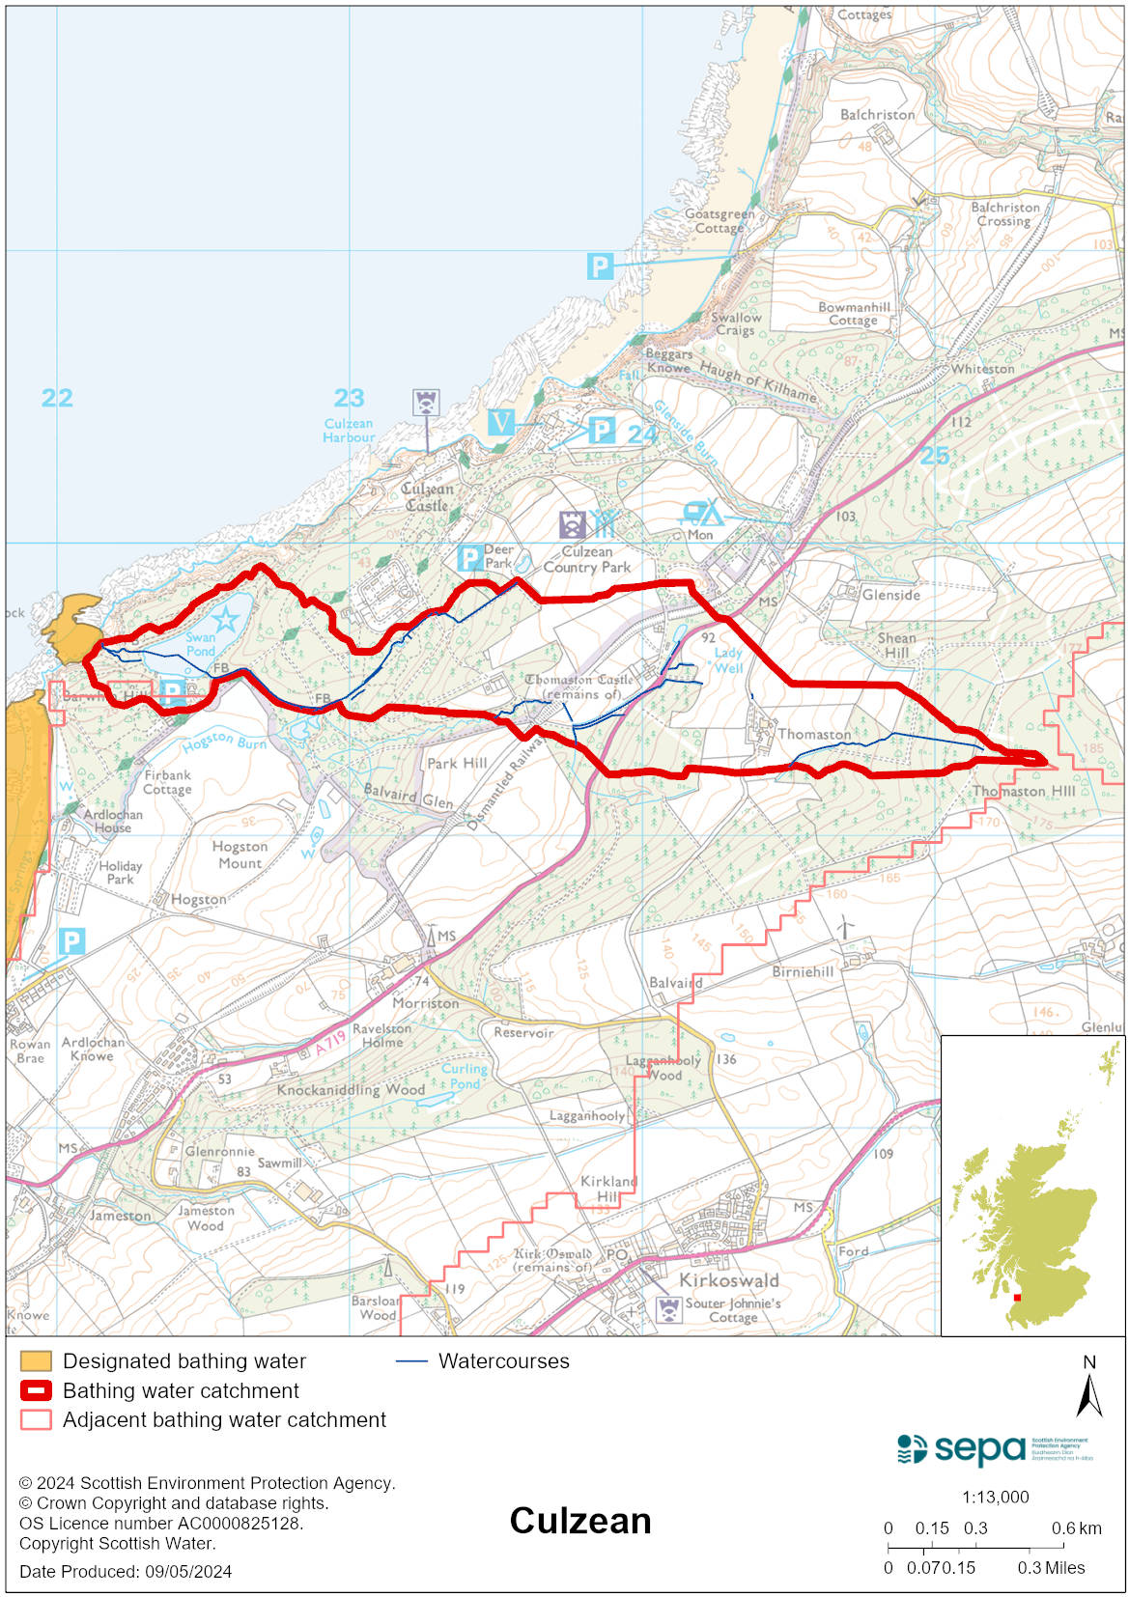

Improving bathing water quality

Sewage
Whilst Scottish Water provides most waste water collection and treatment services in Scotland, there are no Scottish Water assets in the vicinity of this bathing water.

Agriculture
Diffuse pollution from agricultural sources is the result of rain driven events causing cumulative inputs of pollutants to rivers and streams.

Work with land managers to reduce diffuse pollution in the South Ayrshire Coastal catchment is due to be completed by 2027.

Cyanobacteria (blue-green algae), algae and jellyfish
Marine waters are not at risk of cyanobacteria overproduction. This bathing water is not at risk of excessive growth of macroalgae (seaweed) or phytoplankton.

The possibility of increased jellyfish numbers in the water during summer months is a naturally occurring phenomenon. Most species common to the UK are harmless; the Marine Conservation Society advises to ‘look but don’t touch’.

Pollution incidents
Pollution can be reported via our website online form or by calling our 24 hours a day Pollution Hotline number 0800 80 70 60

If pollution is reported to us, or identified by our routine water quality monitoring program, we will investigate and where necessary work with others to remediate. We may contact other relevant organisations including the local authority, that local health board, Scottish Water and Scottish Ministers.

If there is a risk to human health the local authority is responsible for placing signs at the bathing water. Information will also be available on our website.

Everyone can help to keep the bathing water clean:
- If you visit the beach with your dog clear up any fouling
- Don’t leave litter or feed birds - this encourages unnatural behaviour, and they can pollute the water
- At home, don’t flush wipes or other inappropriate items as these can block pipes and cause sewage spills

Contact details and information sources

SEPA bathing waters homepage

SEPA rainfall data

Scottish Government protected waters homepage

South Ayrshire Council

For information on accessing this document in an alternative format or language, please contact SEPA by emailing equalities@sepa.org.uk
If you are a user of British Sign Language (BSL), the Contact Scotland BSL service gives you access to an online interpreter, enabling you to communicate with us using sign language. contactscotland-bsl.org

