Bathing water profile – Saltcoats/Ardrossan
Bathing water classification

Bathing water description
Saltcoats/Ardrossan bathing water is a 1 km stretch of sandy beach that lies between the towns of Ardrossan and Saltcoats on the North Ayrshire coast. There are rocky areas at Bath Rocks in the north-west and at the former boating ponds in the south-east. The nearby island of Arran can be seen to the west of the bathing water.
The sandy beach slopes gently towards the water and depending on the tide, there can be 0-390 metres of beach before the water’s edge.

Site details:
- Local authority: North Ayrshire Council
- Year of designation: 1987
- Water sampling location: NS 23453 41997

Risks to water quality
This bathing water is subject to short term pollution following heavy rainfall. Bathing is not advised during or 1-2 days after heavy rainfall due to the risk to bathers’ health from water pollution.

Pollution risks include sewer overflows, agricultural run-off and surface water discharges.

Water quality forecasts
As water quality is likely to be impacted by rainfall we make daily predictions of good or poor bathing water quality. We advise against bathing when poor water quality is predicted as there is an increased risk to bathers’ health from water pollution.

These predictions are displayed on the electronic sign at the beach and online between 15 May and 15 September.

Catchment description
A catchment area of 9 km2 drains into the Saltcoats/Ardrossan bathing water. The area varies in elevation from the hills in the north/north-west to lowlands around the towns of Saltcoats and Ardrossan along the coast. The catchment is predominantly rural (68%) with agriculture the major land use. There are several dairy farms in the catchment and the surrounding fields are used for grazing and for growing grass for silage. The area immediately surrounding the bathing water is mainly urban (30% of the catchment) and comprises of the towns of Saltcoats and Ardrossan which are situated along the coastline. The town of Stevenston is just out with the catchment, about 1 km south of the bathing water.

Map 1: Saltcoats/Ardrossan bathing water
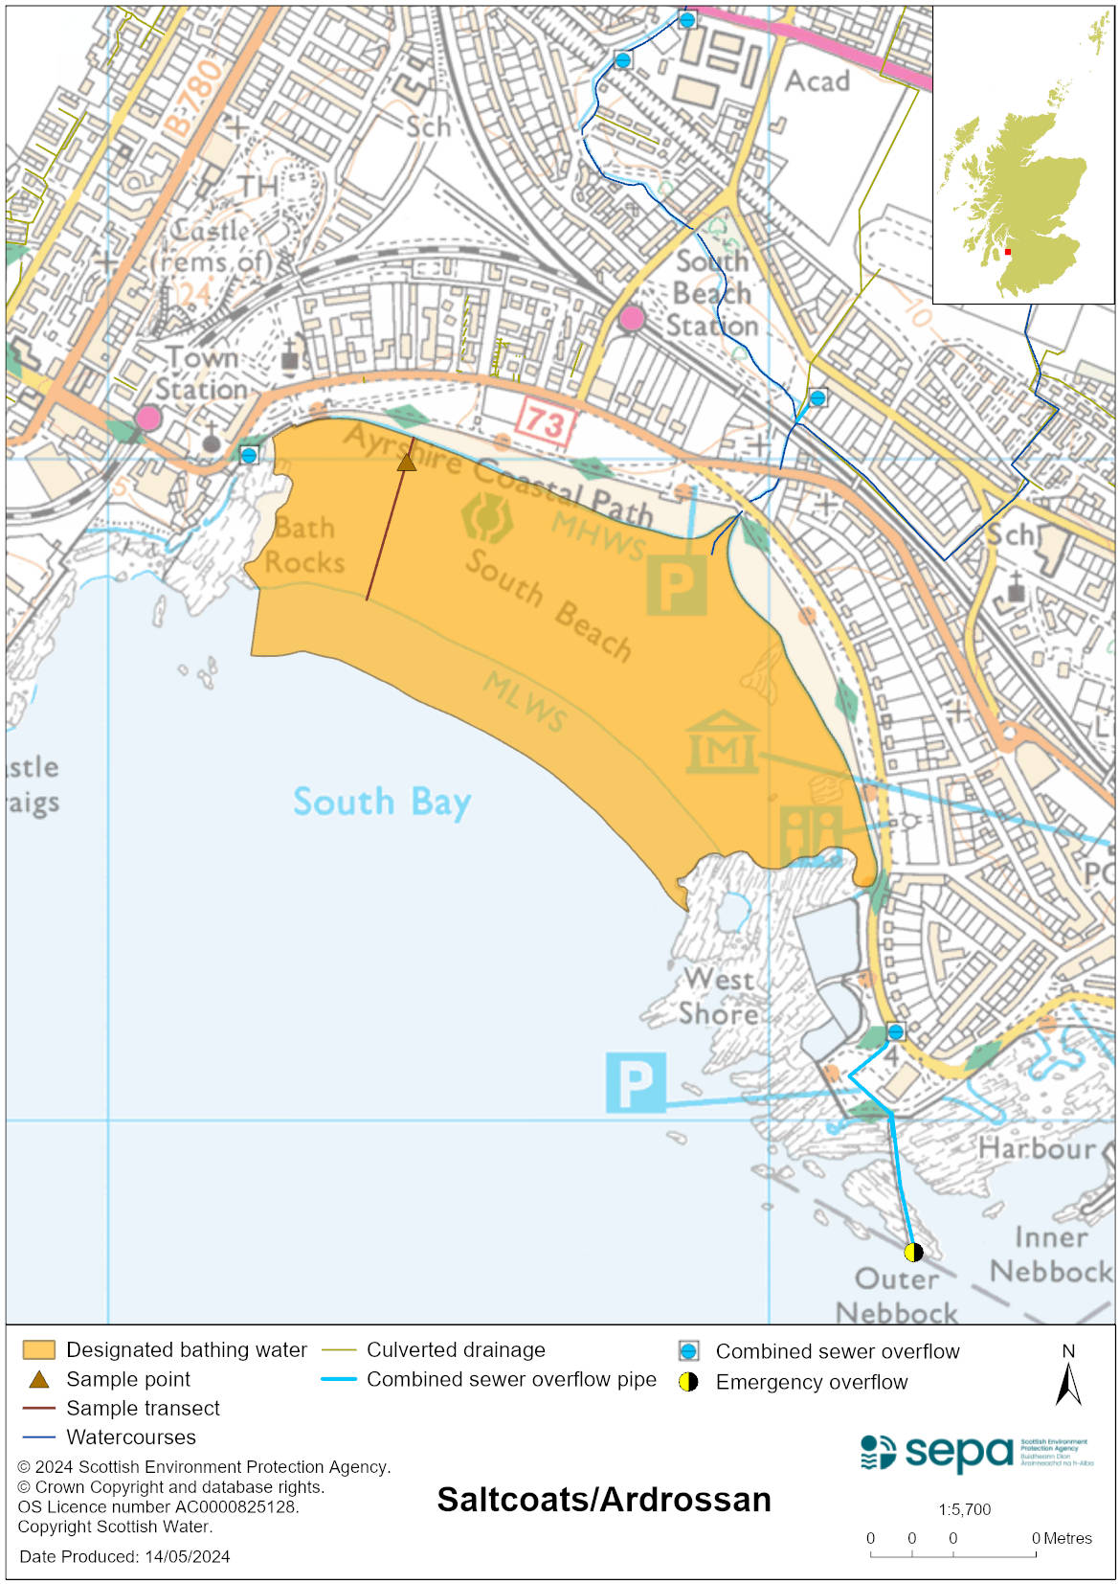

Map 2: Catchment draining into Saltcoats/Ardrossan bathing water
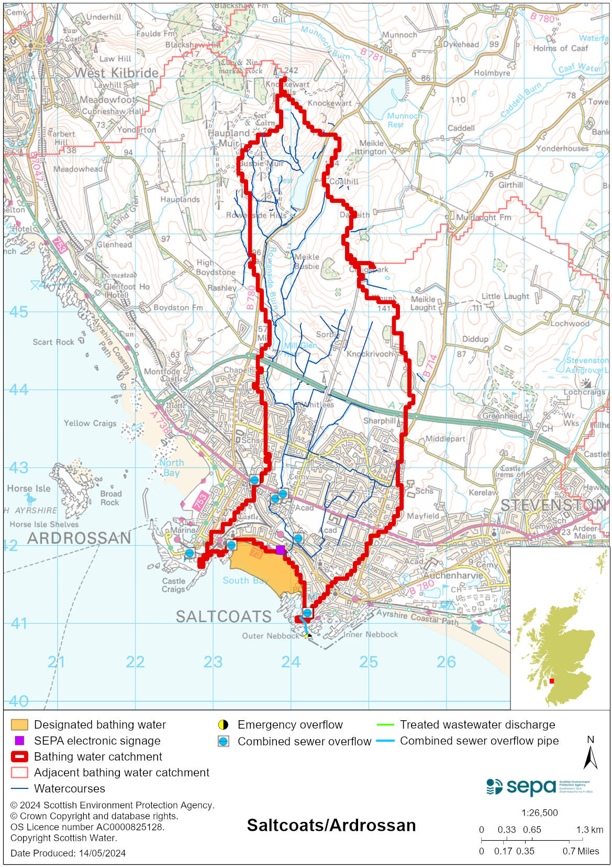

Improving bathing water quality

Sewage
Scottish Water provides most waste water collection and treatment services in Scotland.

Improvements were made to Saltcoats Sewage Pumping Station in 2014 as it was found not to be operating correctly. Investigations have been ongoing into sewer flooding to determine if any improvements can be made in this area. Combined sewer overflows, together with diffuse urban and agricultural drainage, contribute to the bacterial load carried by the Stanley Burn. Most of the bacterial pollution affecting the bathing water quality is carried by the burn. A recent Scottish Water study identified a number of misconnections between the foul and surface water drainage networks which were impacting on water quality in the Stanley Burn. Remedial works were carried out to reduce contamination of the surface water discharges to the burn.

In 2023 Scottish Water replaced a large section of the rising main south of Saltcoats bathing water. Further works are to be completed in 2024 to another section, to reduce bursts of the pipe which could potentially effect bathing water quality.

Agriculture
Diffuse pollution from agricultural sources is the result of rain driven events causing cumulative inputs of pollutants to rivers and streams.
There is potential for agricultural diffuse pollution to occur in the Stanley Burn and other small rural tributaries, which could impact on the bathing beach during and following heavy rain.
Farm visits started in the North Ayrshire Coastal priority catchment in 2013 and are ongoing. These visits look to identify diffuse pollution sources and pathways. Mitigation measures have been agreed with land managers to reduce the risk of bacterial pollution on water quality.
SEPA has observed significant changes in land management practice within the catchments and will continue to work with farmers to reduce the risk of pollution to the bathing water.

Urban
Urban diffuse source pollution comes from contaminated rainwater discharging to rivers and streams. The Stanley Burn is affected by surface water run-off from the urban area through which it runs.

Cyanobacteria (blue-green algae), algae and jellyfish
Marine waters are not at risk of cyanobacteria overproduction. This bathing water is not at risk of excessive growth of macroalgae (seaweed) or phytoplankton.

The possibility of increased jellyfish numbers in the water during summer months is a naturally occurring phenomenon. Most species common to the UK are harmless; the Marine Conservation Society advises to ‘look but don’t touch’.

Pollution incidents
Pollution can be reported via our website online form or by calling our 24 hours a day Pollution Hotline number 0800 80 70 60

If pollution is reported to us, or identified by our routine water quality monitoring program, we will investigate and where necessary work with others to remediate. We may contact other relevant organisations including the local authority, that local health board, Scottish Water and Scottish Ministers.

If there is a risk to human health the local authority is responsible for placing signs at the bathing water. Information will also be available on our website.

Everyone can help to keep the bathing water clean:
- If you visit the beach with your dog clear up any fouling
- Don’t leave litter or feed birds - this encourages unnatural behaviour, and they can pollute the water
- At home, don’t flush wipes or other inappropriate items as these can block pipes and cause sewage spills

Contact details and information sources

SEPA bathing waters homepage

SEPA rainfall data

Scottish Government protected waters homepage

North Ayrshire Council

For information on accessing this document in an alternative format or language, please contact SEPA by emailing equalities@sepa.org.uk
If you are a user of British Sign Language (BSL), the Contact Scotland BSL service gives you access to an online interpreter, enabling you to communicate with us using sign language. contactscotland-bsl.org

