Bathing water profile - Rockcliffe
Bathing water classification

Bathing water description
Rockcliffe bathing water is a small, shallow bay about 300 metres long. It is on the south coast of Dumfries and Galloway in the Urr Estuary. It is close to the small town of Rockcliffe. The beach is prized for its scenery of the nearby hills, Rough Island and Hestan Island. Depending on the tide, the distance to the water’s edge can vary by over a kilometre. Mud flats are exposed at low tide, making the water’s edge difficult to access in certain areas.

Site details:
- Local authority: Dumfries and Galloway Council
- Year of designation: 1999
- Water sampling location: NX 84777 53682

Risks to water quality
This bathing water is subject to short term pollution following heavy rainfall. Bathing is not advised during or 1-2 days after heavy rainfall due to the risk to bathers’ health from water pollution.

Pollution risks include agricultural run-off and sewer overflows.

Water quality forecasts
As water quality is likely to be impacted by rainfall we make daily predictions of good or poor bathing water quality. We advise against bathing when poor water quality is predicted as there is an increased risk to bathers’ health from water pollution.

These predictions are displayed on the electronic sign at the beach and online between 15 May and 15 September.

Catchment description
A catchment area of 10 km2 drains into Rockcliffe bathing water. It features a series of hills including Barcloy Hill in the southeast. To the north and northeast are Greenan, Whinny, Kirkland and Torbay Hills. The main rivers in the catchment are the Mill Burn and an unnamed tributary which enters the Rough Firth just north of the bathing water.
Agriculture is the main land use in the catchment. The upland areas support mixed sheep and beef farming. The lowlands are used for mixed grazing and arable farming. The catchment includes woodland coverage. The main population centres are Rockcliffe and Kippford of Scaur.
Average summer rainfall for the region is 356 mm compared to 331 mm across Scotland as a whole.

Map 1: Rockcliffe bathing water
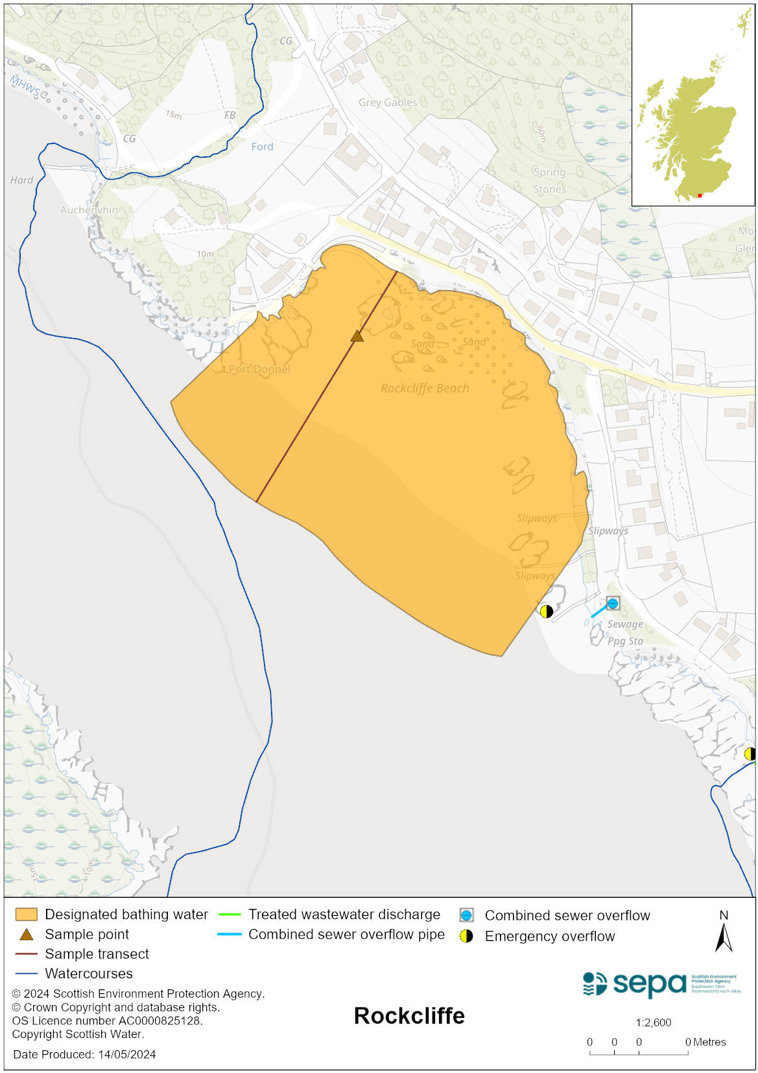

Map 2: Catchment draining into Rockcliffe bathing water
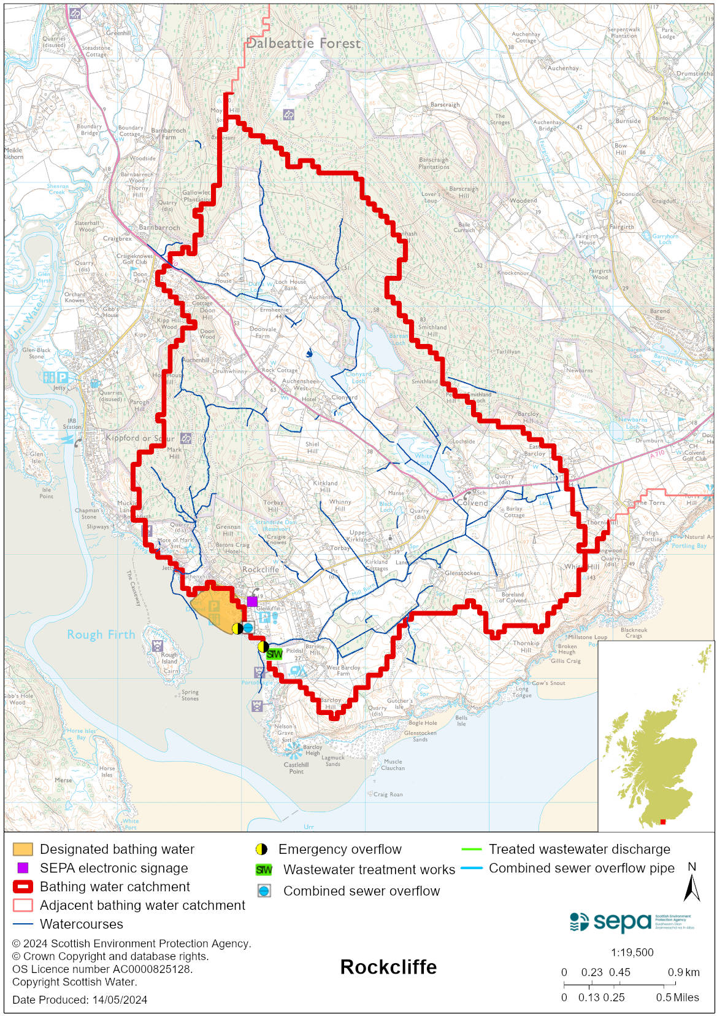

Improving bathing water quality

Sewage
Scottish Water provides most waste water collection and treatment services in Scotland.

Improvements to the sewerage system have led to a significant reduction in faecal pollutants in the bathing water. Upgrades to Rockcliffe sewage treatment works took place in 2004 with further work in 2013/14. Scottish Water undertook upgrade work at Dalbeattie sewage treatment works in 2014. Studies revealed the Scottish Water septic tank at Kippford to be having a significant impact on the Rockcliffe bathing water. It was built for a population of around 300, but due to population growth and seasonal fluctuations, the peak population requiring treatment is now over 1300. Following trials, Scottish Water installed chemical dosing as a temporary measure at the septic tank at Kippford. This was brought into operation prior to the start of the 2021 bathing season. Conditions in the permit require Scottish Water to ensure chemical dosing is controlled and the environmental impacts monitored and reported to SEPA. The chemical dosing in place at the Kippford septic tank is proposed to continue until the development of a new permanent solution. This is in progress and will ensure that environmental impacts are minimised and bathing water quality standards are achieved. The local community are being engaged in the development of this new asset and it will be subject to planning permission from the local authority and an authorisation from SEPA.

Private sewerage may continue to pose a risk to the bathing water with a number of properties in the Orchard Knowes and Rough Firth areas not currently connected to public sewerage. The proposed new solution will have capacity to accommodate these properties, if they wish to connect, thereby reducing the risk to the bathing water.

Agriculture
Diffuse pollution from agricultural sources is the result of rain driven events causing cumulative inputs of pollutants to rivers and streams.

There is potential for agricultural diffuse pollution to occur in the Mill Burn which could impact on the bathing beach during and following heavy rain.

Farm visits to identify diffuse pollution sources were undertaken as part of the Galloway priority catchment work in 2014 until completion in 2017. These visits looked to identify diffuse pollution sources and pathways. Mitigation measures were agreed with land managers to reduce the risk of bacterial pollution on water quality. Significant investment and improvements to farming practices have been observed within the catchment, often going beyond compliance. The priority catchment program is now complete.

Even though all agricultural compliance work has been completed in this bathing water catchment and all farms are in a compliant state, SEPA will continue to engage with farmers and the NFUS to remind them of good practice when applying slurries and manures and grazing livestock.

Cyanobacteria (blue-green algae), algae and jellyfish
Marine waters are not at risk of cyanobacteria overproduction. This bathing water is not at risk of excessive growth of macroalgae (seaweed) or phytoplankton.

The possibility of increased jellyfish numbers in the water during summer months is a naturally occurring phenomenon. Most species common to the UK are harmless; the Marine Conservation Society advises to ‘look but don’t touch’.

Pollution incidents
Pollution can be reported via our website online form or by calling our 24 hours a day Pollution Hotline number 0800 80 70 60

If pollution is reported to us, or identified by our routine water quality monitoring program, we will investigate and where necessary work with others to remediate. We may contact other relevant organisations including the local authority, that local health board, Scottish Water and Scottish Ministers.

If there is a risk to human health the local authority is responsible for placing signs at the bathing water. Information will also be available on our website.

Everyone can help to keep the bathing water clean:
- If you visit the beach with your dog clear up any fouling
- Don’t leave litter or feed birds - this encourages unnatural behaviour, and they can pollute the water
- At home, don’t flush wipes or other inappropriate items as these can block pipes and cause sewage spills

Contact details and information sources

SEPA bathing waters homepage

SEPA rainfall data

Scottish Government protected waters homepage

Dumfries and Galloway Council

For information on accessing this document in an alternative format or language, please contact SEPA by emailing equalities@sepa.org.uk
If you are a user of British Sign Language (BSL), the Contact Scotland BSL service gives you access to an online interpreter, enabling you to communicate with us using sign language. contactscotland-bsl.org

