Bathing water profile – Pease Bay
Bathing water classification

Bathing water description
The Pease Bay bathing water is approximately 1.6 km east of the small town of Cockburnspath in the Scottish Borders. It is a sandy bay, about 600 metres long. The beach is popular for surfing. Depending on the tide, the distance to the water’s edge can vary from 5–260 metres. The beach slopes gently towards the water.

Site details:
- Local authority: Scottish Borders Council
- Year of designation: 1987
- Water sampling location: NT 79264 71083

Risks to water quality
This bathing water is at risk of short term pollution following heavy rainfall. Bathing is not advised during or 1-2 days after heavy rainfall due to the risk to bathers’ health from water pollution.

Pollution risks include agricultural run-off and from sewerage.

Catchment description
The Pease Bay bathing water catchment extends to 27 km2. The area is mainly rural (99%) with agriculture the primary land use. The main population centre is the town of Cockburnspath. The nearby caravan park increases the local population in the summer. The main rivers within the catchment are the Pease Burn and the Cockburnspath Burn.
Pease Bridge Glen and the coastal area are two Sites of Special Scientific Interest (SSSI), fully or partly in the bathing water or catchment. The Lothian and Borders area was a surface water Nitrate Vulnerable Zone in 2002.

Map 1: Pease Bay bathing water
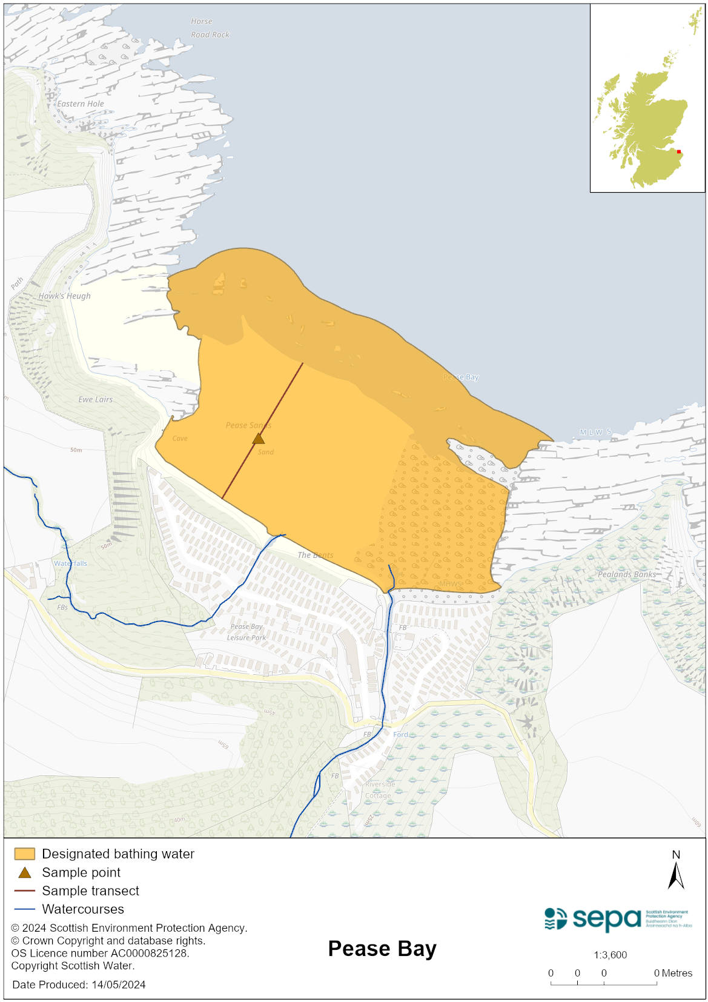

Map 2: Catchment draining into Pease Bay bathing water
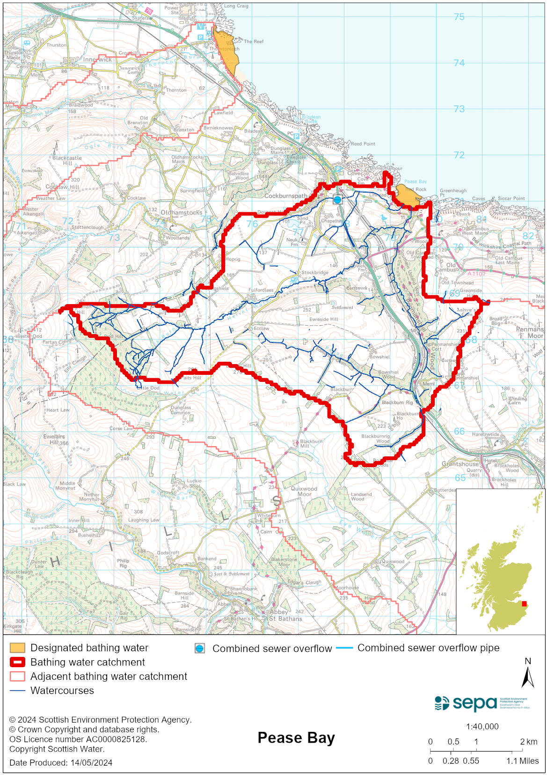

Improving bathing water quality

Sewage
Scottish Water provides most waste water collection and treatment services in Scotland.

Sewage from Cove and Cockburnspath is pumped to Cove sewage treatment works for secondary treatment before being discharged to the North Sea via a long sea outfall. Additional UV treatment is applied to this discharge during the bathing season.

Sewage from Pease Bay Caravan Park is treated by a private sewage treatment works before being discharged to the Pease Burn. Additional UV treatment is applied to this discharge during the bathing season.

Agriculture
Diffuse pollution from agricultural sources is the result of rain driven events causing cumulative inputs of pollutants to rivers and streams.

Farm visits to identify diffuse pollution sources were undertaken as part of the Eye Water priority catchment work in 2012. Incidences of livestock entering watercourses were recorded and mitigation measures were agreed to address this. Large areas along watercourses were fenced off from livestock and alternative water sources provided for them. The priority catchment program is now complete.

Even though all agricultural compliance work has been completed in this bathing water catchment and all farms are in a compliant state, SEPA will continue to engage with farmers and the NFUS to remind them of good practice when applying slurries and manures and grazing livestock.

Cyanobacteria (blue-green algae), algae and jellyfish
Marine waters are not at risk of cyanobacteria overproduction. This bathing water is not at risk of excessive growth of macroalgae (seaweed) or phytoplankton.

The possibility of increased jellyfish numbers in the water during summer months is a naturally occurring phenomenon. Most species common to the UK are harmless; the Marine Conservation Society advises to ‘look but don’t touch’.

Pollution incidents
Pollution can be reported via our website online form or by calling our 24 hours a day Pollution Hotline number 0800 80 70 60

If pollution is reported to us, or identified by our routine water quality monitoring program, we will investigate and where necessary work with others to remediate. We may contact other relevant organisations including the local authority, that local health board, Scottish Water and Scottish Ministers.

If there is a risk to human health the local authority is responsible for placing signs at the bathing water. Information will also be available on our website.

Everyone can help to keep the bathing water clean:
- If you visit the beach with your dog clear up any fouling
- Don’t leave litter or feed birds - this encourages unnatural behaviour, and they can pollute the water
- At home, don’t flush wipes or other inappropriate items as these can block pipes and cause sewage spills

Contact details and information sources

SEPA bathing waters homepage

SEPA rainfall data

Scottish Government protected waters homepage

Scottish Borders Council

For information on accessing this document in an alternative format or language, please contact SEPA by emailing equalities@sepa.org.uk
If you are a user of British Sign Language (BSL), the Contact Scotland BSL service gives you access to an online interpreter, enabling you to communicate with us using sign language. contactscotland-bsl.org

