Bathing water profile – Ayr (South Beach)
Bathing water classification

Bathing water description
Ayr (South Beach) bathing water is a bay of 3.5 kilometres. It runs along the coastline from the River Ayr in the north to beyond the River Doon in the south. The beach is adjacent to the seaside town of Ayr. The sandy beach slopes gently towards the water. Its golden sands are prized by locals. Depending on the tide, the approximate distance to the water’s edge can vary from 25-700 metres.

Site details:
- Local authority: South Ayrshire Council
- Year of designation: 1987
- Water sampling location: NS 32964 21888

Risks to water quality
This bathing water is subject to short term pollution following heavy rainfall. Bathing is not advised during or 1-2 days after heavy rainfall due to the risk to bathers’ health from water pollution.

Pollution risks include agricultural run-off, sewer overflows and surface water discharges.

Water quality forecasts
As water quality is likely to be impacted by rainfall we make daily predictions of good or poor bathing water quality. We advise against bathing when poor water quality is predicted as there is an increased risk to bathers’ health from water pollution.
These predictions are displayed on the electronic sign at the beach and online between 15 May and 15 September.

Catchment description
A catchment area of 930 km2 drains into Ayr (South Beach) bathing water. Its topography varies from hills in the east to low-lying areas around the coastline and urban centres. The main rivers in the bathing water catchment are the River Ayr, River Doon and Slaphouse Burn.
Agriculture is the major land use in the catchment. Approximately half of the agricultural land is used as pasture for dairy cows. The upland areas support sheep and beef farming while the lowlands are used for intensive dairy farming. The catchment includes the main urban area of Ayr town as well as smaller towns and villages.
Average summer rainfall for the region is higher than the average for Scotland as a whole.

Map 1: Ayr (South Beach) bathing water
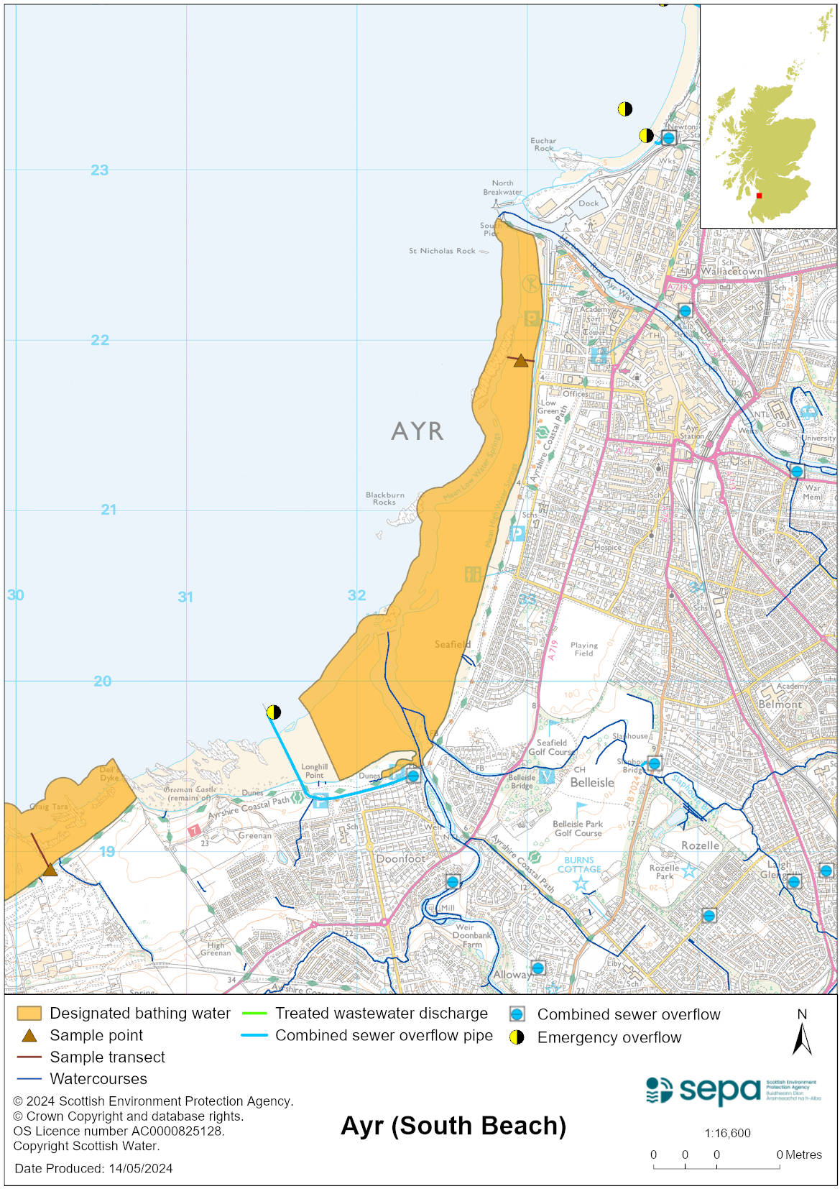

Map 2: Catchment draining into Ayr (South Beach) bathing water
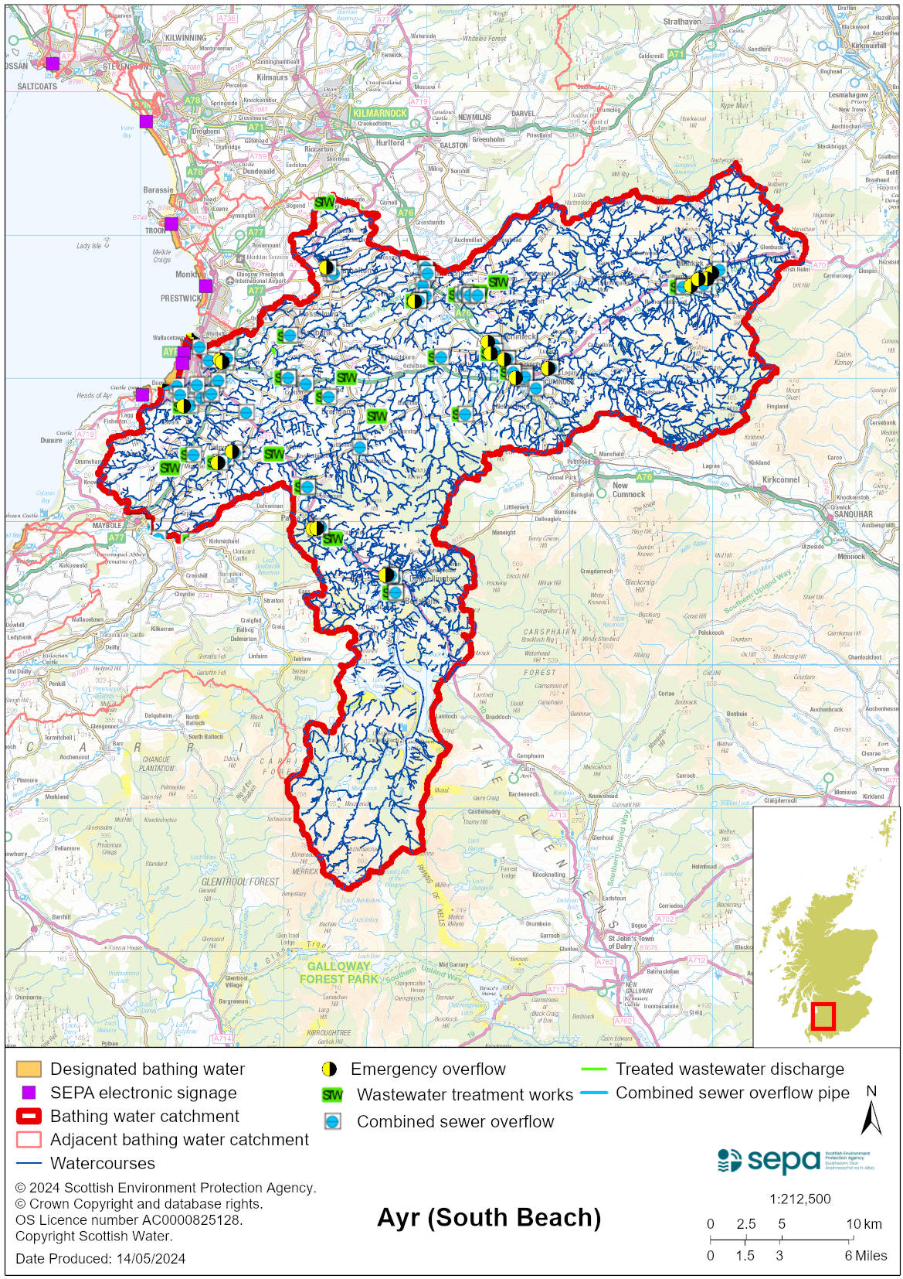

Improving bathing water quality

Sewage
Scottish Water provides most waste water collection and treatment services in Scotland.

Sewage from Ayr is treated at Meadowhead waste water treatment works before it is discharged into the Firth of Clyde. No sewage is discharged into Ayr Bay under normal weather conditions. Under heavy rainfall conditions, storm sewage may be discharged from Ayr pumping station to the sea via a long outfall. Combined sewer overflows (CSOs) may discharge weak storm sewage to rivers and streams. In emergency circumstances, sewage may be discharged from overflows associated with Ayr pumping station.

During 2020/21, Scottish Water completed substantive new capital improvement works which were brought into operation prior to the 2021 bathing season. This included increased storage capacity at two wastewater treatment works (WwTW) in Ayrshire (Drongan and Mauchline), and at a key urban combined sewer overflow asset (Bellisle CSO). Agreement was also reached with Scottish Water to install temporary chemical dosing to disinfect the final effluent at a small septic tank at Minishant until a permanent solution is in place. Scottish Water also committed to operating the public sewerage network to achieve the best possible standards through a proactive inspection and maintenance programme.

SEPA carries out regulatory checks in the area to identify any potential issues. Elevated bacterial concentrations have been observed at various surface water outfalls in Ayr, indicating significant bacterial contamination within the surface water drainage systems. Multiple measures were agreed with Scottish Water to address these issues. Scottish Government funding enabled work to be carried out to fix misconnections within the sewerage system, however some issues still need to be resolved. Scottish Government also agreed to fund a first time provision project for Scottish Water to connect private discharges within the sewered area at the foot of the river Doon to the public sewer. This work is still progressing.

Agriculture
Diffuse pollution from agricultural sources is the result of cumulative inputs of pollutants to rivers and streams.

Pollution from agricultural run-off can occur in the Rivers Ayr and Doon, and to a lesser extent, in the Slaphouse Burn. This is a risk to bathing water quality, particularly during and after periods of wet weather.

In recent years, rural land managers in catchments across Ayrshire have made many improvements to reduce diffuse pollution. There has been significant capital expenditure resulting in many rural land managers going beyond regulatory compliance to address issues arising from their farming activities. Inspections have confirmed that farmers within the Rivers Ayr and Doon catchments are compliant with GBRs.

SEPA will continue to engage with farmers and other relevant parties within both river catchments to promote the importance of maintaining regulatory compliance and the bathing water quality at Ayr South Beach.

Urban
Urban diffuse source pollution comes from contaminated rainwater discharging to rivers and streams.
The river Doon, river Ayr and the Slaphouse burn may be impacted by urban diffuse pollution. This potentially impacts on bathing water quality at Ayr (South Beach). SEPA is monitoring the impact of surface water outfalls on these watercourses.

Cyanobacteria (blue-green algae), algae and jellyfish
Marine waters are not at risk of cyanobacteria overproduction. This bathing water is not at risk of excessive growth of macroalgae (seaweed) or phytoplankton.

The possibility of increased jellyfish numbers in the water during summer months is a naturally occurring phenomenon. Most species common to the UK are harmless; the Marine Conservation Society advises to ‘look but don’t touch’.

Pollution incidents
Pollution can be reported via our website online form or by calling our 24 hours a day Pollution Hotline number 0800 80 70 60

If pollution is reported to us, or identified by our routine water quality monitoring program, we will investigate and where necessary work with others to remediate. We may contact other relevant organisations including the local authority, that local health board, Scottish Water and Scottish Ministers.

If there is a risk to human health the local authority is responsible for placing signs at the bathing water. Information will also be available on our website.

Everyone can help to keep the bathing water clean:
- If you visit the beach with your dog clear up any fouling
- Don’t leave litter or feed birds - this encourages unnatural behaviour, and they can pollute the water
- At home, don’t flush wipes or other inappropriate items as these can block pipes and cause sewage spills

Contact details and information sources

SEPA bathing waters homepage

SEPA rainfall data

Scottish Government protected waters homepage

South Ayrshire Council

For information on accessing this document in an alternative format or language, please contact SEPA by emailing equalities@sepa.org.uk
If you are a user of British Sign Language (BSL), the Contact Scotland BSL service gives you access to an online interpreter, enabling you to communicate with us using sign language. contactscotland-bsl.org

