Bathing water profile – Portobello (Central)
Bathing water classification

Bathing water description
The Portobello (Central) bathing water is in Portobello, on the outskirts of Edinburgh. The area is approximately 1.4 km long. The beach comprises a long stretch of sand and an associated promenade. The area is popular with dog walkers and families. There is an abundance of restaurants and cafés along the front. Depending on the tide, the approximate distance to the water’s edge can vary from 20–310 metres. The beach slopes gently towards the water.

Site details:
- Local authority: City of Edinburgh Council
- Year of designation: 1999
- Water sampling location: NT 31296 73847

Risks to water quality
This bathing water is subject to short term pollution following heavy rainfall. Bathing is not advised during or 1-2 days after heavy rainfall due to the risk to bathers’ health from water pollution.

Pollution risks include sewer overflows and surface water discharges.

Water quality forecasts
As water quality is likely to be impacted by rainfall we make daily predictions of good or poor bathing water quality. We advise against bathing when poor water quality is predicted as there is an increased risk to bathers’ health from water pollution.

These predictions are displayed on the electronic sign at the beach and online between 15 May and 15 September.

Catchment description
The catchment draining into the Portobello (Central) bathing water extends to 32 km2. Land in the area is urban (49%) and rural (49%). The remaining land is mainly coastal. The main urban areas within the catchment are the town of Portobello and the south of Edinburgh city.
The main river within the catchment is the Braid Burn (also known locally as the Figgate Burn) which flows into the sea between the Portobello (West) and Portobello (Central) bathing waters.

Map 1: Portobello (Central) bathing water
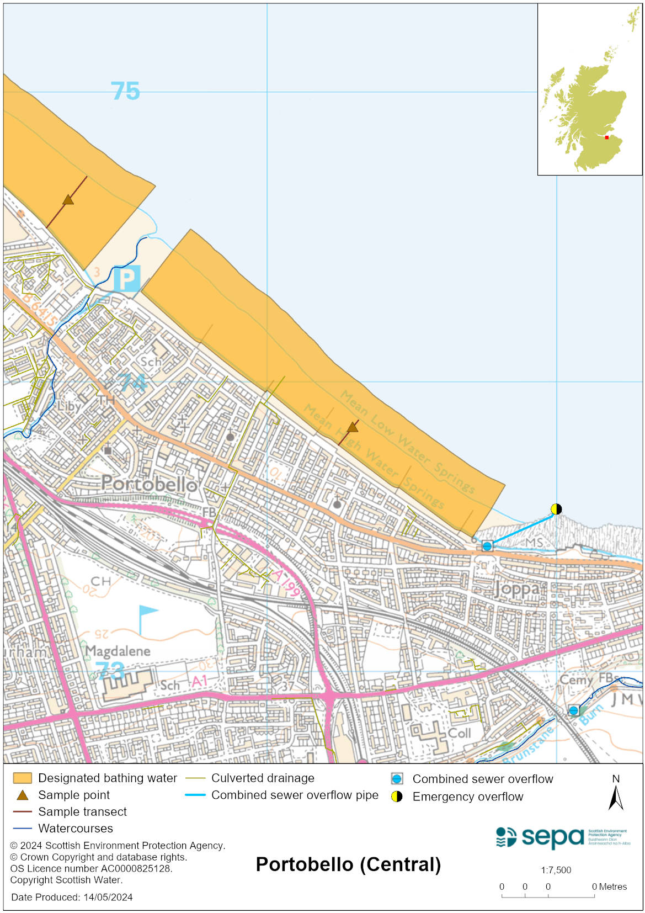

Map 2: Catchment draining into Portobello (Central) bathing water
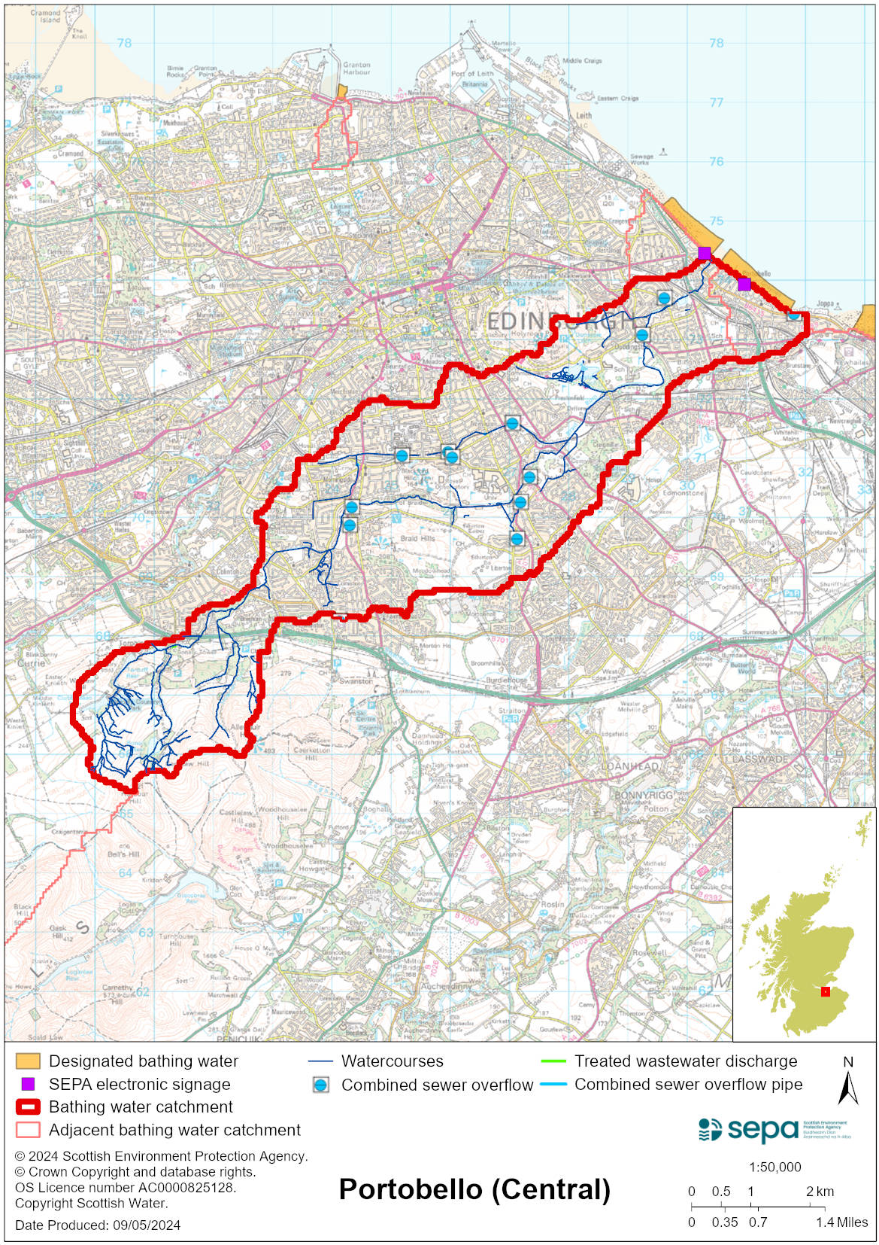

Improving bathing water quality

Sewage
Scottish Water provides most waste water collection and treatment services in Scotland.

Sewage from the Edinburgh area is treated at Edinburgh sewage treatment works before being discharged to the Firth of Forth via a long sea outfall to the North of the works.

Since July 2019 there has been a reduction of spills from the Fillyside combined sewer overflow (CSO) following remediation of a valve in the network to increase the pass forward flow to Seafield sewage treatment works. Whilst this outfall primarily impacts water quality at neighbouring Portobello (West) some improvement is likely at Portobello (Central).

There are combined sewer overflows which can impact the bathing water after heavy rain, particularly those discharging to the Braid Burn and from Joppa at the east end of the beach.

Agriculture
There are no impacts from agriculture affecting this bathing water.

Urban
The Figgate Burn which enters the sea to the west of the bathing water is impacted by urban pollution. This can be from surface water run-off from the urban area through which it runs and mis connections.

Cyanobacteria (blue-green algae), algae and jellyfish
Marine waters are not at risk of cyanobacteria overproduction. This bathing water is not at risk of excessive growth of macroalgae (seaweed) or phytoplankton.

The possibility of increased jellyfish numbers in the water during summer months is a naturally occurring phenomenon. Most species common to the UK are harmless; the Marine Conservation Society advises to ‘look but don’t touch’.

Pollution incidents
Pollution can be reported via our website online form or by calling our 24 hours a day Pollution Hotline number 0800 80 70 60

If pollution is reported to us, or identified by our routine water quality monitoring program, we will investigate and where necessary work with others to remediate. We may contact other relevant organisations including the local authority, that local health board, Scottish Water and Scottish Ministers.

If there is a risk to human health the local authority is responsible for placing signs at the bathing water. Information will also be available on our website.

Everyone can help to keep the bathing water clean:
- If you visit the beach with your dog clear up any fouling
- Don’t leave litter or feed birds - this encourages unnatural behaviour, and they can pollute the water
- At home, don’t flush wipes or other inappropriate items as these can block pipes and cause sewage spills

Contact details and information sources

SEPA bathing waters homepage

SEPA rainfall data

Scottish Government protected waters homepage

City of Edinburgh Council

For information on accessing this document in an alternative format or language, please contact SEPA by emailing equalities@sepa.org.uk
If you are a user of British Sign Language (BSL), the Contact Scotland BSL service gives you access to an online interpreter, enabling you to communicate with us using sign language. contactscotland-bsl.org

