Bathing water profile - Carrick
Bathing water classification

Bathing water description
Carrick bathing water is a relatively small sandy beach on the south coast of Dumfries and Galloway. It lies within 10 km of Kirkcudbright and Gatehouse of Fleet. The bay is approximately 700 metres long with sharp rocky outcrops. Depending on the tide, the approximate distance to the water’s edge can vary from 0-900 metres. However, as this beach is in transitional water, mud flats are exposed at low tide. This makes the water’s edge difficult to access in certain areas.

Site details:
- Local authority: Dumfries and Galloway Council
- Year of designation: 1999
- Water sampling location: NX 57495 49981

Risks to water quality
This bathing water is at risk of short term pollution following heavy rainfall. Bathing is not advised during or 1-2 days after heavy rainfall due to the risk to bathers’ health from water pollution.

Catchment description
The Carrick bathing water catchment extends to 600 m2. The maximum elevation in the catchment is 35 metres at Castle Hill, east of the bathing water. The catchment is almost entirely rural (99%) with agriculture the major land use. The area supports a mixture of sheep and beef farming and some dairy farming.
There is only one small unnamed tributary within the bathing water catchment, flowing in at Carrick Bay.
The bathing water lies within the Borgue Coast Site of Special Scientific Interest. The area is used by birds and could potentially influence water quality at the bathing water.

Map 1: Carrick bathing water
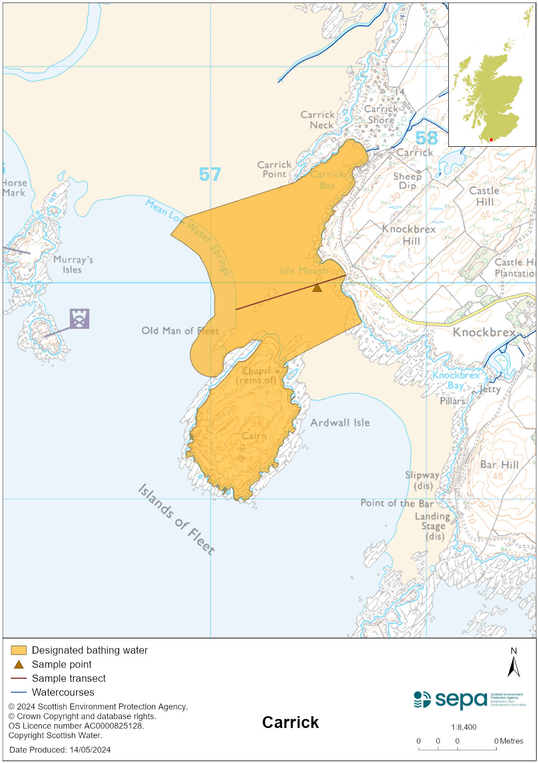

Map 2: Catchment draining into Carrick bathing water
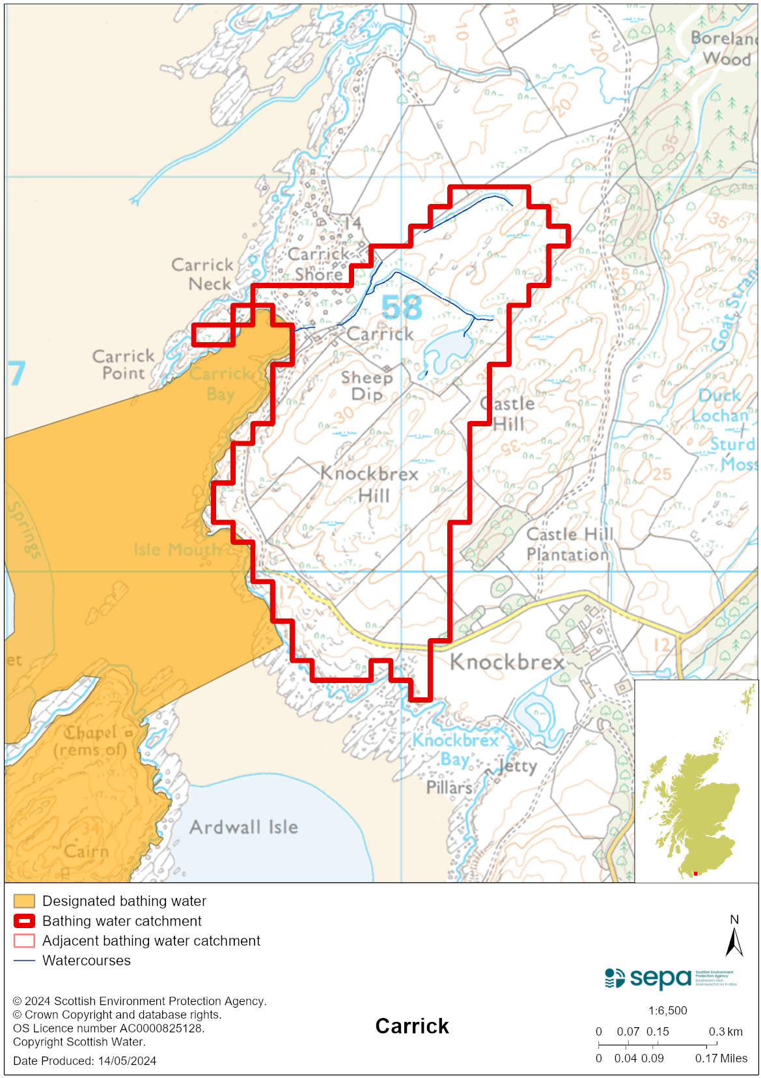

Improving bathing water quality

Sewage
Whilst Scottish Water provides most waste water collection and treatment services in Scotland, there are no Scottish Water assets in the vicinity of this bathing water.
There is a small private chalet development near the beach which drains via private sewage treatment systems to well-maintained soakaways.

Agriculture
Diffuse pollution from agricultural sources is the result of rain driven events causing cumulative inputs of pollutants to rivers and streams.

Farm visits were undertaken in the Galloway catchment during 2014. These visits looked to identify diffuse pollution sources and pathways. Mitigation measures were agreed with land managers to reduce the risk of bacterial pollution on water quality. All agricultural compliance work has been completed in this bathing water catchment and all farms are in a compliant state.

SEPA will continue to engage with farmers and the NFUS to remind them of good practice when applying slurries and manures and grazing livestock.

Cyanobacteria (blue-green algae), algae and jellyfish
Marine waters are not at risk of cyanobacteria overproduction. This bathing water is not at risk of excessive growth of macroalgae (seaweed) or phytoplankton.

The possibility of increased jellyfish numbers in the water during summer months is a naturally occurring phenomenon. Most species common to the UK are harmless; the Marine Conservation Society advises to ‘look but don’t touch’.

Pollution incidents
Pollution can be reported via our website online form or by calling our 24 hours a day Pollution Hotline number 0800 80 70 60

If pollution is reported to us, or identified by our routine water quality monitoring program, we will investigate and where necessary work with others to remediate. We may contact other relevant organisations including the local authority, that local health board, Scottish Water and Scottish Ministers.

If there is a risk to human health the local authority is responsible for placing signs at the bathing water. Information will also be available on our website.

Everyone can help to keep the bathing water clean:
- If you visit the beach with your dog clear up any fouling
- Don’t leave litter or feed birds - this encourages unnatural behaviour, and they can pollute the water
- At home, don’t flush wipes or other inappropriate items as these can block pipes and cause sewage spills

Contact details and information sources

SEPA bathing waters homepage

SEPA rainfall data

Scottish Government protected waters homepage

Dumfries and Galloway Council

For information on accessing this document in an alternative format or language, please contact SEPA by emailing equalities@sepa.org.uk
If you are a user of British Sign Language (BSL), the Contact Scotland BSL service gives you access to an online interpreter, enabling you to communicate with us using sign language. contactscotland-bsl.org

