Bathing water profile – Cruden Bay
Bathing water classification

Bathing water description
Cruden Bay bathing water, on the east coast of Aberdeenshire, is a long sandy bay. It is about 2.5 kilometres long and backed by sand dunes. It slopes gently towards the water. The beach is popular with tourists, water sport enthusiasts and for sea fishing. Depending on the tide, the distance to the water’s edge can vary from 0–200 metres.

Site details:
- Local authority: Aberdeenshire Council
- Year of designation: 2019
- Water sampling location: NK 08760 35464

Risks to water quality
This bathing water is subject to short term pollution following heavy rainfall. Bathing is not advised during or 1-2 days after heavy rainfall due to the risk to bathers’ health from water pollution.

Pollution risks include agricultural run-off and sewer overflows.

Water quality forecasts
As water quality is likely to be impacted by rainfall we make daily predictions of good or poor bathing water quality. We advise against bathing when poor water quality is predicted as there is an increased risk to bathers’ health from water pollution.

These predictions are displayed on the electronic sign at the beach and online between 15 May and 15 September.

Catchment description
A catchment area of 61 km2 drains into Cruden Bay bathing water. Its topography varies from gently rolling hills in the west to low-lying plains along the coast. The main rivers in the bathing water catchment are the Water of Cruden and the Laeca Burn. Slains Burn flows into the sea just to the north of the bathing water.
Agriculture is the major land use in the catchment. Most of the agricultural land supports mixed farming. The remaining land use is urban with Cruden Bay village as the main population centre.

Map 1: Cruden Bay bathing water
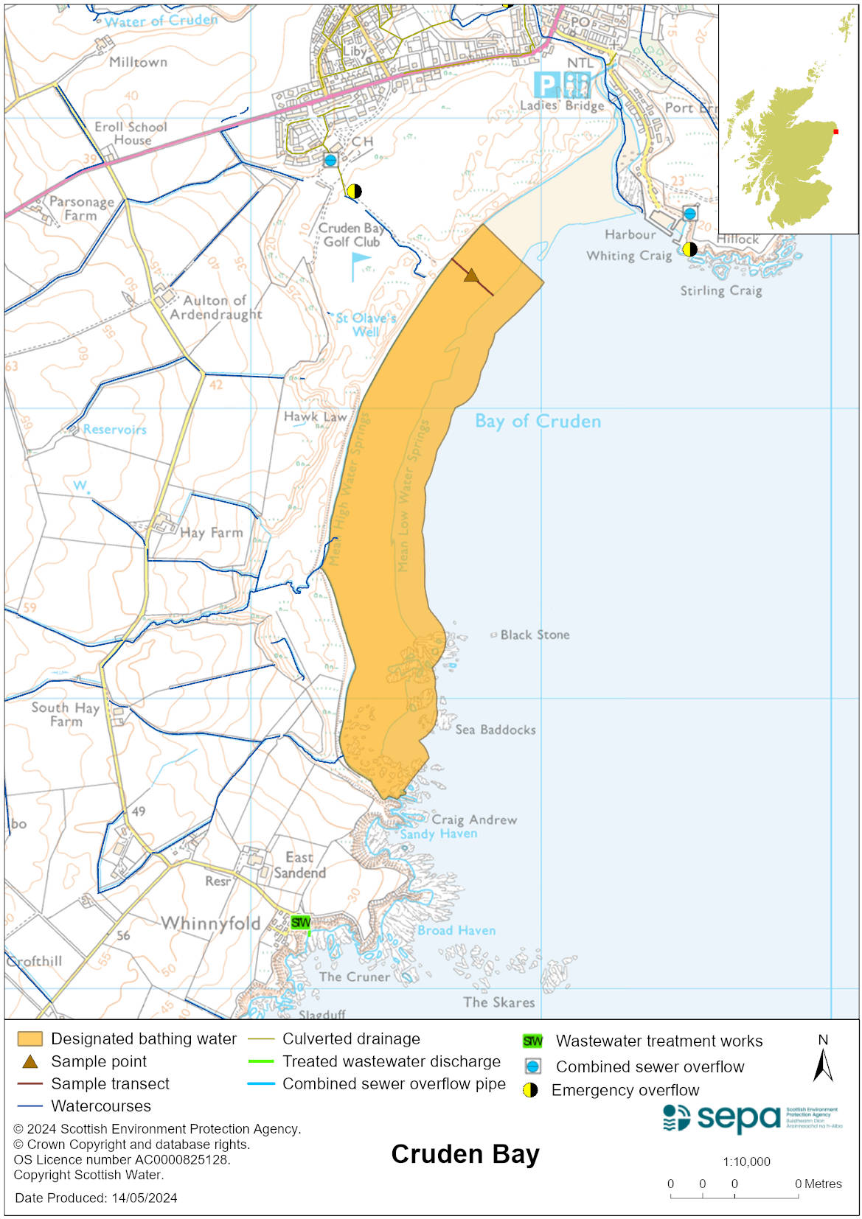

Map 2: Catchment draining into Cruden Bay bathing water
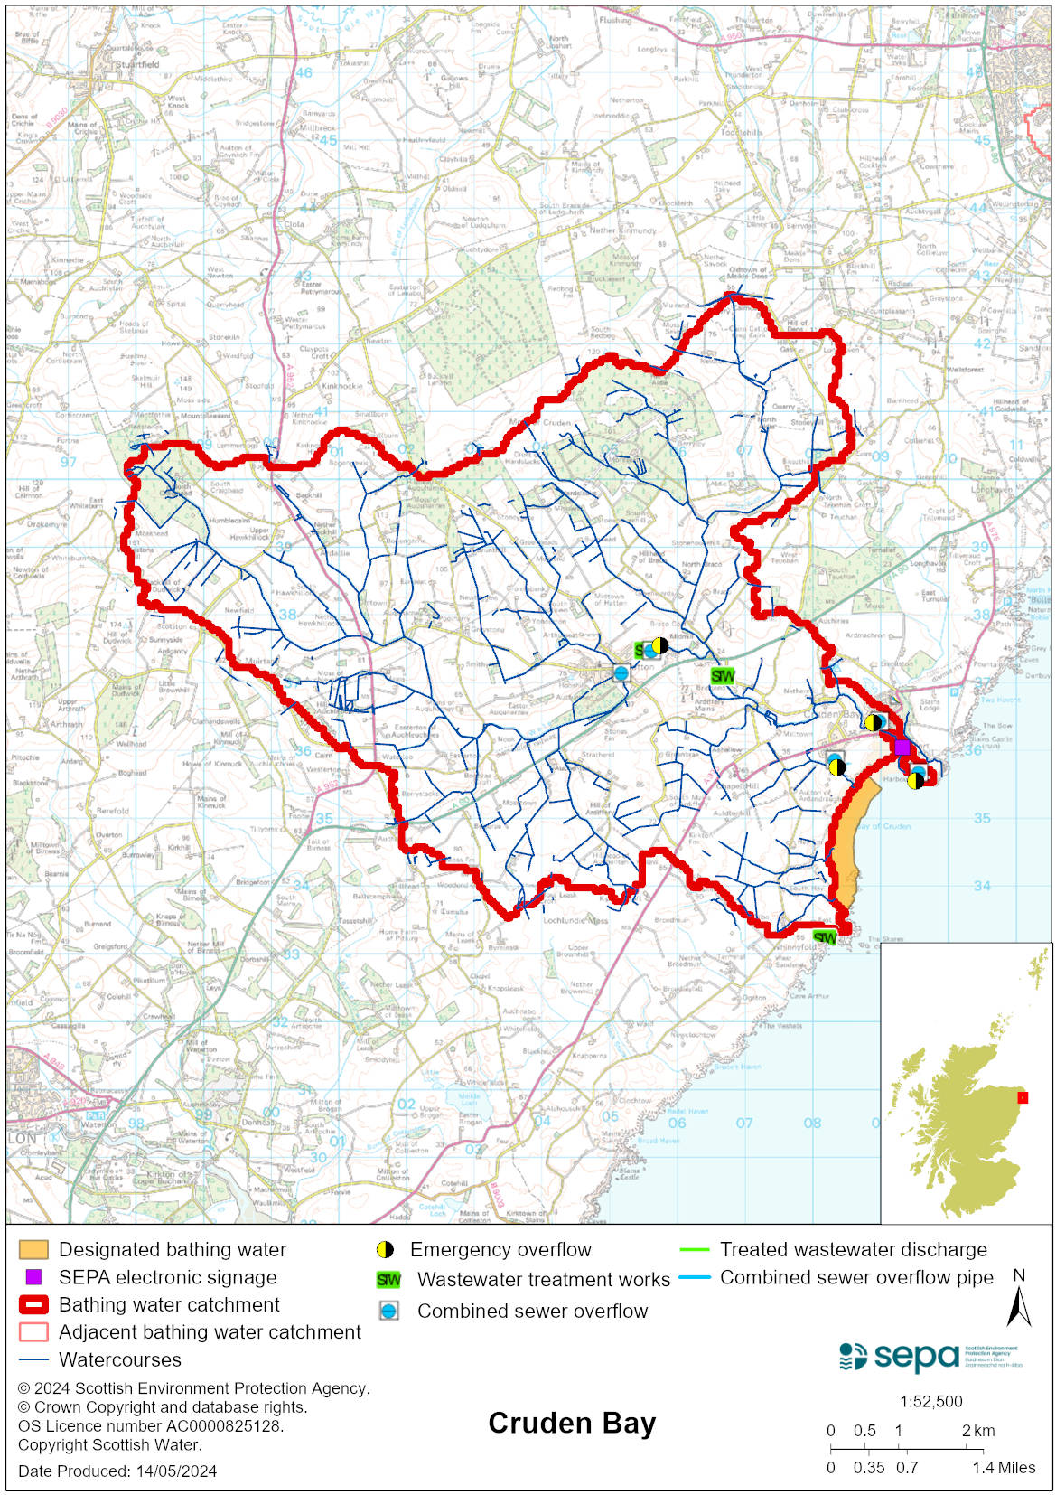

Improving bathing water quality

Sewage
Scottish Water provides most waste water collection and treatment services in Scotland.

Sewage from Cruden Bay village is treated at Peterhead sewage treatment works. Investment at Hatton sewage treatment works in 2009 has reduced bacterial loading to the Water of Cruden.

Several septic tank discharges to the Water of Cruden were removed and replaced by a soakaway in 2006.

Agriculture
Diffuse pollution from agricultural sources is the result of rain driven events causing cumulative inputs of pollutants to rivers and streams.

There is potential for agricultural diffuse pollution to occur in the in the Water of Cruden, Laeca Burn and Slains Burn. This is a risk to Cruden Bay’s bathing water quality, particularly during wet weather periods.

Farm visits were undertaken in the Buchan Coastal catchment during 2015. These visits looked to identify diffuse pollution sources and pathways. Mitigation measures were agreed with land managers to reduce the risk of bacterial pollution on water quality.

SEPA has observed significant changes in land management practice within the catchments and will continue to work with the farmers to reduce the risk of pollution to the bathing water.

Cyanobacteria (blue-green algae), algae and jellyfish
Marine waters are not at risk of cyanobacteria overproduction. This bathing water is not at risk of excessive growth of macroalgae (seaweed) or phytoplankton.

The possibility of increased jellyfish numbers in the water during summer months is a naturally occurring phenomenon. Most species common to the UK are harmless; the Marine Conservation Society advises to ‘look but don’t touch’.

Pollution incidents
Pollution can be reported via our website online form or by calling our 24 hours a day Pollution Hotline number 0800 80 70 60

If pollution is reported to us, or identified by our routine water quality monitoring program, we will investigate and where necessary work with others to remediate. We may contact other relevant organisations including the local authority, that local health board, Scottish Water and Scottish Ministers.

If there is a risk to human health the local authority is responsible for placing signs at the bathing water. Information will also be available on our website.

Everyone can help to keep the bathing water clean:
- If you visit the beach with your dog clear up any fouling
- Don’t leave litter or feed birds - this encourages unnatural behaviour, and they can pollute the water
- At home, don’t flush wipes or other inappropriate items as these can block pipes and cause sewage spills

Contact details and information sources

SEPA bathing waters homepage

SEPA rainfall data

Scottish Government protected waters homepage

Aberdeenshire Council

For information on accessing this document in an alternative format or language, please contact SEPA by emailing equalities@sepa.org.uk
If you are a user of British Sign Language (BSL), the Contact Scotland BSL service gives you access to an online interpreter, enabling you to communicate with us using sign language. contactscotland-bsl.org

