Bathing water profile – Luss Bay
Bathing water classification

Bathing water description
Luss Bay is a relatively small freshwater bay of about 400 metres long. It on the midwest shore on the coast of Loch Lomond, west of Inchlonaig Island. It is located at the conservation village of Luss and owned by Luss Estates. The area is part of the Loch Lomond and Trossachs National Park. The sandy beach is ideal for paddling and is often used by families with young children. The northern portion of the beach is privately owned and is not accessible to the public.

Site details:
- Local authority: Argyll and Bute Council
- Year of designation: 1999
- Water sampling location: NS 36015 93296

Risks to water quality
This bathing water is subject to short term pollution following heavy rainfall. Bathing is not advised during or 1-2 days after heavy rainfall due to the risk to bathers’ health from water pollution.

Pollution risks include gull and dog fouling.

Water quality forecasts
As water quality is likely to be impacted by rainfall we make daily predictions of good or poor bathing water quality. We advise against bathing when poor water quality is predicted as there is an increased risk to bathers’ health from water pollution.

These predictions are displayed on the electronic sign at the beach and online between 15 May and 15 September.

Catchment description
The bathing water catchment extends to 37 km2. The area is mountainous with the highest peaks being Beinn Eich (703 metres) in the north-west and Deinn Chaorach (713 metres) to the west of the bay. These two peaks form the steep valley along which Luss Water flows.
The area is mainly rural (99%) with agriculture the major land use. The catchment supports mixed sheep and cattle farming. Less than one percent of the catchment is urban. The main population centre is Luss.
The main rivers within the catchment are the Luss Water, Auchengavin Burn, Sron an Laoign Burn and Mollochan Burn.
There are Special Areas of Conservation and a Site of Special Scientific Interest in the catchment.

Map 1: Luss Bay bathing water
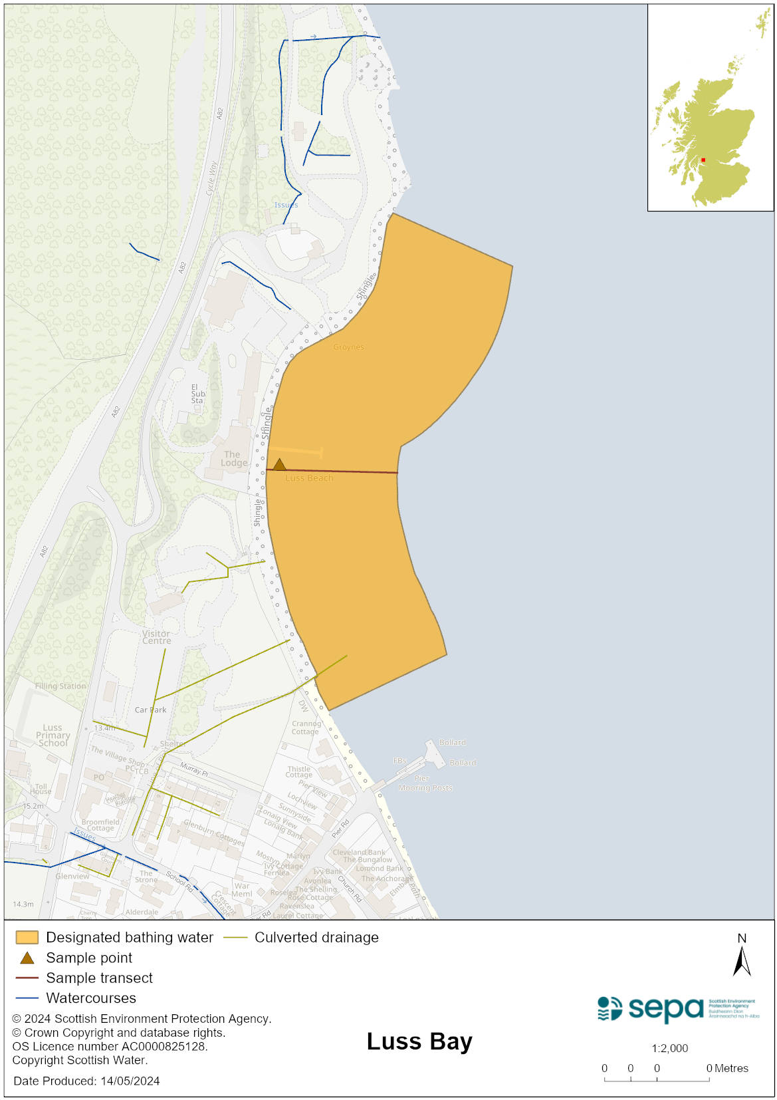

Map 2: Catchment draining into Luss Bay bathing water
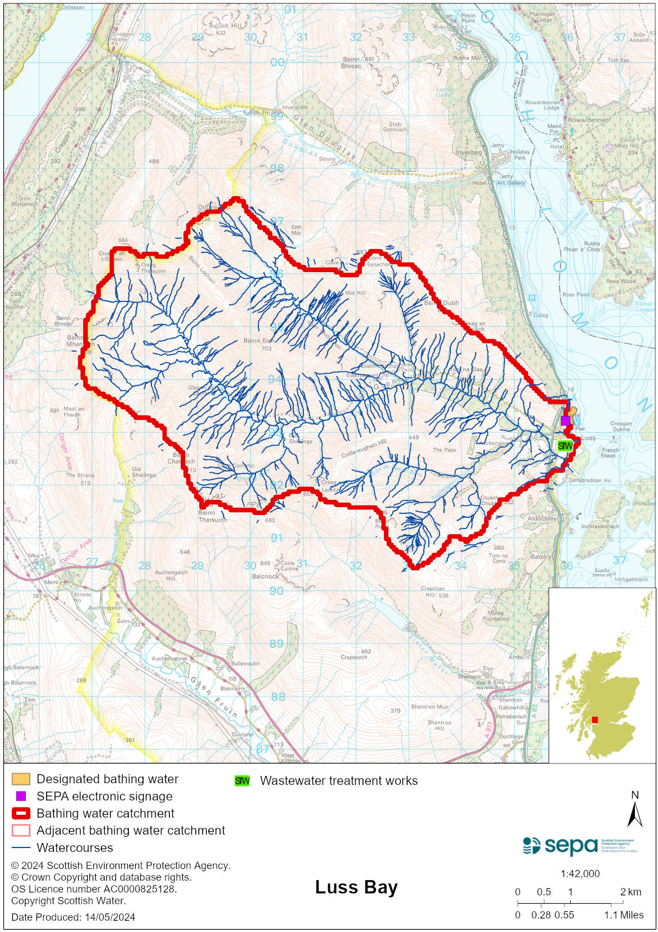

Improving bathing water quality

Sewage
Scottish Water provides most waste water collection and treatment services in Scotland.

Sewage from the caravan site, campsite and local hotels is treated at Luss Sewage Treatment Works. During the bathing season, treatment at the works includes the use of ultraviolet disinfection to treat the final sewage effluent. SEPA monitor and inspect the works and the network prior to and throughout the bathing season to ensure compliance with licence conditions which are in place to ensure protection of the water environment.

There are a small number of properties with private septic tanks which discharge to rivers and soakaways. The risk to the water environment from these discharges is not thought to be significant.

Agriculture
Diffuse pollution from agricultural sources is the result of rain driven events causing cumulative inputs of pollutants to rivers and streams.

SEPA has assessed the agricultural activity taking place within the catchment in 2022 and is content that agriculture does not have a significant impact on Luss bathing water.

Other
Pollution from dog and gull fouling can impact Luss bathing water. Visitors can help to keep the bathing water clean by not leaving litter or feeding the gulls, as this encourages them, and they can pollute the water. Visitors with dogs should clean up any fouling. SEPA is currently working with stakeholders to address these issues.

Cyanobacteria (blue-green algae), algae and jellyfish
Marine waters are not at risk of cyanobacteria overproduction. This bathing water is not at risk of excessive growth of macroalgae (seaweed) or phytoplankton.

The possibility of increased jellyfish numbers in the water during summer months is a naturally occurring phenomenon. Most species common to the UK are harmless; the Marine Conservation Society advises to ‘look but don’t touch’.

Pollution incidents
Pollution can be reported via our website online form or by calling our 24 hours a day Pollution Hotline number 0800 80 70 60

If pollution is reported to us, or identified by our routine water quality monitoring program, we will investigate and where necessary work with others to remediate. We may contact other relevant organisations including the local authority, that local health board, Scottish Water and Scottish Ministers.

If there is a risk to human health the local authority is responsible for placing signs at the bathing water. Information will also be available on our website.

Everyone can help to keep the bathing water clean:
- If you visit the beach with your dog clear up any fouling
- Don’t leave litter or feed birds - this encourages unnatural behaviour, and they can pollute the water
- At home, don’t flush wipes or other inappropriate items as these can block pipes and cause sewage spills

Contact details and information sources

SEPA bathing waters homepage

SEPA rainfall data

Scottish Government protected waters homepage

Argyll and Bute Council

For information on accessing this document in an alternative format or language, please contact SEPA by emailing equalities@sepa.org.uk
If you are a user of British Sign Language (BSL), the Contact Scotland BSL service gives you access to an online interpreter, enabling you to communicate with us using sign language. contactscotland-bsl.org

