Bathing water profile – North Berwick (West)
Bathing water classification

Bathing water description
The North Berwick (West) bathing water is on the northern coast of North Berwick in East Lothian. The sandy beach is approximately 600 metres long. The area is popular with families. There is a small paddling area which retains water when the tide is out. The nearby Scottish Seabird Centre also attracts many visitors. Depending on the tide, the distance to the water’s edge can vary from 0–130 metres.

Site details:
- Local authority: East Lothian Council
- Year of designation: 1999
- Water sampling location: NT 55164 85462

Risks to water quality
This bathing water is at risk of short term pollution following heavy rainfall. Bathing is not advised during or 1-2 days after heavy rainfall due to the risk to bathers’ health from water pollution.

Pollution risks include sewer overflows.

Catchment description
The catchment draining into the North Berwick (West) bathing water extends to 1.5 km2. The area is a mixture of urban and rural land. The main population centre within the catchment is the town of North Berwick.
There are several protected areas within or near the bathing water or catchment. This includes two Special Protection Areas, two Sites of Special Scientific Interest and a Ramsar site.

Map 1: North Berwick (West) bathing water
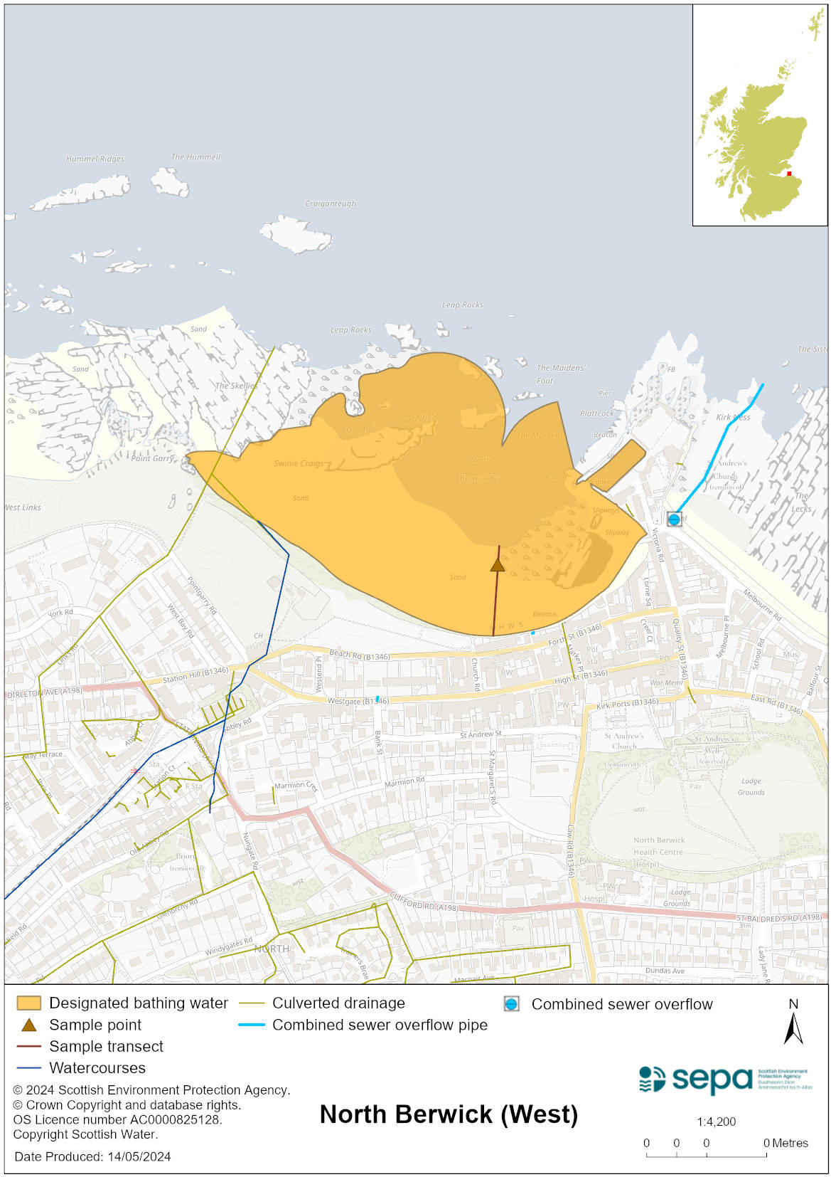

Map 2: Catchment draining into North Berwick (West) bathing water
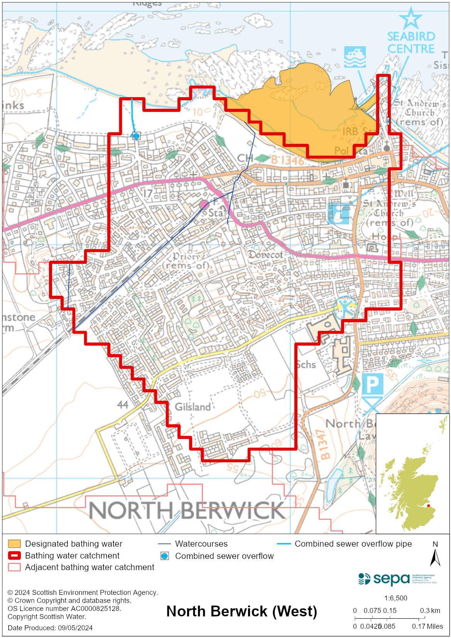

Improving bathing water quality

Sewage
Scottish Water provides most waste water collection and treatment services in Scotland.

Sewage from North Berwick is treated at North Berwick sewage treatment works before being discharged to the Firth of Forth via a long sea outfall to the East of North Berwick.
There is combined sewer overflow (CSO) to the west and east of the bathing water. These may discharge and impact the bathing water during heavy rainfall.

Agriculture
There are no impacts from agriculture affecting this bathing water.

Cyanobacteria (blue-green algae), algae and jellyfish
Marine waters are not at risk of cyanobacteria overproduction. This bathing water is not at risk of excessive growth of macroalgae (seaweed) or phytoplankton.

The possibility of increased jellyfish numbers in the water during summer months is a naturally occurring phenomenon. Most species common to the UK are harmless; the Marine Conservation Society advises to ‘look but don’t touch’.

Pollution incidents
Pollution can be reported via our website online form or by calling our 24 hours a day Pollution Hotline number 0800 80 70 60

If pollution is reported to us, or identified by our routine water quality monitoring program, we will investigate and where necessary work with others to remediate. We may contact other relevant organisations including the local authority, that local health board, Scottish Water and Scottish Ministers.

If there is a risk to human health the local authority is responsible for placing signs at the bathing water. Information will also be available on our website.

Everyone can help to keep the bathing water clean:
- If you visit the beach with your dog clear up any fouling
- Don’t leave litter or feed birds - this encourages unnatural behaviour, and they can pollute the water
- At home, don’t flush wipes or other inappropriate items as these can block pipes and cause sewage spills

Contact details and information sources

SEPA bathing waters homepage

SEPA rainfall data

Scottish Government protected waters homepage

East Lothian Council

For information on accessing this document in an alternative format or language, please contact SEPA by emailing equalities@sepa.org.uk
If you are a user of British Sign Language (BSL), the Contact Scotland BSL service gives you access to an online interpreter, enabling you to communicate with us using sign language. contactscotland-bsl.org

