Bathing water profile - Balmedie
Bathing water classification

Bathing water description
Balmedie beach is an extensive sandy beach on the Aberdeenshire coast. It is adjacent to the Balmedie Country Park. The bathing area is centred round the main access routes to the beach from the country park. Kite surfing and other water sports are popular here. Depending on the tide, the approximate distance to the water’s edge can vary from 0-200 metres. The sandy beach slopes gently towards the water.

Site details:
- Local authority: Aberdeenshire Council
- Year of designation: 1999
- Water sampling location: NJ 98050 18330

Risks to water quality
This bathing water is at risk of short term pollution following heavy rainfall. Bathing is not advised during or 1-2 days after heavy rainfall due to the risk to bathers’ health from water pollution.

Pollution risks include agricultural run-off and sewer overflows.

Catchment description
The catchment draining into Balmedie bathing water extends to 23 km2. The area varies from gently rolling hills in the west to the low-lying plains along the coast. The main rivers within the catchment are the Eigie Burn and Potterton Burn. Both burns enter the sea near the southern end of the bathing area.
The area is mainly rural (93%) with 41% arable agriculture and 47% grassland. Land use in the catchments of the Potterton and Eigie Burns is mainly arable farming with some small holdings supporting livestock. Approximately 3% of the catchment is urban with Balmedie village the main population centre.
There is a Site of Special Scientific Interest within the catchment. The catchment also lies within a designated Nitrate Vulnerable Zone.

Map 1: Balmedie bathing water
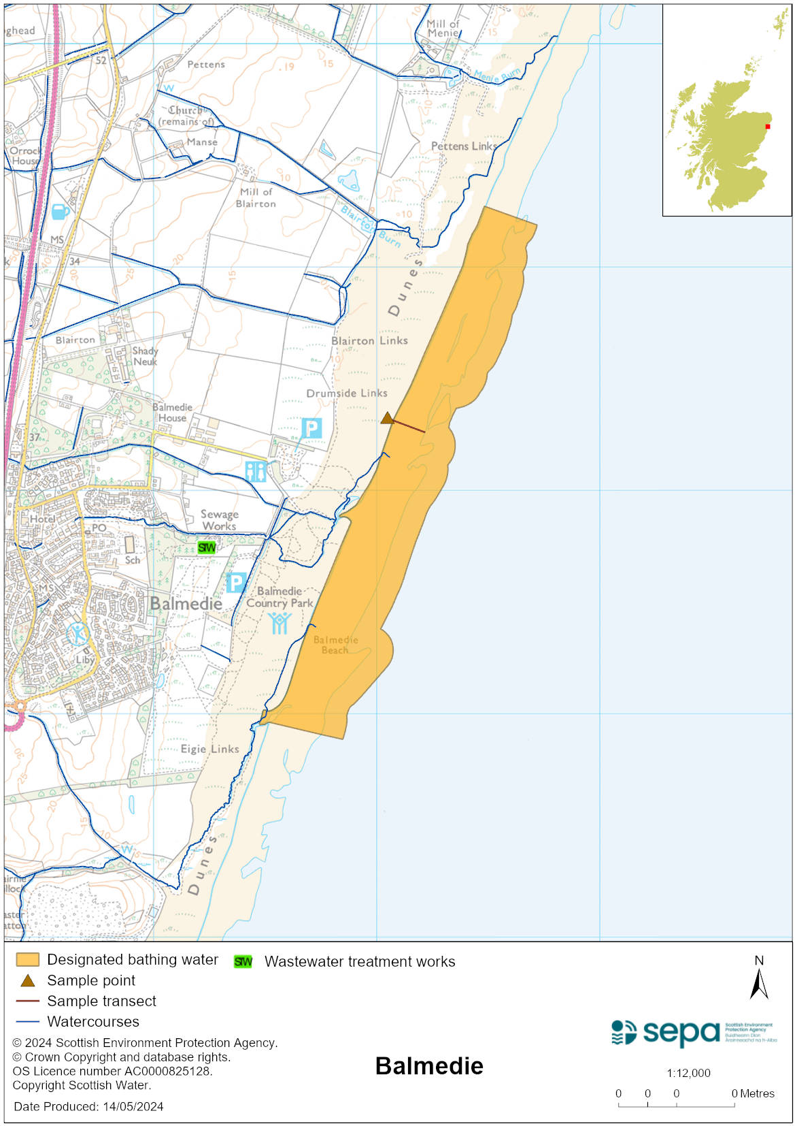

Map 2: Catchment draining into Balmedie bathing water
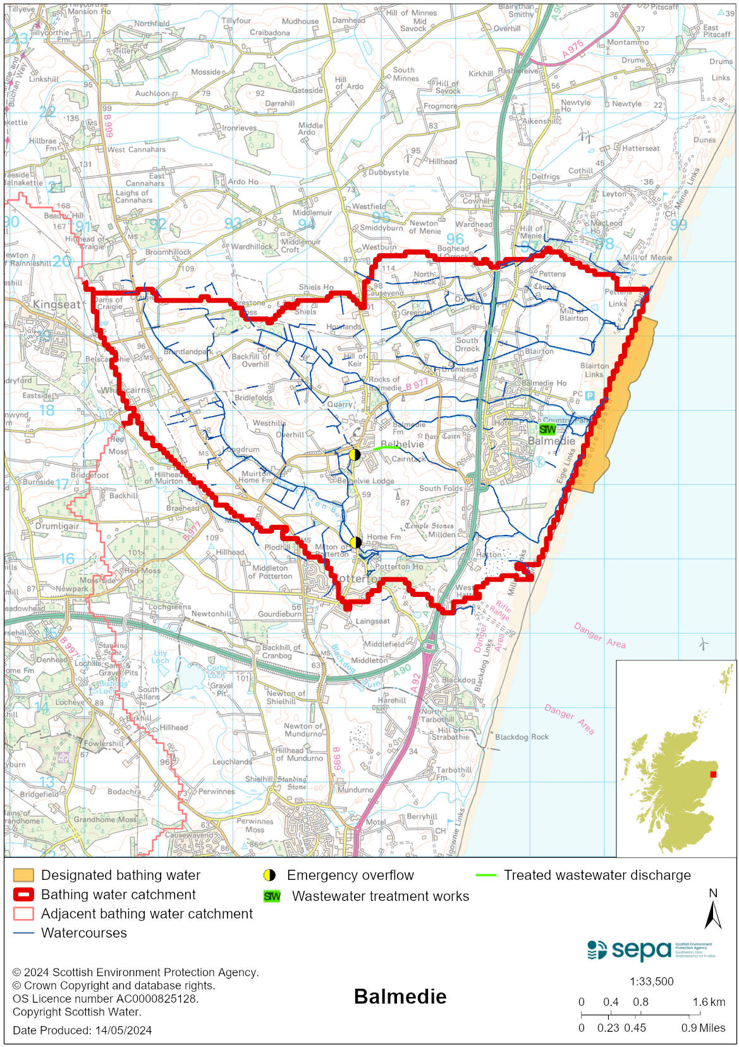

Improving bathing water quality

Sewage
Scottish Water provides most waste water collection and treatment services in Scotland.

The Balmedie sewage treatment works provides secondary treatment for local sewage including from the nearby village of Newburgh. Treated effluent and any combined sewage overflow from the works is discharged via a long sea outfall approximately 1 km offshore from SEPA’s bathing water sampling point.

There are many septic tank discharges from private dwellings to the Potterton and Eigie burns. SEPA has assessed the risk to the water environment from the cumulative impacts of these discharges, and they are thought to pose a potential risk to bathing water quality. It is unlikely that consent will be granted for any further septic tank discharges to the lower reaches of the Eigie Burn when connection to the public sewer is an option.

Agriculture
Diffuse pollution from agricultural sources is the result of rain driven events causing cumulative inputs of pollutants to rivers and streams.

There is the potential for agricultural diffuse pollution to occur in the Eigie and Potterson Burns. This is a risk to Balmedie’s bathing water quality, particularly during periods of wet weather. Farm visits have been on going in the catchment since 2014. These visits looked to identify diffuse pollution sources and provide advice on possible mitigation measure farmers could employ to reduce the risk of pollution.

SEPA has observed significant changes in land management practice within the catchments and will continue to work with the farmers to reduce the risk of pollution to the bathing water.

Cyanobacteria (blue-green algae), algae and jellyfish
Marine waters are not at risk of cyanobacteria overproduction. This bathing water is not at risk of excessive growth of macroalgae (seaweed) or phytoplankton.

The possibility of increased jellyfish numbers in the water during summer months is a naturally occurring phenomenon. Most species common to the UK are harmless; the Marine Conservation Society advises to ‘look but don’t touch’.

Pollution incidents
Pollution can be reported via our website online form or by calling our 24 hours a day Pollution Hotline number 0800 80 70 60

If pollution is reported to us, or identified by our routine water quality monitoring program, we will investigate and where necessary work with others to remediate. We may contact other relevant organisations including the local authority, that local health board, Scottish Water and Scottish Ministers.

If there is a risk to human health the local authority is responsible for placing signs at the bathing water. Information will also be available on our website.

Everyone can help to keep the bathing water clean:
- If you visit the beach with your dog clear up any fouling
- Don’t leave litter or feed birds - this encourages unnatural behaviour, and they can pollute the water
- At home, don’t flush wipes or other inappropriate items as these can block pipes and cause sewage spills

Contact details and information sources

SEPA bathing waters homepage

SEPA rainfall data

Scottish Government protected waters homepage

Aberdeenshire Council

For information on accessing this document in an alternative format or language, please contact SEPA by emailing equalities@sepa.org.uk
If you are a user of British Sign Language (BSL), the Contact Scotland BSL service gives you access to an online interpreter, enabling you to communicate with us using sign language. contactscotland-bsl.org

