Bathing water profile - Montrose
Bathing water classification

Bathing water description
Montrose bathing water is located east of Montrose town. The sandy beach is about 900 metres long and slopes gently towards the water. It is popular with families and there are various amenities in the area. Depending on the tide, the distance to the water’s edge can vary from 60–200 metres. At high tide the water can come right up to the sea wall at East Links, completely covering this stretch of the beach.

Site details:
- Local authority: Angus Council
- Year of designation: 1987
- Water sampling location: NO 72853 57869

Risks to water quality
This bathing water is at risk of short term pollution following heavy rainfall. Bathing is not advised during or 1-2 days after heavy rainfall due to the risk to bathers’ health from water pollution.

Pollution risks include sewer overflows.

Catchment description
The Montrose bathing water catchment extends to 609 km2. The area is mainly rural (86%), with arable agriculture and grassland. Approximately 1% of the catchment is urban. The main population centres are the towns of Montrose and Brechin.
The main rivers in the catchment are the River South Esk and its tributaries, the Prosen Water, the Noran Water and the Pow Burn.
There are several protected areas either fully or partly within the bathing water or the catchment. This includes two Special Areas of Conservation, three Special Protection Areas, 15 Sites of Special Scientific Interest (SSSI) and one Ramsar site. The Strathmore and Fife area was a surface water Nitrate Vulnerable Zone in 2002.

Map 1: Montrose bathing water
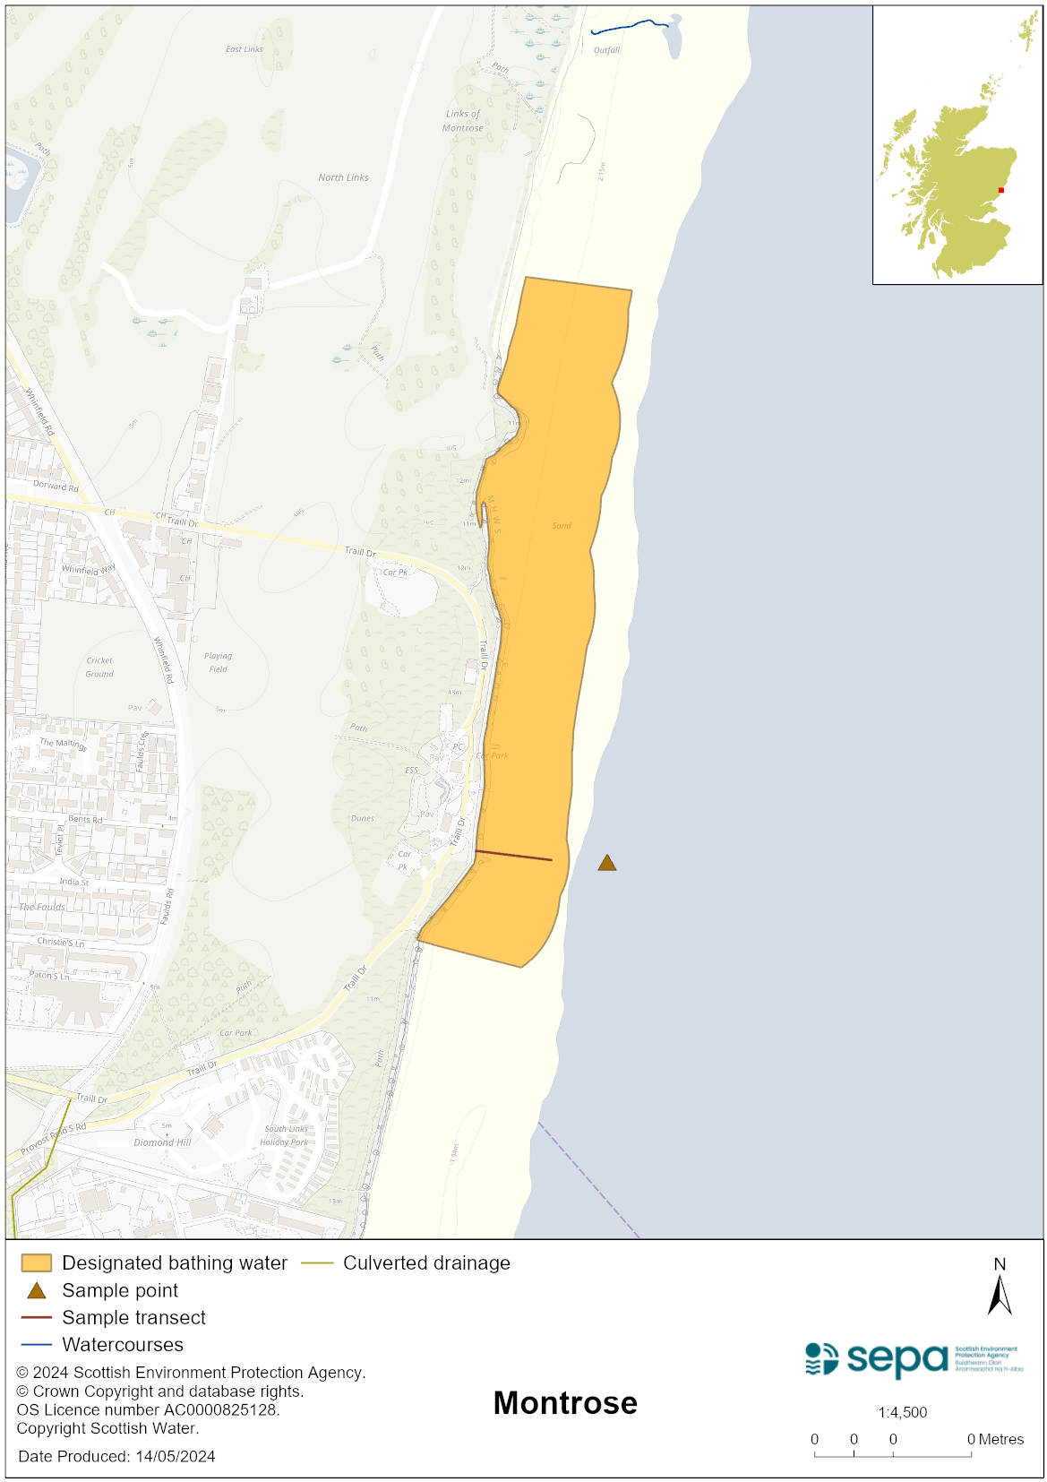

Map 2: Catchment draining into Montrose bathing water
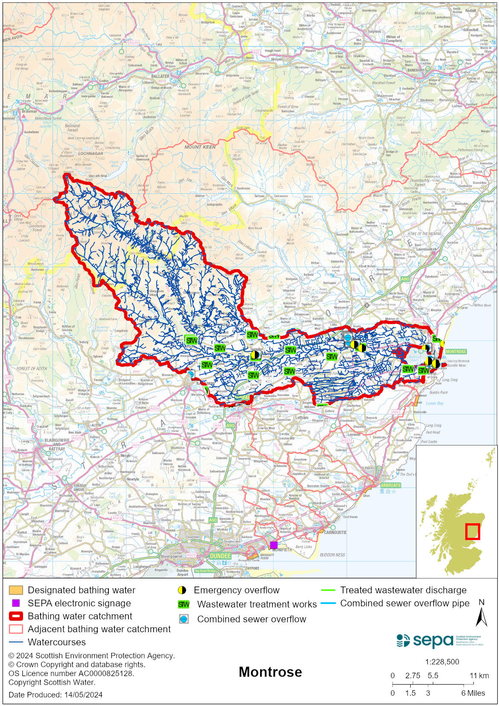

Improving bathing water quality

Sewage
Scottish Water provides most waste water collection and treatment services in Scotland.

Montrose sewage treatment works and its associated overflows, including storm storage and screening, are designed to ensure high water quality at the Montrose bathing water.

Agriculture
There are no impacts from agriculture affecting this bathing water.

Cyanobacteria (blue-green algae), algae and jellyfish
Marine waters are not at risk of cyanobacteria overproduction. This bathing water is not at risk of excessive growth of macroalgae (seaweed) or phytoplankton.

The possibility of increased jellyfish numbers in the water during summer months is a naturally occurring phenomenon. Most species common to the UK are harmless; the Marine Conservation Society advises to ‘look but don’t touch’.

Pollution incidents
Pollution can be reported via our website online form or by calling our 24 hours a day Pollution Hotline number 0800 80 70 60

If pollution is reported to us, or identified by our routine water quality monitoring program, we will investigate and where necessary work with others to remediate. We may contact other relevant organisations including the local authority, that local health board, Scottish Water and Scottish Ministers.

If there is a risk to human health the local authority is responsible for placing signs at the bathing water. Information will also be available on our website.

Everyone can help to keep the bathing water clean:
- If you visit the beach with your dog clear up any fouling
- Don’t leave litter or feed birds - this encourages unnatural behaviour, and they can pollute the water
- At home, don’t flush wipes or other inappropriate items as these can block pipes and cause sewage spills

Contact details and information sources

SEPA bathing waters homepage

SEPA rainfall data

Scottish Government protected waters homepage

Angus Council

For information on accessing this document in an alternative format or language, please contact SEPA by emailing equalities@sepa.org.uk
If you are a user of British Sign Language (BSL), the Contact Scotland BSL service gives you access to an online interpreter, enabling you to communicate with us using sign language. contactscotland-bsl.org

