Bathing water profile – Sand Beach
Bathing water classification

Bathing water description
Sand Beach is a sand and shingle beach. It is found beside Big Sand and to the west of Gairloch village. There is a campsite close to the beach. Gairloch is popular for a number of recreational activities including swimming, boating and snorkelling.
The headland south of Big Sand is a North West Highland Snorkel Trail site.
Depending on the tide, there can be 50-200 metres of beach before the water’s edge.

Site details:
- Local authority: Highland Council
- Year of designation: 2017
- Water sampling location: NG 75860 77940

Risks to water quality
This bathing water is at risk of short term pollution following heavy rainfall. Bathing is not advised during or 1-2 days after heavy rainfall due to the risk to bathers’ health from water pollution.

Pollution risks include those from sewerage.

Catchment description
Sand Beach bathing water has a hilly catchment area of 17 km2. Land use comprises of bogland, heather grassland, rough grassland and improved grassland. There is very little urban development and population density is low. There is a caravan and camping site located close to the beach.
The Allt nan Easan Bàna and the Allt Bualie a’ Cheathaich flow directly into the designated bathing beach area. The River Sand flows from the hills and the tidal section flows adjacent to the northwestern boundary of the bathing water.

Map 1: Sand Beach bathing water
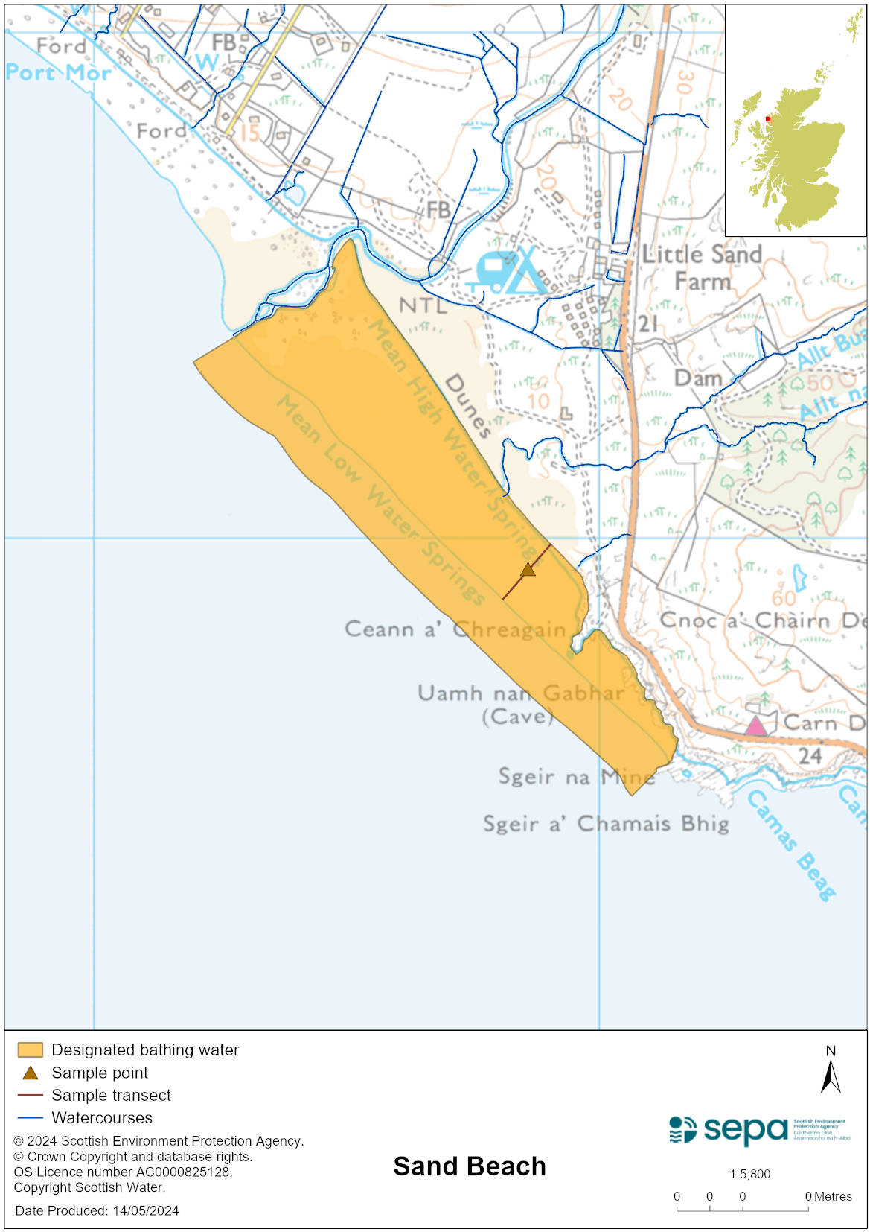

Map 2: Catchment draining into Sand Beach bathing water
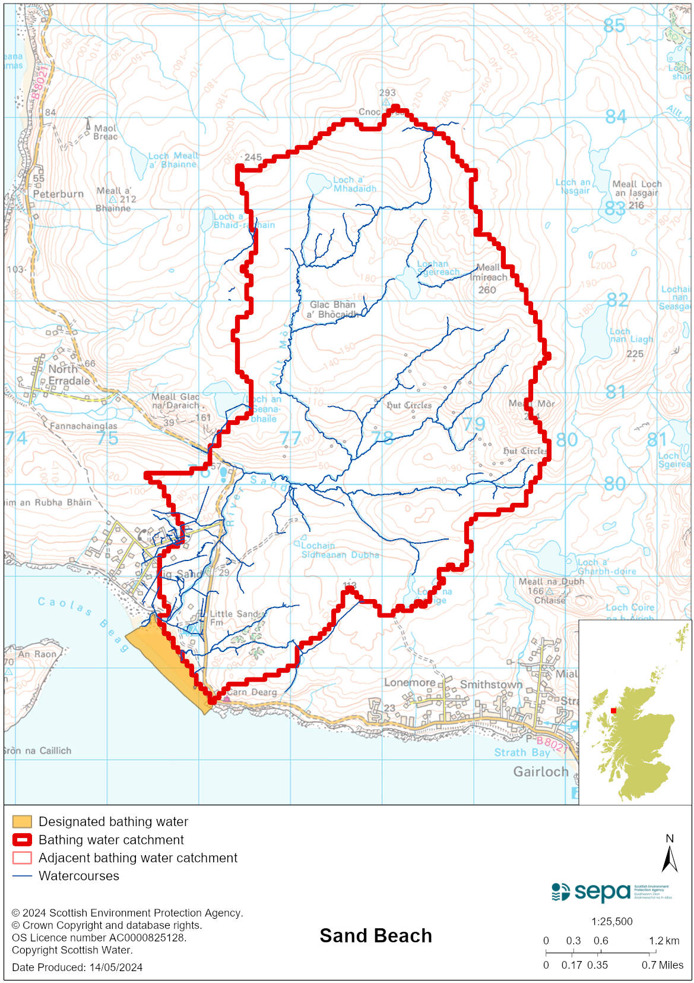

Improving bathing water quality

Sewage
Scottish Water provides most waste water collection and treatment services in Scotland.

Scottish Water provides public wastewater collection and treatment services in the village of Gairloch to the east of Sand Beach, but not in the immediately surrounding area of Big Sand, which is served by private systems.

Private sewerage discharges to the River Sand and Loch Gairloch include those from a caravan park, youth hostel and homes.

Agriculture
There are no impacts from agriculture affecting this bathing water.

Cyanobacteria (blue-green algae), algae and jellyfish
Marine waters are not at risk of cyanobacteria overproduction. This bathing water is not at risk of excessive growth of macroalgae (seaweed) or phytoplankton.

The possibility of increased jellyfish numbers in the water during summer months is a naturally occurring phenomenon. Most species common to the UK are harmless; the Marine Conservation Society advises to ‘look but don’t touch’.

Pollution incidents
Pollution can be reported via our website online form or by calling our 24 hours a day Pollution Hotline number 0800 80 70 60

If pollution is reported to us, or identified by our routine water quality monitoring program, we will investigate and where necessary work with others to remediate. We may contact other relevant organisations including the local authority, that local health board, Scottish Water and Scottish Ministers.

If there is a risk to human health the local authority is responsible for placing signs at the bathing water. Information will also be available on our website.

Everyone can help to keep the bathing water clean:
- If you visit the beach with your dog clear up any fouling
- Don’t leave litter or feed birds - this encourages unnatural behaviour, and they can pollute the water
- At home, don’t flush wipes or other inappropriate items as these can block pipes and cause sewage spills

Contact details and information sources

SEPA bathing waters homepage

SEPA rainfall data

Scottish Government protected waters homepage

Highland Council

For information on accessing this document in an alternative format or language, please contact SEPA by emailing equalities@sepa.org.uk
If you are a user of British Sign Language (BSL), the Contact Scotland BSL service gives you access to an online interpreter, enabling you to communicate with us using sign language. contactscotland-bsl.org

