Bathing water profile - Inverboyndie
Bathing water classification

Bathing water description
Inverboyndie bathing water is close to the small town of Inverboyndie in Aberdeenshire. It is a relatively small, shallow bay, about 700 metres long. The beach is popular for surfing, windsurfing, bathing and wildlife walks. Depending on the tide, the approximate distance to the water’s edge can vary from 0–180 metres. The beach slopes gently towards the water.

Site details:
- Local authority: Aberdeenshire Council
- Year of designation: 1999
- Water sampling location: NJ 67187 64743

Risks to water quality
This bathing water is at risk of short term pollution following heavy rainfall. Bathing is not advised during or 1-2 days after heavy rainfall due to the risk to bathers’ health from water pollution.

Pollution risks include agricultural run-off, sewer overflows and surface water discharges.

Catchment description
The Inverboyndie bathing water catchment extends to 30 km2. The catchment varies from hills in the south to low-lying plains along the coast. The main river within the catchment is the Boyndie Burn which enters the sea at the western end of the bathing area.
The area is mainly rural (99%) with agriculture the major land use. The agricultural land is split between arable farming (65%) and grassland (27%). The area supports mixed farming. Approximately 1% of the catchment is urban. The main population centre is the village of Inverboyndie within 1 km of the bathing water. Population density outside of Inverboyndie is generally low. The larger town of Banff is outside of the catchment, east of the bathing water.

Map 1: Inverboyndie bathing water
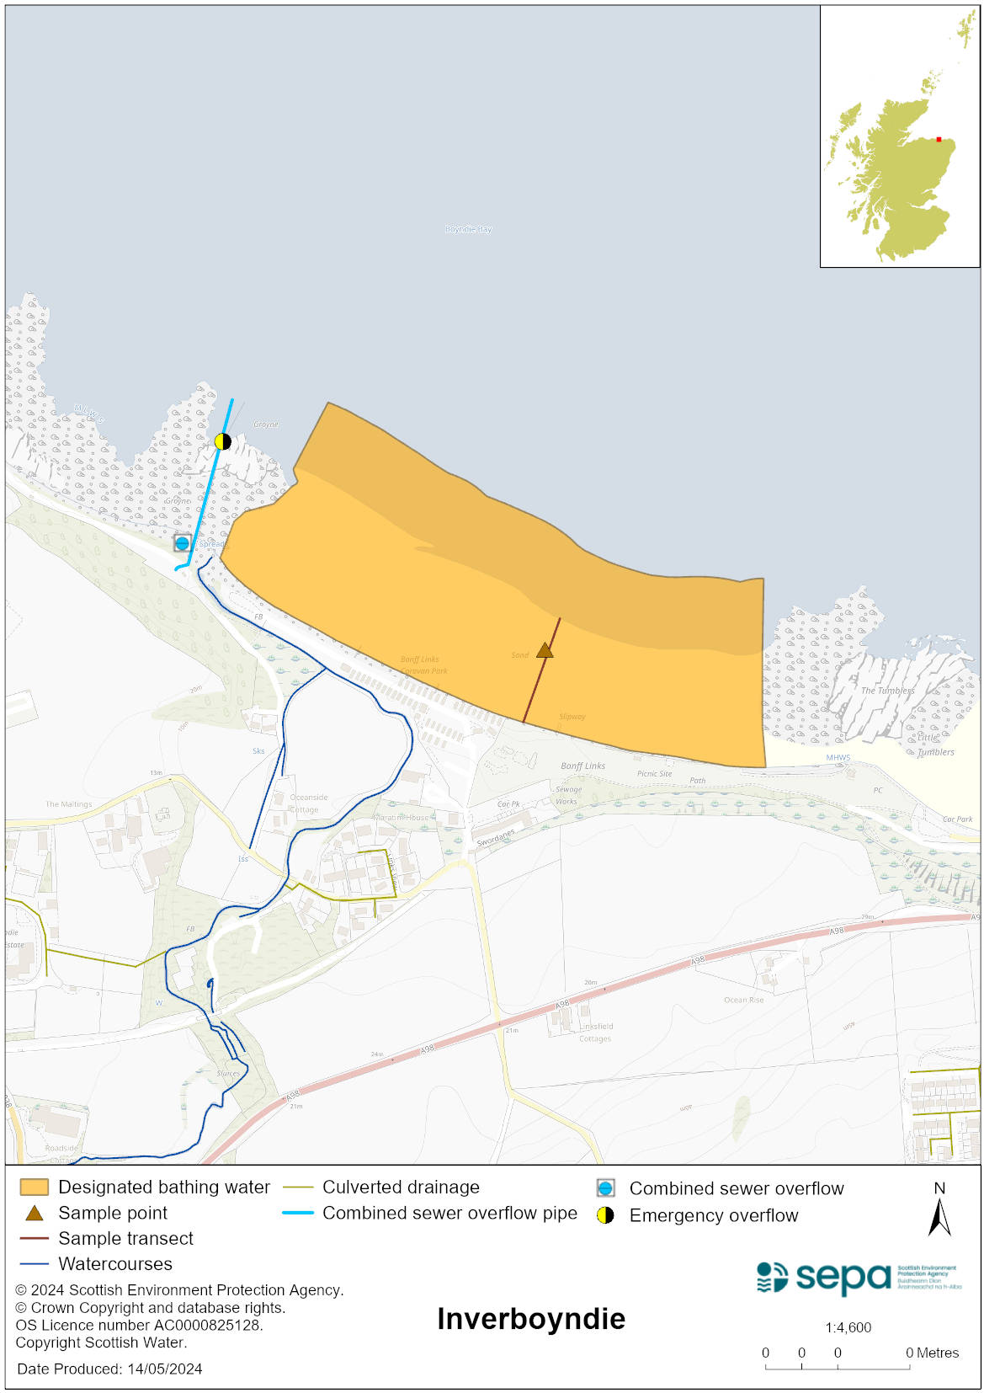

Map 2: Catchment draining into Inverboyndie bathing water
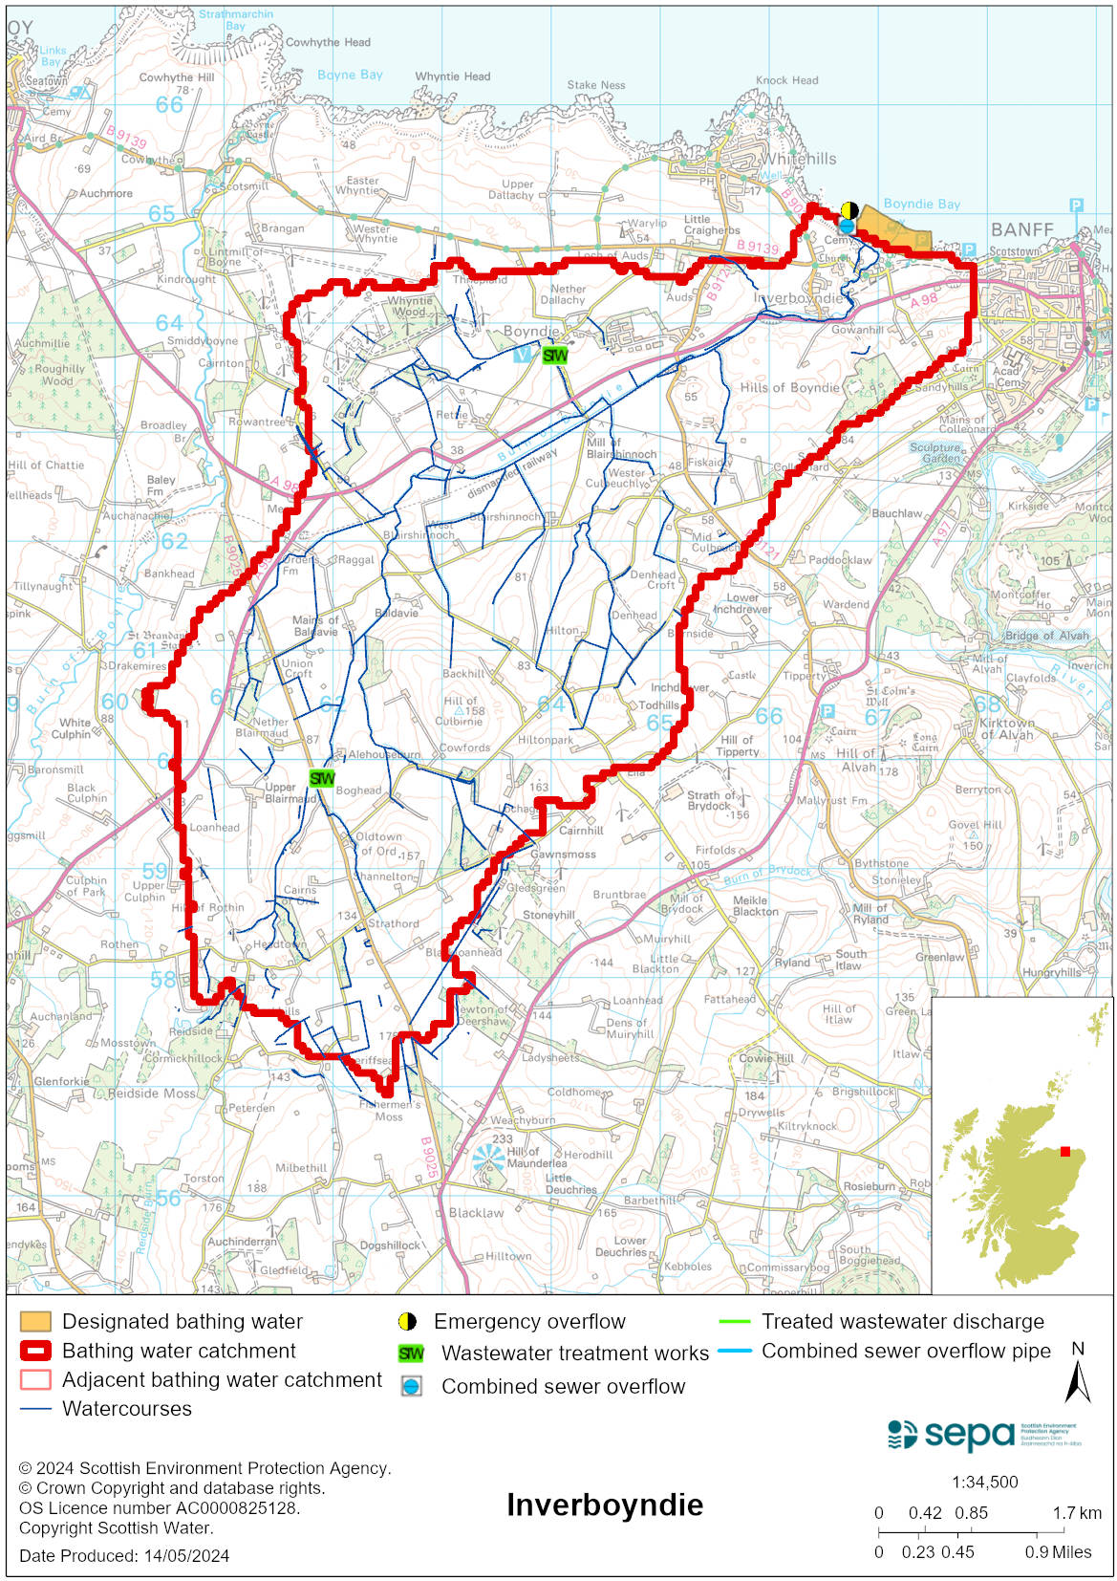

Improving bathing water quality

Sewage
Scottish Water provides most waste water collection and treatment services in Scotland.

Septic tanks serving the caravan site adjacent to the bathing water are connected to the public sewer. There are several other septic tanks in the local area.

Agriculture
Diffuse pollution from agricultural sources is the result of rain driven events causing cumulative inputs of pollutants to rivers and streams.

The bathing water catchment lies within the Banff Coastal priority catchment where work with land managers will take place. Work to address diffuse pollution in the catchment is expected to be completed by 2027.

Urban
Urban diffuse source pollution comes from contaminated rainwater discharging to rivers and streams. The Boyndie Burn is thought to be affected by surface water run-off. It flows through the urban area and the Inverboyndie industrial estate before entering the sea.

Cyanobacteria (blue-green algae), algae and jellyfish
Marine waters are not at risk of cyanobacteria overproduction. This bathing water is not at risk of excessive growth of macroalgae (seaweed) or phytoplankton.

The possibility of increased jellyfish numbers in the water during summer months is a naturally occurring phenomenon. Most species common to the UK are harmless; the Marine Conservation Society advises to ‘look but don’t touch’.

Pollution incidents
Pollution can be reported via our website online form or by calling our 24 hours a day Pollution Hotline number 0800 80 70 60

If pollution is reported to us, or identified by our routine water quality monitoring program, we will investigate and where necessary work with others to remediate. We may contact other relevant organisations including the local authority, that local health board, Scottish Water and Scottish Ministers.

If there is a risk to human health the local authority is responsible for placing signs at the bathing water. Information will also be available on our website.

Everyone can help to keep the bathing water clean:
- If you visit the beach with your dog clear up any fouling
- Don’t leave litter or feed birds - this encourages unnatural behaviour, and they can pollute the water
- At home, don’t flush wipes or other inappropriate items as these can block pipes and cause sewage spills

Contact details and information sources

SEPA bathing waters homepage

SEPA rainfall data

Scottish Government protected waters homepage

Aberdeenshire Council

For information on accessing this document in an alternative format or language, please contact SEPA by emailing equalities@sepa.org.uk
If you are a user of British Sign Language (BSL), the Contact Scotland BSL service gives you access to an online interpreter, enabling you to communicate with us using sign language. contactscotland-bsl.org

