Bathing water profile – Seton Sands
Bathing water classification

Bathing water description
Seton Sands bathing water is found to the east of the small towns of Cockenzie and Port Seton and north west of Longniddry. It is a long beach made up of sand and rocks which joins Longniddry bathing water at the eastern edge. It is popular for pastimes such as horse riding, windsurfing and canoeing.
The beach slopes gently towards the water and depending on the tide, there can be 0-500 metres of beach before the water’s edge.

Site Details:
- Local authority: East Lothian Council
- Year of designation: 1999
- Water sampling location: NT 42738 76251

Risks to water quality
This bathing water is at risk of short term pollution following heavy rainfall. Bathing is not advised during or 1-2 days after heavy rainfall due to the risk to bathers’ health from water pollution.

Pollution risks include sewer overflows.

Catchment description
A catchment of 14.5 km2 drains into the Seton Sands bathing water. The area is predominantly rural (78%) with arable agriculture the major land use. Approximately 17% of the bathing water catchment is urban. There are a number of settlements either fully or partially within the catchment.
The main water course within the bathing water catchment is the Seton Burn. The Canty Burn flows past the western extent of the town of Longniddry and into the eastern end of the bathing water.
The Firth of Forth is a designated as a Site of Special Scientific Interest (SSSI) and a Ramsar site and contains Special Protection Areas (SPA) due to the internationally important bird populations that it supports. The catchment of the Lothian and Borders area was designated as a surface water Nitrate Vulnerable Zone in 2002.

Map 1: Seton Sands bathing water
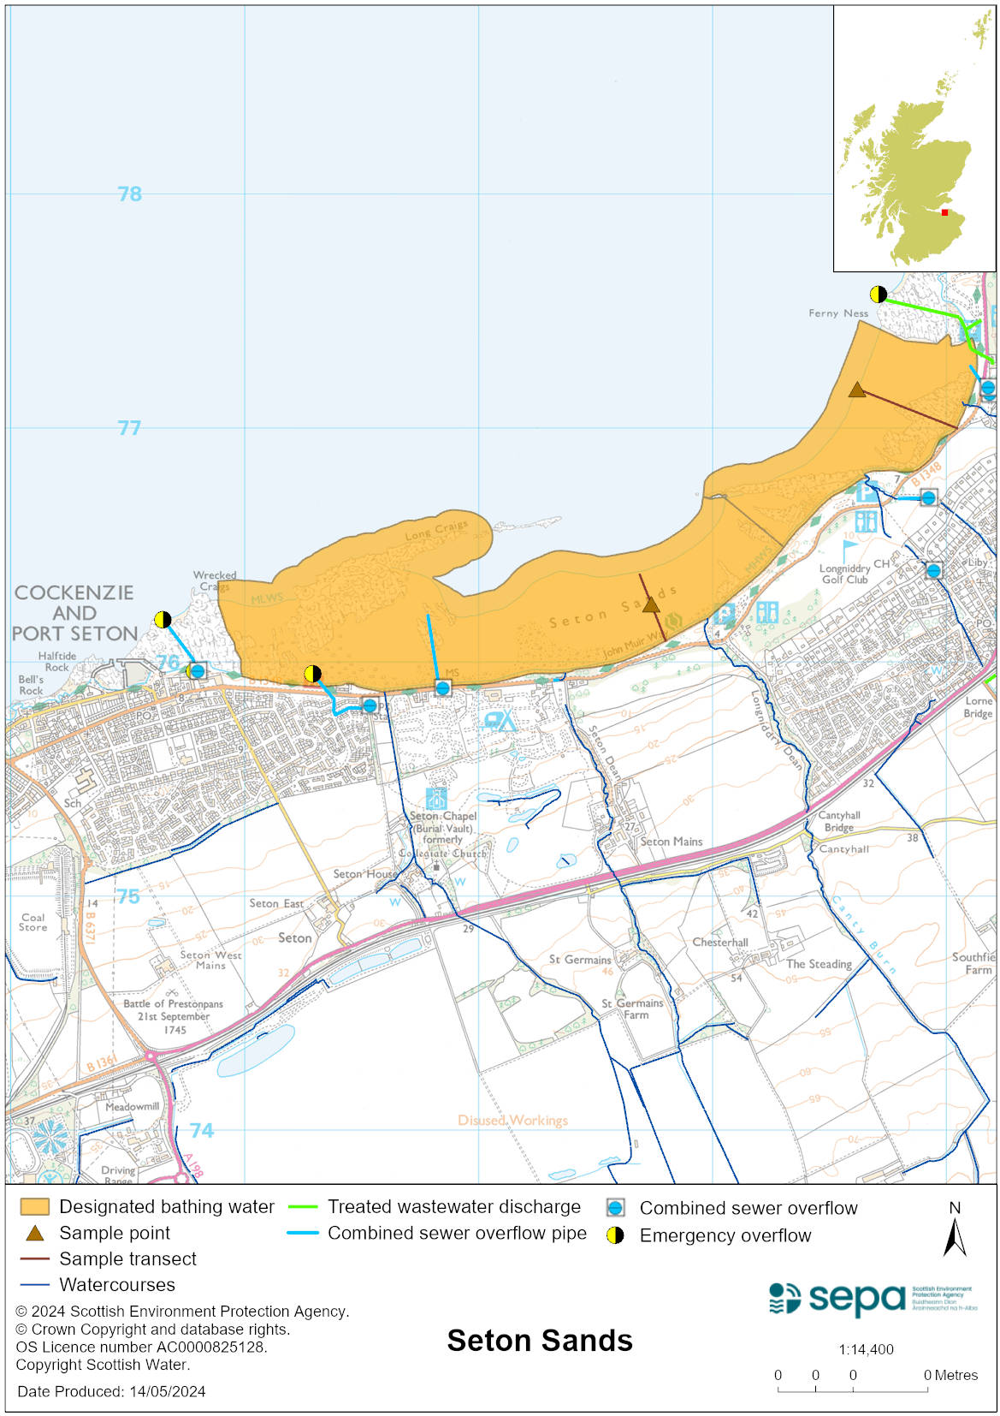

Map 2: Catchment draining into Seton Sands bathing water
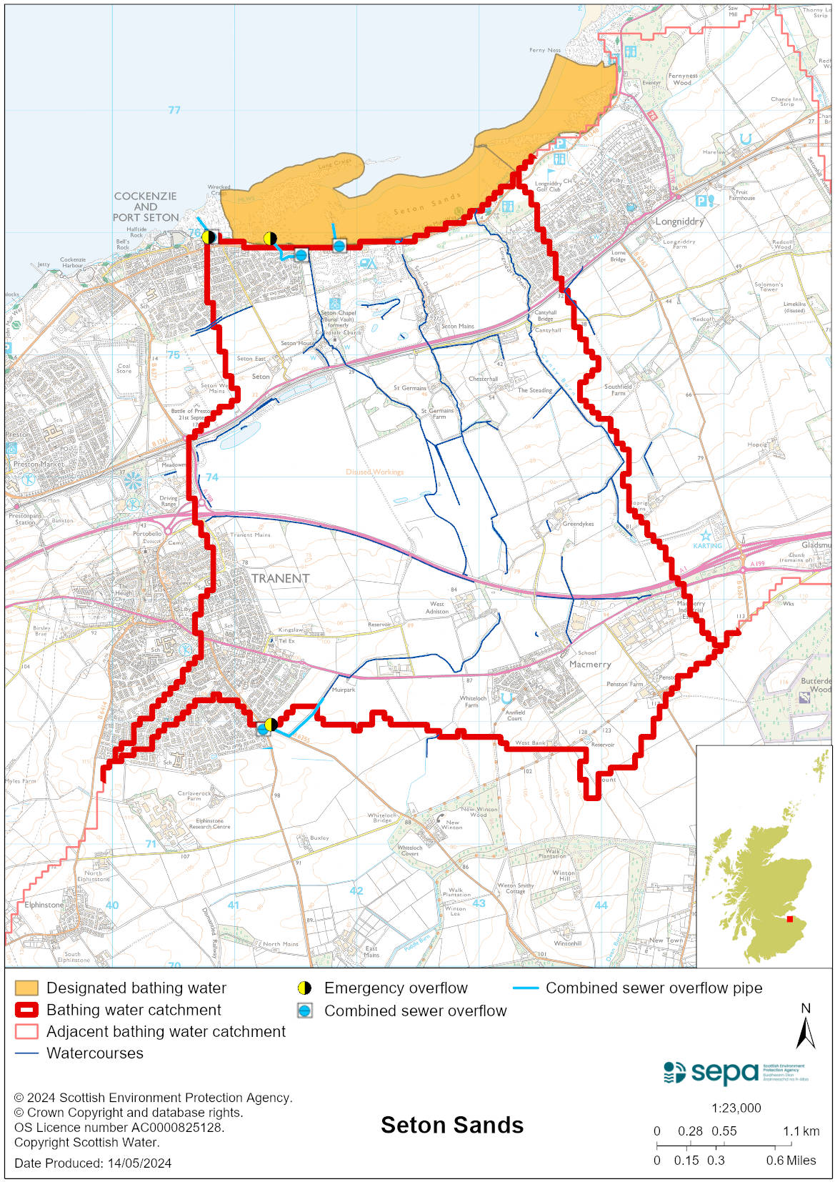

Improving bathing water quality

Sewage
Scottish Water provides most waste water collection and treatment services in Scotland.

Sewage from the surrounding areas of Longniddry, Cockenzie and Port Seton is treated at Edinburgh sewage treatment works before being discharged to the Firth of Forth via a long sea outfall to the North of the works.

Several combined sewer overflows (CSOs) have discharge locations at the western end of the bathing water. These may discharge and impact the bathing water during heavy rainfall. There is also an emergency overflow (EO) to the west. This EO should only discharge under rare, abnormal circumstances.

Agriculture
There are no impacts from agriculture affecting this bathing water.

Cyanobacteria (blue-green algae), algae and jellyfish
Marine waters are not at risk of cyanobacteria overproduction. This bathing water is not at risk of excessive growth of macroalgae (seaweed) or phytoplankton.

The possibility of increased jellyfish numbers in the water during summer months is a naturally occurring phenomenon. Most species common to the UK are harmless; the Marine Conservation Society advises to ‘look but don’t touch’.

Pollution incidents
Pollution can be reported via our website online form or by calling our 24 hours a day Pollution Hotline number 0800 80 70 60

If pollution is reported to us, or identified by our routine water quality monitoring program, we will investigate and where necessary work with others to remediate. We may contact other relevant organisations including the local authority, that local health board, Scottish Water and Scottish Ministers.

If there is a risk to human health the local authority is responsible for placing signs at the bathing water. Information will also be available on our website.

Everyone can help to keep the bathing water clean:
- If you visit the beach with your dog clear up any fouling
- Don’t leave litter or feed birds - this encourages unnatural behaviour, and they can pollute the water
- At home, don’t flush wipes or other inappropriate items as these can block pipes and cause sewage spills

Contact details and information sources

SEPA bathing waters homepage

SEPA rainfall data

Scottish Government protected waters homepage

East Lothian Council

For information on accessing this document in an alternative format or language, please contact SEPA by emailing equalities@sepa.org.uk
If you are a user of British Sign Language (BSL), the Contact Scotland BSL service gives you access to an online interpreter, enabling you to communicate with us using sign language. contactscotland-bsl.org

