Bathing water profile – Elie (Harbour) and Earlsferry
Bathing water classification

Bathing water description
Elie (Harbour) and Earlsferry bathing water is near the town of Elie on the north coast of the Firth of Forth. It is a long, sandy beach (1.3 km in length) which slopes gently towards the water. The area is popular with water sports enthusiasts. Depending on the tides, the approximate distance to the water’s edge can vary from 0–340 metres.

Site details:
- Local authority: Fife Council
- Year of designation: 1999
- Water sampling location: NT 48900 99800

Risks to water quality
This bathing water is at risk of short term pollution following heavy rainfall. Bathing is not advised during or 1-2 days after heavy rainfall due to the risk to bathers’ health from water pollution.

Pollution risks include sewer overflows.

Catchment description
The catchment draining into Elie (Harbour) and Earlsferry bathing water extends to 2.3 km2. The area is mainly rural (94%) with arable agriculture the major land use. Approximately 6% of the catchment is urban. The main population centre is the town of Elie. There are no major rivers within the bathing water catchment.
There are two Sites of Special Scientific Interest (SSSI) within or near the bathing water or catchment. Firth of Forth is an SSSI for its internationally important bird populations. Kilconquhar Loch is an SSSI for birds and habitat. These bird populations may potentially influence bathing water quality.

Map 1: Elie (Harbour) and Earlsferry bathing water
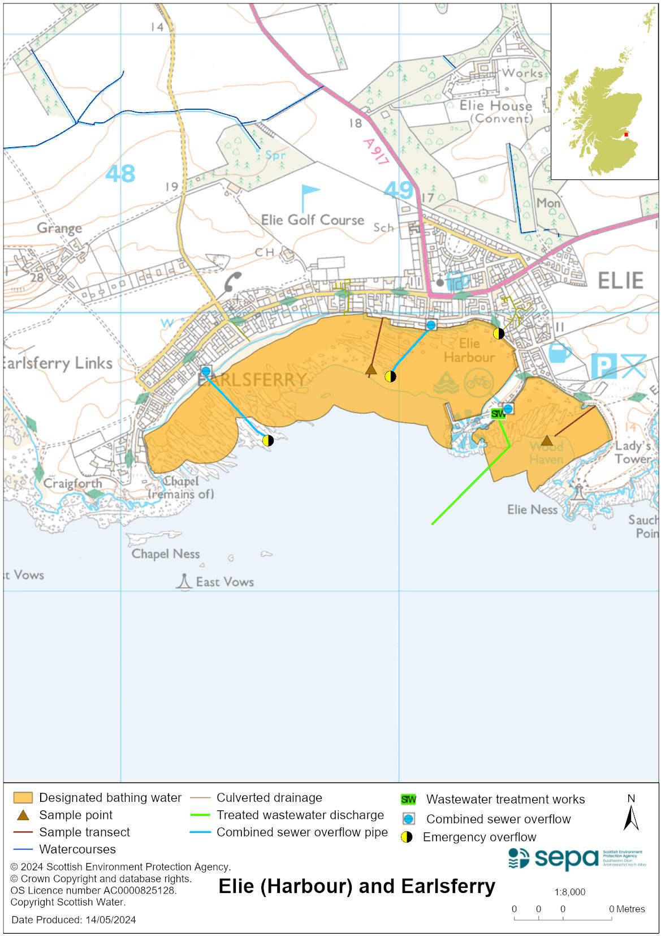

Map 2: Catchment draining into Elie (Harbour) and Earlsferry bathing water
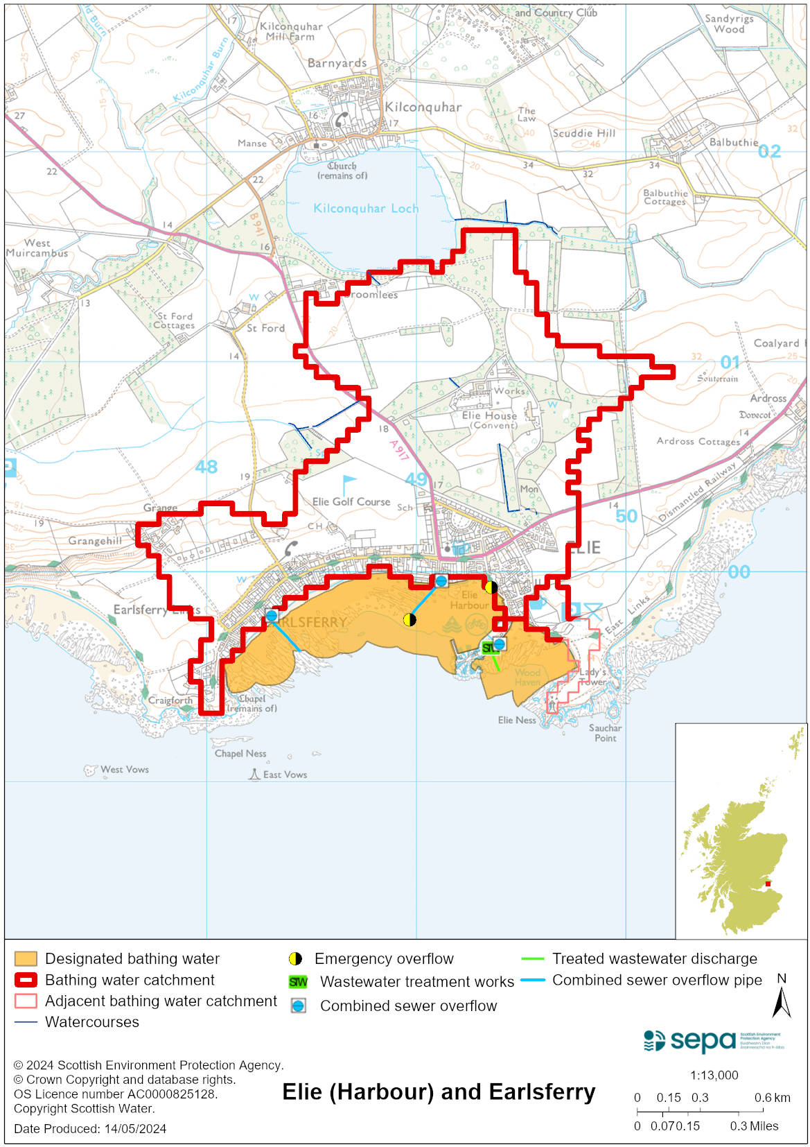

Improving bathing water quality

Sewage
Scottish Water provides most waste water collection and treatment services in Scotland.

Improvement works have been carried out to South Street and Earlsferry sewage pumping stations. Remedial works at Cadger’s Wynd pumping station have also been carried out. The effluent from the Elie sewage treatment works is discharged to the Firth of Forth via a long sea outfall.

There are combined sewer overflow (CSO) outfalls to the bathing water. This may discharge and impact the bathing water during heavy rainfall.

Agriculture
There are no impacts from agriculture affecting this bathing water.

Cyanobacteria (blue-green algae), algae and jellyfish
Marine waters are not at risk of cyanobacteria overproduction. This bathing water is not at risk of excessive growth of macroalgae (seaweed) or phytoplankton.

The possibility of increased jellyfish numbers in the water during summer months is a naturally occurring phenomenon. Most species common to the UK are harmless; the Marine Conservation Society advises to ‘look but don’t touch’.

Pollution incidents
Pollution can be reported via our website online form or by calling our 24 hours a day Pollution Hotline number 0800 80 70 60

If pollution is reported to us, or identified by our routine water quality monitoring program, we will investigate and where necessary work with others to remediate. We may contact other relevant organisations including the local authority, that local health board, Scottish Water and Scottish Ministers.

If there is a risk to human health the local authority is responsible for placing signs at the bathing water. Information will also be available on our website.

Everyone can help to keep the bathing water clean:
- If you visit the beach with your dog clear up any fouling
- Don’t leave litter or feed birds - this encourages unnatural behaviour, and they can pollute the water
- At home, don’t flush wipes or other inappropriate items as these can block pipes and cause sewage spills

Contact details and information sources

SEPA bathing waters homepage

SEPA rainfall data

Scottish Government protected waters homepage

Fife Council

For information on accessing this document in an alternative format or language, please contact SEPA by emailing equalities@sepa.org.uk
If you are a user of British Sign Language (BSL), the Contact Scotland BSL service gives you access to an online interpreter, enabling you to communicate with us using sign language. contactscotland-bsl.org

