Bathing water profile - Carnoustie
Bathing water classification

Bathing water description
The Carnoustie bathing water, south of the town of Carnoustie, is in a relatively small and shallow bay. It is about 0.7 km in length and slopes gently towards the water. Depending on the tide, the distance to the water’s edge can vary from 0–300 metres. At high tide the water comes up to the sea wall on some parts of the beach leaving no sand visible.

Site details:
- Local authority: Angus Council
- Year of designation: 1987
- Water sampling location: NO 56655 34227

Risks to water quality
This bathing water is at risk of short term pollution following heavy rainfall. Bathing is not advised during or 1-2 days after heavy rainfall due to the risk to bathers’ health from water pollution.

Pollution risks include sewer overflows.

Catchment description
The Carnoustie bathing water catchment extends to 31 km2 and ranges from low hills in the west to low-lying plains along the coast. The catchment is mostly rural (91%). The major land use is arable agriculture with some soft fruit and livestock production. Approximately 9% of the catchment is urban and includes the town of Carnoustie. Population density outside of the town is generally low.
There are two watercourses within the catchment. Barry Burn flows southwest of the bathing water, and Lochty Burn flows directly into the bathing water.

Map 1: Carnoustie bathing water
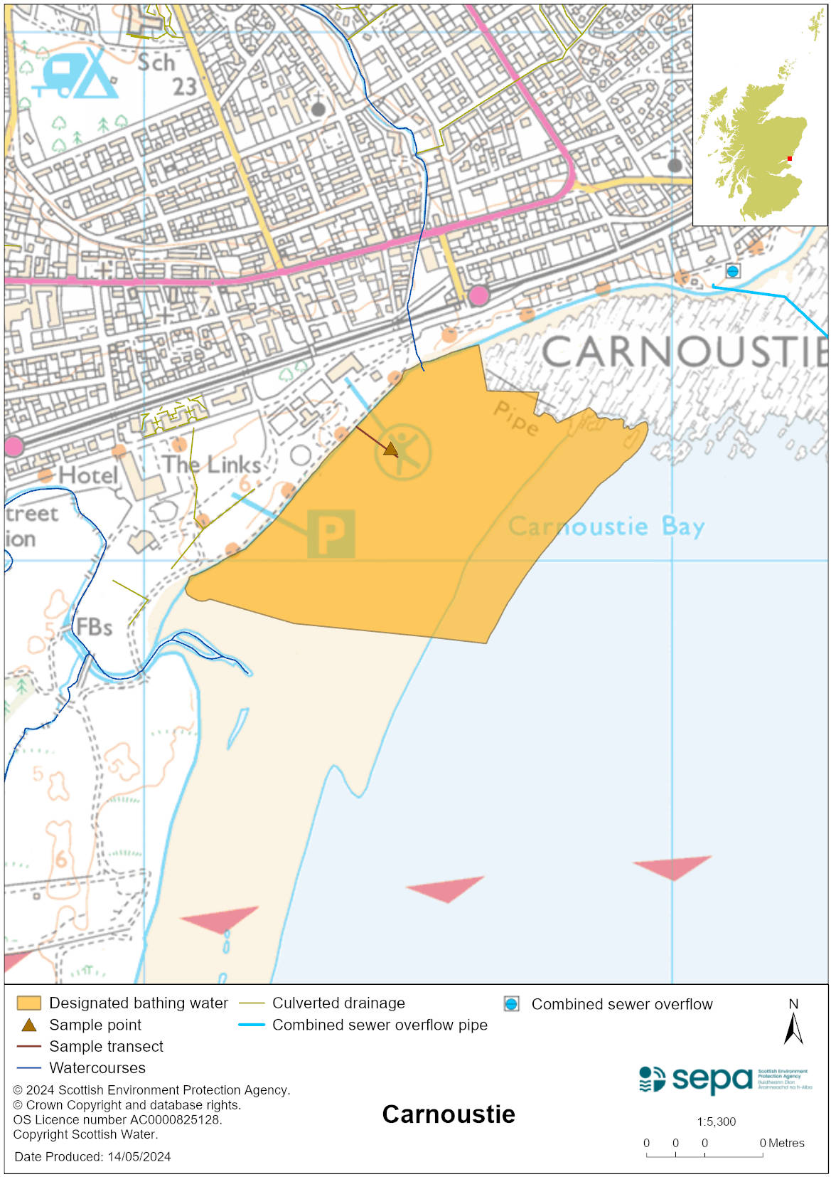

Map 2: Catchment draining into Carnoustie bathing water
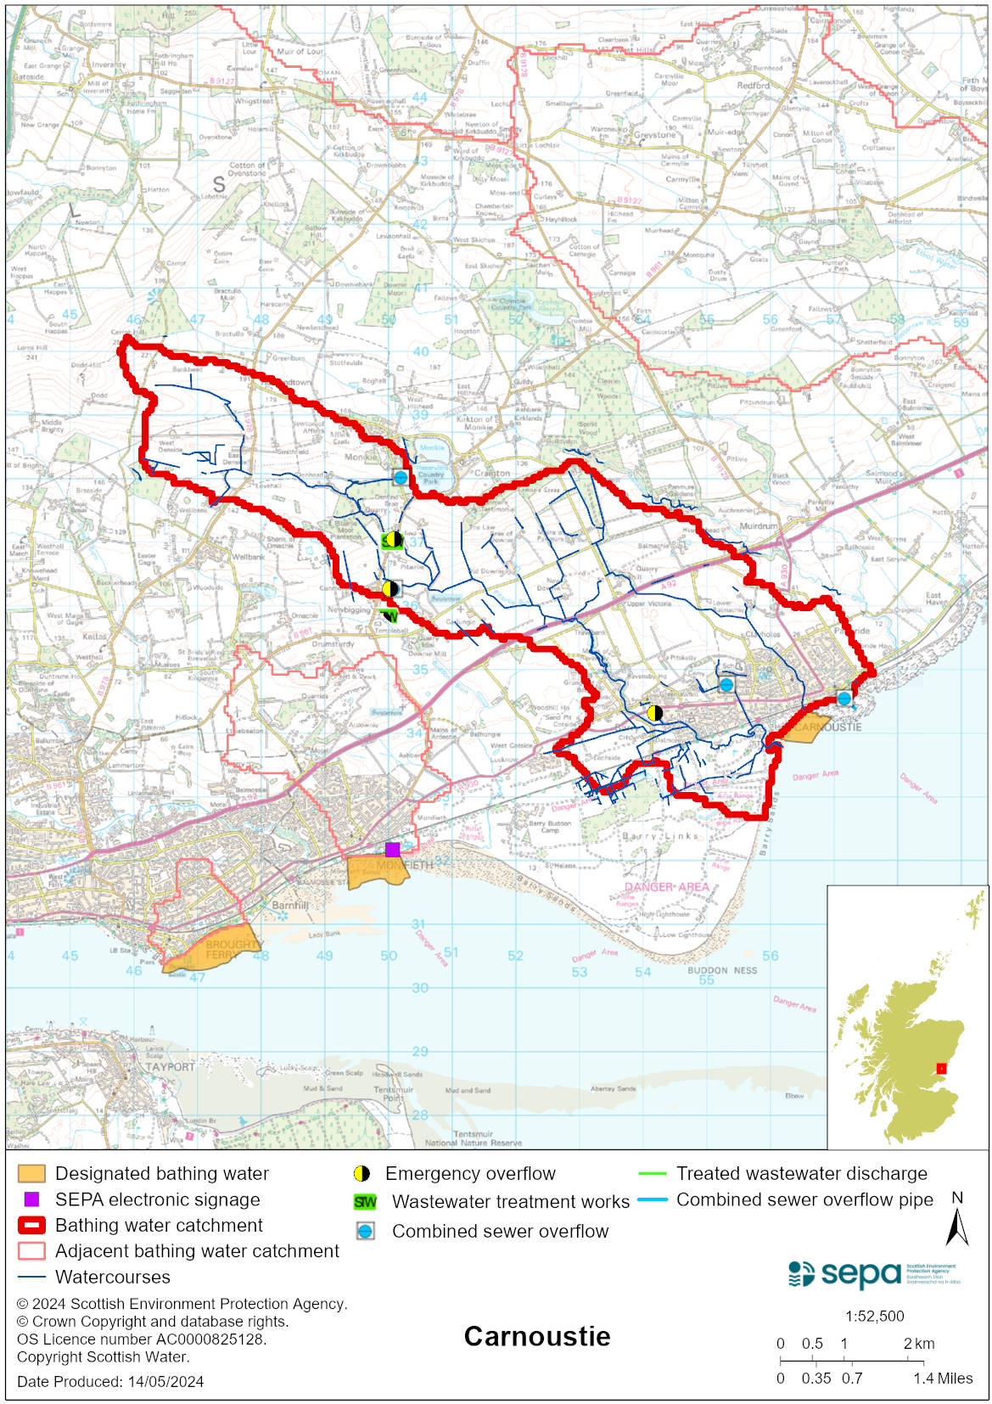

Improving bathing water quality

Sewage
Scottish Water provides most waste water collection and treatment services in Scotland.

Sewage from Carnoustie is treated at Hatton sewage treatment works and is then discharged to the Firth of Tay via a long sea outfall. Monikie sewage treatment works and combined sewers discharge to the Barry Burn. Treatment at the Monikie works includes bio-filters and humus tanks.

There is a combined sewer overflows (CSO) outfall to east of the bathing water. This may discharge and impact the bathing water during heavy rainfall.

Agriculture
There are no impacts from agriculture affecting this bathing water.

Cyanobacteria (blue-green algae), algae and jellyfish
Marine waters are not at risk of cyanobacteria overproduction. This bathing water is not at risk of excessive growth of macroalgae (seaweed) or phytoplankton.

The possibility of increased jellyfish numbers in the water during summer months is a naturally occurring phenomenon. Most species common to the UK are harmless; the Marine Conservation Society advises to ‘look but don’t touch’.

Pollution incidents
Pollution can be reported via our website online form or by calling our 24 hours a day Pollution Hotline number 0800 80 70 60

If pollution is reported to us, or identified by our routine water quality monitoring program, we will investigate and where necessary work with others to remediate. We may contact other relevant organisations including the local authority, that local health board, Scottish Water and Scottish Ministers.

If there is a risk to human health the local authority is responsible for placing signs at the bathing water. Information will also be available on our website.

Everyone can help to keep the bathing water clean:
- If you visit the beach with your dog clear up any fouling
- Don’t leave litter or feed birds - this encourages unnatural behaviour, and they can pollute the water
- At home, don’t flush wipes or other inappropriate items as these can block pipes and cause sewage spills

Contact details and information sources

SEPA bathing waters homepage

SEPA rainfall data

Scottish Government protected waters homepage

Angus Council

For information on accessing this document in an alternative format or language, please contact SEPA by emailing equalities@sepa.org.uk
If you are a user of British Sign Language (BSL), the Contact Scotland BSL service gives you access to an online interpreter, enabling you to communicate with us using sign language. contactscotland-bsl.org

