Bathing water profile – Largs (Pencil Beach)
Bathing water classification

Bathing water description
Largs (Pencil Beach) bathing water is a relatively small, shallow bay about 300 metres in length. It is on the north Ayrshire coast at the southern end of Largs town. On a clear day, the beach offers great views of Little Cumbrae and Great Cumbrae islands. The bathing water is north of the Pencil monument. It is a sandy bay with a mixture of grass and pebble interspersed by rocky outcrops. Depending on the tide, the distance to the water’s edge can vary from 0–130 metres.

Site details:
- Local authority: North Ayrshire Council
- Year of designation: 2006
- Water sampling location: NS 20700 58050

Risks to water quality
This bathing water is subject to short term pollution following heavy rainfall. Bathing is not advised during or 1-2 days after heavy rainfall due to the risk to bathers’ health from water pollution.

Pollution risks include agricultural run-off and sewer overflows.

Water quality forecasts
As water quality is likely to be impacted by rainfall we make daily predictions of good or poor bathing water quality. We advise against bathing when poor water quality is predicted as there is an increased risk to bathers’ health from water pollution.

These predictions are displayed on the electronic sign at the beach and online between 15 May and 15 September.

Catchment description
The Largs (Pencil beach) bathing water catchment extends to only 1.2 km2. The area is mainly rural (90%) with agriculture as the major land use. There is also some moorland and a golf course. The lowland parts of the catchment are mostly urban. The urban areas make up approximately 8% of the catchment. The main towns in the area are Largs and Fairlie, about 1 km south of the bathing water.

Map 1: Largs (Pencil Beach) bathing water
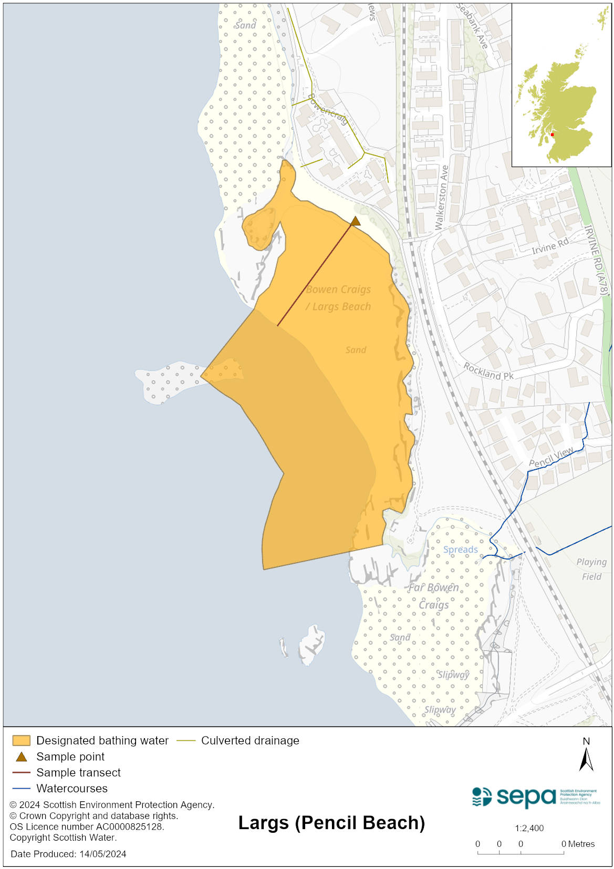

Map 2: Catchment draining into Largs (Pencil Beach) bathing water
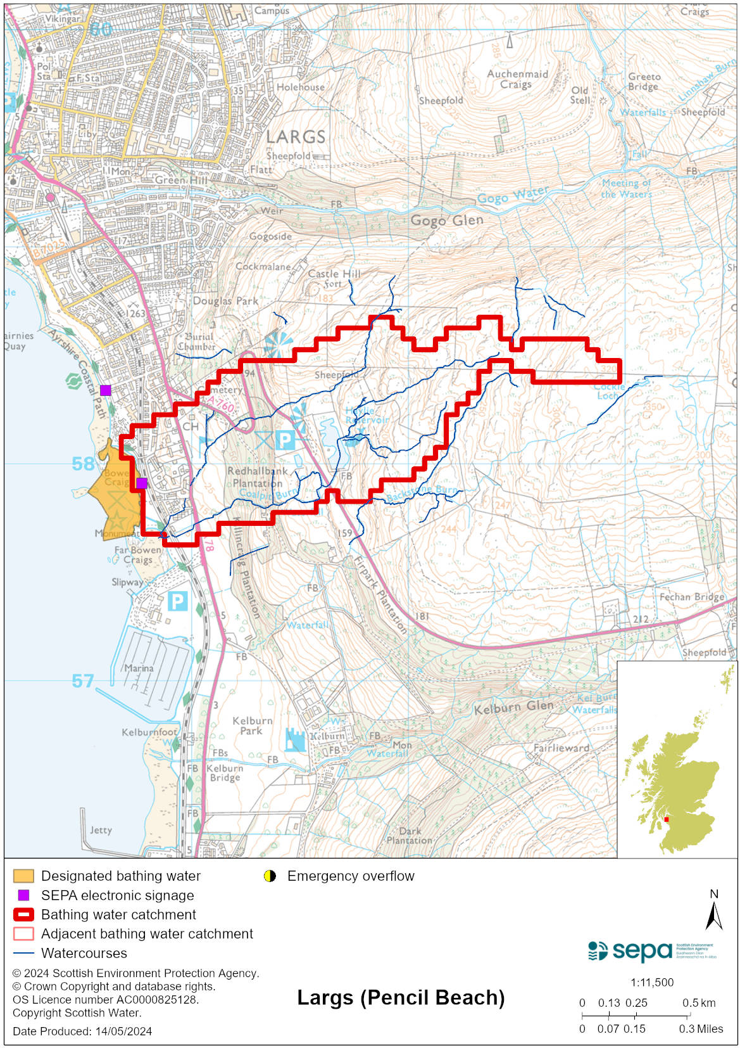

Improving bathing water quality

Sewage
Scottish Water provides most waste water collection and treatment services in Scotland.

There are several combined sewer and emergency overflows within Largs. Under storm conditions, they can discharge to the south of the beach, or to the two main watercourses. Sewage from Largs town is pumped to a sewage treatment works situated to the north. Treated sewage from the works is discharged offshore into deep water.

Agriculture
Diffuse pollution from agricultural sources is the result of rain driven events causing cumulative inputs of pollutants to rivers and streams.

There is potential for agricultural diffuse pollution to occur in small tributaries discharging onto the bathing beach. These are a risk to Largs (Pencil) bathing water quality, particularly during and after periods of wet weather.

Farm visits have been on going in this catchment since 2013 and SEPA will continue to work with rural land managers in to reduce the risk of pollution to the bathing water. SEPA has observed significant changes in land manager practice and improvements which are known to reduce pollution risk. There has been significant capital expenditure resulting in many rural land managers going beyond regulatory compliance to address issues arising from their farming activities.

Cyanobacteria (blue-green algae), algae and jellyfish
Marine waters are not at risk of cyanobacteria overproduction. This bathing water is not at risk of excessive growth of macroalgae (seaweed) or phytoplankton.

The possibility of increased jellyfish numbers in the water during summer months is a naturally occurring phenomenon. Most species common to the UK are harmless; the Marine Conservation Society advises to ‘look but don’t touch’.

Pollution incidents
Pollution can be reported via our website online form or by calling our 24 hours a day Pollution Hotline number 0800 80 70 60

If pollution is reported to us, or identified by our routine water quality monitoring program, we will investigate and where necessary work with others to remediate. We may contact other relevant organisations including the local authority, that local health board, Scottish Water and Scottish Ministers.

If there is a risk to human health the local authority is responsible for placing signs at the bathing water. Information will also be available on our website.

Everyone can help to keep the bathing water clean:
- If you visit the beach with your dog clear up any fouling
- Don’t leave litter or feed birds - this encourages unnatural behaviour, and they can pollute the water
- At home, don’t flush wipes or other inappropriate items as these can block pipes and cause sewage spills

Contact details and information sources

SEPA bathing waters homepage

SEPA rainfall data

Scottish Government protected waters homepage

North Ayrshire Council

For information on accessing this document in an alternative format or language, please contact SEPA by emailing equalities@sepa.org.uk
If you are a user of British Sign Language (BSL), the Contact Scotland BSL service gives you access to an online interpreter, enabling you to communicate with us using sign language. contactscotland-bsl.org

