Bathing water profile - Dornoch
Bathing water classification

Bathing water description
Dornoch bathing water is located on the Dornoch Firth. It is a 4 km long sandy beach, sloping gently towards the water. It stretches from the rocky outcrops at its northern end to the headland projecting into the southern end of the Dornoch Firth. Depending on the tide, the distance to the water’s edge can vary from 0–600 metres.

Site details:
- Local authority: Highland Council
- Year of designation: 1999
- Water sampling location: NH 80500 89400

Risks to water quality
Our water quality monitoring indicates that there are no significant pollution inputs to this bathing water under normal situations, including after rainfall.

There remains a risk that water pollution may occur after extreme rainfall.

Catchment description
The Dornoch bathing water catchment extends to 9 km2. The catchment varies from hills in the west to low-lying plains along the coast. The main river in the catchment is the Dornoch Burn which flows into the bathing water at the midpoint of the bay.
The area is 96% rural (55% grassland, 24% woodland, 15% arable agriculture). Agriculture is the main land use. The area supports mixed farming. Approximately 4% of the catchment is urban. The main population centre is the town of Dornoch, situated within 1 km of the bathing water. Population density outside of the town is generally low. There is some intensive and large-scale commercial and industrial activity in Dornoch and Tain.
There are a few protected areas partially within the catchment, including two Special Areas of Conservation and a Ramsar site. Dornoch Bay is of international importance for aggregations of birds. The bird populations have the potential to affect water quality at the bathing area.

Map 1: Dornoch bathing water
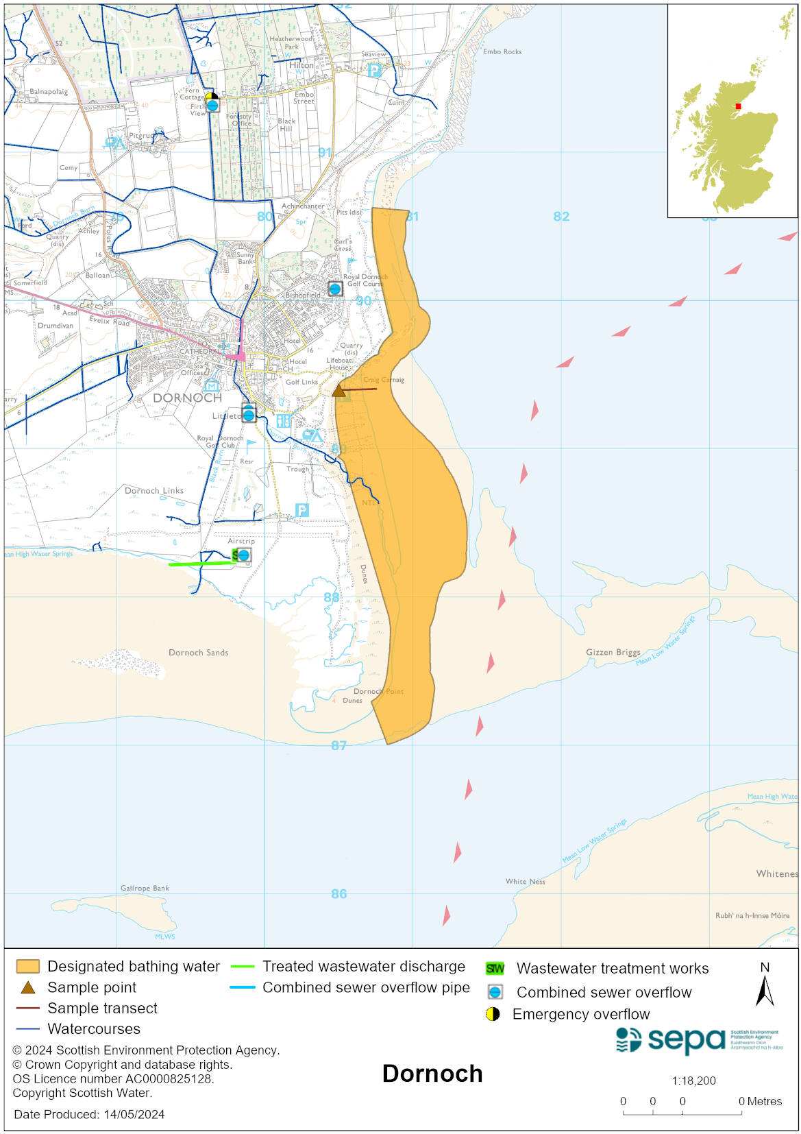

Map 2: Catchment draining into Dornoch bathing water
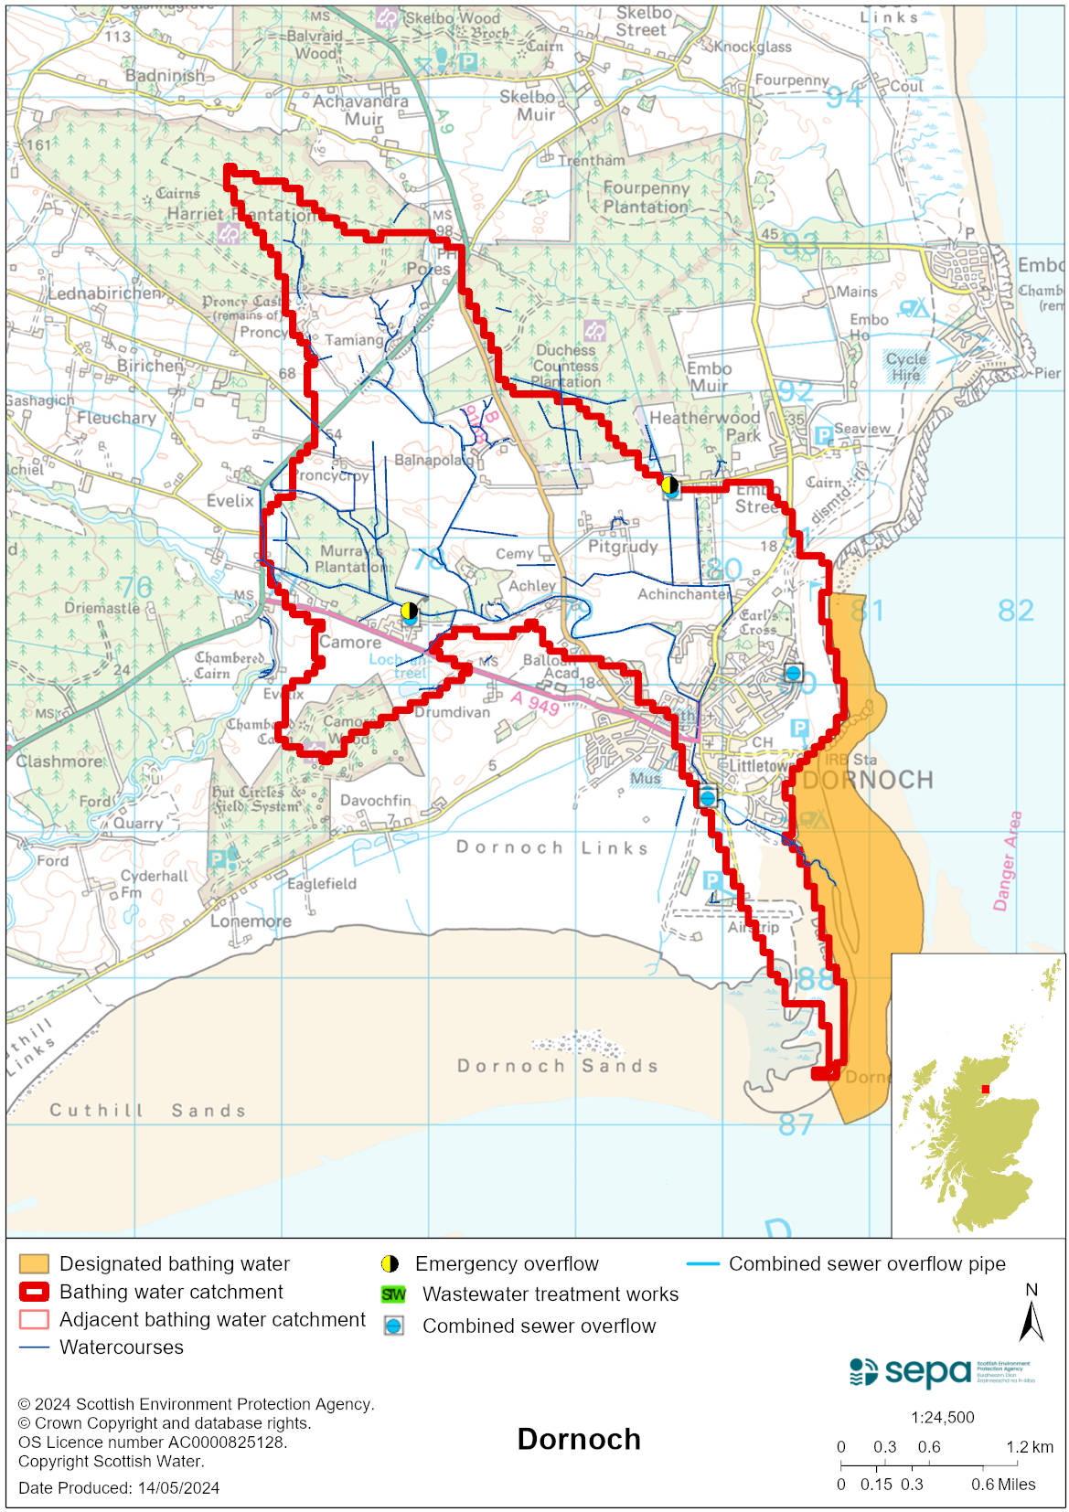

Improving bathing water quality

Sewage
Scottish Water provides most waste water collection and treatment services in Scotland.
Dornoch sewage treatment works include ultraviolet disinfection of the effluent prior to discharge. Dornoch sewerage network has combined sewer overflows and emergency overflows to the Dornoch Burn. Under wet weather conditions or pumping station malfunction these overflows may discharge and pose a potential risk to water quality at the beach.
There are private septic tanks in the area. Our evidence suggests that they do not impact the bathing water.

Agriculture
Diffuse pollution from agricultural sources is the result of rain driven events causing cumulative inputs of pollutants to rivers and streams.

The catchment draining to Dornoch bathing water is within the Dornoch coastal catchment. Work to address diffuse pollution issues in this catchment is expected to be completed by 2027.

Cyanobacteria (blue-green algae), algae and jellyfish
Marine waters are not at risk of cyanobacteria overproduction. This bathing water is not at risk of excessive growth of macroalgae (seaweed) or phytoplankton.

The possibility of increased jellyfish numbers in the water during summer months is a naturally occurring phenomenon. Most species common to the UK are harmless; the Marine Conservation Society advises to ‘look but don’t touch’.

Pollution incidents
Pollution can be reported via our website online form or by calling our 24 hours a day Pollution Hotline number 0800 80 70 60

If pollution is reported to us, or identified by our routine water quality monitoring program, we will investigate and where necessary work with others to remediate. We may contact other relevant organisations including the local authority, that local health board, Scottish Water and Scottish Ministers.

If there is a risk to human health the local authority is responsible for placing signs at the bathing water. Information will also be available on our website.

Everyone can help to keep the bathing water clean:
- If you visit the beach with your dog clear up any fouling
- Don’t leave litter or feed birds - this encourages unnatural behaviour, and they can pollute the water
- At home, don’t flush wipes or other inappropriate items as these can block pipes and cause sewage spills

Contact details and information sources

SEPA bathing waters homepage

SEPA rainfall data

Scottish Government protected waters homepage

Highland Council

For information on accessing this document in an alternative format or language, please contact SEPA by emailing equalities@sepa.org.uk
If you are a user of British Sign Language (BSL), the Contact Scotland BSL service gives you access to an online interpreter, enabling you to communicate with us using sign language. contactscotland-bsl.org

